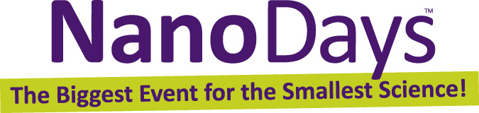

Tips for Engaging Visitors

Greet visitors
Say “hello,” make eye contact, and smile. Simply looking like you’re available and friendly will bring visitors to your station.

Let visitors do the activity
As much as possible, let visitors do the hands-on parts of the activity, and let them discover what happens. (If your activity has a surprise, don’t give it away!)

Share what you know
Use clear, simple language. Focus on one main idea—don’t feel that you need to tell visitors everything at once! Keep the information basic for starters, and be willing to expand on an idea for interested learners.

Use examples from everyday life
Familiar examples can help explain abstract concepts. Be aware of visitors’ abilities, keeping in mind that children do not have the same skills or vocabulary as adults.

Ask questions
Help visitors observe and think about the activity. Try to use questions that have more than one answer, such as:
- What do you see happening?
- Why do you think that happened?
- What surprised you about what you saw?
- Does this remind you of anything you’ve seen before?

Be a good listener
Be interested in what visitors tell you, and let their curiosity and responses drive your conversation forward.

Offer positive and encouraging responses
If visitors haven’t quite grasped a concept, you might say, “That’s a good guess,” or “Very close, does anyone else have something to add?” Don’t say, “No” or “Wrong” in response to visitors’ observations or explanations.

Share accurate information
If you aren’t sure about something, it’s OK to say, “I don’t know. That’s a great question!” Suggest that visitors go to whatisnano.org to learn more about nanoscale science, engineering, and technology.

Remain positive throughout the interaction
Remember that nonverbal communication is important, too. Try to maintain an inviting face and body language.

Thank visitors
As your interaction ends, suggest that visitors explore other NanoDays activities.

HAVE FUN! A positive experience will lead to learning.

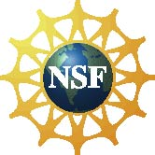 | This project was supported by the National Science Foundation under Award No. 0940143. Any opinions, findings, and conclusions or recommendations expressed in this document are those of the author and do not necessarily reflect the views of the Foundation.

Copyright 2011, Sciencenter, Ithaca, NY. Published under a Creative Commons Attribution-Noncommercial-ShareAlike license: http://creativecommons.org/licenses/by-nc-sa/3.0/us/

