**Macintosh HD:Users:raeostman:Desktop:Frankenstein200 Design Pack:Frankenstein200 Logo:EPS - Print:frankenstein200-K.epsFACILITATOR GUIDE TO**

**SPARK OF LIFE**

# DESCRIPTION

In this activity, learners will create a battery from two kinds of metal and their own body! This activity is designed to prompt conversation and reflection about responsible innovation, inspired by themes raised in Mary Shelley’s novel *Frankenstein.*

# AUDIENCES

This activity is best suited for ages 5 and up. Younger children can participate successfully with support from an educator or caregiver.

# LEARNING OBJECTIVES

# The primary objective of this activity is to encourage exploration and reflection about responsible innovation. In addition, learners will investigate the following concepts:

# People are creative! We’re always learning more about the world and inventing new things.

* It’s important to think ahead as we study science and make new technologies.
* Some medical technologies take advantage of the fact that your body can complete an electrical circuit.

# MATERIALS

* Sheet of galvanized steel (about 8”x12”), edges sanded for safety
* Sheet of copper (about 8”x12”), edges sanded for safety
* Multimeter
* Electrical lead wires with alligator clips
* Sponge
* Plastic bowl
* Activity booklet
* Sign holder and table sign
* Optional: TENS unit, electrodes, and batteries (TENS stands for *transcutaneous electrical nerve stimulation)*
* Optional: Alcohol packets to clean TENS unit electrodes

Materials sources and instructions for creating your own kit materials are provided at the end of this facilitator guide.

# PRESENTATION

**Advance preparation:**

You will need ample time to prepare for this activity. Read through all parts of this facilitator guide well in advance of delivering the activity.

Assemble the hand battery and practice using it. Instructions for assembly, and troubleshooting tips, are provided below. All participants can use the hand battery.

The TENS unit is an optional demonstration to supplement the hand battery activity. Read the special note in the **Safety** section on the TENS unit and secure any necessary permissions you may need to use it. Set up and practice using the TENS unit, if you choose to include it in the activity (see below, under Safety, and see also the instructions that come with your unit).

The activity booklet provides step-by-step instructions for the activity. It also includes contextual information about Mary Shelley’s novel *Frankenstein* and the questions the story raises for current science and engineering.

**Hand Battery assembly:**

1. Place the sheet metal plates on a piece of wood or another nonmetallic surface. Put the steel sheet on the left and the copper sheet on the right.
2. Place the multimeter above the metal sheets. Be sure its probes are inserted correctly and it is set to measure microamps (μA). Check that it has a fresh battery. (Consult the manual for your unit.)
3. Use one lead to connect the steel plate to the black probe of the multimeter.
4. Use another lead to connect the copper plate to the red probe of the multimeter.

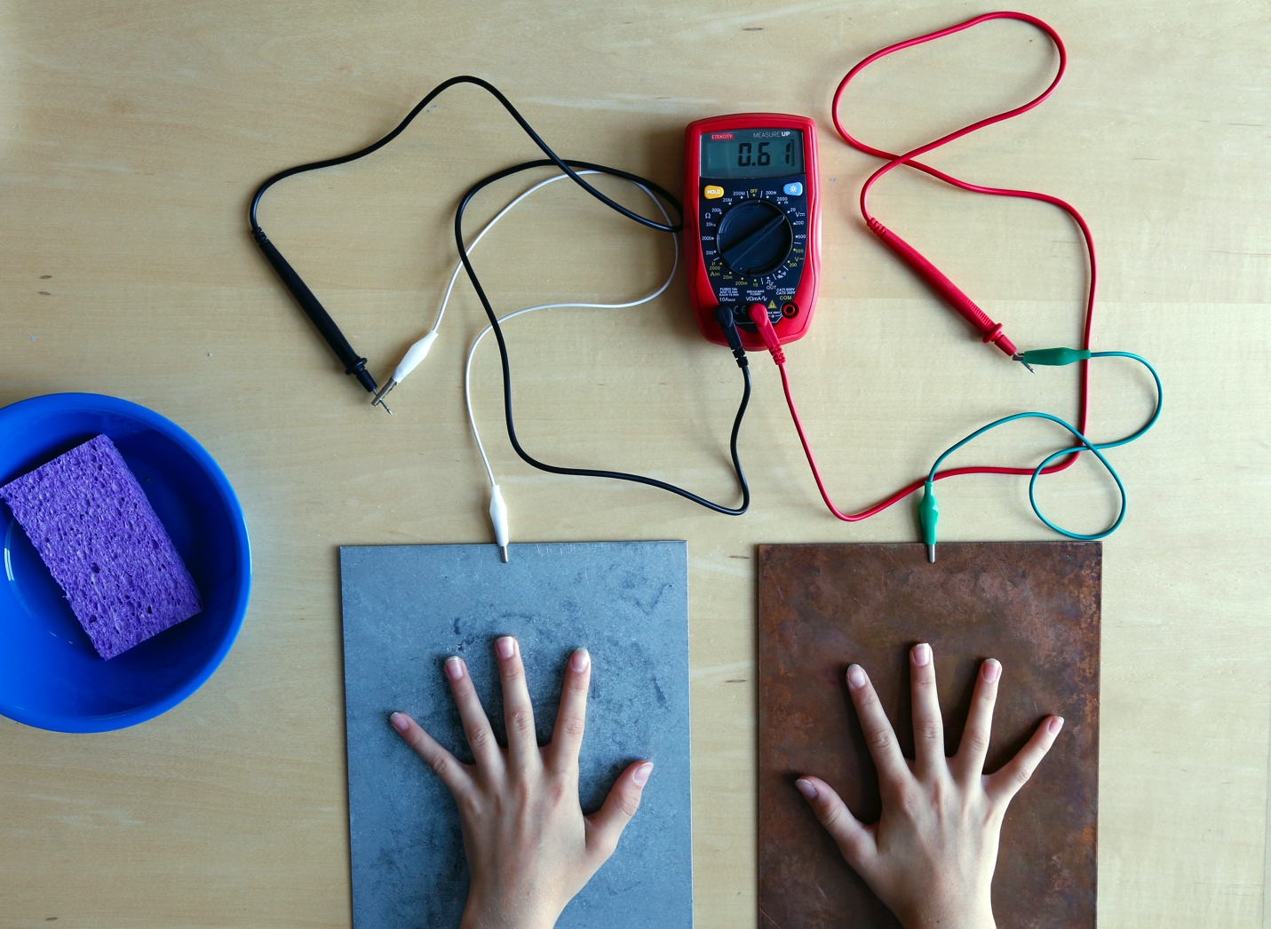

**Hand Battery assembly**

Troubleshooting:

* When you place one hand on each plate, you should notice a positive reading on the meter.
* If you don’t get a reading, or get a very low reading, press down harder on the plates, so your hands are making good contact with the metal. You can also get your hands damp and try again: the water should reduce the resistance.
* If the meter shows a negative current, reverse your connections. Switch the probes connected to the steel plate with the one connected to the copper plate and vice versa.
* If the meter shows no current, check to be sure you have it set to the right reading. If the meter still shows no current, check the connections and the wiring. Then, if the meter still shows no current, try cleaning the plates with steel wool to remove oxidation.

**TENS unit assembly:**

1. Be sure the unit has a fresh battery and the controls are set to the off (0) position. (Consult the manual for your unit.)
2. Insert a lead wire into one of the channels at the top of the unit. The lead splits into two ends, one red and one black. Insert the pin at each end of the lead into one electrode pad.
3. Turn it on and check the settings. Digital units tend to default to a high setting, so you may need to adjust it to a very low setting before applying the electrode pads.
4. Place one electrode pad on your forearm near your elbow. Place the other on your forearm near your wrist.
5. Slowly adjust the unit until you can feel a sensation. (Use the control that corresponds to the channel where you inserted the lead.) It depends on the person using the device, but a good range to stay within is 2-6.
6. If you slowly increase the intensity, you may notice the muscles on your hand and fingers twitching. Keep the intensity at a low level. DO NOT increase the intensity to the point where it feels too strong or uncomfortable.
7. After use, clean the electrode pads with alcohol and return the parts to the storage case.

**Set up:**

* Wet the sponge and wring it out. You will need to do this periodically as you facilitate the activity, so you may find it convenient to put a small amount of water in the bowl and keep the sponge in the bowl.
* Set up the hand battery apparatus and test it.
* Optional: Set up the TENS unit and test it.

**Activity flow:**

Open by asking participants if they’ve ever heard of Frankenstein’s “monster.” Share that the original story was written 200 years ago by Mary Shelley, and has been retold many times. Ask if they know what happens in the story, and establish the basic plotline. In the novel, a student named Victor Frankenstein builds a creature from dead body parts, and uses electricity to bring it to life. Unfortunately, Frankenstein didn’t think ahead to what his creature would do, or how he would take care of it, if he succeeded in bringing it to life. Be sure to mention that Victor Frankenstein used electricity to help bring his creature to life.

Explain that the author of the Frankenstein story, Mary Shelley, was familiar with early experiments with electricity, including experiments on animals and human corpses. You can ask some reflection questions to help participants think about this kind of research:

* *How do you think Shelley may have felt about the electrical experiments going on during her lifetime?*
* *How would you have felt about them?*

Invite participants to try the hand battery activity. As a variation, you can also have one person put a hand on the copper plate and another person put a hand on the aluminum plate, and then have them join their free hands.

Afterwards, you can ask if they would like to see a demonstration of the TENS machine. Reassure participants that the device does not hurt you but does feel tingly. You can provide additional context by sharing examples of other medical devices that use electricity, including cardiac pacemakers.

Finally, be sure to ask participants some or all of the reflection questions:

* *Would you try a TENS unit to help heal an injury? Would you be nervous or excited to see if it worked?*
* *Would you get a chip in your brain to help you move a paralyzed arm?*
* *Would you get a brain chip to become better at sports?*

There’s no right or wrong answer to the reflection questions! Everyone can form their own opinions. You can help encourage visitors to develop and share their own ideas by referring to the Conversation Tips guide.

**Audiences:**

Young children and individuals with special needs may need assistance with some steps in this activity.

**Safety:**

Hand Battery:

* All participants can safely use the hand battery. They will not receive a shock.
* The edges and corners of the sheet metal may be sharp,even when sanded. Do not allow participants to handle the sheets. They should remain flat on a non-conductive (non-metallic) surface. If the sheets need to be moved so that participants can reach them, you can slide them toward the participants or place them on a tray.
* Supervise young children to ensure they do not mouth any materials, as some materials may present choking hazards.

TENS unit:

* The TENS unit can be used as an optional demonstration to supplement the hand battery activity. It is not necessary to use the unit to successfully facilitate this activity. There is a photo and information on TENS in the activity booklet if you choose not to demonstrate the unit in use.
* The TENS unit should only be operated by experienced staff or volunteers and is not intended for use on the visiting public. If you choose to demonstrate the use of a TENS unit, use reasonable precautions and always follow the instructions.Read all the special safety information provided in this guide, and with your TENS unit.
* Check with your organization’s safety officer or other appropriate supervisor before testing or using the TENS unit.
* The TENS unit stimulates your nerves with electricity. It is used to treat pain. It creates a tingling sensation that some people find slightly uncomfortable.
* The TENS unit is not recommended for use by individuals with heart conditions. If you have any concerns about its effect on your body, do not use it (or consult your doctor first).
* Before you demonstrate the TENS unit, read and be sure you understand all the instructions provided with your particular unit. Practice using it so you are comfortable with the device.
* For the purposes of this activity, demonstrate the use of the TENS unit on your forearm only.
* When you use the unit, increase the intensity gradually and keep it at a low level. Never set the intensity to a level that feels too strong or uncomfortable.
* Follow all instructions included with the TENS unit.
* Never leave the TENS unit unattended or allow children to play with it.

**PROGRAMMING OPTIONS**

This activity can be incorporated into a variety of educational programs, such as after-school programs, family workshops, and summer camps. In longer program formats, you can use videos and books to familiarize participants with the Frankenstein story:

* The 1931 Hollywood movie *Frankenstein,* directed by James Whale, introduced the world to Boris Karloff’s iconic version of the creature.
* *Frankenweenie* is a 2012 retelling of the Frankenstein story, directed by Tim Burton.
* There are also many books that share the story, which are appropriate for a variety of audiences.

You can also use videos to provide more information on the human body, electricity, and medical devices:

* [How the Human Body Creates Electricity](https://youtu.be/1-NA86aAMvY) (Medical Confessions) provides an overview of the electricity that the human body naturally creates. YouTube: https://youtu.be/1-NA86aAMvY

# MATERIALS INFORMATION

**Sources:**

* Sheet metal is available at some hardware and building supply stores or through online retailers that specialize in metals. Sandpaper is available at hardware and building supply stores.
* Multimeters are available at building supply, electronics, and educational supply stores and large discount stores.
* Wire leads with alligator clips are available at electronics and educational supply stores.
* TENS units are available from medical supply stores and some discount stores.
* All other materials are available at discount stores.
* Print materials for this activity can be downloaded from [nisenet.org](http://nisenet.org/).

**Preparation:**

* Sand the edges of the sheet metal all the way around and round the corners.

**CREDITS AND RIGHTS**



Copyright 2017, Arizona State University. Published under a Creative Commons Attribution-Noncommercial-ShareAlike license: <http://creativecommons.org/licenses/by-nc-sa/3.0/us/>



Distributed in collaboration with the National Informal STEM Education Network: nisenet.org



This project was supported by the National Science Foundation under Grant Number 1516684. Any opinions, findings, conclusions, or recommendations expressed in this program are those of the authors and do not necessarily reflect the views of the Foundation.

This is a common activity that exists in many variations. The Frankenstein200 version was adapted from was adapted fromHand Battery, developed by The Bakken Museum.

Instruction and promotion photos and illustrations by the Science Museum of Minnesota for Frankenstein200.

Historic image of an electrical experiment on a corpse from Wikimedia Commons. Retrieved from: https://commons.wikimedia.org/wiki/File:Houghton_Typ_815.67.3922_-_Les_merveilles_de_la_science,_Figuier,_fig._333.jpg

X-ray image of a pacemaker inside the human body from Wikimedia Commons. Retrieved from: https://commons.wikimedia.org/wiki/File:Herzschrittmacher_auf_Roentgenbild.jpg

Historic image of Galvani’s experiment with a frog from Wikimedia Commons. Retrieved from: https://commons.wikimedia.org/wiki/File:Galvani-frogs-legs-electricity.jpg

Photograph of therapy on a paralyzed patient courtesy The Ohio State University Wexner Medical Center/Battelle. Used with permission.