STEM Learning Ecosystem Videos
Reflection and Discussion Guide

OVERVIEW
Discussion prompts designed to accompany the STEM learning ecosystem video series and promote conversation and reflection between small teams or groups of professionals.
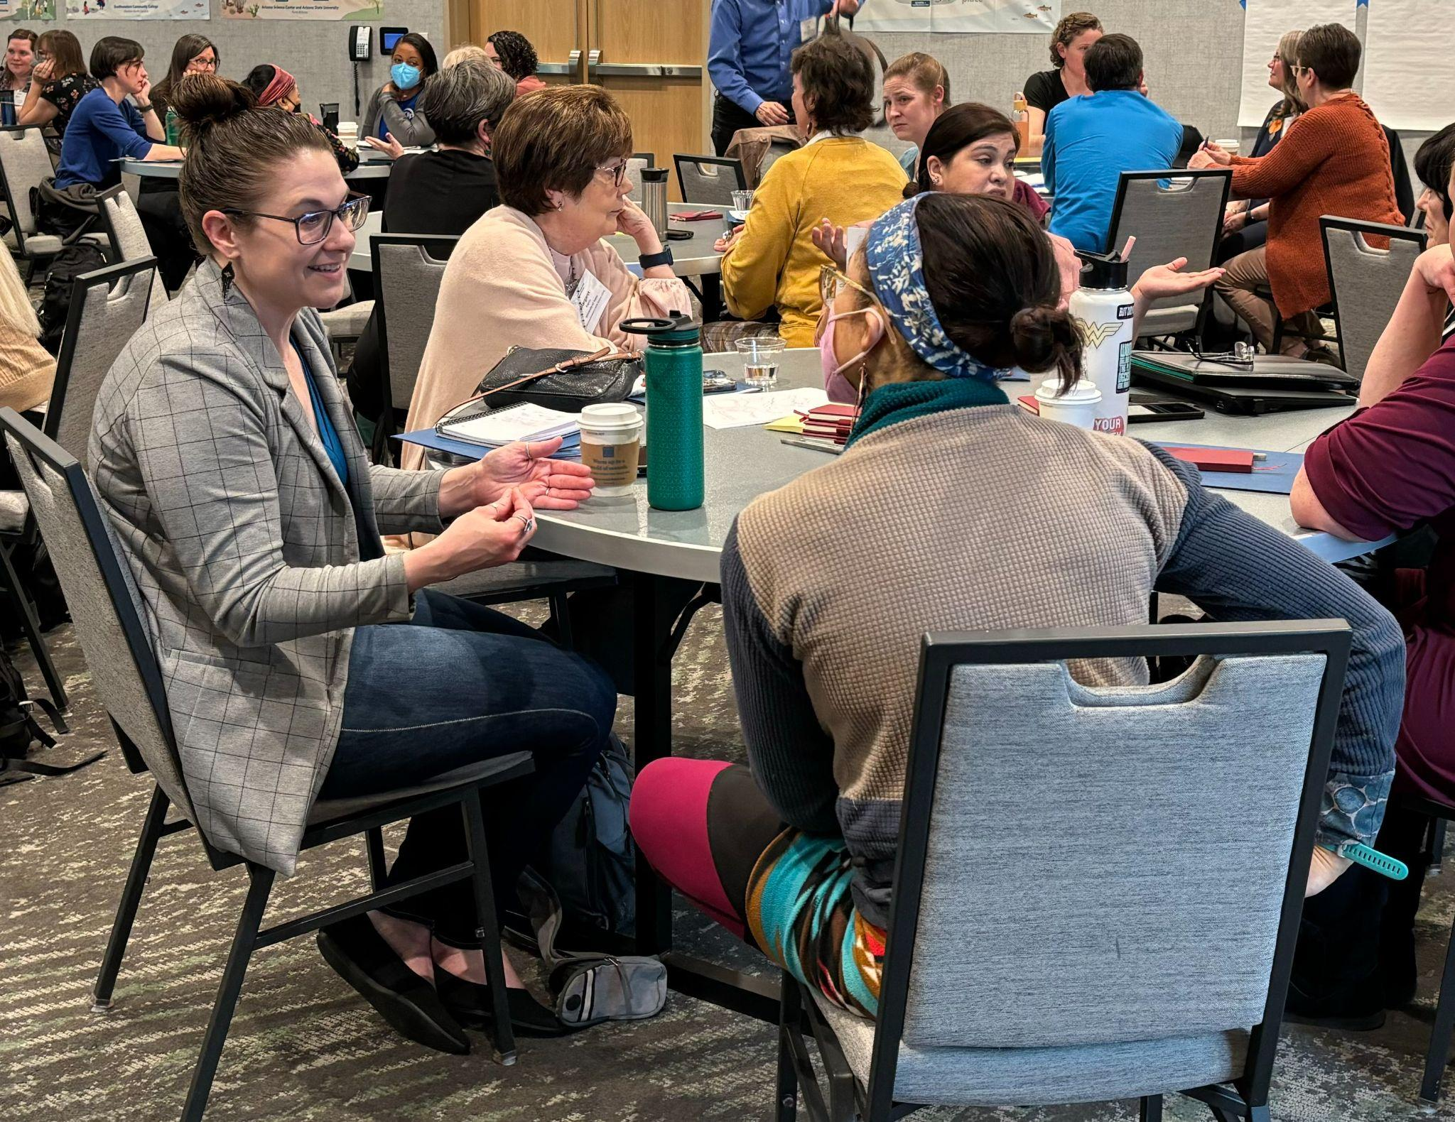
Gather a team or small group.
Together, watch one or more of the STEM Learning Ecosystem Video series and review this guide.
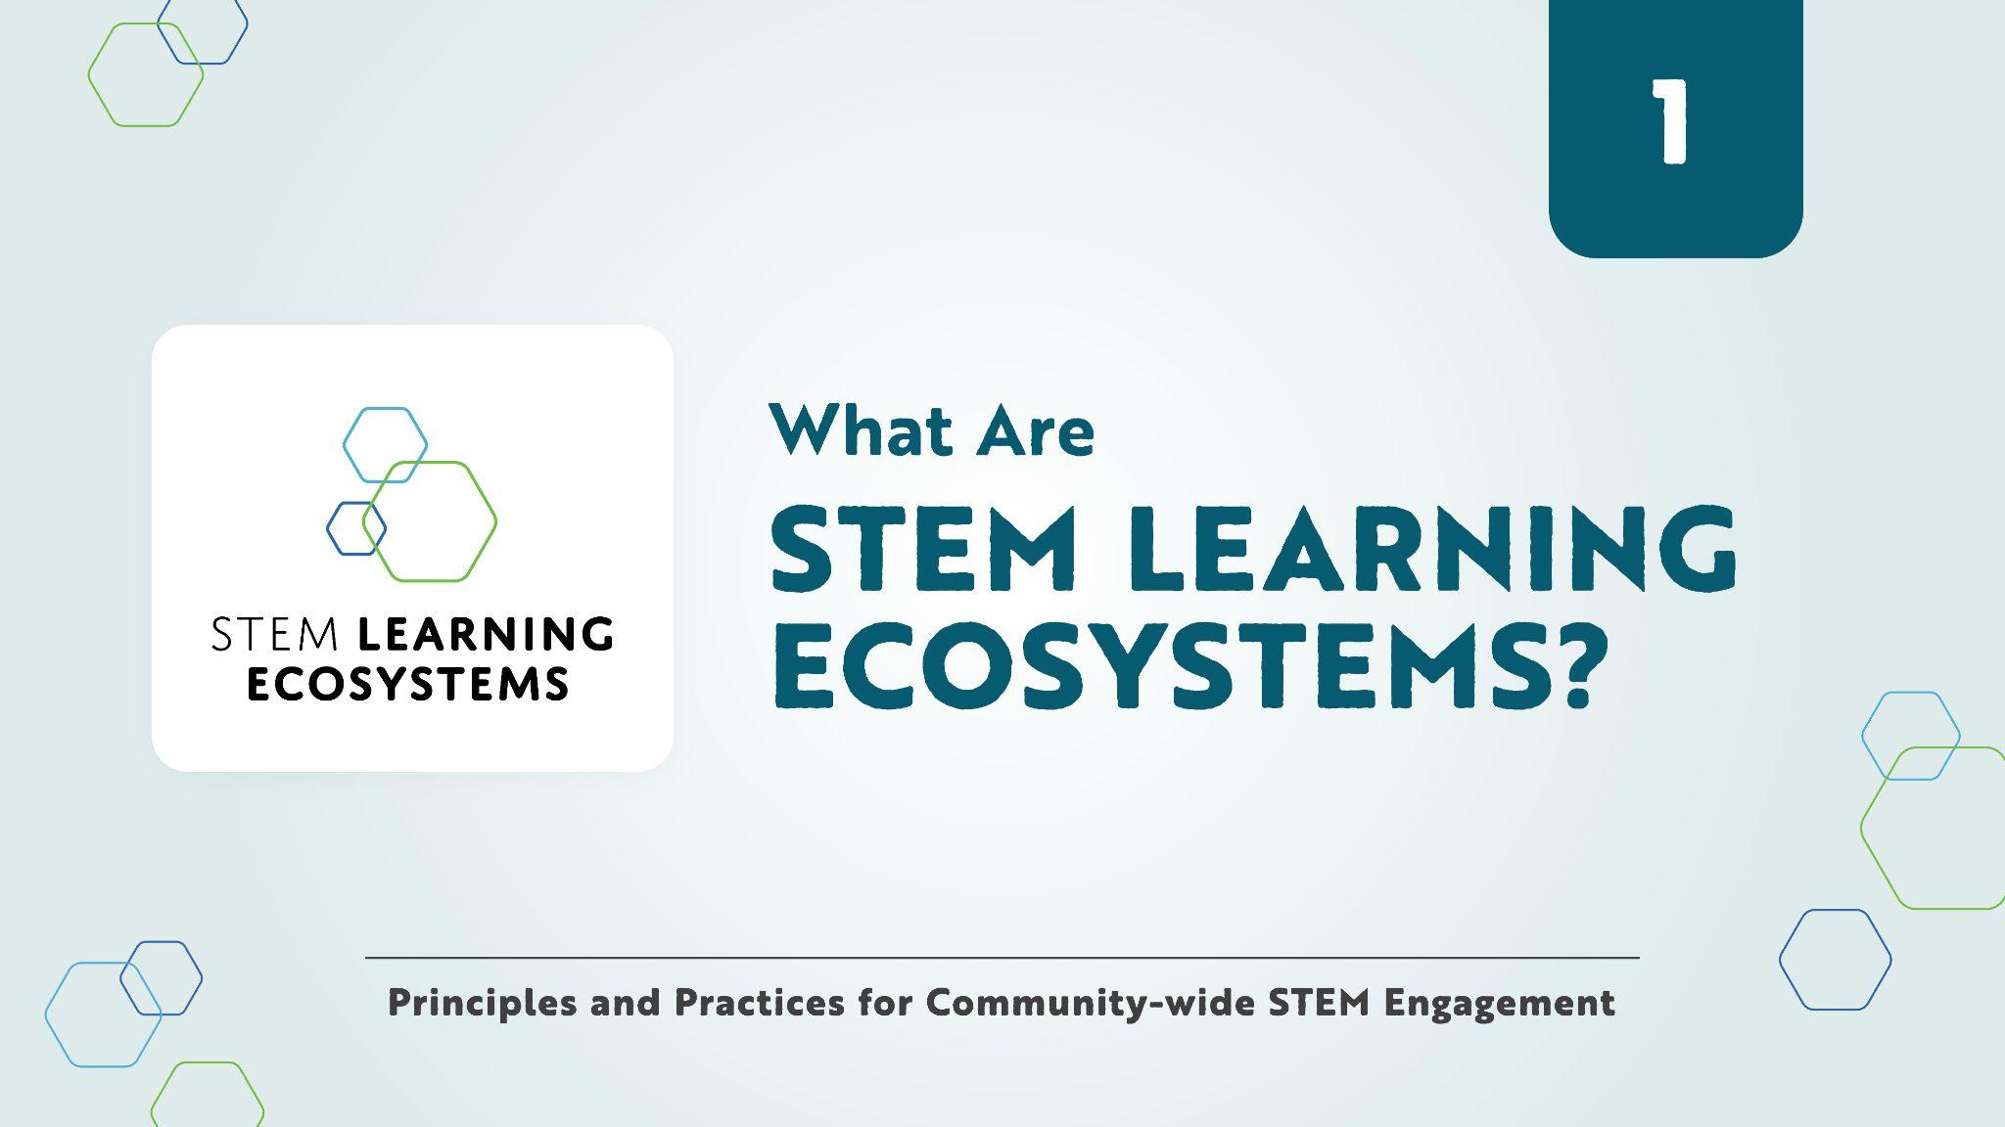
After each video, spend about 10-15 minutes together debriefing the content and making connections to your own work. Watching the videos and having the conversations can be done as one longer professional development session or you can sequence them in multiple viewing and discussion sessions over time.
Consider where you are now and where you want to be in the future.

Video Series
https://www.nisenet.org/stem-learning-ecosystems-videos

1. What Are STEM Learning Ecosystems? (2 minutes)
2. Introduction to STEM Learning Ecosystems? (6 minutes)
3. Building and Supporting Strong Partnerships (7 minutes)
4. Using Equitable Approaches to Broaden Participation (6 minutes)
5. Creating Authentic STEM Learning Experiences (7 minutes)

Watch Video # 1.
What Are STEM Learning Ecosystems? (2 minutes)
Reflect, Share, & Plan
Reflect: This introductory video provides an overview of STEM learning ecosystems. In the context of your work, what does a more vibrant future mean to you? (Jot down notes and reflect for about 2-3 minutes.)

Share: Describe your vision for connecting learners and community members with your discussion group. (Try to keep your answer to less than a minute!)

Plan: What’s one next step you can take to deepen your connections with your community of STEM professionals and learners? (Develop an actionable statement you can hold yourself to.)
____________________________________________________________________________
____________________________________________________________________________
____________________________________________________________________________
____________________________________________________________________________

Watch Video # 2.
Introduction to STEM Learning Ecosystems (6 minutes)
Reflect, Share, & Plan
Reflect: What are some characteristics of STEM learning ecosystems that resonate with you? Reflecting back on your own learning pathway and experience, who are some of the people, programs, or organizations who helped you find your way? (Jot down notes and reflect for about 2-3 minutes.)

Share: Describe these personal experiences and your reflections to your discussion group. (Try to keep your answer to less than a minute!)

Plan: How could or do you implement some of the principles of STEM learning ecosystems in your projects? What next steps can you take to move that work forward? (Develop an actionable statement you can hold yourself to.)
____________________________________________________________________________
____________________________________________________________________________
____________________________________________________________________________
____________________________________________________________________________

Watch Video #3.
Building and Supporting Strong Partnerships (7 minutes)
Reflect, Share, & Plan
Reflect: How are social, historical, and cultural contexts important to your work? How is the physical and biological environment important to your work? (Jot down notes and reflect for about 2-3 minutes.)

Share: Describe how you think about and work within these relationships, local contexts, and place-based environments to your discussion group. (Try to keep your answer to less than a minute!)

Plan: What distinguishes STEM learning ecosystems from other kinds of partnerships you’ve been part of? How might you borrow from the concepts presented in the video to imagine, build, and develop new partnerships in your community? (Develop an actionable statement you can hold yourself to.)
____________________________________________________________________________
____________________________________________________________________________
____________________________________________________________________________
____________________________________________________________________________

Watch Video #4.
Using Equitable Approaches to Broaden Participation (6 minutes)
Reflect, Share, & Plan
Reflect: Choose one term and think about how it relates to your work:
- Diversity refers to the ways in which people are similar and different, including identities, social positions, lived experiences, values, and beliefs.
- Equity means providing different people with fair access to resources so they can participate fully in society and meet their own needs.
- Accessibility means accommodating everyone along the continuum of human ability and experience.
- Inclusion is valuing diverse ideas, backgrounds, and perspectives and creating an environment of involvement, respect, and connection.
- Belonging refers to the feeling of being connected to a community, place, or situation, and being supported and welcomed there.

Where do you, your work, and your teams have room to grow in meeting your commitments to DEAIB (diversity, equity, accessibility, inclusion, and belonging)? (Jot down notes and reflect for about 2-3 minutes.)

Share: How might you use the concepts shared in this video to help you change your work and approach? (Try to keep your answer to less than a minute!)

Plan: Describe one thing you can do to intentionally improve or change some of your partnership practices to reflect your DEAIB goals. (Develop an actionable statement you can hold yourself to.)
____________________________________________________________________________
____________________________________________________________________________
____________________________________________________________________________

Watch Video #5.
Creating Authentic STEM Learning Experiences (7 minutes)
Reflect, Share, & Plan
Reflect: How do the STEM engagement experiences that we offer connect with other learning opportunities in your community or ecosystem? How are your experiences relevant to local people and places? How do they incorporate authentic STEM content? How do you encourage active learning? (Jot down notes and reflect for about 2-3 minutes.)

Share: Thinking from a STEM learning ecosystems perspective, share your reflections on where you are doing well and where you can improve your work. (Try to keep your answer to less than a minute!)

Plan: How can the practices shared in these videos and your own learnings change your work and plan? What kinds of knowledge, principles, and practices could help you improve your work and engage our communities? (Develop an actionable statement you can hold yourself to.)
____________________________________________________________________________
____________________________________________________________________________
____________________________________________________________________________
____________________________________________________________________________

CREDITS AND RIGHTS
Copyright 2024 Arizona State University.
Published under a Creative Commons Attribution-Noncommercial-ShareAlike license: http://creativecommons.org/licenses/by-nc-sa/3.0/us/
Definitions for Diversity, Equity, Accessibility, Inclusion from Garibay, C. & Olson, J. (2020). CCLI National Landscape Study: The state of DEAI practices in museums. Cultural Competence Learning Institute.
Photo of professionals in conversation, Catherine McCarthy for the NISE Network

This material is based upon work supported by NASA under cooperative agreement award number 80NSSC21M0007. Any opinions, findings, and conclusions or recommendations expressed in this material are those of the author(s) and do not necessarily reflect the view of the National Aeronautics and Space Administration (NASA).

