Exploring Products—Liquid Crystal Displays

Try this!  - Place your hand on the liquid crystal sheets. Can you see your handprint? Does it look the same on each sheet?  - Place the cup of ice on each sheet. Does it leave the same color marks as your hand? | 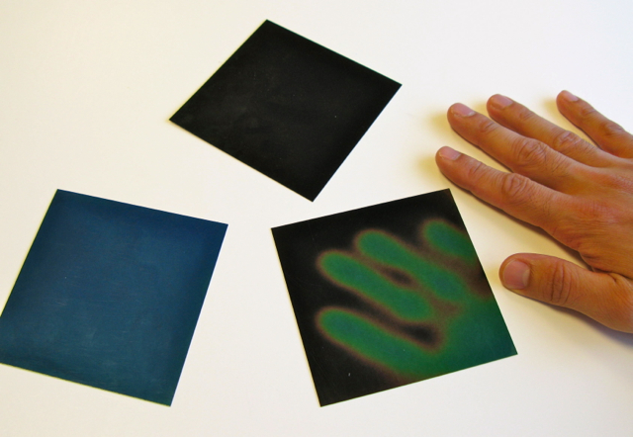 | 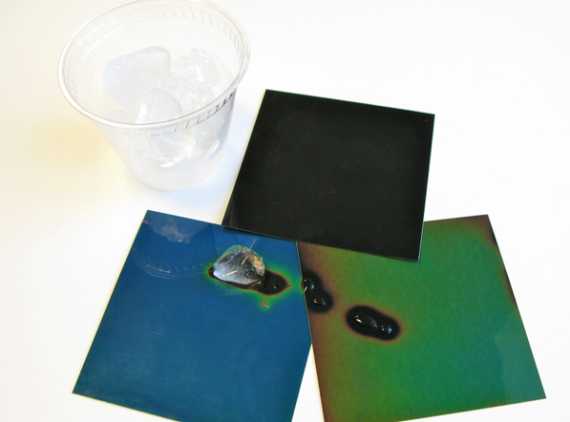
What’s going on?
The liquid crystal sheets change color in response to changes in temperature. They can detect where your hand warmed up the sheet or the ice cooled it down. As the temperature increases, the color of the liquid crystals changes from red to orange, yellow, green, blue, and purple. Each sheet is senses different range of temperatures.
Liquid crystals represent a phase in between liquid and solid. The molecules in a liquid crystal can move independently, as in a liquid, but remain somewhat organized, as in a crystal (solid).
Now try…  - Remove the liquid crystal display (LCD) from a calculator.  - Look closely at the front side of the plastic ribbon attached to the LCD.  At the bottom edge, there is an exposed contact area with metallic stripes.  - Place one of the wires from the battery snap connector on the exposed contact area. Slowly run the other wire along the rest of the contact area. What happens?  What’s going on? | 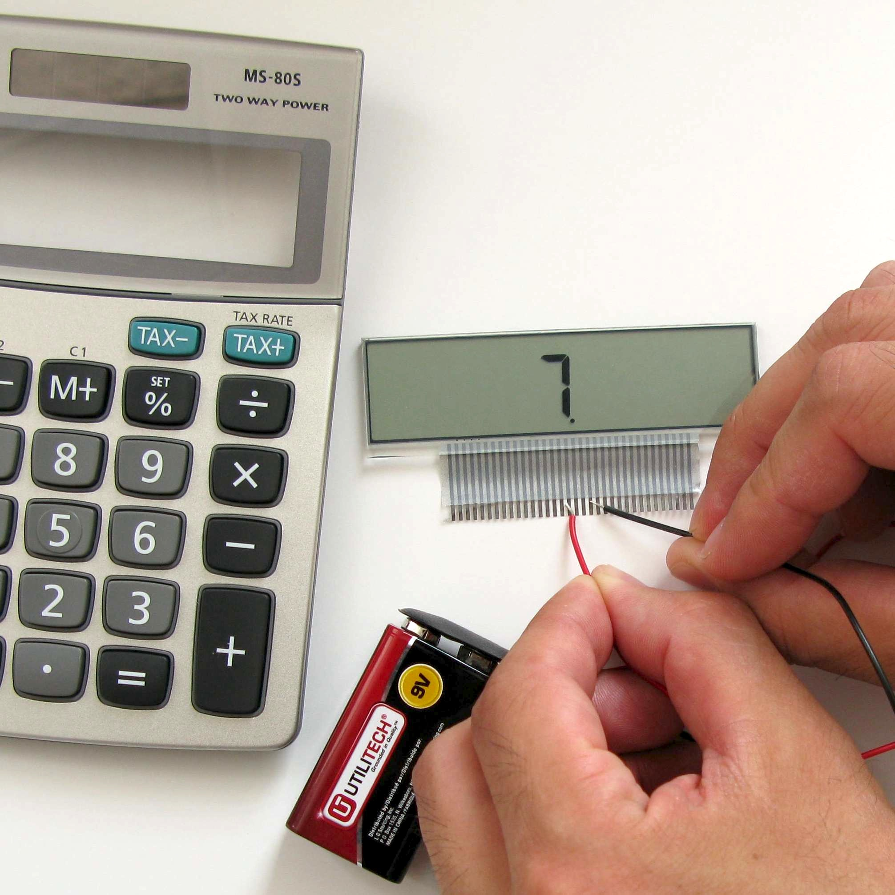
Parts of the display light up when you touch them with the wires from the battery. That’s because the liquid crystals in the calculator display change color as a reaction to electricity (rather than temperature). The electric field changes the alignment of the liquid crystal molecules and affects the way that light passes through them, which makes them look black to your eyes.

Each thin metallic stripe on the ribbon directs electricity through a small region of the screen, allowing you to control which parts of the display turn black using the battery and wires. When the calculator is assembled, you direct the electricity by pressing the buttons.

How is this nano?
Laptop with a  liquid crystal display | The way a material behaves on the macroscale is affected by its structure on the nanoscale. Changes to a material’s molecular structure are too small to see directly, but we can sometimes observe corresponding changes in a material’s properties. The liquid crystals in this activity change color as a result of nanoscale shifts in the arrangement of their molecules.  Nanotechnology takes advantage of special properties at the nanoscale to create new materials and devices. Liquid crystals are used in cell phone displays, laptop computer screens, and strip thermometers. The same manufacturing equipment used for making LCDs may in the future be converted to make thin film solar cells.

Learning objectives
- The way a material behaves on the macroscale is affected by its structure on the nanoscale.
- The liquid crystals in this activity change color as a result of nanoscale shifts in the arrangement of their molecules.

Materials
- Assortment of liquid crystal sheets
- Calculator
- 9v battery
- Snap connector for 9v battery
- Cup of ice

Liquid crystal sheets are available from www.teachersource.com (#LC-ASTX, assortment with different transition temperatures).

The NanoDays physical kit comes with a calculator with the display already removed. To take apart your own calculator, see the instructions below, under “Notes to the presenter.” Choose a calculator with a relatively large liquid crystal display. They’re available at office supply stores and discount stores.
Snap connectors for 9v batteries are available from www.radioshack.com (#270-324).

Notes to the presenter
SAFETY: The face of the calculator display is glass. Handle it with care. Avoid letting visitors handle it.

Before doing this activity, fill the cup with ice. (If you don’t have ice, you can use cool water or eliminate this part of the activity.)

The three liquid crystal sheets are sensitive to different temperature ranges: 20°-25°C, 25°-30°C, and 30°-35°C. If you can’t see a reaction on one of the sheets, try holding the liquid crystal against a cool surface and then warming it with your hands. (You can warm your hands by rubbing them together.)

The contact area for the liquid crystal display is at the bottom edge of the plastic strip attached to the screen. If you have trouble getting numbers to appear on the screen, be sure the battery wires are touching the exposed part of the display wires on the front side of the plastic ribbon. The exposed part has no coating over the metallic stripes. To get the display to work, the wires need to touch two different metallic stripes. For children and individuals with limited dexterity, you may demonstrate the application of electricity to the LCD.

Do not allow the battery wires to touch each other, as that will drain your battery. When you store the kit, remove the snap connector from the battery.

The display has already been removed from the calculator that is provided in the physical NanoDays kit. To remove the screen from a calculator yourself, use a small screwdriver to remove the screws in back of the calculator. Pull apart the front and back of the calculator case. Carefully lift up the display inside. Peel the plastic ribbon off the circuit board, keeping the ribbon attached to the display. To make it easier to peel off the ribbon, you can try warming it with a hair dryer.

Related educational resources
The NISE Network online catalog (www.nisenet.org/catalog) contains additional resources to introduce visitors to nanomaterials:
- Public programs include Aerogel, Biomimicry: Synthetic Gecko Tape Through Nanomolding, Nanoparticle Stained Glass, Nanosilver—Breakthrough or Biohazard? and World of Carbon Nanotubes.
- NanoDays activities include Exploring Materials—Ferrofluid, Exploring Materials—Thin Films, and Exploring Structures—Buckyballs.
- Exhibits include Bump and Roll, Changing Colors, and Unexpected Properties.

LCD Background Information

What are liquid crystals?  Liquid crystals represent a phase in between liquid and solid. The molecules can move independently, as in a liquid, but remain somewhat organized, as in a crystal (solid).  How do the liquid crystal sheets work?  The liquid crystal sheets used in this activity are thermotropic, which means that they respond to changes in temperature by changing color. As the temperature increases, the color of the liquid crystal changes from red to orange, yellow, green, blue, and purple. | Liquid crystal
Liquid crystals are made of mixtures of long, thin molecules stacked in rotating layers, like a spiral staircase. This shape is called a helix. When light strikes a liquid crystal, some of the light is reflected. As the temperature of the liquid crystal changes, the spacing of the helix changes. This changes the wavelength of light that is reflected and the color that you see.
How does the calculator display work?  The liquid crystal display (LCD) in the calculator has many layers:  - Glass plate with polarizing filter oriented vertically  - Glass plate with electrodes to form the numbers  - Liquid crystal material  - Transparent conductive material  - Glass plate with polarizing filter oriented horizontally  - Reflective surface to send light back to the viewer | 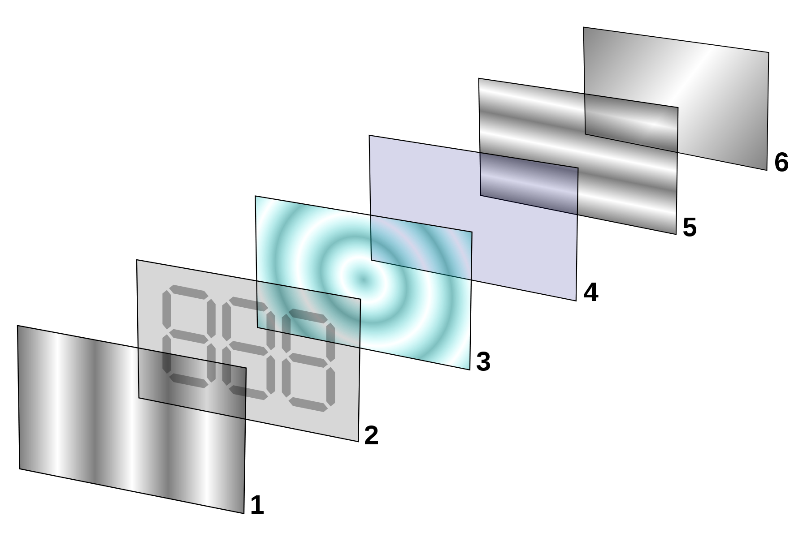
Light passing through the first polarizing filter (1) becomes polarized, which means that the light waves are oscillating in one direction only. Polarized light cannot go through the second polarizing filter that is perpendicular to the first (5), because the light waves are not oscillating in the correct direction.

The liquid crystals molecules located between the two polarizing filters (3) are oriented to rotate the polarized light coming through the first filter by 90 degrees so that the light can pass through the second filter. The light is rotated just a little with each step along the liquid crystal helix until it reaches the other filter in the correct orientation.

When electricity is applied to specific regions of the display (2), the liquid crystal molecules line up with the electric field. This disrupts the helical alignment, so the liquid crystal can’t rotate the light.

When no electricity is applied, light travels though both polarizing filters, reflects off the mirror (6), and comes back to your eye. When electricity is applied to certain areas of the display, light passes through one filter but not the other, so that part of the screen is black.
How are liquid crystals used?
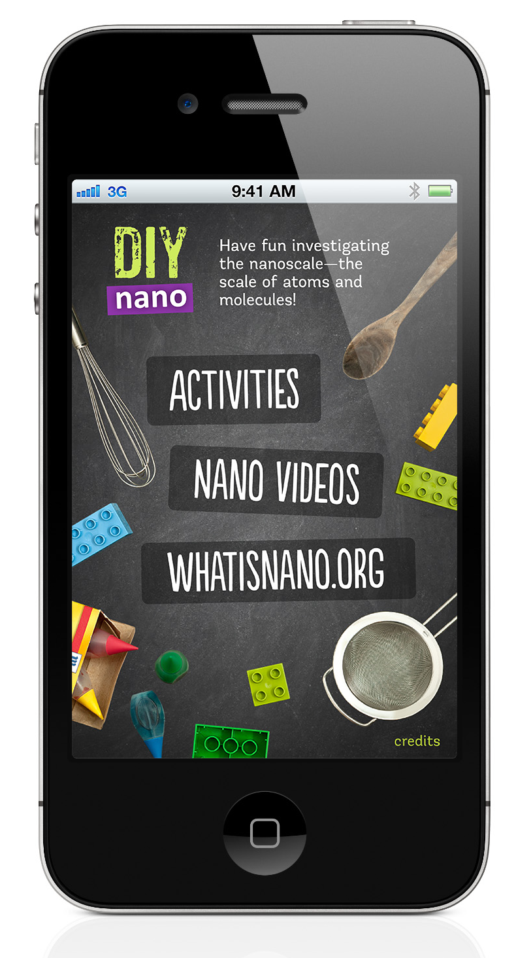 | The properties of liquid crystals make them useful for many applications. Because the color of a liquid crystal depends on the alignment of its molecules, anything that disrupts that alignment can be detected by a color change.  Liquid crystals are used in displays for cell phones, laptop computers, and other electronics. In these displays, an electric field changes the alignment of the liquid crystal molecules and affects the polarization of light passing through them. Liquid crystal nanosensors can detect certain chemicals, electrical fields, and changes in temperature.

Credits and rights
This activity was adapted from “Disassembly of a Liquid Crystal Watch,” developed by the National Science Foundation-supported Materials Research Science and Engineering Center (MRSEC) on Nanostructured Interfaces at the University of Wisconsin-Madison. The original activity is available at: http://mrsec.wisc.edu/Edetc/nanolab/watch/index.html

Image of liquid crystal courtesy Gary Koeing, University of Wisconsin-Madison.

Diagram of LCD layers by Ed g2s, from Wikimedia Commons.

This project was supported by the National Science Foundation under Award No. 0940143. Any opinions, findings, and conclusions or recommendations expressed in this program are those of the author and do not necessarily reflect the views of the Foundation.

Copyright 2012, Sciencenter, Ithaca, NY. Published under a Creative Commons Attribution-Noncommercial-ShareAlike license: http://creativecommons.org/licenses/by-nc-sa/3.0

