Binary Code

Computers use binary code to store information. Binary code is a way of representing information in a series of 1s and 0s. Most modern hard drives use magnetic regions on the hard disk surface to represent these 1s and 0s. If the region is magnetized with the north pole facing up, it represents a 1. If the south pole is facing up, it represents a 0.

In this activity, we use a floating magnet to represent a 1 and a sticking magnet to represent a 0. Below are the codes for lower-case letters in the 8-bit ASCII (American Standard Code for Information Interchange) scheme.

Letter | Binary Code |  | 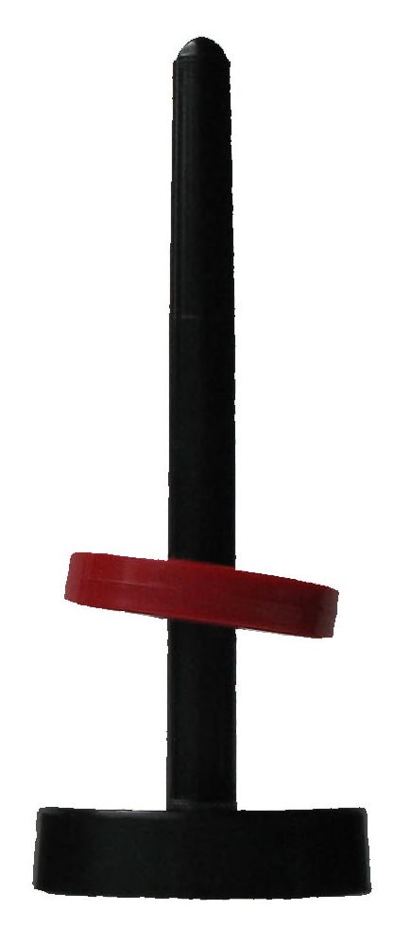 | =1
a | 01100001
b | 01100010
c | 01100011
d | 01100100
e | 01100101
f | 01100110
g | 01100111
h | 01101000
i | 01101001
j | 01101010
k | 01101011
l | 01101100
m | 01101101
n | 01101110 |  | 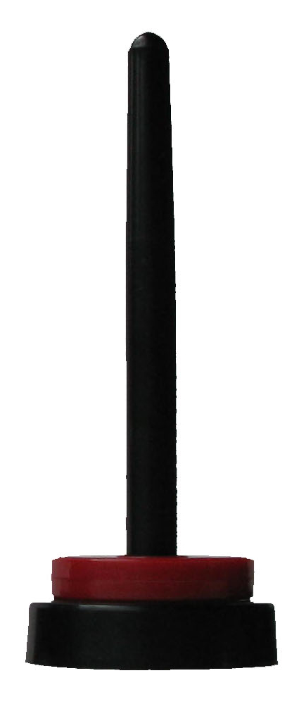 | =0
o | 01101111
p | 01110000
q | 01110001
r | 01110010
s | 01110011
t | 01110100
u | 01110101
v | 01110110
w | 01110111
x | 01111000
y | 01111001
z | 01111010

