Exploring Materials—Memory Metal

Try this!  - Stretch out the NiTi spring.  - Hold the stretched-out NiTi spring by one end, and use the “high” setting of the hair dryer to heat it up. What happens?  - Does the ordinary steel spring do the same thing when it’s heated with the hair dryer? | 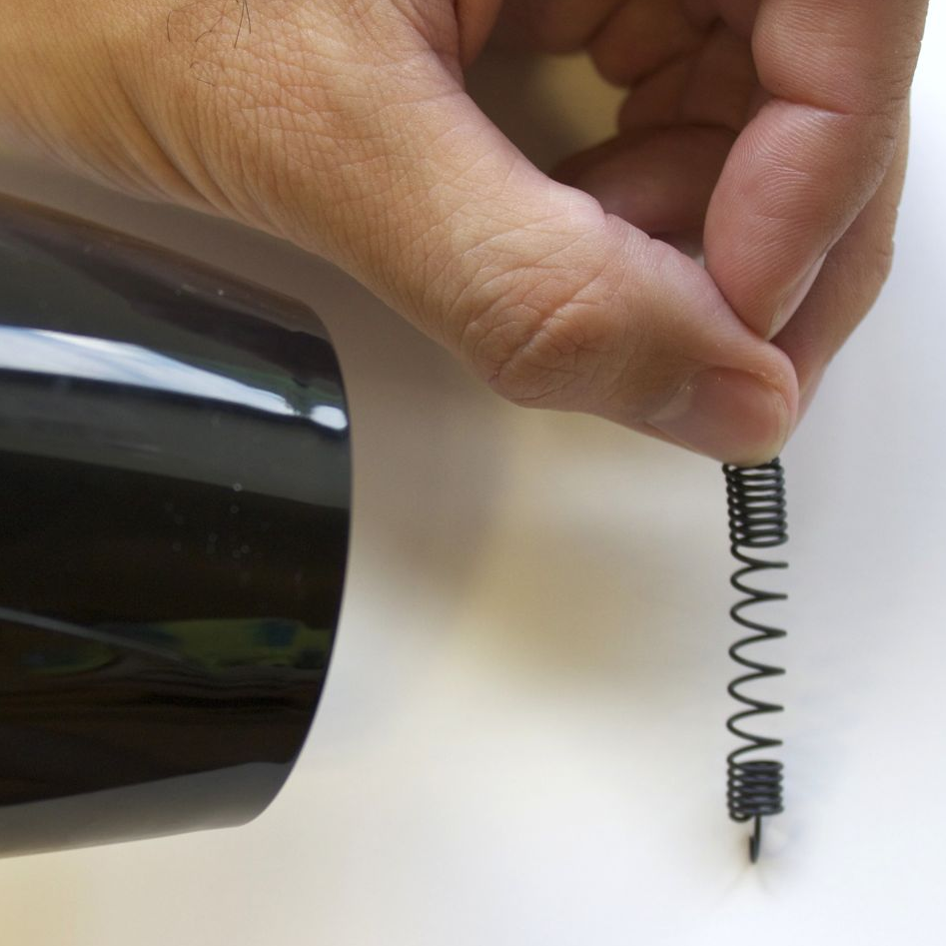
What’s going on?
The NiTi spring returns to its original shape when heated by the hair dryer, but the steel spring doesn’t. NiTi is an alloy of nickel and titanium called nitinol, or NiTi, for short. It’s also known as “memory metal.”

Memory metal changes between two solid structures, a low-temperature phase and a high-temperature phase. The spring changes shape because its atoms rearrange themselves during this phase change. Each atom moves only a tiny bit, but there are so many atoms in the spring that the movement is big enough for you to see.

Mars rover | Some NiTi alloys respond to electricity, rather than temperature, to change shape. For example, the Mars rover Sojourner uses a NiTi wire to shake dust off a solar cell. The NiTi wire is heated, which shortens it and pulls the cover open. This allows the cover to shed accumulated dust, so the solar cell can gather energy from the sun.  The properties of smart metals make them useful for many applications. The most familiar use of NiTi is the dental arch wire and springs used in orthodontic braces. Other commercial products include eyeglass frames, cell phone antennas, and surgical staples.

Now try…  - Stretch out the NiTi spring.  - Attach it to the handle of the pail.  - Add a few pennies to the pail.  - Use the hair dryer to heat the spring again. Can the spring lift the pail?  How is this nano? | 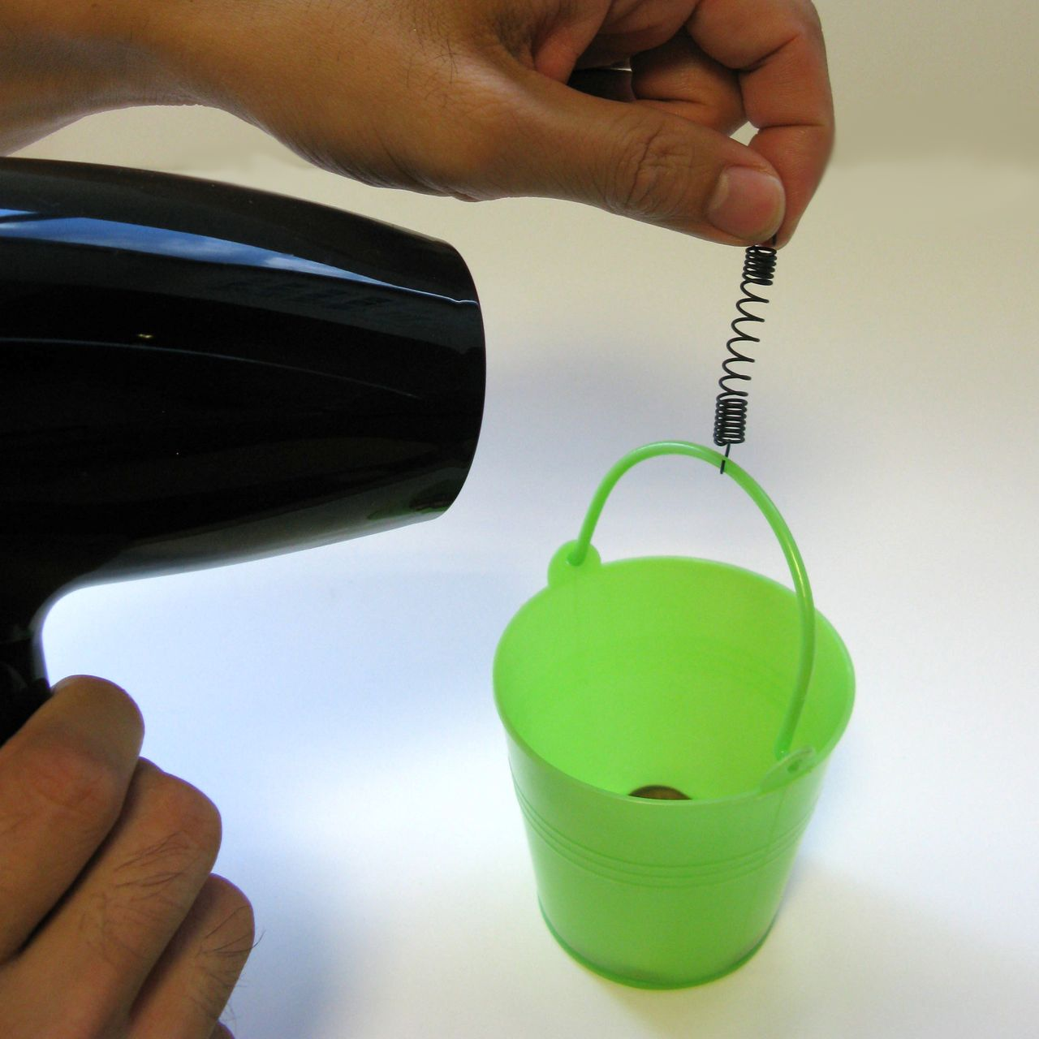

The way a material behaves on the macroscale is affected by its structure on the nanoscale. Changes to a material’s molecular structure are too small to see directly, but we can sometimes observe corresponding changes in a material’s properties. Memory metal changes size and shape as a result of nanoscale shifts in the arrangement of its atoms.

Nanotechnology takes advantage of special properties at the nanoscale to create new materials and devices. Researchers are investigating the use of memory metal in heat engines. Memory metal is already used in a variety of technologies, from orthodontic braces to satellites.

Learning objectives
- The way a material behaves on the macroscale is affected by its structure on the nanoscale.
- Memory metal changes size and shape as a result of nanoscale shifts in the arrangement of its atoms.

Materials
- Memory metal (NiTi) extension spring with hooks
- Stainless steel extension spring with hooks
- Hair dryer
- Small plastic pail
- Roll of pennies

NiTi springs are available from www.musclewires.com (#3-642) or www.jameco.com (#357835).

Similar stainless steel springs are available from www.mcmaster.com (#9433K44).

Small plastic pails are available from www.orientaltrading.com (#IN-3/341).

Notes to the presenter

Hold the NiTi spring extended for just a moment after stretching it out, so it will hold its distorted shape.

After heating the NiTi spring, don’t re-stretch it while it’s still warm from the hair dryer. Let it cool thoroughly, to avoid “resetting” it in a distorted shape. After repeated use, the NiTi spring may eventually reset in a distorted shape. At that point, it will need to be replaced.

The ordinary steel spring will become distorted as soon as it’s stretched out, and you won’t be able to return it to its original shape. This will help visitors see how the memory metal spring is special.

Related educational resources
The NISE Network online catalog (www.nisenet.org/catalog) contains additional resources to introduce visitors to nanomaterials:
- Public programs include Aerogel, Biomimicry: Synthetic Gecko Tape Through Nanomolding, Nanoparticle Stained Glass, Nanosilver—Breakthrough or Biohazard?, and World of Carbon Nanotubes.
- NanoDays activities include Exploring Materials—Ferrofluid, Exploring Materials—Thin Films, and Exploring Structures—Buckyballs.
- Exhibits include Bump and Roll, Changing Colors, and Unexpected Properties.

Credits and rights
This activity was adapted from the “Quick Reference Activity Guide: Memory Metal,” developed by the National Science Foundation-supported Internships in Public Science Education (IPSE) Educator Resources, Materials Research Science and Engineering Center on Nanostructured Materials and Interfaces at the University of Wisconsin-Madison. The original activity is available at http://mrsec.wisc.edu/Edetc/IPSE/educators/memMetal.html

Additional information was drawn from:
- Jones, M. Gail, Michael R. Falvo, Amy R. Taylor, and Bethany P. Broadwell. “NanoMaterials: Memory Wire.” In Nanoscale Science: Activities for Grades 6-12. pp. 109-114. Arlington, VA: NSTA Press.
- Ramirez, A. “Ainissa Ramirez: Magical metals, how shape memory alloys work.” TEDEd video series. http://ed.ted.com/lessons/ainissa-ramirez-magical-metals-how-shape-memory-alloys-work

This project was supported by the National Science Foundation under Award No. 0940143. Any opinions, findings, and conclusions or recommendations expressed in this program are those of the author and do not necessarily reflect the views of the Foundation.

Copyright 2012, Sciencenter, Ithaca, NY. Published under a Creative Commons Attribution-Noncommercial-ShareAlike license: http://creativecommons.org/licenses/by-nc-sa/3.0

