

Exploring Materials—Thin Films
Try this!
- Write your name on a strip of black paper.  - Slide the paper into the pan. Make sure it’s completely under water.  - Use the brush to drip one drop of nail polish onto the surface of the water. The polish will spread out into a thin film.  - Hold one end of the paper and lift it up out of the water. The film of nail polish will stick to the paper. Does the nail polish still look clear? | 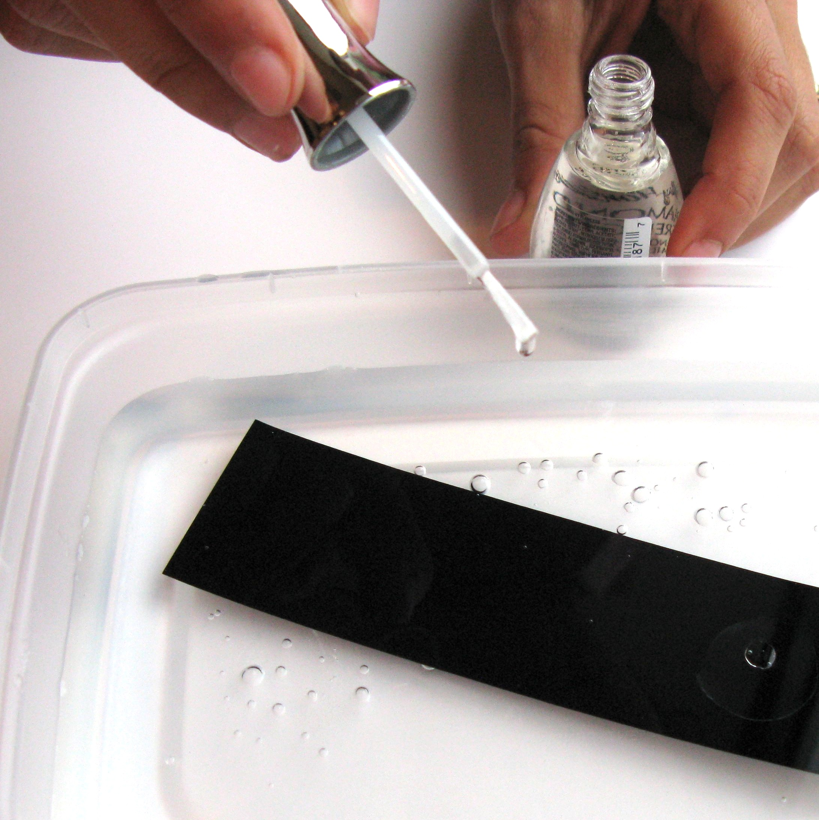 | 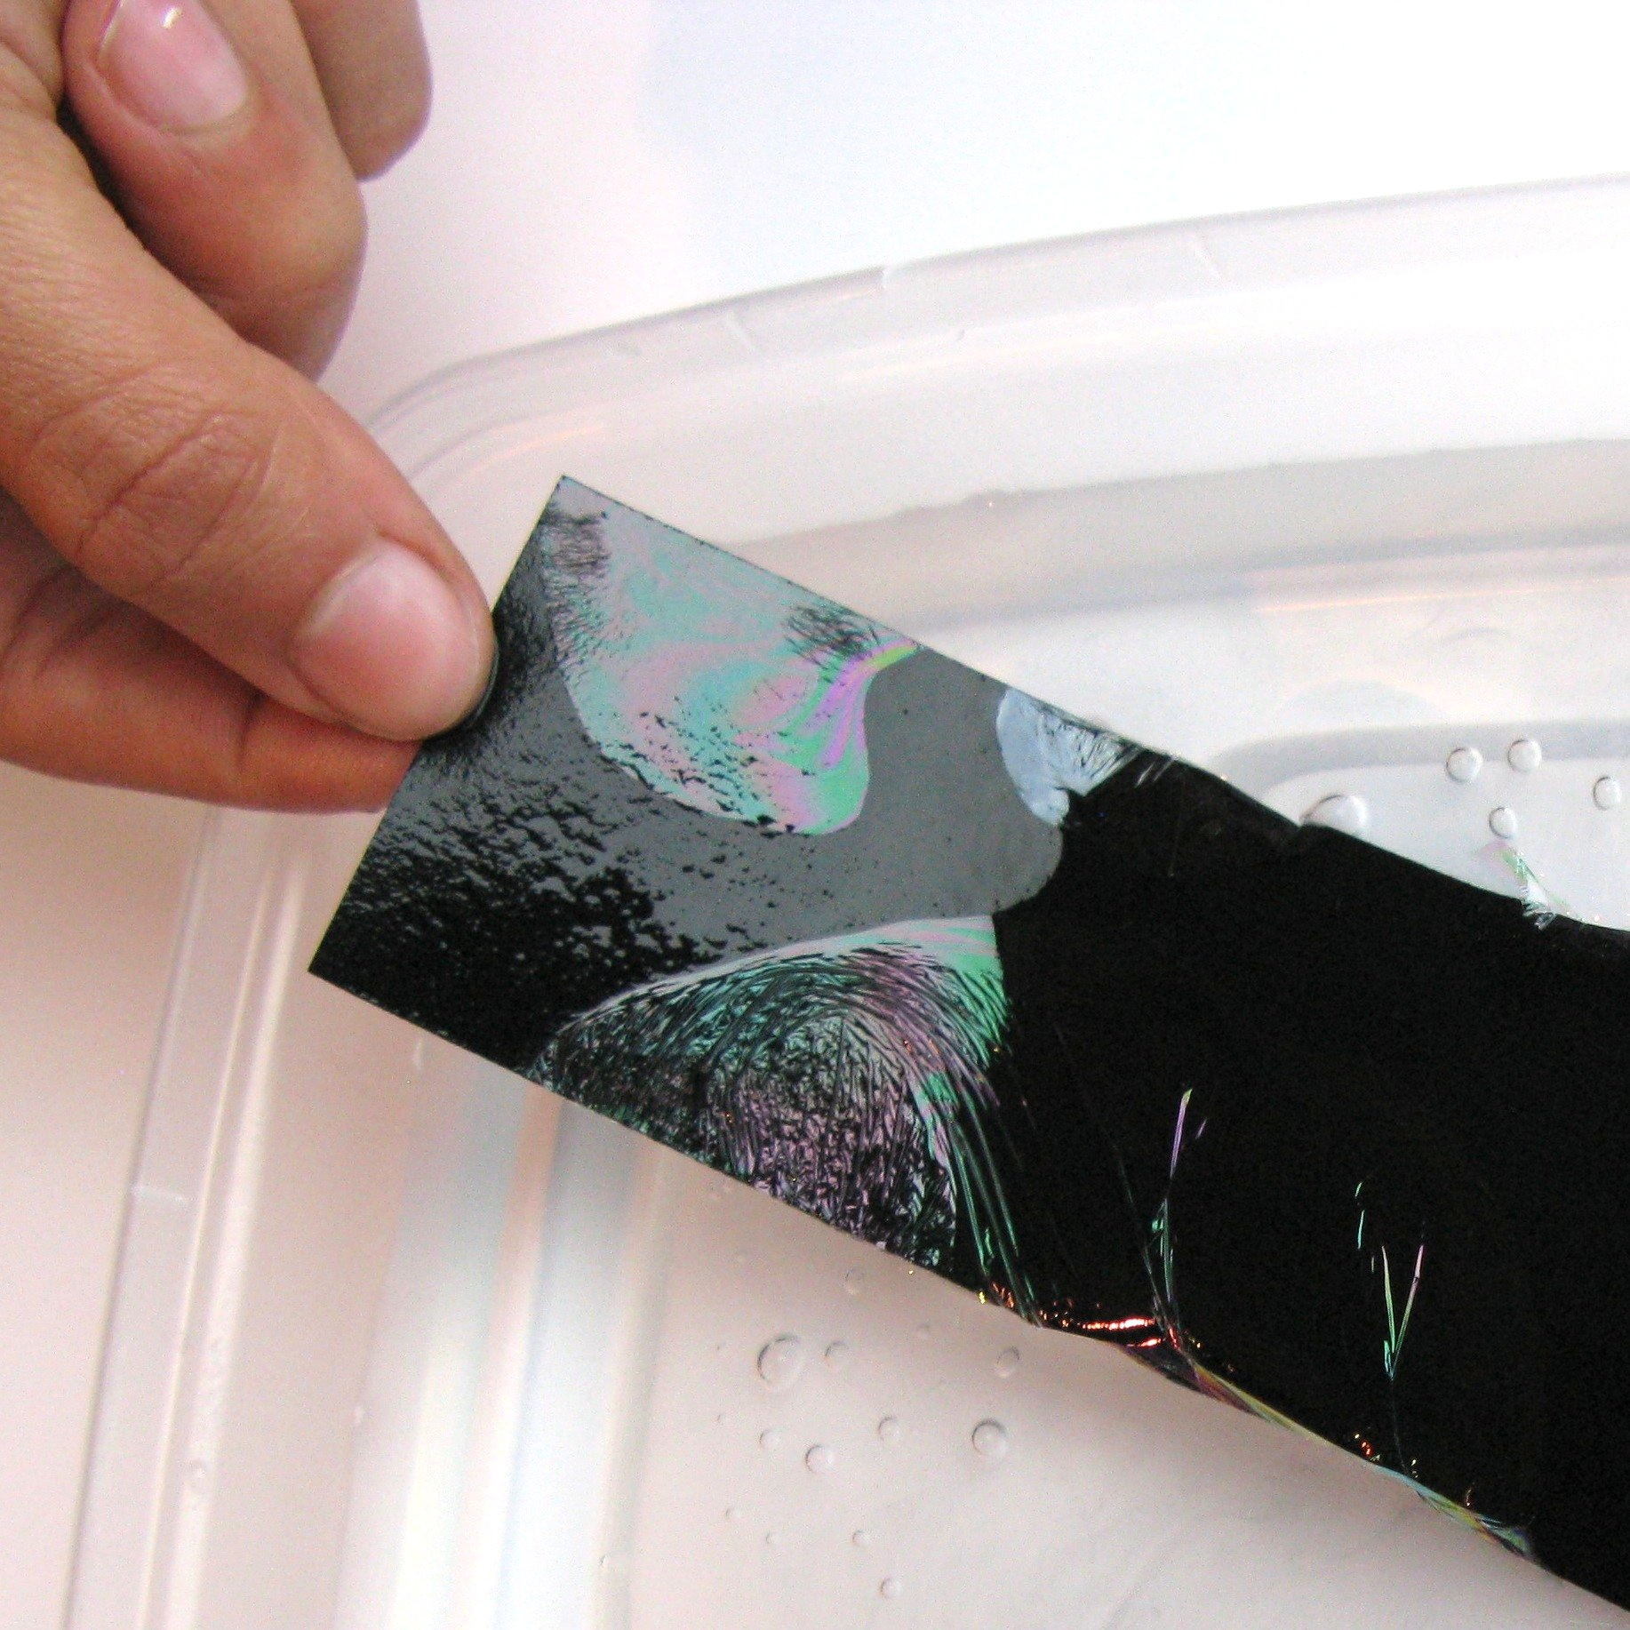
What’s going on?
The nail polish spreads out into a super-thin film, which creates iridescent, rainbow colors on the paper. The thin film is only a few hundred nanometers thick, about as thick (or thin!) as a soap bubble. The film is slightly thicker in some places and thinner in others. As the thickness of the film changes, the color changes.

The film reflects light differently depending on how thick it is, so you see different colors. White light is made up of all wavelengths, or colors, of light. Wavelengths that are in sync, hitting both the front and back of the film, are reflected back to your eyes as bright colors. Different wavelengths are in sync at different parts of the film, depending on its thickness.  Many beautiful things in nature get their iridescent colors this way—through the constructive interference of light. Bird feathers, butterfly wings, shells, and beetle shells all have nano-sized, semi-transparent layers that create an iridescent effect when they reflect light. | 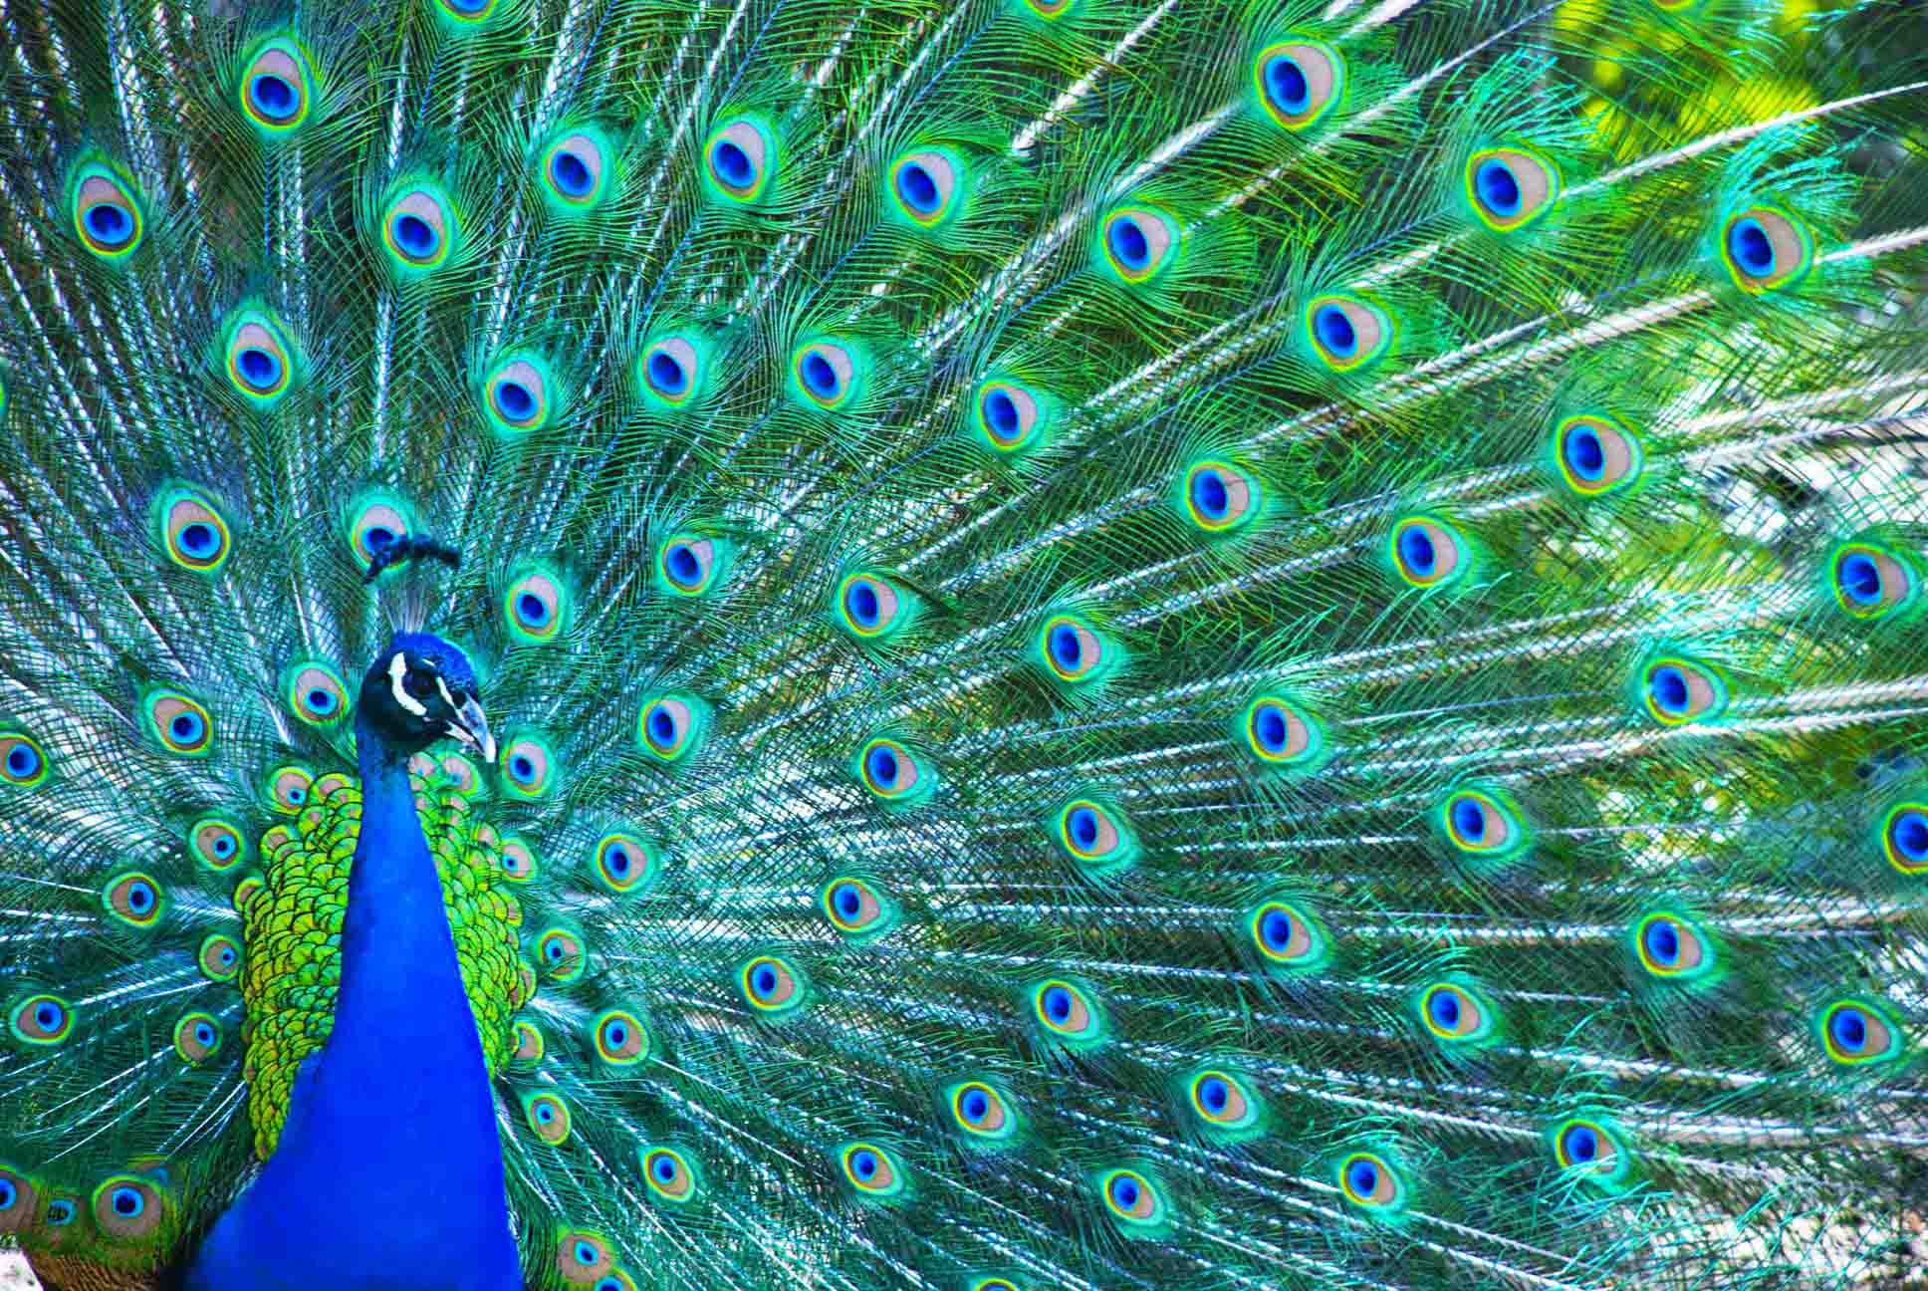  Peacock feathers are iridescent

How is this nano?
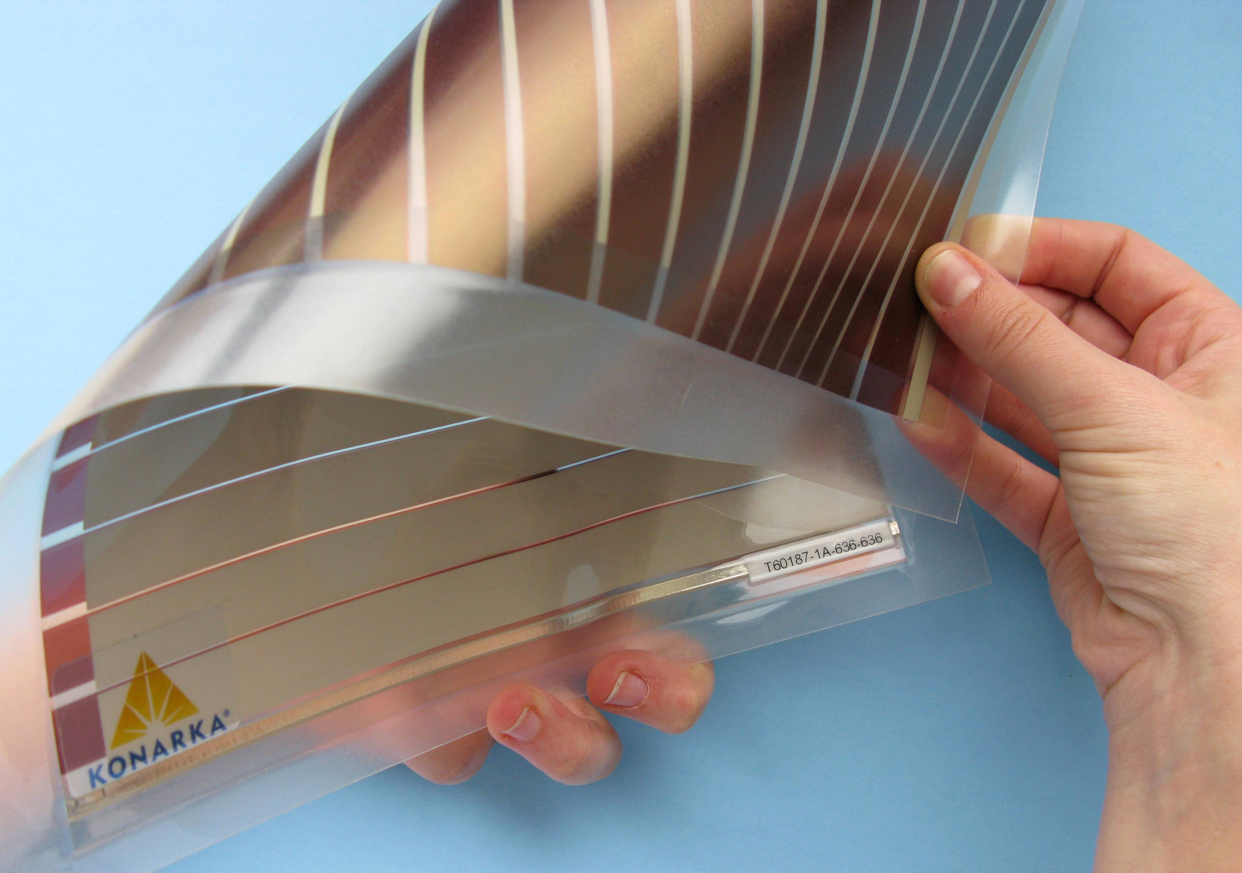  Thin film solar panel | The way a material behaves on the macroscale is affected by its structure on the nanoscale. Thin films can reflect light in special ways, because they’re only a few hundred nanometers thick—in the same size range as the wavelength of visible light.  Nanotechnology takes advantage of special properties at the nanoscale to create new materials and devices. Researchers are creating thin film batteries, solar cells, electronic displays, and coatings for different surfaces.

Learning objectives
- The way a material behaves on the macroscale is affected by its structure on the nanoscale.
- The thin film reflects light differently depending on how thick it is, so you see different colors.

Materials
- Shallow pan
- Strips of black paper
- Clear nail polish
- Permanent markers in metallic color
- Peacock feather (optional)
- Thin film solar cell sample (optional)

Bristol paper works best for this activity. You can use regular construction paper, but a lot of color will bleed from the paper into the water.

The nail polish should be completely clear (no shimmer or glitter), and regular formula (not fast-drying).

Notes to the presenter
SAFETY: Do this activity in a well-ventilated area.
Before you begin:
- Fill the pans halfway with water.
- Set up an area to let the strips of paper dry.

Black paper is used for this activity because it absorbs all visible light. The colors that appear are created by the interaction of light with the thin film.
Writing their name with the permanent marker helps visitors find their thin film later. The marker doesn’t make the colors appear on the black paper—that’s the thin film created by the nail polish.

Related educational resources
The NISE Network website (www.nisenet.org) contains additional resources to introduce visitors to nanomaterials:
- Public programs include Aerogel, Biomimicry: Synthetic Gecko Tape Through Nanomolding, Nanoparticle Stained Glass, Nanosilver: Breakthrough or Biohazard? and World of Carbon Nanotubes.
- NanoDays activities include Exploring Materials—Ferrofluid, Exploring Materials—Liquid Crystals, and Exploring Structures—Buckyballs.
- Exhibits include Bump and Roll, Changing Colors, and Unexpected Properties.

Thin Film Background Information
What are thin films?
A thin film is a layer of material ranging from less than a nanometer (one billionth of a meter) to several micrometers thick. Everyday examples of thin films include soap bubbles, oil slicks on water, and anti-reflection coating on eyeglasses.
Why do some thin films have beautiful colors?
Light travels in waves. Just like water waves, light waves have crests (high points) and troughs (low points). The distance between crests is a wavelength. Different colors of light have different wavelengths.
The wavelength of visible light ranges from about 400-700 nanometers. The nanostructures of iridescent feathers, shells, and wings are in this same size range. So are thin films.  Light can interact in special ways with very tiny structures, like those found in nature and in nanotechnology. | 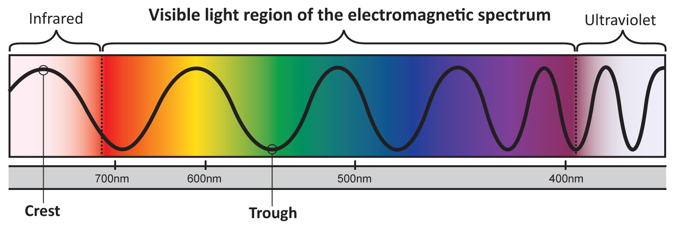

White light is made up of all wavelengths, or colors, of light. When white light hits a thin film, some of the light is reflected from the front surface of the film, and some travels through it and is reflected from the back surface.
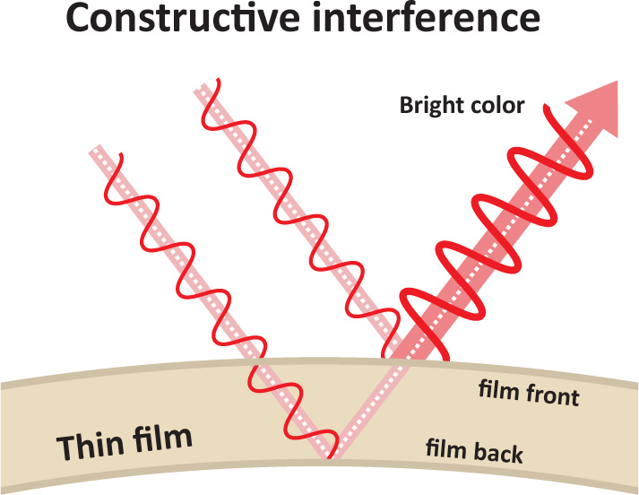 | 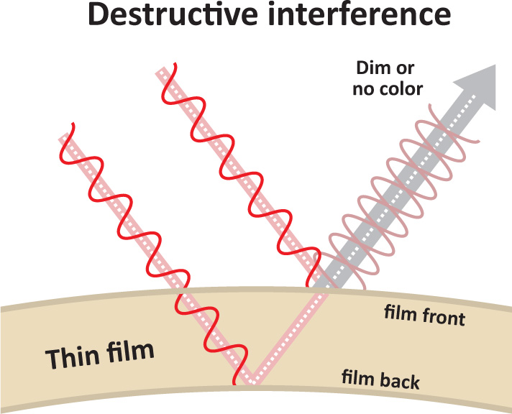 | If the waves reflected from the  front and back have crests that overlap, they reinforce each other and the reflected color is bright. This is called constructive interference.  If the waves reflected from the front and back have crests that overlap with troughs, the waves cancel each other out and the reflected color is dim. This is called destructive interference.
The thickness of the film determines which colors will be bright and which will be cancelled out. In a very thin film (less than 400 nanometers thick) all the colors cancel out, and the film appears black.
How are thin films used?  Scientists are developing thin films to use as computer memory and in solar cells. Flexible thin film batteries can be made by printing onto plastic, thin metal foil or paper. Thin films are expected to have cheaper manufacturing and materials costs than conventional materials. |   Thin film solar panels

Credits and rights
This activity was adapted from “Create Some Iridescent Art,” in the DragonflyTV Nano Educator’s Guide, published by Twin Cities Public Television, 2009. The original activity is available at:
www-tc.pbskids.org/dragonflytv//web_assets/pdf/dftv_nanoedguide_butterflywings.pdf

Illustration of interfering wavelengths of light by Emily Maletz.
Photo of solar panel array in the public domain, from Wikimedia.

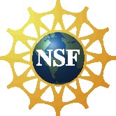 | This project was supported by the National Science Foundation under Award No. 0940143. Any opinions, findings, and conclusions or recommendations expressed in this program are those of the author and do not necessarily reflect the views of the Foundation.

Copyright 2010, Sciencenter, Ithaca, NY. Published under a Creative Commons Attribution-Noncommercial-ShareAlike license: http://creativecommons.org/licenses/by-nc-sa/3.0/us/

