Try this!

1. These cards show different foods made using bioengineering technologies. Some of these already exist, while others are future possibilities.
1
If you were offered these foods, which ones would you choose to eat? (Read more about each food on the back of its card!)

2. Place each card onto a plate that best fits your opinion:
2
• Would you Eat it?
• Would you need to Think about it?
• Or is there No way! you would put it into your mouth?

Talk about it…

Why would you be comfortable eating some of these foods? What made you feel cautious about others?
What kinds of problems are researchers trying to solve with these engineered foods? What do you like or dislike about their solutions? Can you think of different solutions?

Synthetic biologists solve problems by applying engineering principles to the life sciences.

We all have a role in shaping the development and use of new technologies. Many factors can affect our decisions about what foods we eat, including availability, family and cultural traditions, price, nutritional value, and food safety.
The impact of the choices we make extends far beyond our shopping carts. For example, when lots of people decide to limit carbohydrates or buy organic products, it can lead to big changes in the agriculture and food industries.
Your decisions about which products to buy can have a big impact on technologies and systems.
Informed consumers can help shape the kinds of products and technologies we develop and use. In making your own decisions, you can consider the costs, risks, and benefits of using existing and new technologies.

Synthetic biology may provide solutions to problems in areas such as food security, healthcare, energy, and the environment. It may seem surprising to think about foods as technologies, but since the beginning of agriculture, people have been modifying plants and animals to make better-tasting, more nutritious, and more resilient foods.
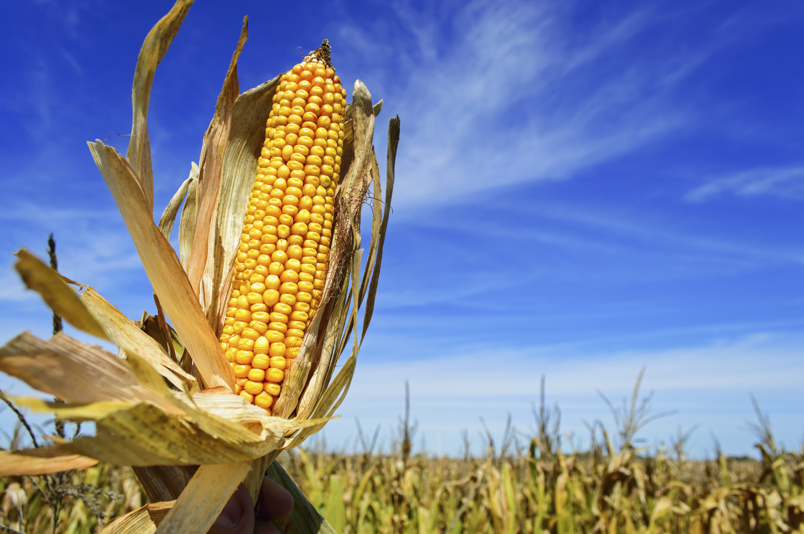
Some people think that new food technologies will help us feed the world’s growing human population. Others think we can find alternative solutions, such as decreasing food waste. It’s important for all of us to think ahead and to talk about new and emerging technologies as they are developed and used.

People have been using selective breeding to improve plants and animals for thousands of years. More recently, we have begun using genetic engineering and synthetic biology.

