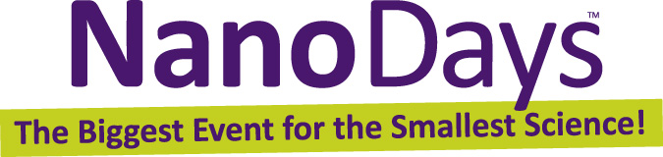

Exploring Materials—Hydrogel

Try this!  - Fill a small cup about half full with water.  - Put a stir stick in the cup. Place the bottom of the stick about half an inch from the side of the cup, and rest the top of the stick against the side of the cup.  - Sprinkle in a quarter spoonful of the white powder. What happens?  What’s going on?  The powder absorbs all the water, expanding into a gel and moving the stir stick! The powder is a polymer called sodium polyacrylate that can absorb up to 1,000 times its weight in water! | 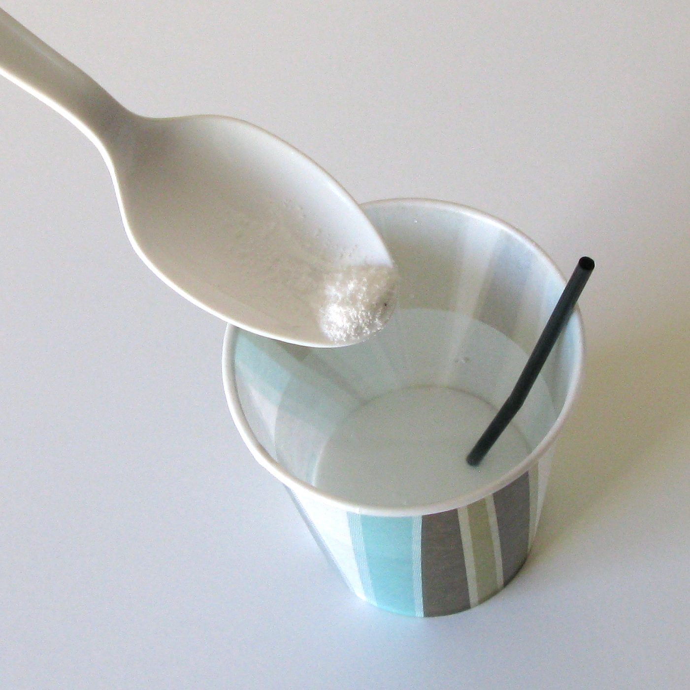

A polymer is a long chain-like molecule made up of many repeating “links.” The links of this particular polymer can attract and hold many water molecules. It’s used in baby diapers to make them absorbent, and in plantings to help soil retain water.

Researchers are experimenting with similar materials called hydrogels. For example, a group at Harvard University is using hydrogels as “muscles” to control micro-sized structures.  The gels can be designed to respond to changes in their environment, such as pH, temperature, or humidity. When the gels get bigger or smaller, they move tiny structures around them. | 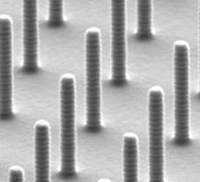  Posts before hydrogel is added  2,000 nm wide | 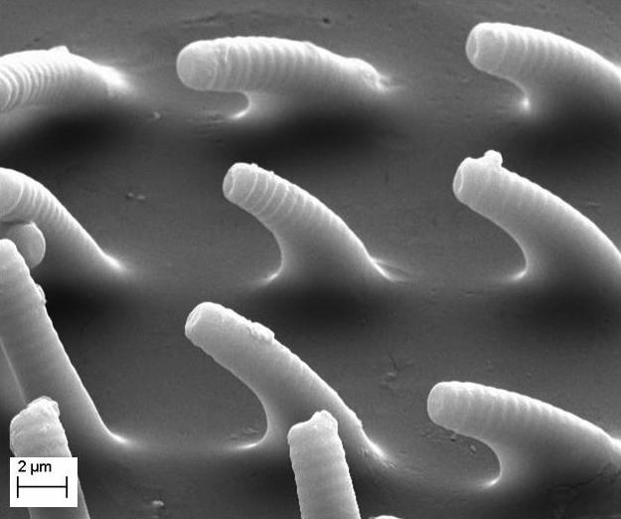  Posts moved by hydrogel  2,000 nm wide

How is this nano?
The way a material behaves on the macroscale is affected by its structure on the nanoscale. Some polymer crystals can absorb a lot of water, because they’re made of long, chain-like molecules with many smaller “links” that attract water molecules.
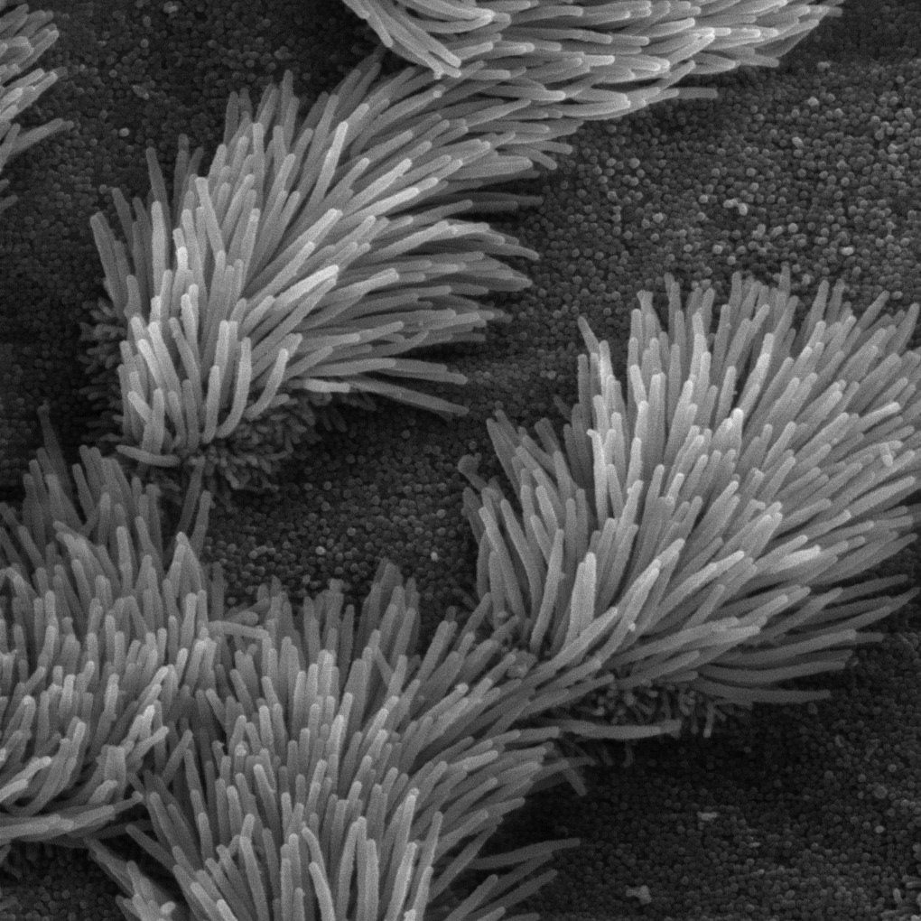  Cilia keep our lungs clean  300 nm wide | Nanotechnology takes advantage of different properties—like super-absorption—at the nanoscale to make new materials and tiny devices smaller than 100 nanometers in size. (A nanometer is a billionth of a meter.)  For example, researchers are using hydrogel “muscles” to move tiny structures. This research is inspired by the way muscles move parts of the human body, such as the tiny cilia that help sweep away dust from our lungs.  Nanotechnology allows scientists and engineers to make things like smaller, faster computer chips and new medicines to treat diseases like cancer.

Learning objectives
The way a material behaves on the macroscale is affected by its structure on the nanoscale.

Materials
- Sodium polyacrylate powder
- Plastic spoon
- Plastic water bottle
- Small paper cups (3 oz. bathroom size)
- Stir sticks or toothpicks

Sodium polyacrylate powder is available from www.teachersource.com (#GB-6A, #GB-6B, or #GB-620).

Notes to the presenter
SAFETY: Visitors should not ingest the sodium polyacrylate powder. Visitors should be supervised when doing this activity. You may choose to perform this as a demonstration, rather than allowing visitors to do it as a hands-on activity.

Before beginning this activity, fill the bottle with water. You’ll need a trash can nearby to dispose of the cups and polymer.

Related educational resources
The NISE Network online catalog (www.nisenet.org/catalog) contains additional resources to introduce visitors to nanomaterials:
- Public programs include Aerogel, Nanoparticle Stained Glass, Nanosilver: Breakthrough or Biohazard?, World of Carbon Nanotubes, and Tiny Particles, Big Trouble!
- NanoDays activities include Exploring Materials—Ferrofluid, Exploring Materials—Graphene, Exploring Materials—Liquid Crystals, Exploring Materials—Nano Gold, Exploring Materials—Thin Films, and Exploring Structures—Buckyballs.
- Exhibits include Changing Colors and Unexpected Properties.

Credits and rights
This activity was adapted from:
- “Diaper Polymers,” in You Be the Chemist. Activity Guide: Lesson Plans for Making Chemistry Fun. Grades K-4, published by the Chemical Educational Foundation. The source book is available at: www.chemed.org.
- “Super Soakers” polymer activity developed by Lauren Zarzar of the Aizenberg Group at Harvard University and the Strategic Projects Group at the Museum of Science, Boston.

Images of hydrogel and microstructures courtesy Lauren Zarzar and Joanne Aizenberg, Harvard University.

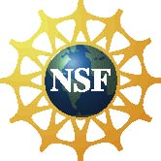 | This project was supported by the National Science Foundation under Award No. 0940143. Any opinions, findings, and conclusions or recommendations expressed in this program are those of the author and do not necessarily reflect the views of the Foundation.

Copyright 2012, Sciencenter, Ithaca, NY. Published under a Creative Commons Attribution-Noncommercial-ShareAlike license: http://creativecommons.org/licenses/by-nc-sa/3.0/us/.

