

Exploring Size—Powers of Ten Game

Try this!  - Each player is dealt five cards.  - Three cards are placed face up on the table, starting three rows of play.  - Players take turns adding a card from their hand above or below one of the rows of play.  - You must place the cards in the correct size order. Smaller objects go at the bottom of the row. Larger objects go at the top.  - Each card has a number on it that tells you how big or small the object is. Bigger objects have positive numbers. Smaller objects have negative numbers.  - Cards can’t be played if they are identical in rank to the end of the row.  - You can’t sneak a card into the middle of a row—it has to go on the top or bottom.  - If you can't play a card, pass on your turn.  - Whoever gets rid of all their cards first wins! (If no one can get rid of every card, then whoever has the fewest cards wins.)  What’s going on?  Things in the universe come in different sizes—and size is important! The objects on the cards are organized according to powers of ten.  Each number on the scale represents a ten-fold change in size. An object marked with a 0, like a pirate, is about a meter tall. An object marked with a +1, like the Statue of Liberty, is around ten times bigger than a pirate. An object marked with a -1, like a chicken, is around ten times smaller. |  | 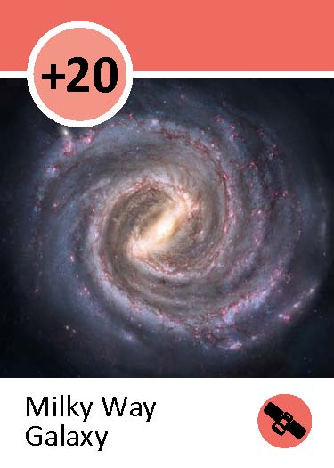  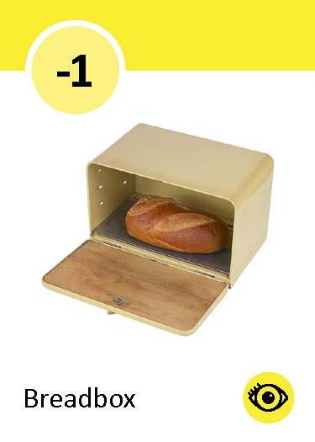  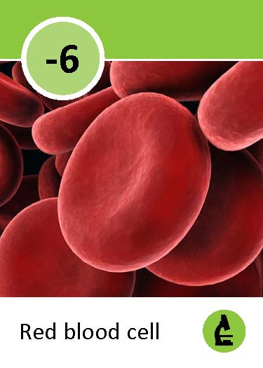  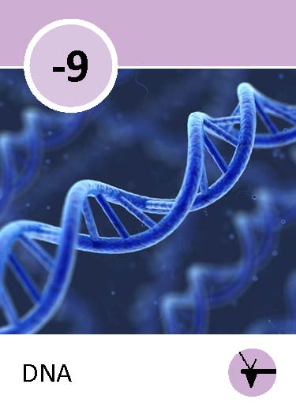  Sample row
Really tiny objects, like DNA, are marked with even lower numbers. DNA (-9) is so tiny it’s measured in nanometers! A nanometer is a billionth of a meter. In the emerging field of nanotechnology, scientists work with very tiny things measured in nanometers.

Nanometers, centimeters, and meters are all part of the metric system. The metric system is a measuring system using units based on powers of ten. Scientists use the metric system because it makes calculations easier.

How is this nano?
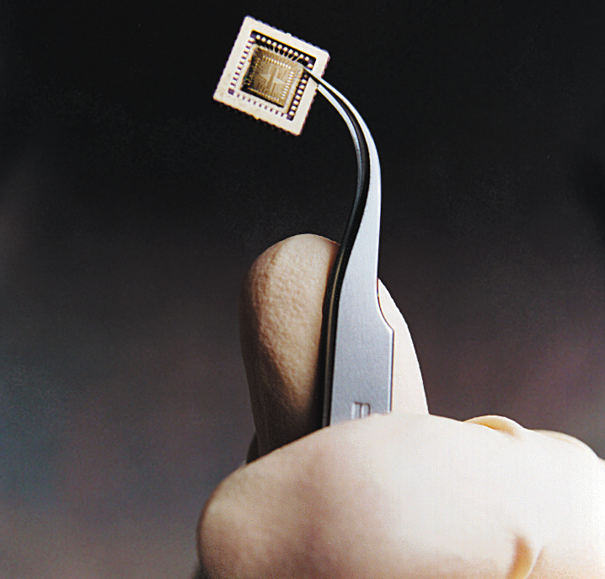  Computer chip | A nanometer is a billionth of a meter. That’s really tiny! Nanometers are used to measure things that are too small to see, like atoms and molecules, the basic building blocks of our world.  Nanoscale science focuses on things that are measured in nanometers. Scientists use special tools and equipment to work with things that have nanometer-sized parts, such as microchips.  In the field of nanotechnology, scientists and engineers make new materials and tiny devices. Nanotechnology allows them to make things like smaller, faster computer chips and new medicines to treat diseases like cancer.

Learning objectives
- Things come in different sizes—and size is important!
- A nanometer is a billionth of a meter.

Materials
- “Sizing Things Down” playing cards
- “Sizing Things Down” orders of magnitude sheet

Notes to the presenter
Here are some hints for learning and playing the game with visitors:
- After each group of visitors, leave the last hand played out on the table. The cards and pictures will attract the attention of another group. Use the last hand’s cards to explain the game, and then deal a new hand.
- Add more rows if you have many players. With fewer than four players, three rows are enough. With more players, additional rows give everyone more chances to play. One row per player is a good guideline.
- After each play, say the size comparison aloud: “A cruise ship is bigger than a breadbox,” or “DNA is smaller than Jupiter.” (Ask visitors to reconsider if they make an invalid move.)
- There’s a useful training video showing how the game is played: vimeo.com/channels/nisenet#11049272
For older audiences, you can introduce additional vocabulary, explain the scientific notation system, or provide additional information:
- The metric system is a logarithmic scale. Each ten-fold increase in size is called an order of magnitude. The “Sizing Things Down” sheet provides more information.
- The numbers on the top left corner of the cards indicate the approximate length of the different objects in meters. For example, objects with a –9 are measured in nanometers. They’re about 10⁻⁹ meters across.
- The colored circles on the bottom right corner of the cards indicate some of the tools used to see objects of different sizes.

Related educational resources
The NISE Network online catalog (www.nisenet.org/catalog) contains additional resources to introduce visitors to the nanoscale and nanometers:
- Public programs include Cutting it Down to Nano and Shrinking Robots!
- NanoDays activities include Exploring Size—Measure Yourself, Exploring Size—Memory Game, Exploring Size—Scented Balloons, Exploring Size—Scented Solutions, Exploring Size—StretchAbility Game, and Exploring Size—Tiny Ruler.
- Media include How Small is Nano?, Image Scaler Software, Intro to Nano, Multimedia Zoom into a Human Hand, Multimedia Zoom into a Nasturtium Leaf, Scale Ladder, Zoom into a Butterfly Wing, Zoom into a Computer Chip, and Zoom into the Human Bloodstream.
- Exhibits include At the Nanoscale and Three Drops.

Credits and rights
This activity was adapted from Sizing Things Down, developed by the Oregon Museum of Science and Industry for the NISE Network. The original program is available at www.nisenet.org/catalog

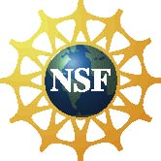 | This project was supported by the National Science Foundation under Award No. 0940143. Any opinions, findings, and conclusions or recommendations expressed in this program are those of the author and do not necessarily reflect the views of the Foundation.

Copyright 2010, Sciencenter, Ithaca, NY. Published under a Creative Commons Attribution-Noncommercial-ShareAlike license: http://creativecommons.org/licenses/by-nc-sa/3.0/us/

