

Exploring Materials—Ferrofluid

Try this!  - Move a magnet around next to the vial of black sand. How does the sand react?  - Do the same thing with the vial of ferrofluid. Does the ferrofluid act the same way the sand does?  - Now, hold the magnet next to the crisp dollar bill. What happens to the money? |  | 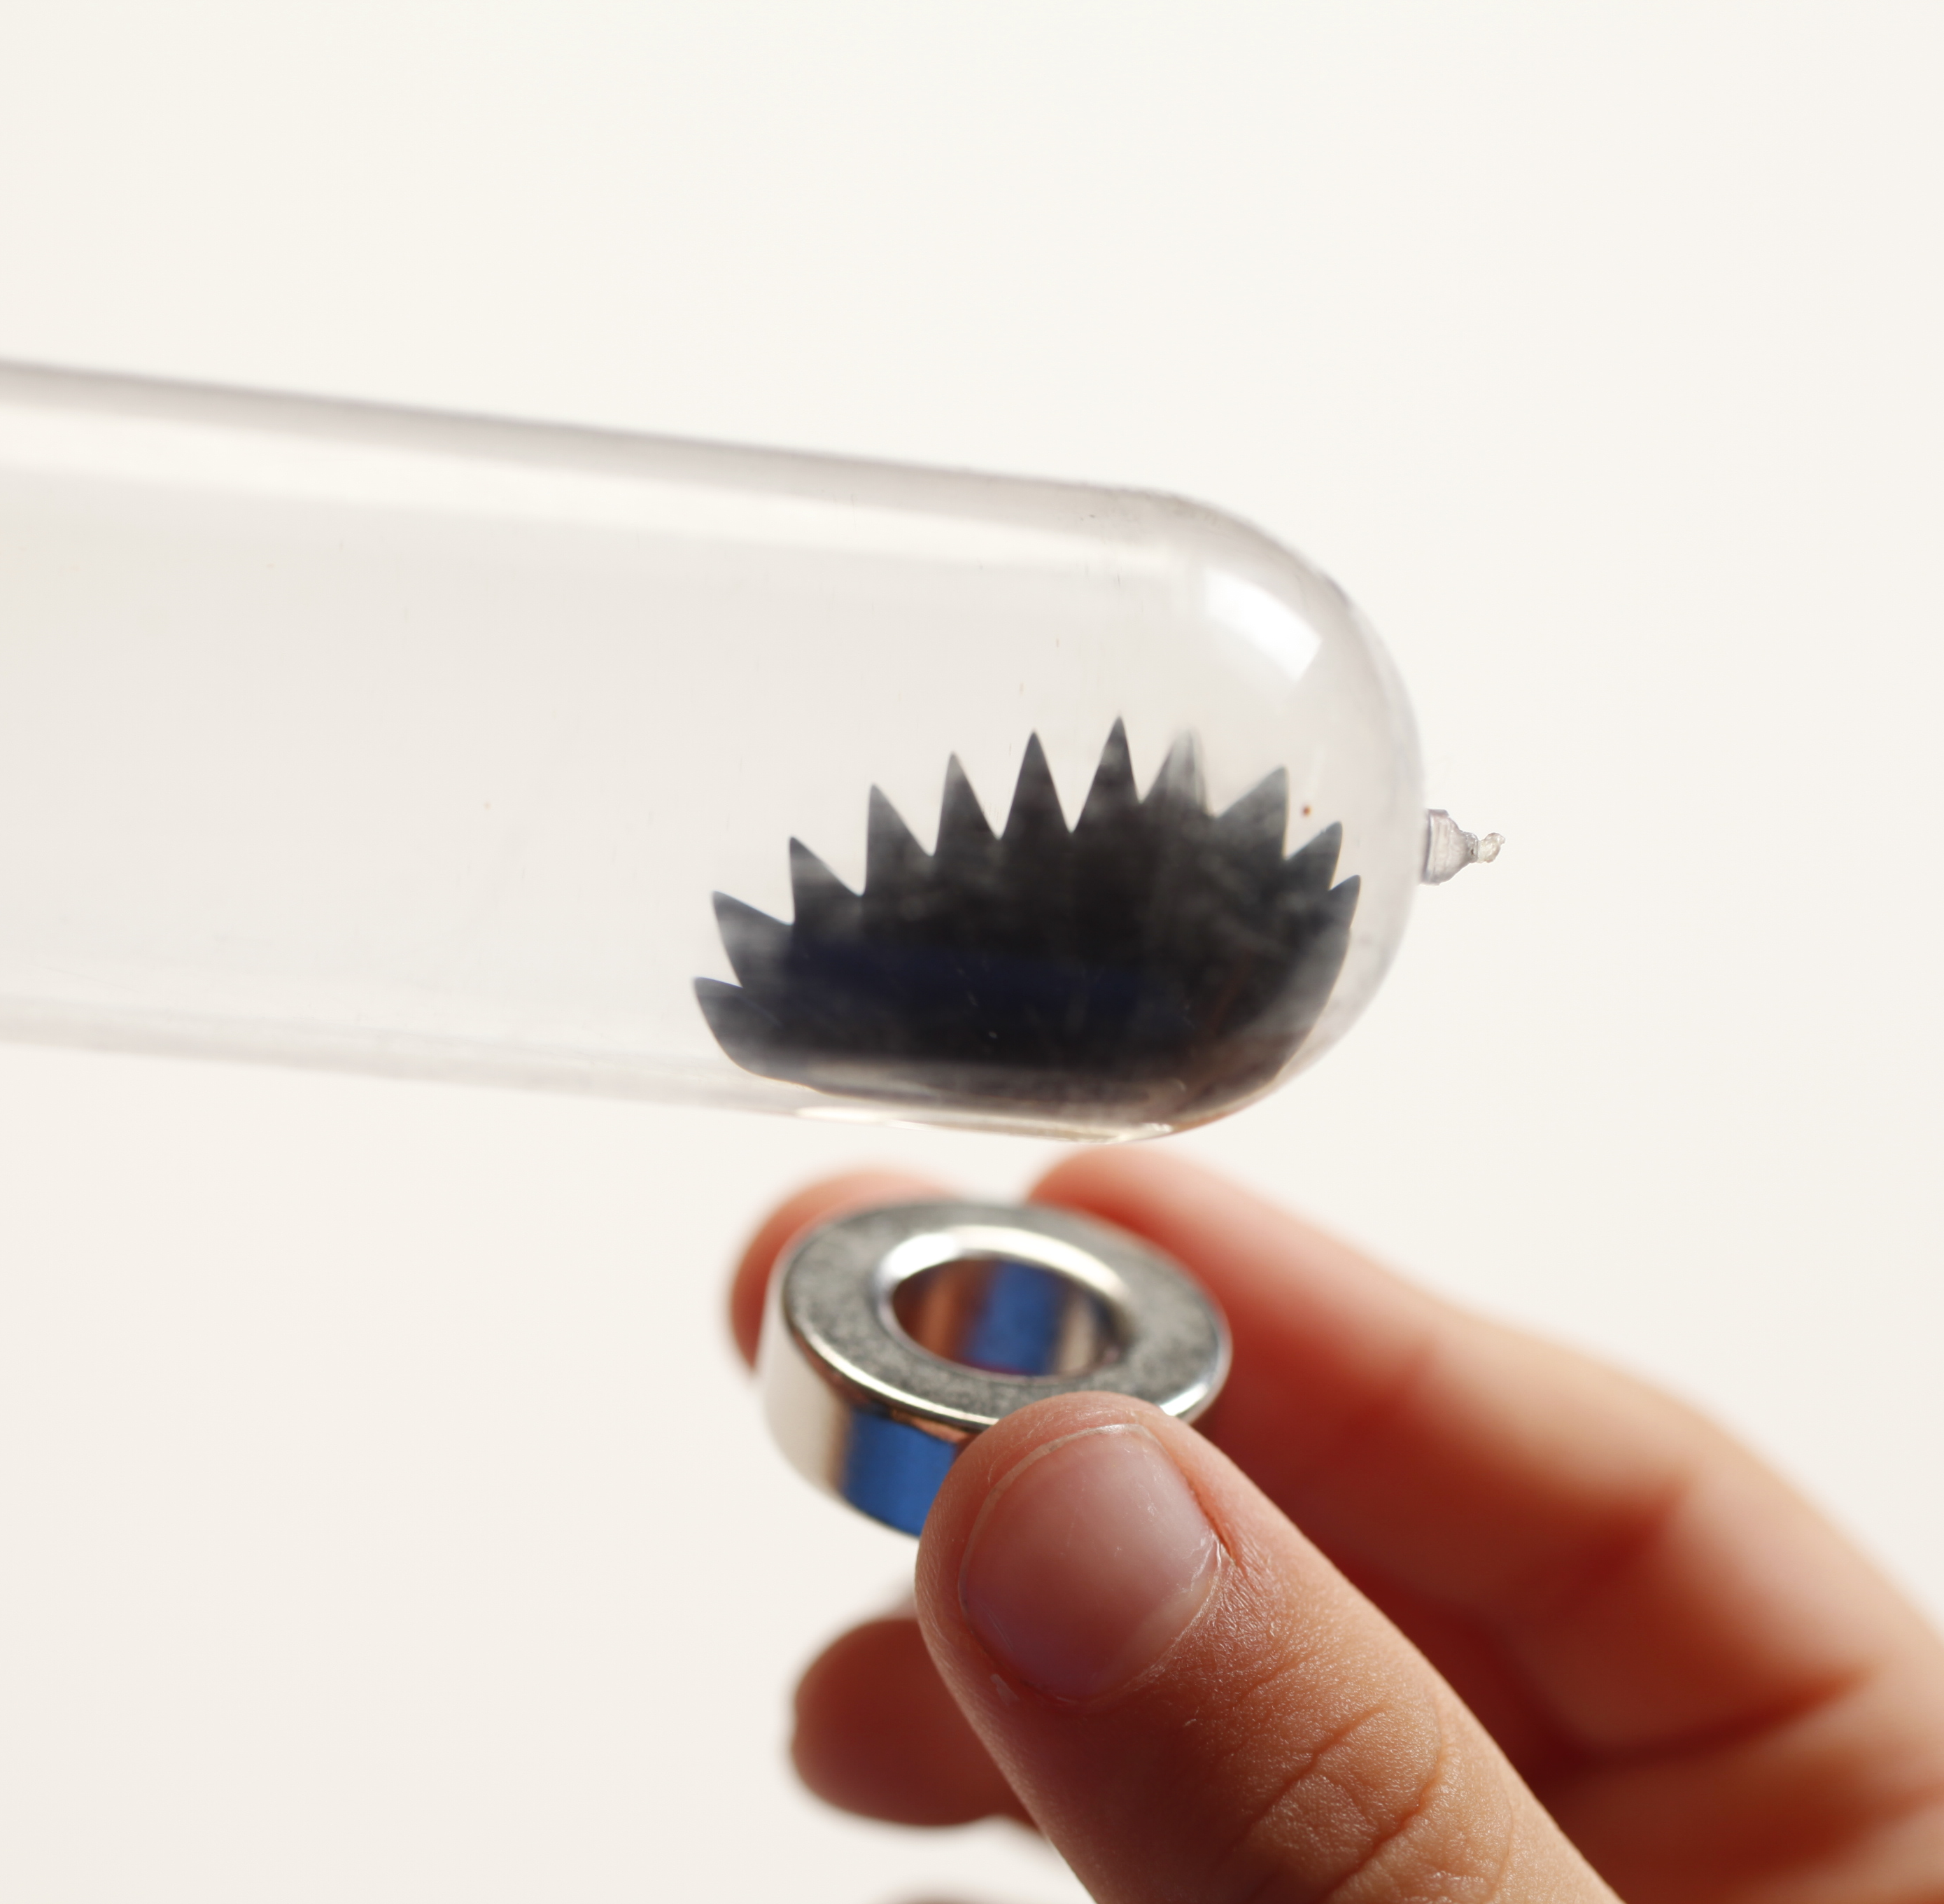
What’s going on?
Ferrofluid is a unique material that acts like a magnetic solid and like a liquid. In contrast, black sand is a regular magnetic solid. Surprisingly, both ferrofluid and black sand are made of magnetite! The difference in their behavior is due to size.

Ferrofluid is made of tiny, nanometer-sized particles of coated magnetite suspended in liquid. When there’s no magnet around, ferrofluid acts like a liquid. The magnetite particles move freely in the fluid. But when there’s a magnet nearby, the particles are temporarily magnetized. They form structures within the fluid, causing the ferrofluid to act more like a solid. When the magnet is removed, the particles are demagnetized and ferrofluid acts like a liquid again. Black sand is also made of magnetite, but it doesn’t have ferrofluid’s unusual properties because the grains of sand are much larger.

The dollar bill moves because the ink used in printing contains ferrofluid! This special ink is used to deter counterfeit printing. The ferrofluid used in the ink also helps vending machines know if you’ve put in $1 or $5 or $50!

How is this nano?
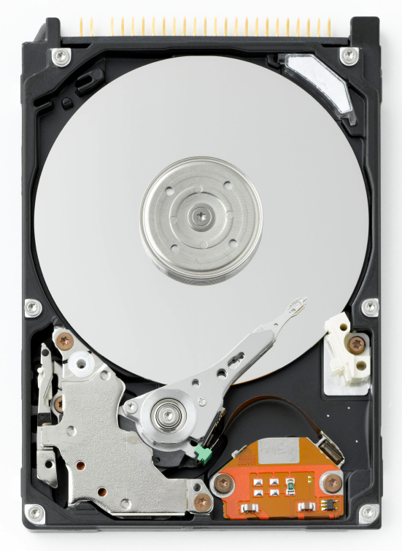  Inside a hard drive | A material can act differently when it’s nanometer-sized. (A nanometer is a billionth of a meter.) Nanometer sized magnetite particles suspended in liquid (ferrofluids) behave like paramagnets, meaning that it’s magnetic only in the presence of a magnet. But on the macroscale, magnetite is permanently magnetic.  Nanotechnology takes advantage of special properties at the nanoscale—such as paramagnetism—to create new materials and devices.  In addition to the ink used in printing US dollar bills, ferrofluid is used in rotary seals for computer hard drives and other rotating shaft motors, and in loudspeakers to dampen vibrations. In medicine, researchers are looking at ways to use ferrofluid as a contrast agent for magnetic resonance imaging (MRI).

Learning objective
A material can act differently when it’s nanometer-sized.

Materials

Ferrofluid display cell
- Vial of magnetic black sand
- Neodynium magnet wand
- Dollar bill
- Bill sized paper
- 2 giant binder clips (only the black base)
- Ferrofluid Material Safety Data Sheet (MSDS)

Ferrofluid display cells are available from www.teachersource.com (#FF200).
Iron filings can be substituted for magnetic black sand, available from www.teachersource.com (#M-600).

Notes to the presenter
SAFETY: Small fingers can be pinched by magnets! To minimize the pinch hazard, have visitors use caution when holding magnets near magnetic metals.

Before doing this activity, read the MSDS information on the ferrofluid display cell provided by the supplier.

Related educational resources
The NISE Network online catalog (www.nisenet.org/catalog) contains additional resources to introduce visitors to nanomaterials:
- Public programs include Aerogel, Biomimicry: Synthetic Gecko Tape Through Nanomolding, Nanoparticle Stained Glass, Nanosilver: Breakthrough or Biohazard? and World of Carbon Nanotubes.
- NanoDays activities include Exploring Materials—Liquid Crystal, Exploring Materials—Memory Metal, Exploring Materials—Thin Films, and Exploring Structures—Buckyballs.
- Exhibits include the Nano mini-exhibition, Bump and Roll, Changing Colors, and Unexpected Properties.

Ferrofluid Background Information

What is ferrofluid?

Ferrofluid is a colloidal suspension of small magnetic particles in a fluid. In a suspension, solid particles are dispersed. The viscosity of the fluid, the tiny size of the particles, and the particles’ constant motion keep the solids from settling out. The magnetic particles in ferrofluid are around 10 nanometers in size. (A nanometer is a billionth of a meter.) Particles this size are known as colloids.
The magnetic particles in ferrofluids are usually iron oxide (magnetite), synthesized in solution and precipitated as nanoparticles:
- Iron salts (iron II chloride and iron III chloride) are mixed in a basic solution. Tiny particles of iron oxide (Fe₃O₄) precipitate from the solution.
- The iron oxide particles are coated with a surfactant to keep them from sticking to each other.
- The particles are dispersed in a water- or oil-based fluid.
Iron oxide is the same compound as magnetite, a naturally magnetic mineral found in many igneous and metamorphic rocks. The first ferrofluids, developed by NASA in the 1960s, were ground from natural magnetite.
How can it act like a liquid and a solid?
Ferrofluid is superparamagnetic, a property that is found only at the nanoscale. At the macroscale, ferromagnetic materials (like refrigerator magnets) are permanently magnetic. But when ferromagnetic materials are nanometer-sized, they became paramagnetic, which means that they behave like magnets only in the presence of a magnetic field.  When there is no magnet nearby, the magnetite particles in ferrofluid act like normal metal particles in suspension. But in the presence of a magnet, the particles are temporarily magnetized. They form structures within the fluid, causing the ferrofluid to act more like a solid. When the magnetic field is removed, the particles are demagnetized and ferrofluid acts like a liquid again. |   Ferrofluid near a magnet

  Speaker | How is ferrofluid used?  Ferrofluid’s properties make it useful for many different applications. The US government uses ferrofluid-based ink to print dollar bills as one of many anti-counterfeiting measures. Loudspeakers use ferrofluid to dampen vibrations. It is used in rotary seals for computer hard drives and other rotating shaft motors. In the future, ferrofluid might be used to carry medications to specific locations in the body.

Credits and rights
This activity was adapted from the NanoDays activity Exploring Materials—Ferrofluid supported by the National Science Foundation under Award No. ESI-0532536. The original program is available at www.nisenet.org/catalog.
And from the “Quick Reference Activity Guide: Ferrofluids,” developed by the National Science Foundation-supported Internships in Public Science Education (IPSE) Program at the Materials Research Science and Engineering Center (MRSEC) on Nanostructured Materials and Interfaces at the University of Wisconsin-Madison. The original activity is available at mrsec.wisc.edu/Edetc/IPSE/educators/ferrofluid.html.

Photo of ferrofluid courtesy of Opoterser. From Wikimedia Commons.

 | This project was supported by the National Science Foundation under Award No. 0940143. Any opinions, findings, and conclusions or recommendations expressed in this program are those of the author and do not necessarily reflect the views of the Foundation.

Copyright 2013, Sciencenter, Ithaca, NY. Published under a Creative Commons Attribution-Noncommercial-ShareAlike license: http://creativecommons.org/licenses/by-nc-sa/3.0/us/.

