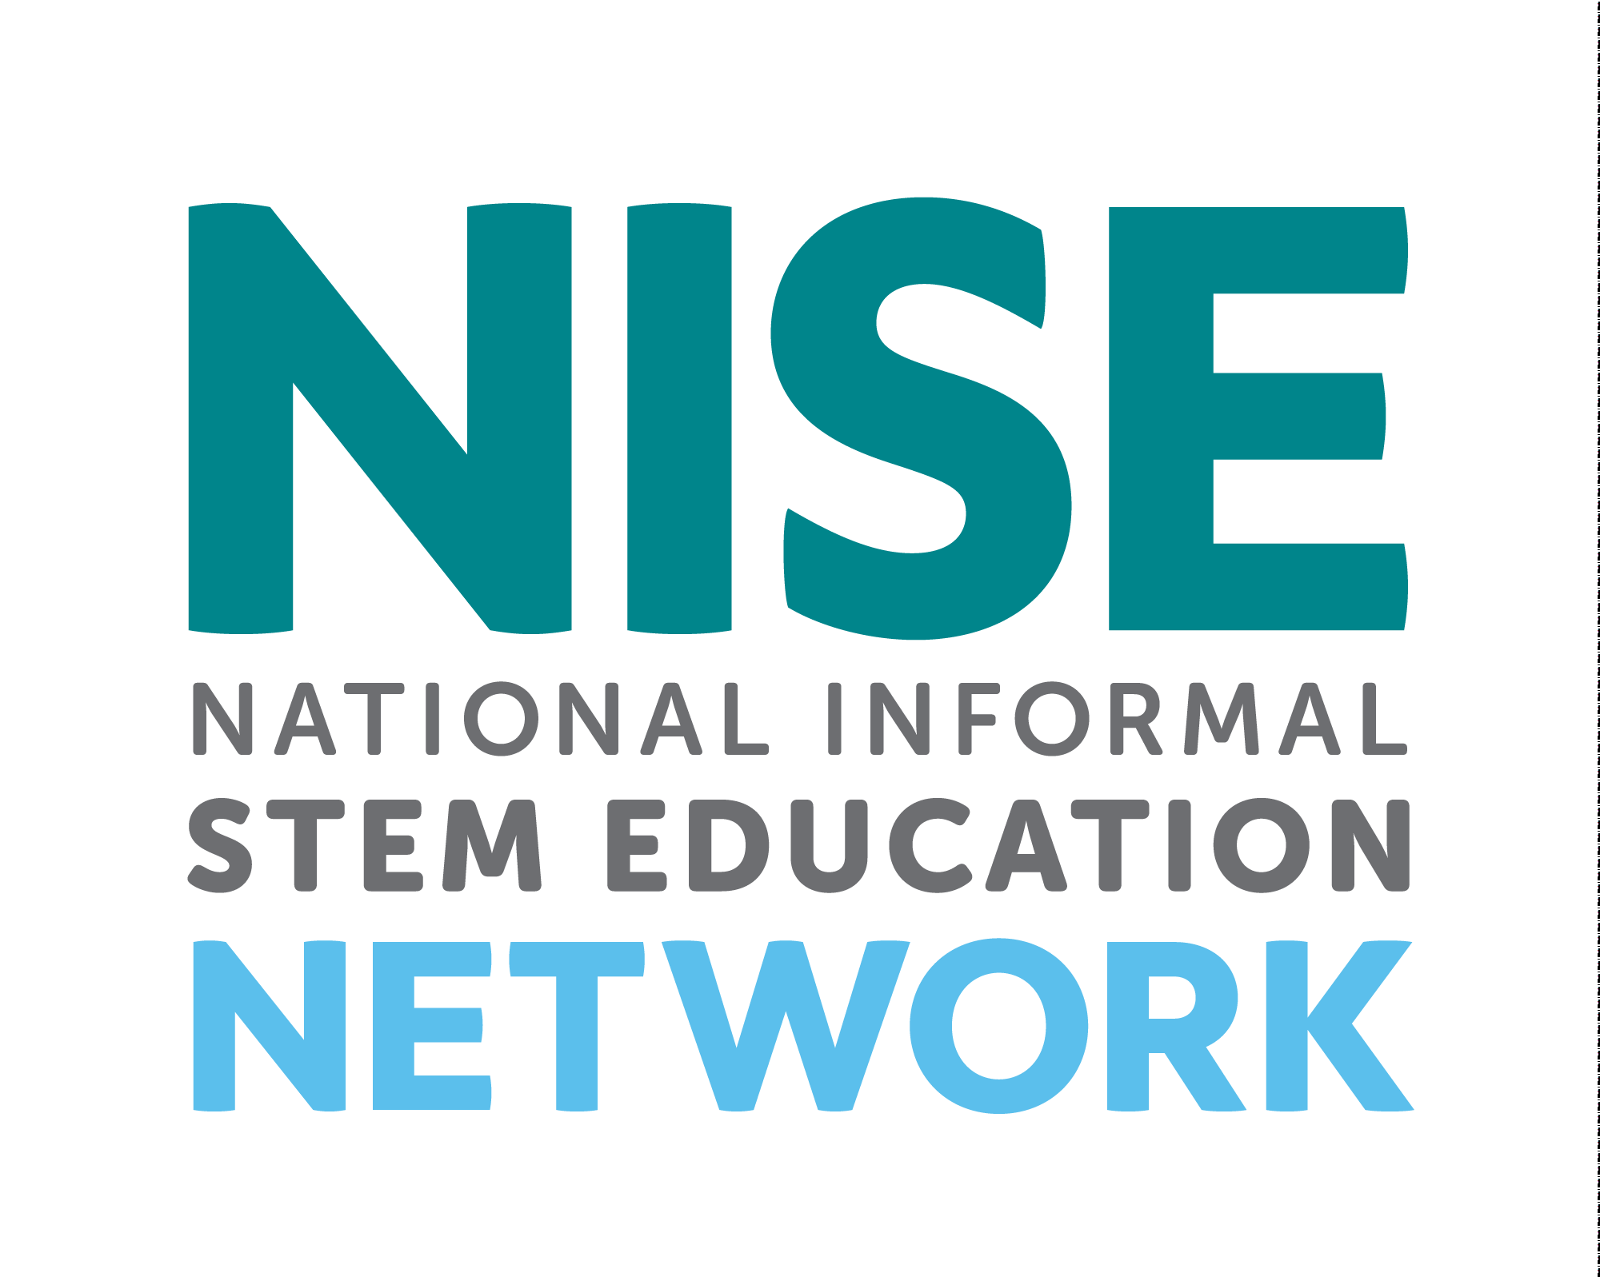
Resources for Museums
Finding and working with STEM Expert Volunteers
Association of Children’s Museums Interactivity May 2018
Conference Presentation Handout

Catherine McCarthy, Science Museum of Minnesota, cmccarthy@smm.org
revised 5-4-18
______________________________________________________________________________

Collaborating for special STEM events, holidays

A great way to bring in experts to your museums is during special events.
You can find a list of STEM related and seasonal events and holidays and resources:
- http://www.nisenet.org/seasons
______________________________________________________________________________

Finding Local Subject Matter Experts
– Professional Societies and Expert Networks
We strongly encourage museums to collaborate with local experts. Volunteer experts are key ingredients to many successful public engagement efforts. It is up to your organization to choose your local collaborators. NISE Network regional hub leaders can assist you in finding local partners in your geographic area. NISE Network materials include training and orientation materials to help prepare your event volunteers and staff for facilitating the activities.

- Chemistry
Many chemists are already active in events such as National Chemistry Week and Chemists Celebrate Earth. Volunteers can include local chemistry teachers, college and university chemistry faculty and staff and students, and local American Chemical Society (ACS) Local Sections and Student Chapters.

- American Chemical Society (ACS) Local Sections
ACS has 185 local sections of ACS members located throughout the United States. To find contact information for your state please visit:
https://lslookup.acs.org/lslookup/local_search

- American Chemical Society (ACS) Student Chapters
ACS has student chapters located on many college campuses across the country.
To find the closest chapter to you please visit:
https://www.acs.org/content/acs/en/education/students/college/studentaffiliates/find-a-chapter.html
Once you find the name of a student chapter, please contact undergrad@acs.org to reach out to their faculty advisor.

- Colleges and Universities departments:
Your local colleges or universities will usually have a chemistry department, and some of these have existing outreach programs or clubs.

- High school chemistry teachers:
Once you connect with a high school teacher they may be able to suggest high school students who could volunteer at your event.

- Earth and Space
Volunteer networks focused on Earth and space science include:
  - The Solar System Ambassadors Program (SSA)
This is a public outreach program designed to work with motivated volunteers across the nation. These volunteers communicate the excitement of the NASA Jet Propulsion Lab’s (JPL) space exploration missions and information about recent discoveries to people in their local communities. For 2016, there are 700 ambassadors in 50 states, Washington DC, Puerto Rico, US Virgin Islands, and Guam. Volunteer ambassadors bring the excitement of space to the public. Ambassadors are space enthusiasts from various walks of life who are interested in providing greater service and inspiration to the community at large. http://solarsystem.nasa.gov/ssa/home.cfm
- The Night Sky Network
This is a nationwide coalition of amateur astronomy clubs bringing the science, technology, and inspiration of NASA's missions to the general public. Night Sky Network members share their time and telescopes to provide unique astronomy experiences at science museums, observatories, classrooms, and under the real night sky.
http://nightsky.jpl.nasa.gov/index.cfm

- AAS Astronomy Ambassadors
The American Astronomical Society (AAS), in partnership with the Astronomical Society of the Pacific (ASP), members of the Center for Astronomy Education (CAE), and other organizations active in science education and public outreach (EPO), has launched a series of professional development workshops and a community of practice designed to help improve early-career astronomers’ ability to effectively communicate with students and the public. Called Astronomy Ambassadors, the program provides mentoring and training experiences for young astronomers, from advanced undergraduates to new faculty. It also provides access to resources and a network of contacts within the astronomy EPO community.
http://aas.org/outreach/roster-aas-astronomy-ambassadors

- Colleges and Universities
Many colleges and universities have astronomy and Earth science departments. Others may have clubs or local chapters of professional societies. Once you connect with a faculty or staff member they should be able to also suggest undergraduate and graduate students who could volunteer at your event.
- Online workshop 2017 (recorded)
http://www.nisenet.org/catalog/online-workshop-finding-and-collaborating-astronomy-experts-and-volunteers-recorded

- Synthetic Biology
A key piece of the Building with Biology project was to facilitate conversations between scientists and the public about how synthetic biology might affect our society
  - Local colleges
Many colleges and universities have synthetic biology scientists on staff. Some colleges have synthetic biology programs, but you may often find people in this field located in a variety of departments including genetics, microbiology, molecular biology, biological engineering, and chemical engineering. Once you connect with a faculty or staff member, they can also suggest undergraduate and graduate students who could volunteer at your event.

  - Professional societies with local chapters
    - The purpose of the American Society for Biochemistry and Molecular Biology (ASBMB) is to advance the science of biochemistry and molecular biology. ASBMB has thousands of members in the United States; a list of student chapters is available here:
http://www. asbmb.org/education/studentchapters/regions/
    - Society for Biological Engineers has several student chapters in the United States; a list of student chapters is available here: http://www.aiche.org/sbe/community/students/ chapters

  - iGEM teams
The iGEM Foundation is dedicated to education and competition, advancement of synthetic biology, and the development of open community and collaboration. The iGEM Competition is designed for college students studying synthetic biology; there are over 70 active iGEM teams located in the United States, as well as many iGEM alumni: http://igem.org/Team_List
  - DIYBio spaces
DIYBio spaces are a network of local community labs that provide opportunities and training for citizen scientists, do-it-yourself biologists and engineers, makers, and biohackers: http://diybio. org/local/

  - Industry representatives
- The Wilson Center has created an interactive map showing both public and private synthetic biology labs: http://www.synbioproject.org/sbmap/
- Synberc is a multi-university research center established in 2006 with a grant from the National Science Foundation (NSF) to help lay the foundation for synthetic biology. Synberc’s member companies come from all sectors of the biotechnology industry and range from startup to large multinational in size: http://www.synberc.org/industry/members

______________________________________________________________________________
Finding Additional Volunteers for your STEM event
In addition to finding subject matter experts, you will probably need to recruit other volunteers to help with your event. Potential sources of volunteers may include:
- College students, classes, or clubs with community service requirements
- High school science clubs, or students suggested by local high school science teachers
- Local chapters of professional science and engineering groups that are often associated with local colleges, such as:
- American Indian Science and Engineering Society: http://www.aises.org/
- Materials Research Society (MRS): http://www.mrs.org
- National Action Council for Minorities in Engineering: http://www.nacme.org
- MAES – Latinos in Science and Engineering: http://mymaes.org
- National Society of Black Engineers (NSBE): http://www.nsbe.org/home.aspx
- National Organization for the Professional Advancement of Black Chemists and Chemical Engineers (NOBCChE): http://www.nobcche.org/
- National Organization of Gay and Lesbian Scientists and Technical Professionals: http://www.noglstp.org
- Society for Advancement of Chicanos and Native Americans in Science (SACNAS): http://sacnas.org
- Society of Asian Scientists and Engineers: http://www.saseconnect.org
- Society of Hispanic Professional Engineers: http://shpe.org
- Society of Women Engineers (SWE): http://societyofwomenengineers.swe.org
- Drama and theater students
- Local industry staff and retirees
______________________________________________________________________________

______________________________________________________________________________
Training Resources
The NISE Network has created training resources that will help your staff and volunteers feel comfortable engaging public audiences in STEM topics.
- Training materials within hands-on kit activities:
Training materials include orientation presentation for staff, facilitator guides for each activity, and training videos. 
- Explore Science: Earth & Space toolkits (2017, 2018)
http://www.nisenet.org/earthspacekit
- Explore Science: Let's Do Chemistry kit - Coming in September 2018
http://www.nisenet.org/chemistry-kit
- Frankenstein200 kit (2018)
http://www.nisenet.org/frankensteinkit
- Building with Biology kit (2016) Activities and Conversations about Synthetic Biology
http://www.nisenet.org/building-with-biology-kit
- SustainABLE kit (2016)
http://www.nisenet.org/sustainable-kit
- Museum & Community Partnerships Explore Science – Zoom into Nano kit (2016)
http://www.nisenet.org/explorescience-nano
- NanoDays (2009-2015)
http://www.nisenet.org/nanodays
- Training Videos
Training videos are available for many NISE Net educational products:
- NISE Network Vimeo site: https://vimeo.com/nisenet
- Explore Science: Earth & Space training videos:
https://vimeopro.com/nisenet/explore-science-earth-space
- Frankenstein200 training videos:
https://vimeopro.com/nisenet/frankenstein200-activity-training-videos
- Building with Biology training videos: https://vimeopro.com/nisenet/buildingwithbiology
- Sustainability training videos: https://vimeopro.com/nisenet/sustainability
- Explore Science: Zoom into Nano training videos:
https://vimeopro.com/nisenet/exploresciencezoomintonano
- NanoDays training videos: https://vimeopro.com/nisenet/nanodays-training-videos
- Additional Professional Development Tools
The NISE Network has created a wide variety of professional development tools, guides, workshops, and training materials as resources designed for educators and scientists to improve their capacity to engage the public in current science and technology.
  - http://www.nisenet.org/About_Professional_Development

- Tips for Leading Hands-on Activities
This is a simple reference sheet, offering basic tips for leading the hands-on activities in your toolkit. It includes suggestions for engaging and encouraging visitors, as well as for handling difficult concepts and misconceptions. http://www.nisenet.org/catalog/explore-science-tips-leading-hands-activities

- Portal to the Public
The Portal to the Public (PoPNet) approach helps organizations connect public audiences with current science in their own communities through conversations with local scientists. Led by Pacific Science Center in Seattle, Washington, the PoP Network provides strategies and resources to build local communities of scientists and educators who are dedicated to public engagement with current science.
https://popnet.pacificsciencecenter.org
- Science communication tools for scientists
  - Workshop intended for graduate students and early career scientists: Sharing Science Workshop & Practicum Planning & Implementation Guide
http://www.nisenet.org/catalog/tools_guides/sharing_science_workshop_practicum
  - Workshop intended for Research Experiences for Undergraduate (REU) students: REU Science Communication Workshop Planning & Implementation Guide
http://www.nisenet.org/catalog/reu-science-communication-workshop-planning-implementation-guide-v50
  - Mastering Science and Public Presentations Video
http://www.nisenet.org/catalog/mastering-science-and-public-presentations-video
  - More resources
http://www.nisenet.org/About_Professional_Development

- Online Workshops
In addition to the resources listed above, the NISE Network will also offer a variety of free online workshops that your staff and volunteers are welcome and encouraged to participate in. There will be multiple one-hour workshops featuring training on a variety of topics. All online workshops will be recorded and archived.
- Upcoming online workshops: http://www.nisenet.org/events/online-workshop
- Recordings of past online workshops: http://www.nisenet.org/event-type/online-workshop

______________________________________________________________________________
Planning Guest Presentations
Expert speakers can be a wonderful addition to your event. With extra preparation and support, guest presentations can provide a great experience for both the speaker and the audience.
Here are some suggestions to help make things go smoothly:
  - When inviting scientists to participate, be clear about their role and type of experience you’re seeking.
  - Familiarize invited guest speakers with your expected audience, including anticipated ages, level of background knowledge.
  - Let speakers know about any expectations you may have related to audience involvement.
  - Discuss the content and length of the planned presentation.
  - Share the “Tips for guest speakers,” with your presenter. You might also share some of the other training materials.
  - Encourage your invited speaker to use plain language, avoiding jargon and technical terms.
  - Discuss details about your facility, including room size, seating style, and audio-visual equipment.
  - Ask to review a draft slideshow or notes in advance and discuss the planned presentation together.
  - Schedule time before the presentation to work out any audio-visual or logistical issues.
  - Prepare questions that may help stimulate audience discussion.

______________________________________________________________________________

______________________________________________________________________________
Tips for Guest Speakers
Public audiences find emerging science and technology interesting. Keep in mind, however, that only a small percentage of the population knows much about this topic. Here are a few pointers for communicating with the public about science, engineering, and technology.
Know your audience
The more you know about your audience, the better you can adapt your presentation to their interests. Keep in mind the diversity of your audience’s experience and backgrounds. Remember that many visitors attend in family groups, which can include a wide range of ages.
Keep the message simple
Come up with one “big idea” you want the audience to take away from the experience, and make sure your presentation reiterates and reinforces this idea in different ways. Define your terms, avoiding jargon and acronyms as much as possible. Check in with your audience periodically to see if they’re following you.
Use familiar analogies
Use comparisons to everyday experiences. Explain how the topic relates to something that’s been in the news or in popular culture.
Use relative size and scale
Focus on relative size and scale rather than exact measurements. Consider using parts of the human body to explain relative scale.
Use visuals
Simple images and models will reinforce and clarify your message.
Use several modes of presentation
In addition to talking, you can include demonstrations, videos, and pictures. You can involve the audience by providing objects to pass around, asking questions, doing brief experiments, providing hands-on activities, and playing games.
Involve the audience in the processes of science
Encourage your audience to observe, predict, and explore by asking them questions: “
What do you think will happen when . . . ?” “Were you surprised?” “Why do you think that happened?” “What if you tried . . .?” “Can you think of any practical uses for this?” “What about unintended consequences?”
Be friendly and approachable
Remember to make eye contact, smile, and let the audience know who you are. If you’re a scientist, consider including personal stories about your work life and your career decisions.
Be prepared to answer common questions
But don’t be afraid to let your audience know if you don’t know the answer to their question.
Share ways to learn more Remember that your presentation is only one exposure that people will have to this topic—it’s not the end of their learning. Help the audience connect to other opportunities for more exploration.
______________________________________________________________________________
Tips for Leading Hands-on Activities
Greet your guests
Say “hello,” make eye contact, and smile. People will come over if you look welcoming, available, and friendly. As much as possible, let your guests do the hands-on parts of the activity, and let them discover what happens. (If your activity has a surprise, don’t give it away!)
Encourage exploration
Provide positive feedback and assistance when people need it, but let them experiment and learn for themselves. Don’t insist people do things the “right” way—sometimes learning how something doesn’t work is just as valuable as learning how it does work.
Ask open-ended questions
Help people observe and think about the activity. Try to use questions that have more than one answer, such as: “What do you see happening?”, “Why do you think that happened?”, “What surprised you about what you saw?”, and “Does this remind you of anything you’ve seen before?”
Be a good listener
Be interested in what your guests tell you, and let their curiosity and responses drive your conversation forward.
Share what you know
Use clear, simple language. Focus on one main idea—you don’t need to explain everything at once! Start with very basic information, and then share more with interested learners.
Use examples from everyday life
Familiar examples can help explain abstract concepts. Be aware of different abilities, keeping in mind that children do not have the same skills or vocabulary as adults.
Offer positive responses
If people haven’t quite grasped a concept, you might say, “That’s a good guess!” or, “Very close, any other ideas?” Don’t say, “No” or “Wrong.” You can offer hints or suggestions for things to think about or watch carefully.
Share accurate information
If you aren’t sure about something, it’s ok to say, “I don’t know. That’s a great question!” Suggest ways that people can learn more, either by trying another activity or looking up information at the library or online.
Remain positive
Maintain an inviting facial expression, positive tone, and open body language throughout the interaction.
Thank your guests
As your interaction ends, suggest other activities that you think your guests might enjoy.
Have fun!
A positive experience will encourage learning.

