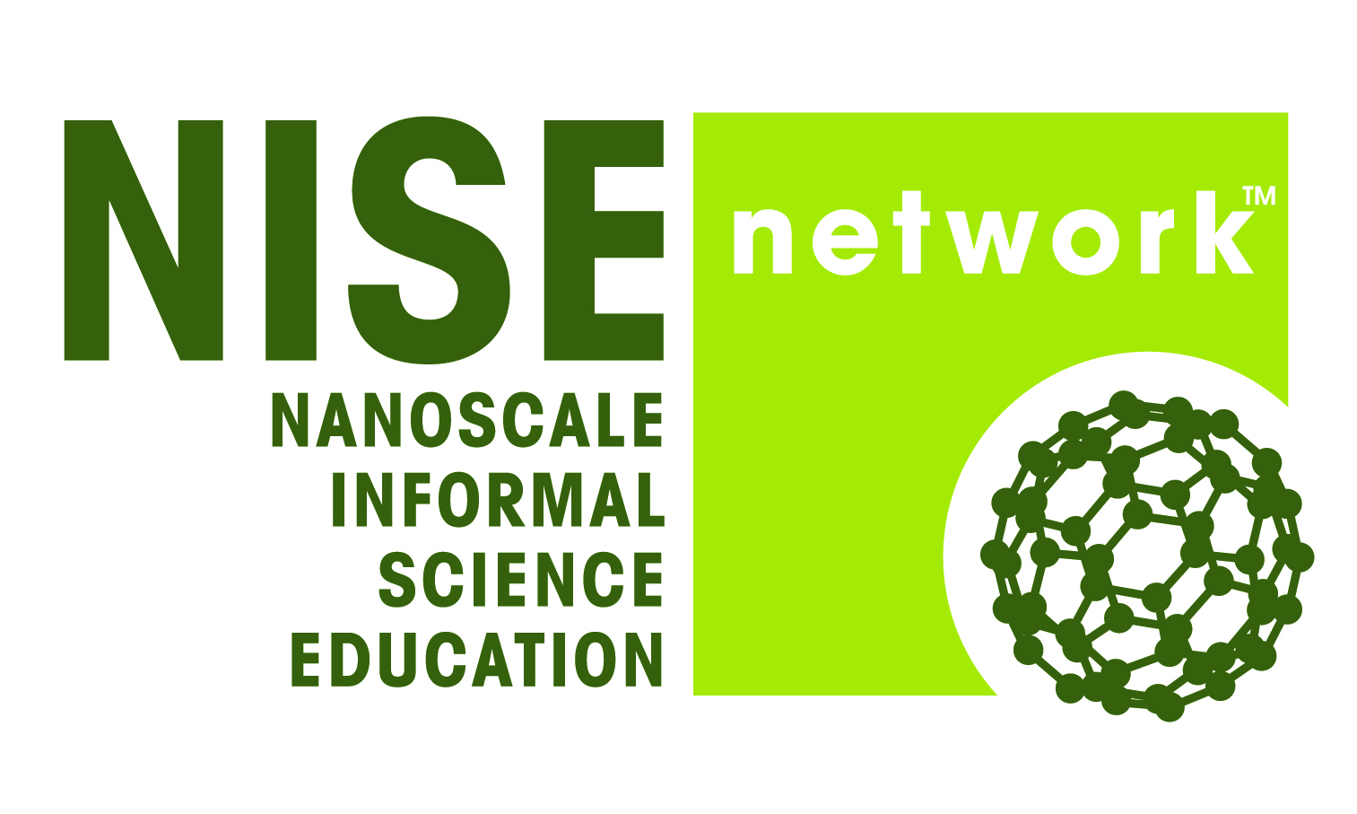
New Opportunities
Leveraging the NISE Network
_________________________________________________________________________________________
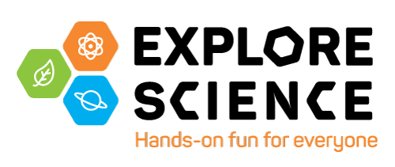
Museum & Community Partnerships
100 kits with hands-on activities designed to facilitate collaborations that engage underserved audiences in nanoscale science, engineering and technology
- Timeline: applications due November 13, 2015; kits distributed in 2016
- Eligibility: existing active NISE Network museum and university partners in the United States; free digital materials will be available to everyone
- More Information: www.nisenet.org/museum-community-partnerships
- Funding: National Science Foundation through the NISE Network
_________________________________________________________________
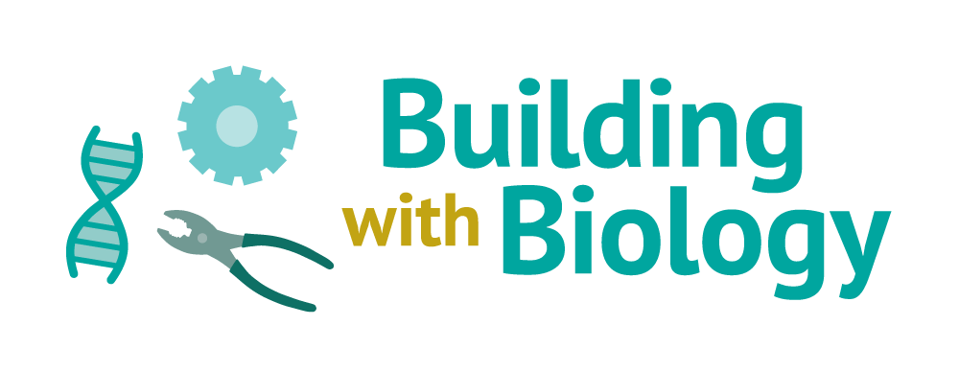
Building with Biology
200 kits with hands-on activities designed to promote conversations in museums among scientists and public audiences about synthetic biology
- Timeline: applications due February 1, 2016; kits distributed in 2016
- Eligibility: museums and universities in the United States; free digital materials will be available to everyone
- More Information: www.nisenet.org/building-with-biology
- Website: www.buildingwithbiology.org
- Funding: National Science Foundation through Museum of Science
_________________________________________________________________

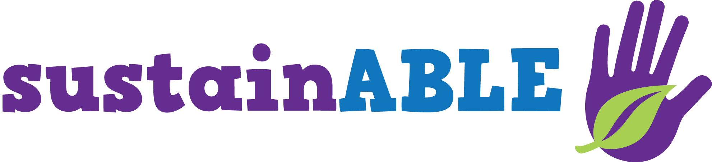
Sustainability in Science Museums
50 kits with hands-on activities about sustainability
- Timeline: applications anticipated in Fall 2016; kits distributed in 2017
- Eligibility: science museums and natural history museums; free digital materials will be available to everyone
- More Information: www.nisenet.org/sustainability
- Website: https://sustainabilitysolutions.asu.edu/sciencemuseums/
- Funding: Walton Sustainability Solutions Initiatives at Arizona State University
_________________________________________________________________

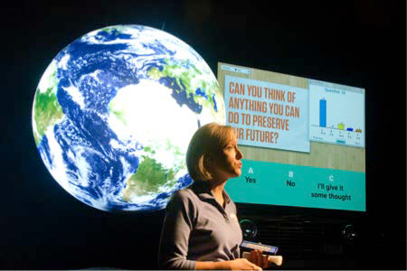
NASA Space & Earth Informal STEM Education
Network (NASA SEISE Net)
Building on the work of the NISE Network, NASA has recently announced funding for the NASA Space and Earth Informal STEM Education
- Eligibility: museums and public planetariums in the United States; free digital materials will be available to everyone
- Information: coming soon on www.nisenet.org
- Funding: NASA through Science Museum of Minnesota
_________________________________________________________________

_________________________________________________________________
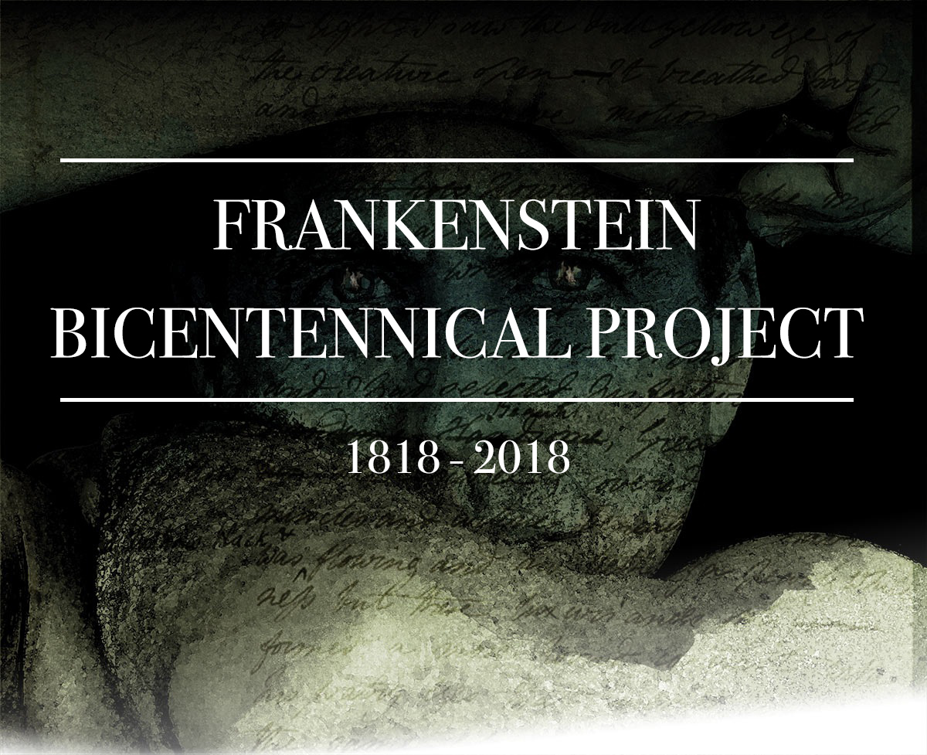
Transmedia Museum
50 Frankenstein’s Footlocker kits with hands-on activities exploring science-in-society questions raised by Mary Shelley’s novel Frankenstein; digital museum where visitors can curate their own online exhibitions
- Timeline: kit applications anticipated in Fall 2017; kits distributed in 2018
- Eligibility: museums, libraries, and universities in the United States; free digital materials will be available to everyone
- Information: coming soon on www.nisenet.org
- Website: http://frankenstein.asu.edu
- Funding: National Science Foundation through Arizona State University
_________________________________________________________________
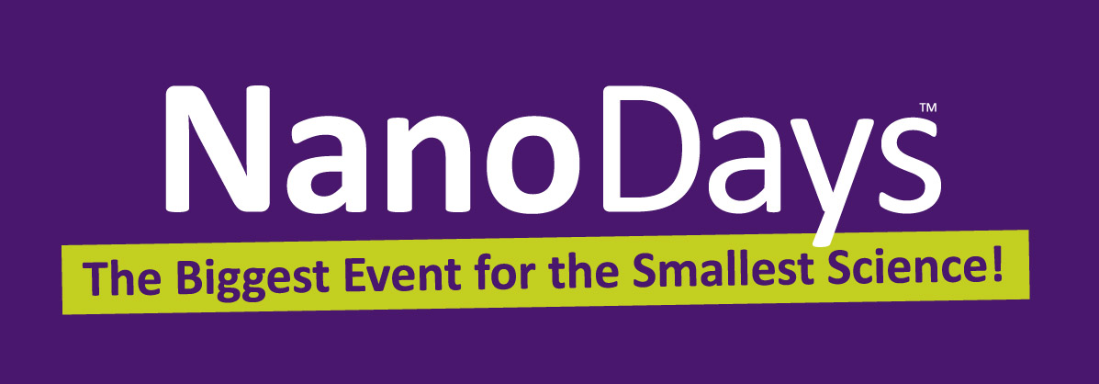
NanoDays
The NISE Network will no longer be producing new NanoDays kits. We encourage partners to continue holding events and using NanoDays materials!
- Eligibility: free digital materials are available to everyone
- Information: www.nisenet.org/nanodays
- Upcoming dates:
2016: March 26-April 3
2017: March 25-April 2
2018: March 31-April 8
2019: March 30-April 7
2020: March 28-April 5
- Funding: National Science Foundation through Museum of Science
_______________________________________________________________
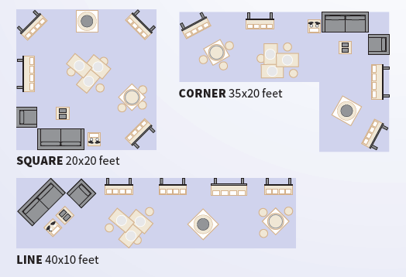
Small Footprint Exhibitions
The NISE Network leadership is exploring opportunities to develop, fabricate, and distribute modular small footprint exhibitions on different topics modeled on the Nano exhibition. We are interested in talking with partners about their interest in this model and different topics they may be interested in.
- Information: www.smm.org/smallfootprint
_______________________________________________________________

Revised October 14, 2015

