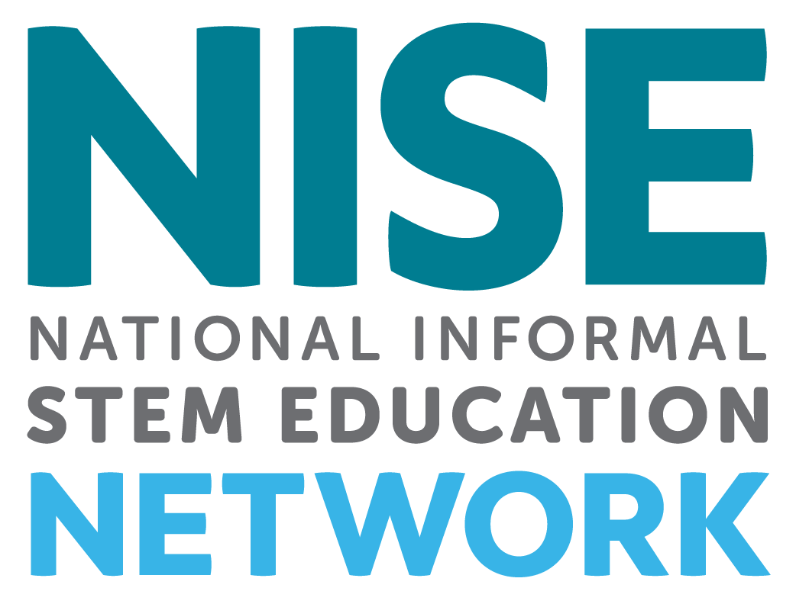
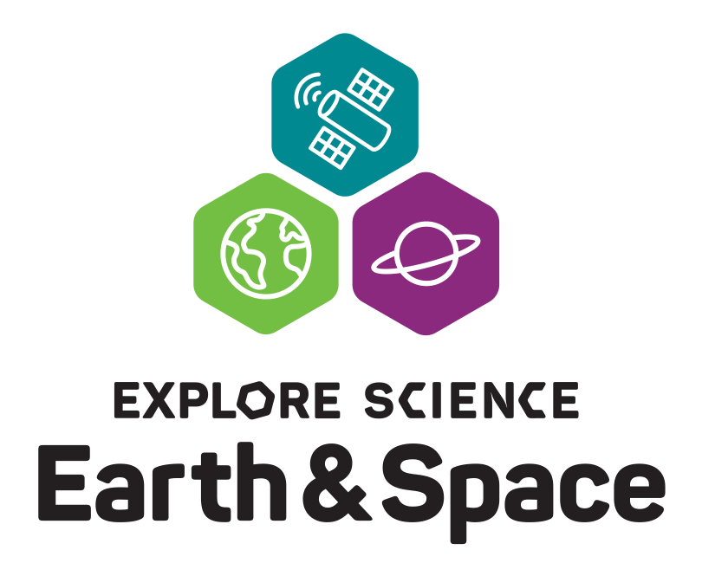

NISE Network Earth & Space

Project-based Professional Learning Community

2021 Application PREVIEW

Application must be completed online using Alchemer (formerly SurveyGizmo)
https://survey.alchemer.com/s3/6327743/EarthSpaceProjects2021Application

Revised: 6/1/21

Introduction

The National Informal STEM Education Network (NISE Network) is pleased to offer a funded opportunity to participate in a project-based professional learning community focused on making Earth & Space science relevant and inclusive for your community. In collaboration with NASA, the NISE Network is making this new professional development opportunity available to 100 eligible NISE Network partner organizations within the United States to support their efforts in making Earth & Space science relevant and inclusive and to promote a more equitable STEM future for their communities.

Each successful organization will receive $2,000 in funding to participate in the program’s professional development activities and develop a project that aligns with your organization’s mission and to increase relevancy and inclusion for Earth & Space science.

Please fill out this application by August 1, 2021 to be considered for this funded opportunity.

Overview: The application overview includes application instructions, eligibility requirements, and project expectations. Please read the overview and preview the application before applying:

https://www.nisenet.org/earthspaceprojects2021

Preview the application: Please note that it is NOT possible to save your work in the Alchemer online application and return for additional edits. Applications left idle for too long will go blank when you progress to the next screen. Please plan to complete the online application in one session. You may want to write your responses in this Word doc, save, and then cut and paste that information into the online application form.

1) Enter the name of the primary contact person who will oversee the project and attend all online and in-person meetings.

First Name:
Last Name:
Job Title:
Organization:
Organization Address 1:
Organization Address 2:
Organization City/Town:

Organization State:
Organization Country:
Organization Zip Code:
Email Address:
Organization Website:
Phone Number:

Organization Information

2) Confirm your organization

Please confirm your organization in the pull-down selection in Alchemer. Organizations are sorted alphabetically by state (A through L and M through Z), then city, and organization. If your organization is not listed, please choose "OTHER" at the bottom of the list.

3) Which best describes your organization?
- museum / science center / informal science education organization
- college / university
- other (please describe):

4) Which best describes your organization? Please check boxes to indicate all types that apply:
- science or technology museum / science center
- children's museum
- art or history museum
- natural history museum or nature center
- emerging or developing museum
- planetarium
- observatory
- NASA Visitor Center
- other (please specify):
- N/A

Describe your plans

5) Your Project Plans
In your application, please describe your proposed project, including:
- Your Earth & Space focus
- Your intended audience
- How you plan to make your project relevant and inclusive to your local audiences
- How your organization will build on existing Diversity, Equity, Inclusion, and Access work
- Collaborators such as community-based and/or youth-serving organizations and subject matter experts.
(Please see application overview for eligible projects and timelines.)
(Limit: 500 words)

6) Broadening Participation
What previous experience do you and your organization have with Diversity, Equity, Accessibility and Inclusion work? How will your participation in this program build on your or your organization's prior work?
(Please note that all levels of experience are equally welcome in the program.)

(Limit: 300 words)

7) Audiences

Please categorize the underserved audiences you hope to reach through your project (please check all that apply):
- racial and ethnic minorities / communities of color
- American Indian / Alaska Native
- girls
- low-income / lower socio-economic status
- Spanish-speaking audiences
- other non-native English speakers
- disabled / differently abled
- rural
- inner city
- at-risk youth
- other underserved audiences:
- N/A

8) Proposed project formats, venues, and collaborators

Please categorize your proposed project (please check all that apply):
- creating or modifying programming at our facility
- creating or modifying exhibits at our facility
- family science nights
- afterschool programming
- special one-time events
- community events
- camps (e.g. summer camp, holiday camp, day camp)
- library outreach
- K-12 school outreach
- home school programs
- virtual / online engagement
- adult-only events
- celestial events (such as star gazing, meteor showers, moon viewing, etc.)
- professional development for staff and/or volunteers
- citizen science project
- collaborations with subject matter experts
- collaborations with local youth service organizations
- (4-H, Boys & Girls Clubs of America, Boy Scouts of America, Girl Scouts, Girls Inc., PTA, the Y, YWCA, etc.)
- collaborations with local community groups (e.g.: places of worship, senior center)
- other:

Program requirement agreement
If you are selected to participate in the Earth & Space project-based professional learning community, you are expected to take part in the following activities:
- Attend a Plenary Kickoff Meeting (online) A two-hour Plenary Kickoff Meeting will be held on October 26, 2021 from 2:00 PM to 4:00 PM Eastern;
- Use the $2,000 in funding, payable to your institution for eligible expenses, to develop a project designed to increase relevancy and inclusion for Earth and/or space science;
- Attend a series of five, 90-minute planning sessions between November 2021 - March 2022 (one planning session per month). Four identical sessions will be offered each month on different days of the week to accommodate schedules. Successful applicants will choose which day works best and attend this session each month (please note that these online sessions require participants to have access to and use of Zoom and Google Classroom online collaboration tools);
- Attend an in-Person culminating meeting (if health and safety allows) in Tempe, Arizona April 19-22, 2022. Hotel, flight and all group meal expenses will be covered; and
- Submit an online report describing your project and your experience in the Earth & Space project-based professional learning community. The NISE Network will provide a template for this report.

9) Do you agree to these terms?
- Yes
- No

