**Macintosh HD:Users:raeostman:Desktop:Frankenstein200 Design Pack:Frankenstein200 Logo:EPS - Print:frankenstein200-K.epsFACILITATOR GUIDE TO**

**MONSTER MASK**

# DESCRIPTION

In this activity, learners make a mask with a special feature: an LED bulb that lights up. The activity is designed to prompt conversation and reflection about responsible innovation, inspired by themes raised in Mary Shelley’s novel *Frankenstein.*

# AUDIENCES

This activity is best suited for ages 5 and up. Younger children can participate successfully with support from an educator or caregiver, making the mask without the LED bulb and battery.

Important: It is dangerous to swallow button batteries like those used in this activity. To minimize this risk, young children should make the mask without adding the bulb and battery. (See the **Safety** note below for more information.)

# LEARNING OBJECTIVES

# The primary objective of this activity is to encourage creativity and reflection about responsible innovation. In addition, learners will explore the following concepts:

# People are creative! We’re always learning more about the world and inventing new things.

* It’s important to think ahead as we study science and make new technologies.
* Researchers in the fields of *genetic engineering* and *synthetic biology* can create modified and entirely new organisms.

# MATERIALS

* Mask templates printed on cardstock (1 per person)
* CR2032 batteries (1–2 per person)
* LED bulbs, 3mm or 5mm (1–2 per person)
* Jumbo craft sticks (1 per person)
* Markers
* Colored pencils
* Scissors
* Tape
* Hole punch that makes a hole slightly smaller than the diameter of the LED bulbs
* Hand mirror
* Activity booklet
* Sign holder and table sign

Sources and instructions for creating your own kit materials are provided at the end of this facilitator guide.

# PRESENTATION

**Preparation:**

Before beginning this activity, make sample masks for practice. This will ensure you know how to make one so you can easily help participants, and will help you work out how to best organize your materials.

To familiarize yourself with the activity, use the activity booklet. It provides step-by-step instructions for the activity. It also includes contextual information about Mary Shelley’s novel *Frankenstein* and the questions the story raises for current science and engineering.

Make examples to show participants. If you make several examples that use the templates in creative ways, it will help participants recognize that there are many ways to customize the simple mask outlines. (If you are working with young children, make examples without batteries and bulbs.)

**Activity flow:**

Open by asking participants if they’ve ever heard of Frankenstein’s “monster.” Share that the original story was written 200 years ago by Mary Shelley, and has been retold many times. Ask if they know what happens in the story, and establish the basic plotline. In the novel, a student named Victor Frankenstein builds a creature from dead body parts, and uses electricity to bring it to life. Unfortunately, Frankenstein didn’t think ahead to what his creature would do, or how he would take care of it, if he succeeded in bringing it to life.

Frankenstein’s monster was surprised when people were scared of him because of the way he looked. At first he was sad, and then he became angry that people judged him based on his appearance.

Show participants the example masks and ask them if they’d like to make their own masks to disguise themselves. Emphasize that they will use their creativity, and they can choose to make whatever kind of masks they want—it doesn’t have to be something scary like a monster.

You (or a caregiver) can assist participants as needed. Share the activity guide with participants so they can follow use the instructions and read the information.

As participants work, you can ask guiding questions to help them plan and complete their project:

* *What can you add to give the mask character?*
* *How will we know if your mask is friendly or scary?*

After the participants have made their masks, they can try them on and look in the mirror to see how the masks change their appearance. You can ask some or all of these questions as they try on their masks:

* *Did you design your mask to give it a certain personality or character?*
* *What makes a face seem funny, scary, or just plain weird?*

Finally, return to Mary Shelley’s story. You can ask:

* *Do you think it is fair that everyone thinks the creature is a monster because of the way he looks?*
* *Why do we think beautiful things are good and ugly things are evil?*

There is no right or wrong answer to the reflection questions! Everyone can form their own opinions. You can help encourage visitors to develop and share their own ideas by referring to the Conversation Tips guide.

**Audiences:**

Young children and individuals with special needs may need assistance with some steps in this activity.

**Safety:**

* Supervise young children to ensure they do not mouth any materials, as some materials may present choking hazards.
* It is dangerous for anyone to ingest batteries. Children must be supervised carefully with the button batteries used in this activity. Young children should make the mask without the batteries and LED bulbs, to minimize the safety hazard.
* Instruct both children and parents never to put the batteries (or any other supplies) in their mouths. Suggest parents remove the batteries and store them separately when they’re not supervising children in the use of the mask.

**PROGRAMMING OPTIONS**

This activity can be incorporated into a variety of educational programs, such as after-school programs, family workshops, and summer camps. In longer program formats, you can use videos and books to familiarize participants with the Frankenstein story:

* The 1931 Hollywood movie *Frankenstein,* directed by James Whale, introduced the world to Boris Karloff’s iconic version of the creature.
* *Frankenweenie* is a 2012 retelling of the Frankenstein story, directed by Tim Burton.
* There are also many books that share the story, which are appropriate for a variety of audiences.

You can also use videos to introduce new fields of research, such as synthetic biology and genetic engineering, that are modifying existing living things and creating new forms of life:

* [Synthetic Biology Explained](https://youtu.be/mlOFE9-3CN0) introduces a new field of research that combines the principles of engineering with the building blocks of biology. YouTube: https://youtu.be/mlOFE9-3CN0

# MATERIALS INFORMATION

**Sources:**

* Print materials, including mask templates, can be downloaded from [nisenet.org](http://nisenet.org/).
* LED bulbs are available at electronic stores, and can be ordered in bulk online. 3mm or 5 mm will work well for this activity.
* Batteries are available at discount stores. Look for button batteries marked CR2032.
* Hole punches are available in a variety of sizes at craft stores. Choose one that makes a hole that is slightly smaller across than the head of your LED bulbs. You want to be able to slip the legs of the LED through the hole but not the bulb part. (If in doubt, bring an LED with you to the store so you can be sure you get the right size!)
* Craft sticks, markers, colored pencils, scissors, and tape are available at craft, educational supply, and discount stores.

**Preparation:**

Optional: Before the activity, you can use a permanent marker to color the long leg of the LEDs. This makes it easy for participants to distinguish the short and long legs.

**CREDITS AND RIGHTS**



Copyright 2017, Arizona State University. Published under a Creative Commons Attribution-Noncommercial-ShareAlike license: <http://creativecommons.org/licenses/by-nc-sa/3.0/us/>

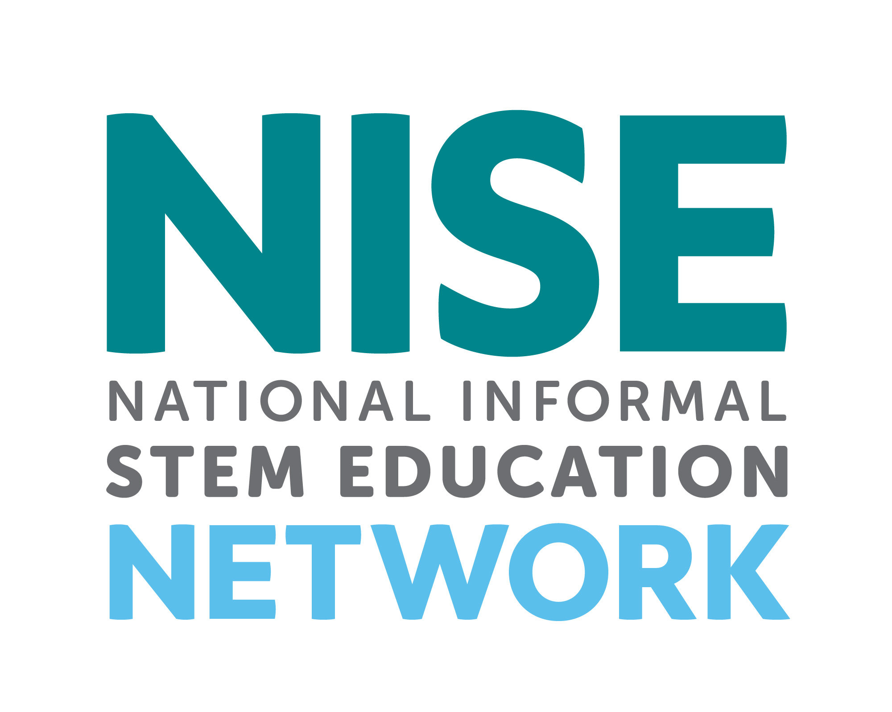

Distributed in collaboration with the National Informal STEM Education Network: nisenet.org

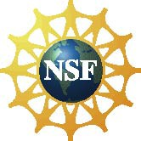

This project was supported by the National Science Foundation under Grant Number 1516684. Any opinions, findings, conclusions, or recommendations expressed in this program are those of the authors and do not necessarily reflect the views of the Foundation.

This is a common activity with many variations. The Frankenstein200 version was adapted fromBlinky Bling developed by The Bakken Museum.

Instruction and promotion photos by the Science Museum of Minnesota for Frankenstein200.

Illustration from an early edition of *Frankenstein* from Wikimedia Commons. Retrieved from: https://commons.wikimedia.org/wiki/File:Frankenstein,_pg_7.jpg

Photograph of Boris Karloff as Frankenstein’s monster from Wikimedia Commons. Retrieved from: https://commons.wikimedia.org/wiki/File:Frankenstein%27s_monster_(Boris_Karloff).jpg

Photograph of GloFish from Wikimedia Commons. Retrieved from: https://commons.wikimedia.org/wiki/File:GloFish.jpg

Photograph of mosquito from Wikimedia Commons. Retrieved from: https://commons.wikimedia.org/wiki/File:Aedes_aegypti_during_blood_meal.jpg