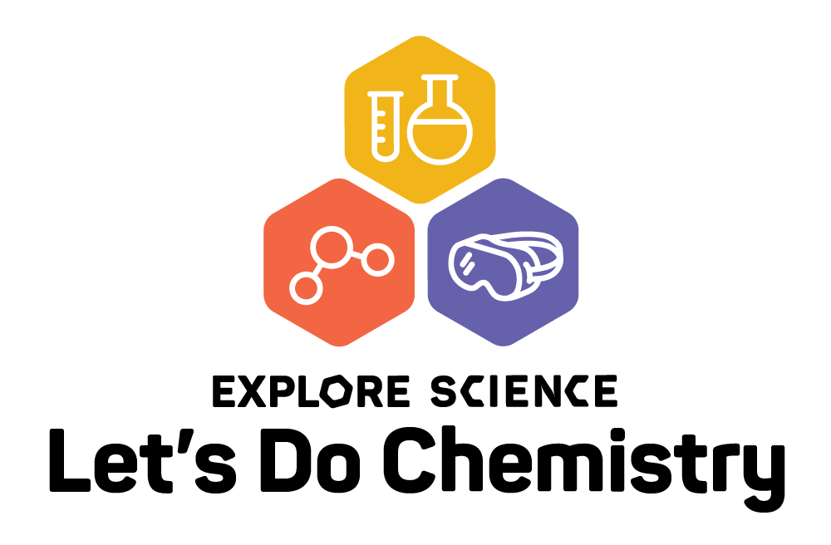
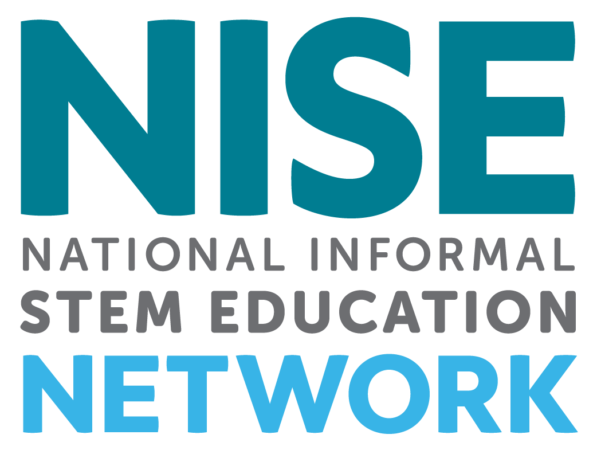

Kit Application Overview
________________________________________________________________________________

Revised 2-21-17

The National Informal STEM Education Network (NISE Net) is pleased to offer free Explore Science: Let’s Do Chemistry kits to eligible institutions in the United States. In collaboration with the American Chemical Society, the NISE Network has assembled a set of engaging, hands-on experiences designed to stimulate interest, sense of relevance, and feelings of self-efficacy about chemistry among public audiences.

________________________________________________________________________________

KIT CONTENTS & AUDIENCES
Two hundred and fifty (250) free Explore Science: Let’s Do Chemistry physical kits will be awarded to successful applicants from eligible organizations.
- Activities are designed for use in children’s museums, science centers, science museums, and chemistry public outreach programs in the United States.
- Activities are designed for family audiences with a range of experiences appropriate for visitors ages 6 through adult.
In addition to the physical kits, all digital materials will be available online for free download.

Explore Science: Let’s Do Chemistry kits will include:
- Eight to ten hands-on activities to engage the public in chemistry
- Professional development materials including activity training videos
- Event planning guide, safety guide, marketing and promotional materials

Equipment and safety requirements
- Kit activities are designed to utilize consumable materials that are easily and inexpensively available
- Reusable safety glasses for both facilitators and visitors will be included in the kit
- The kit will include a general safety guide for event planners and educators, as well as specific safety information for each activity
- Kits are designed for indoor use as well as outdoor events
- Kit activities will not require:
  - electricity, open flames
  - special ventilation hoods
  - purchase of additional lab equipment
  - special storage for flammable or combustible materials
  - special disposal for hazardous materials
________________________________________________________________________________

________________________________________________________________________________

TIMELINE
- March 1, 2018: Online application opens to apply for a free physical kit
- June 1, 2018: Deadline to submit application
- July 2018: Notification of award decisions
- September 2018: Kits delivered to successful applicants
- October-December 2018: Successful applicants host required public event(s)
- October 21- 27, 2018 National Chemistry Week (NCW)
- December 15, 2018: Event reports due online (In addition to the required report,
project evaluators may also be sending out an additional survey)
________________________________________________________________________________

ELIGIBILITY
The physical kit is designed for informal science education public events and outreach. To be eligible to receive a physical kit, organizations must be:
- Located in the United States
- Educational institutions offering informal science outreach programs such as:
  - Museums: science museums and science centers, children’s museums, and natural history museums
  - Chemistry outreach programs: American Chemical Society Local Sections, American Chemical Society Student Chapters, College/university chemistry outreach programs
Please note that K-12 schools, afterschool programs, libraries, and parks are not eligible to receive physical kits. Consider downloading a digital kit if your organization does not meet eligibility criteria. The digital kit will include digital files for all activity guides, marketing materials, and training resources. Digital kits will be available for download in September 2018 at:
http://www.nisenet.org/chemistry-kit
________________________________________________________________________________

APPLICATION PROCESS
Applications for the physical kits must be submitted online using SurveyGizmo by June 1, 2018:
http://www.surveygizmo.com/s3/4198198/Explore-Science-Chemistry
Please note that it is NOT possible to save your work in the SurveyGizmo online form and return for additional edits. Applications left idle for too long will go blank when you progress to the next screen. Please plan to complete the online report in one session. You may want to write your responses in a Word doc, save, and then cut and paste that information into this report. You may download the application in PDF and Word document formats here:
http://www.nisenet.org/chemistry-apply
________________________________________________________________________________

SELECTION PROCESS
A total of 250 kits will be awarded through a competitive award process. The NISE Network project team will review the kit applications and award kits only to organizations that meet the eligibility criteria. Applications will undergo a peer review process by project representatives. Successful applications will demonstrate strong alignment with the project purpose, comply with the project terms, and help the project achieve geographic diversity and reach underserved audiences. If multiple applications are received from the same geographic location, applicants will likely be asked to collaborate on an event and to share a kit. Applicants will be informed of award status in July 2018.
________________________________________________________________________________

________________________________________________________________________________

REQUIREMENTS

Organizations receiving kits are required to:

- Host an event between October and December 2018:
Host at least one public engagement event using your kit. Public events can be stand-alone events OR you can incorporate your event into existing STEM events such as National Chemistry Week (NCW) October 21- 27, 2018.
- Report on the use of the kit: Physical kit recipients are required to complete a short online report describing their experiences with the kit. Successful applicants will be provided with a link to the final report. Reports will include optional evaluation questions to capture the impacts of the project activities on the public. Required reports must be submitted online by December 15, 2018.
Strongly encouraged:

- Museum-Scientist Collaborations: We strongly encourage collaboration between museums and local chemists and chemistry students. (Museum hosts please see information provided on page 4 for advice on finding chemists and chemistry students; Chemists please see details on pages 4 and 6 for finding local museum collaborators.)

Additional opportunities (not required but encouraged):

- Attending professional development online workshops: The NISE Network will offer several free one-hour online workshops: http://www.nisenet.org/events
All online workshops will be recorded and archived on nisenet.org.

- Collaborating locally to reach underserved audiences: Partnerships with K-12 schools, afterschool programs, local chapters of national youth-serving organizations, libraries, and local community groups can help your event reach underserved audiences. Tips for collaboration can be found here: http://www.nisenet.org/collaboration-guide

- Evaluation: Evaluation is also a part of this project in a variety of ways in order to capture the impacts of the project activities on activity facilitators as well as members of the public. In addition to the required report, project evaluators may also ask kit recipients to share activity facilitator email addresses so that we can send them a survey about their experiences

- Using your kit all year long: We also encourage you to use your kit all year round for STEM educational events and other programming for public audiences (see page 6)

________________________________________________________________________________

________________________________________________________________________________

COLLABORATIONS

FOR MUSEUMS: FINDING LOCAL EXPERTS

We strongly encourage museums to collaborate with local experts, including local chemistry teachers, college and university chemistry faculty and staff and students, and local American Chemical Society (ACS) Local Sections and Student Chapters. Volunteer experts are key ingredients to many successful public engagement efforts.

It is up to your organization to choose your local collaborators. NISE Network regional hub leaders can assist you in finding local partners in your geographic area. Kits will include training and orientation materials to help prepare your event volunteers and staff for facilitating the activities.

1) American Chemical Society (ACS) Local Sections
ACS has 185 local sections of ACS members located throughout the United States.
To find contact information for your state please visit:
https://lslookup.acs.org/lslookup/local_search

2) American Chemical Society (ACS) Student Chapters
ACS has student chapters located on many college campuses across the country.
To find the closest chapter to you please visit:
https://www.acs.org/content/acs/en/education/students/college/studentaffiliates/find-a-chapter.html
Once you find the name of a student chapter, please contact undergrad@acs.org to reach out to their faculty advisor.

3) Colleges and Universities departments:
Your local colleges or universities will usually have a chemistry department, and some of these have existing outreach programs or clubs.

4) High school chemistry teachers:
Once you connect with a high school teacher they may be able to suggest high school students who could volunteer at your event.
________________________________________________________________________________

FOR CHEMISTS: FINDING LOCAL MUSEUMS

NISE Network regional hub leaders can help find a science or children’s museum in your area.
Please contact your regional hub leader listed on page 6.
Lists of existing NISE Network partners are available here:
http://www.nisenet.org/partners
NISE Network regional hub leaders would be able to put you in touch with a contact person at these organizations.
________________________________________________________________________________

________________________________________________________________________________

FINDING ADDITIONAL VOLUNTEERS

In addition to finding subject matter experts, you will probably need to recruit other volunteers to help with your event. Potential sources of volunteers may include:
  - College students, classes, or clubs with community service requirements
  - High school science clubs, or students suggested by local high school science teachers
  - Local chapters of professional science and engineering groups that are often associated with local colleges, such as:
  - American Indian Science and Engineering Society: http://www.aises.org/
  - National Action Council for Minorities in Engineering: http://www.nacme.org
  - National Society of Black Engineers (NSBE): http://www.nsbe.org/home.aspx
  - National Organization for the Professional Advancement of Black Chemists and Chemical Engineers (NOBCChE): http://www.nobcche.org/
  - National Organization of Gay and Lesbian Scientists and Technical Professionals: http://www.noglstp.org
  - Society for Advancement of Chicanos and Native Americans in Science (SACNAS): http://sacnas.org
  - Society of Asian Scientists and Engineers: http://www.saseconnect.org
  - MAES - Latinos in Science and Engineering: http://mymaes.org
  - Society of Hispanic Professional Engineers: http://shpe.org
  - Society of Women Engineers (SWE): http://societyofwomenengineers.swe.org
  - Local industry staff and retirees
________________________________________________________________________________

MORE RESOURCES

The National Chemistry Week, (NCW) October 21- 27, 2018
The NCW 2018 theme is Chemistry is Out of this World, focusing on chemistry and outer space.
  - ACS National Chemistry Week resources:
https://www.acs.org/ncw
  - ACS Celebrating Chemistry materials
https://www.acs.org/celebratingchemistry
  - NISE Network National Chemistry Week links:
http://www.nisenet.org/national-chemistry-week
  - NISE Network space themed activities:
If you are looking for additional activities on this theme, this is a great opportunity to use astronomy related activities included in the NISE Network’s Explore Science: Earth & Space toolkits: http://www.nisenet.org/earthspacekit and more space themed activities at http://www.nisenet.org/national-chemistry-week

________________________________________________________________________________

________________________________________________________________________________

USING YOUR KIT ALL YEAR LONG

We encourage you to use your kit all year round at STEM educational events and other programming for public audiences:
- Calendar of STEM-related events:
http://www.nisenet.org/seasons
- Chemists Celebrate Earth Week (CCEW):
https://www.acs.org/CCEW
- National Chemistry Week:
https://www.acs.org/ncw
- Summer camps and outreach events
________________________________________________________________________________

MORE INFORMATION
For project questions and inquiries, please contact your regional hub leader listed below.
________________________________________________________________________________

NISE NETWORK REGIONAL HUB LEADERS
Regional hub leaders will be able to help connect you with experts in your area and answer other questions about the project:

- NORTHEAST
CT, DC, DE, MA, MD, ME, NH, NY, NJ, OH, PA, RI, VT, and WV
Ali Jackson, ajackson@sciencenter.org, Sciencenter, Ithaca, NY, 607-272-0600x144

- SOUTHEAST
AL, AR, FL, GA, KY, LA, MS, NC, OK, PR, SC, TN, TX, and VA
Brad Herring, brad.herring@lifeandscience.org, Museum of Life and Science, Durham, NC,
919-220-5429x360

- MIDWEST
IA, IL, IN, KS, MI, MN, MO, ND, NE, SD, and WI
Christina Leavell, cleavell@smm.org, Science Museum of Minnesota, St. Paul, MN,
651-221-9434

- WEST
AK, AZ, CA, CO, HI, ID, MT, NM, NV, OR, UT, WA, and WY
Frank Kusiak, frank_kusiak@berkeley.edu, Lawrence Hall of Science, Berkeley, CA,
510-643-7827
________________________________________________________________________________

ACKNOWLEDGEMENTS
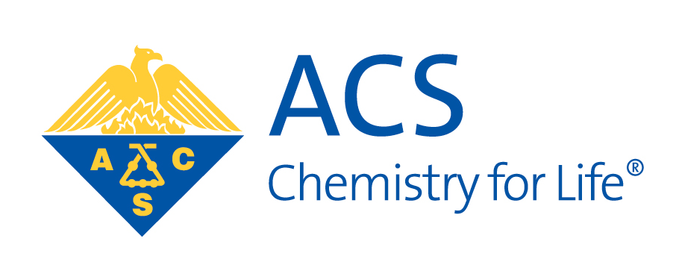
Funded by the National Science Foundation through the Museum of Science. This material is based upon work supported by the National Science Foundation under Grant Number DRL 1612482. Any opinions, findings, and conclusions or recommendations expressed in this material are those of the author(s) and do not necessarily reflect the view of the National Science Foundation.

