Sample Press Release
Your logo here

Date:
Contact:
Phone:
Email:

FRANKENSTEIN COMES TO LIFE AT [name of your organization]
Guests will participate in hands-on science activities that explore
Frankenstein’s legacy in the 21st century.

[Your City] Mary Shelley’s Frankenstein is rapidly approaching [alternatively, depending on send date, currently celebrating] its 200th anniversary, but its themes continue to resonate in our technological age and raise new, complex questions about the nature of life, our role as creators, and our responsibilities to the things we bring into the world. Now, [name of your organization], in partnership with the National Science Foundation and Arizona State University, will present [Name of your event] on [local event date] to engage audiences in using their creativity, exploring current and emerging topics in science and technology, and considering what it means to be a responsible innovator.

[Name of your event], on [Date] at [Time] will include exciting maker activities related to robotics, genetic engineering, and electricity. By teaching a robot how to draw, experimenting with simple machines, or even bringing their own “creature” to life, guests will confront the same questions and ideas that bedeviled the fictional Victor Frankenstein on a dark and stormy night two centuries ago. [Name of your organization] believes that these activities provide today’s science learners with important tools for exploration, discovery, and critical thinking.

“Frankenstein emerged in a moment of great social and technological change,” said [name of organization spokesperson]. “Similarly, through today’s incredible scientific advances, we all have the power to create and transform the world around us. [name of your event] demonstrates the power of Mary Shelley’s original vision, and gives our guests a fresh perspective on emerging technologies such as artificial intelligence, synthetic biology, and human enhancement.”

[Name of your event] is part of the nationwide Frankenstein200 project, led by Arizona State University and distributed in collaboration with the National Informal STEM Education Network (NISE Network). Throughout 2018, events like those hosted by
[name of your organization] will be paired with an interactive digital narrative and a set of at-home maker activities that reimagine Frankenstein for 21st-century audiences.
More information can be found at [your website] and Frankenstein200.org.
________________________________________________________________________
About Frankenstein200

Frankenstein200 is a national research project led by Arizona State University and funded by the National Science Foundation that uses Mary Shelley’s enduring tale of creation and responsibility to foster interest in science, technology, engineering, and mathematics (STEM) in informal settings. Through an original digital narrative, hands-on activities at 51 museums and science centers nationwide, and the expertise of a community of makers, tinkerers, and citizen scientists from around the globe, Frankenstein200 is an integrated transmedia experience designed to inspire deeper understanding, ability, and engagement with science-in-society topics. Learn more at Frankenstein200.org.

About Mary Shelley’s Frankenstein
Through classic movies, a Halloween costumes, comic book adaptations, or breakfast cereals, Mary Shelley’s Frankenstein; or the Modern Prometheus has endured in the popular imagination for two hundred years. The idea for the novel was sparked by a ghost story competition among famous authors in 1816, when Shelley was just 18 years old. Published on January 1, 1818, the thrilling tale of Victor Frankenstein and his stitched-together creature has never been out of print, and is currently the most-assigned novel in university courses. Its themes of innovation and its consequences remain relevant in our technological age, as we grapple with the effects of stunning advances in medicine, computing, and engineering.
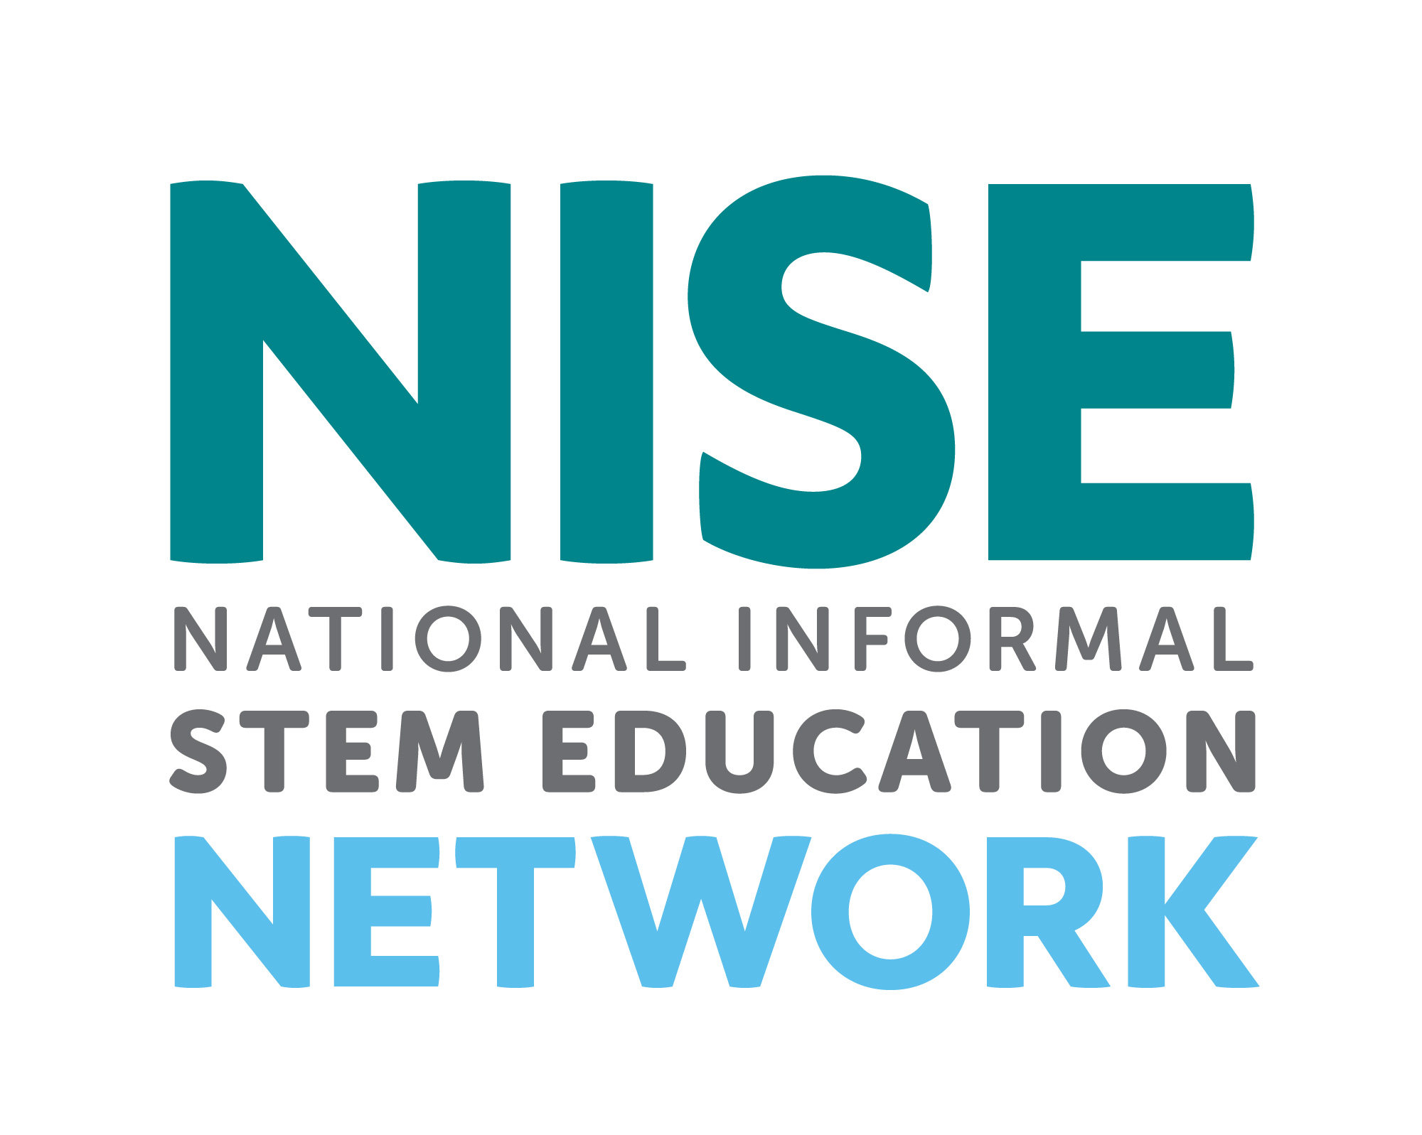
The National Informal STEM Education Network (NISE Net) is a community of informal educators and scientists dedicated to supporting learning about science, technology, engineering, and math (STEM) across the United States. For more information about NISE Net and to download a digital Frankenstein200 kit please visit nisenet.org.
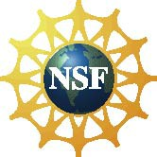
This project was supported by the National Science Foundation under Grant Number 1516684. Any opinions, findings, conclusions, or recommendations expressed in this material are those of the authors and do not necessarily reflect the views of the Foundation. Learn more at nsf.gov.

