Try this!
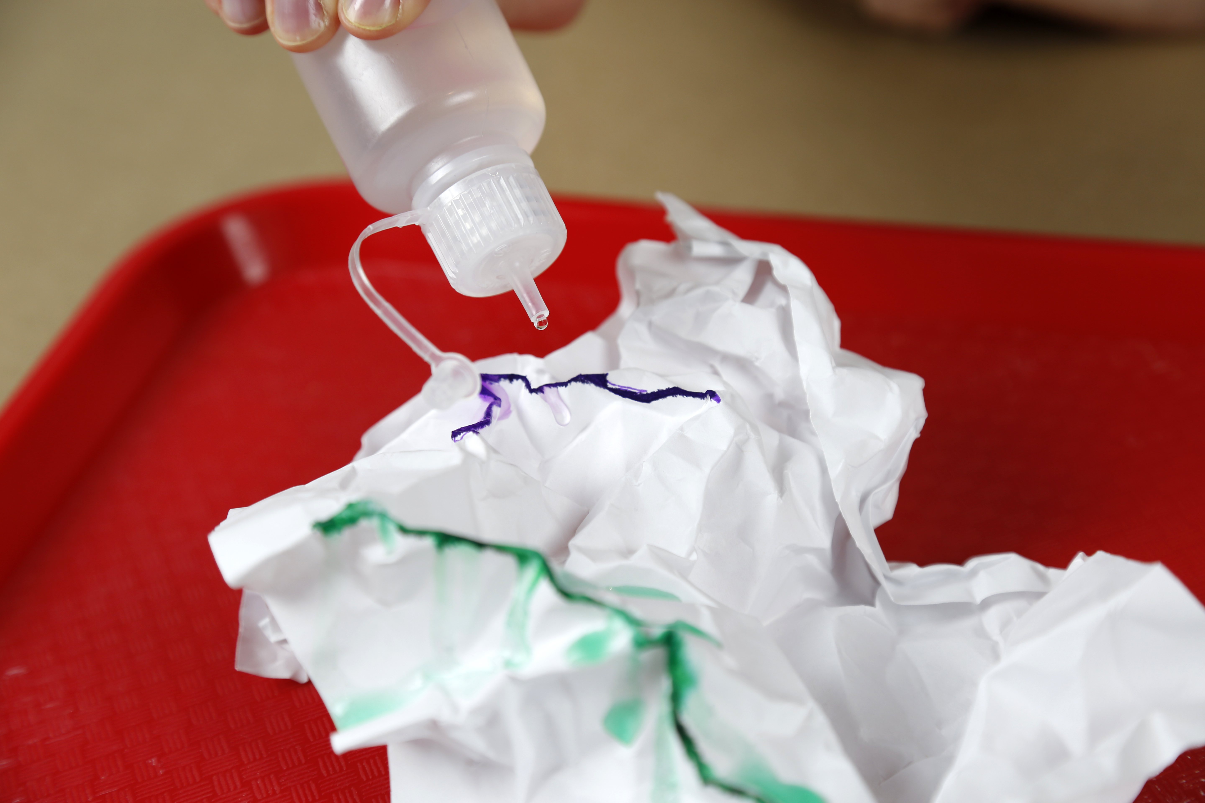  2  3  1 | Crumple up a piece of paper and gently open it most of the way. It should still show ridges (high points) and valleys (low points).  Choose one of the ridges and color the whole ridgeline with a washable marker. Use lots of ink! Place the paper on an absorbent microfiber towel.  Make a prediction. If water fell on the ridge you just colored, where would it go? What would happen to the colored ink? Now, test your prediction. Use the dropper to place water onto the peak, simulating a rainstorm. Was your prediction correct? Were you surprised by anything?  Repeat this experiment with more ridges on your crumpled paper. Do your predictions change as you make and observe more simulated rainstorms?
Try this at home!
Follow the instructions on the takeaway card to build a simple rain gauge at home and learn how you can share data with researchers who collaborate with NASA!

Earth is a constantly changing and dynamic system.

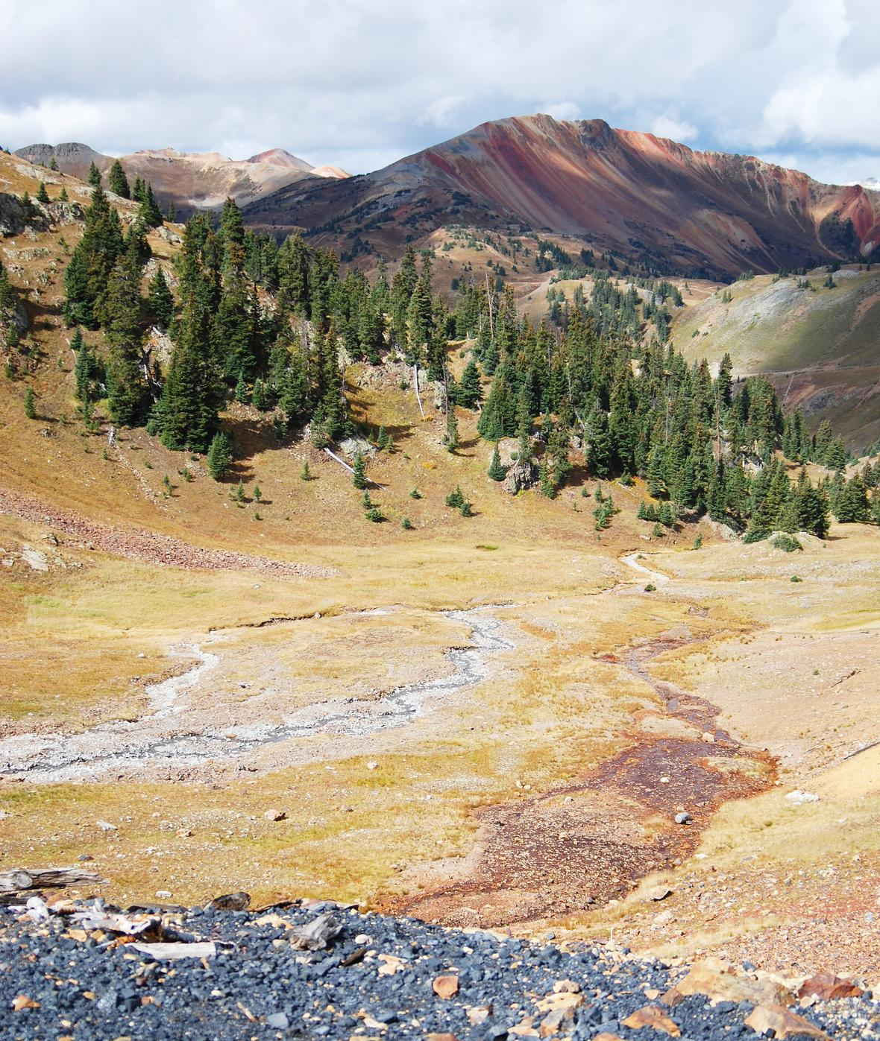
The shape of the land and the pull of gravity both influence how water moves over Earth. The paper mountains in this activity behave like a miniature model watershed. The way the marker ink moves with the water represents how water can carry surface particles through a watershed. A watershed is all of the land that drains runoff into a shared body of water.
Rainwater and snowmelt pick up and carry whatever is on the land—such as trash and debris on streets, exposed soil from landslides or construction, or pollution from mines or farms—to the nearest body of water. What happens upstream always influences the water quality and processes downstream.
The red on the ridge shows acidic runoff from mine pollution in the North Fork Cement Creek drainage.

NASA scientists use observations to make predictions about the future of our planet. Understanding our planet’s interconnected processes can help researchers make predictions about global climate, weather patterns, and natural disasters, and better understand how Earth will change in the future.
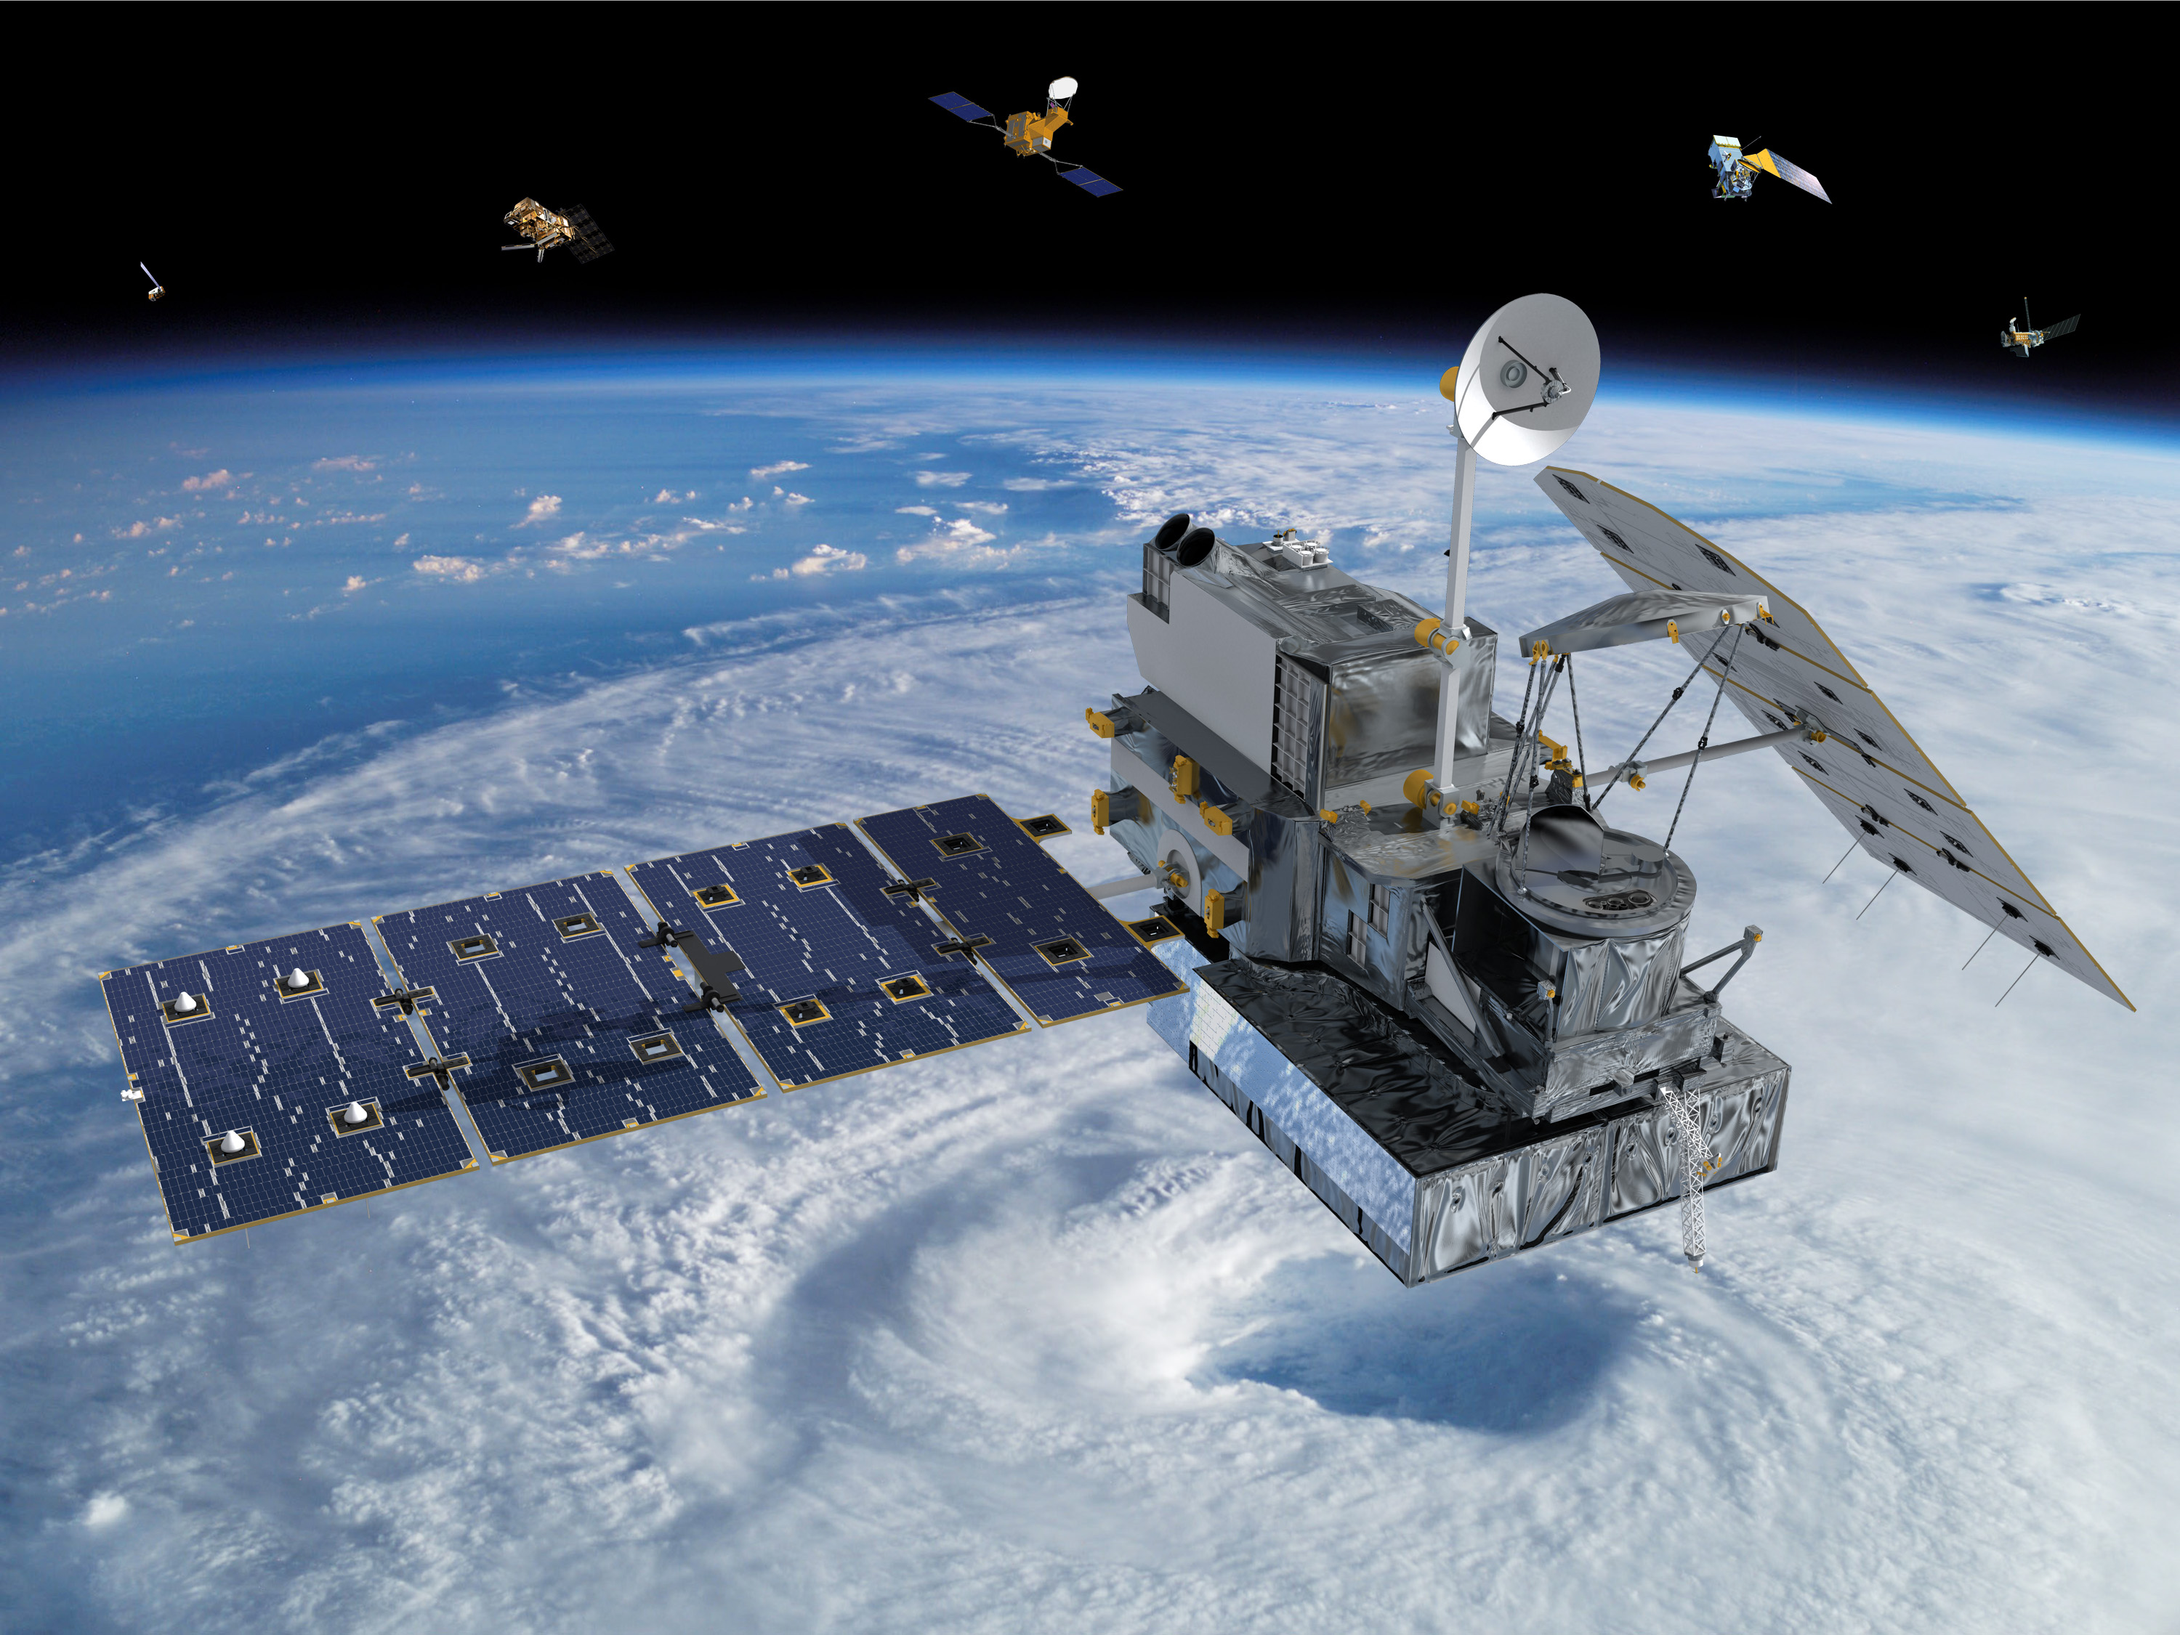
Scientists use ground-based instruments here on Earth, as well as satellites and other aircraft, to study our planet. NASA observes Earth from above to learn more about how Earth systems are changing, and how science can benefit society.
The Global Precipitation Measurement mission is focused on learning more about one of our planet’s most precious resources: water.

