**Try this!**

|  |  |
| --- | --- |
| 2  1  3 | Slowly move the rubber end of the pencil probe tool around the Earth globe. What do you notice?  Carefully watch how the small metal piece of the tool moves. Can you find the invisible magnetic field?  Sprinkle some small steel pieces onto the Earth globe. What happens?  Now, scoop the pieces off the Earth globe and try sprinkling them onto the larger Sun globe. What do you notice?Tip: Remember to pull all the metal pieces off the Sun for the next group! |

*Scientists have observed active magnetic fields throughout the solar system.*

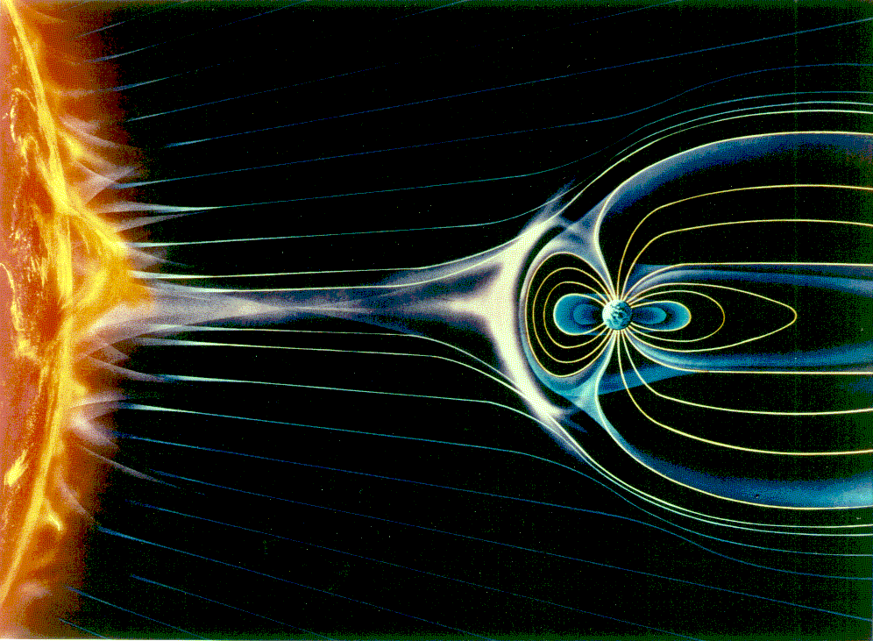**Earth has a strong, protective magnetic field.** In this activity the pencil probe tool and the small metal pieces allow you to observe the magnetic field of the Earth globe. Our planet’s strong magnetic field is the result of hot, liquid metal surrounding its solid iron core. The swirling motion of this conductive liquid creates electrical currents, which develop into the magnetic field.

**Earth’s magnetic field protects the planet from charged particles from the Sun and cosmic rays from outside the solar system.**

Scientists use a variety of tools to detect and study magnetic fields in the solar system. Here on Earth, a compass can detect our planet’s magnetic field. An instrument called a *magnetometer*, which works a lot like the simple pencil tool, can be used to detect solar and planetary magnetic fields.

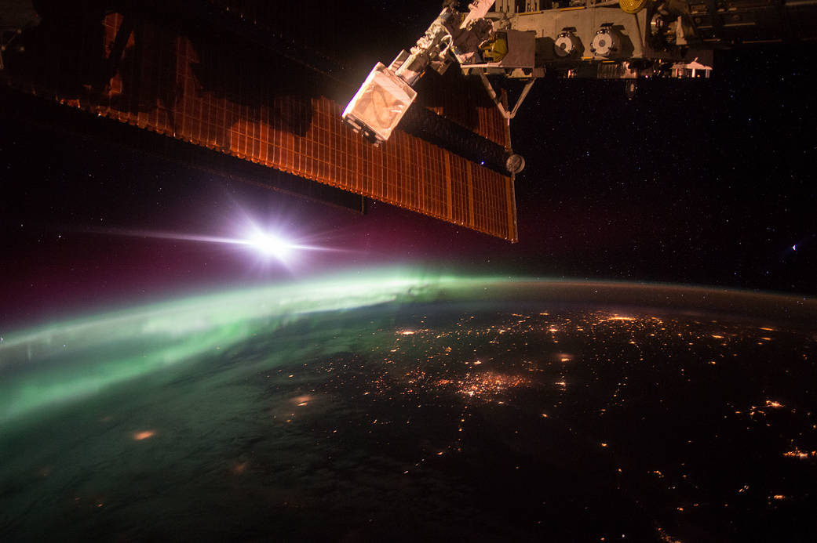**The Sun’s magnetic field extends out into space and sends powerful bursts of magnetic energy into the solar system.** In this activity, the small metal pieces on the surface of the Sun globe reveal some of the ways these magnetic fields interact. Sometimes the magnetic field lines are straight and simple; sometimes the magnetic material inside the Sun stretches and twists, making the fields more complex.

A planet’s magnetic field can protect it from most of the Sun’s magnetic energy, but some particles coming from the Sun enter a planet’s atmosphere to collide with and excite molecules. This interaction generates shimmering light displays called *auroras*. Also called “northern or southern lights” on Earth.

**Image of an aurora on Earth taken from the International Space Station.**