**Try this!**

|  |  |
| --- | --- |
| 3  2  1 | Without looking inside the box, count how many squares are mostly dark and how many are mostly light. Record your observations on the worksheet.  Close your eyes while a second object is placed in the box, and count the squares again. Record your observations. Then, count and record one more time for a third object.  Make a guess! Based on the number of dark and light squares, which of the mystery objects was biggest and which was smallest? What else could you tell about the object? What couldn’t you tell? |

*Scientists are searching the universe for planets orbiting distant stars.*

**When a planet, or other object, moves between its star and Earth, some light from that star gets blocked from view.** We call the path of an object moving between its star and our view from Earth—or from a telescope orbiting in space—a *transit*.

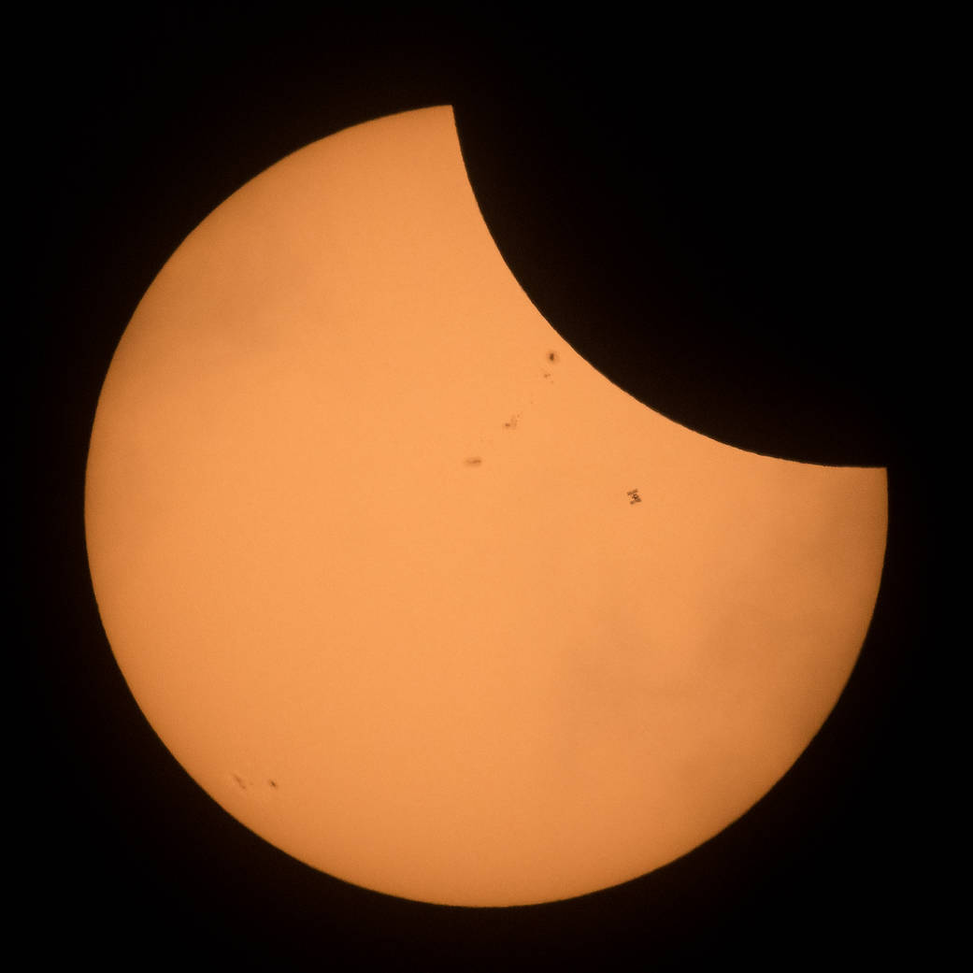

The light blocked by a transit is similar to the way the cubes in the activity block some light when placed between the light source and the grid screen. A higher number of darker squares indicate a bigger cube, while fewer dark squares suggest a smaller cube. When you count how many squares appear darker and then make a guess about the size of the objects, you are modeling the way scientists use telescopes to study objects moving across a star.

**The International Space Station (circled) passed between the Sun and Earth during the 2017 North American Solar Eclipse.**

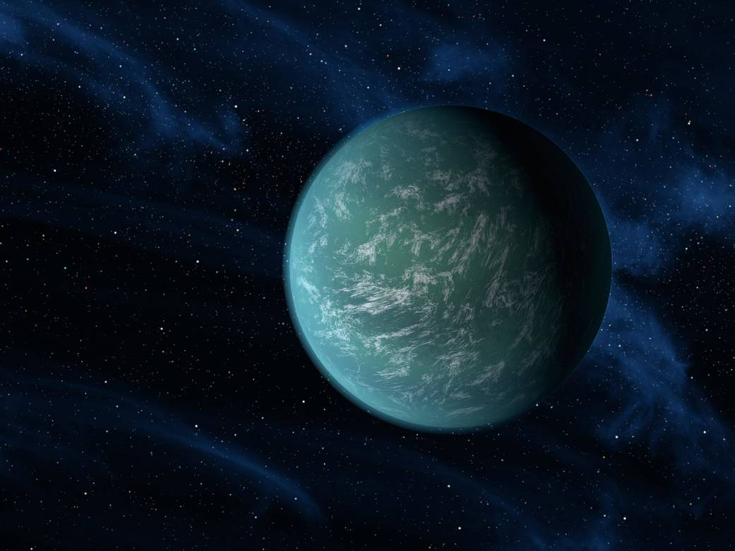**The transit method is one of the ways NASA scientists search for distant planets.** Scientists observe stars and make graphs called *light curves* by plotting the amount of starlight that reaches a telescope over a set period of time. They look for subtle periodic decreases in the brightness of a star. A regular dip in brightness indicates that a planet, called an *exoplanet*, might be crossing—or transiting—between the star and Earth. This type of planet hunting is called the *transit method.*

Scientists can also estimate the size of the exoplanet by analyzing the light curves. Just like with the cubes, bigger planets block more light and smaller planets block less light. The size of the dip corresponds directly to the size of the planet.

**An artist’s impression of an exoplanet, Kepler-22b, discovered using the transit method.**