
Explorando materiales: Polarizadores
¡Intenta esto!  - Utiliza tiras de cinta adhesiva transparente para hacer diseños en una lámina de plástico transparente. ¡Coloca muchos trozos superpuestos de cinta adhesiva!  - Coloca tu diseño entre dos filtros polarizadores y ponlo todo frente a una fuente de luz: una ventana con luz del día o una lámpara de techo.  - Trata de rotar uno de los filtros. ¿Qué le sucede a tu diseño? | 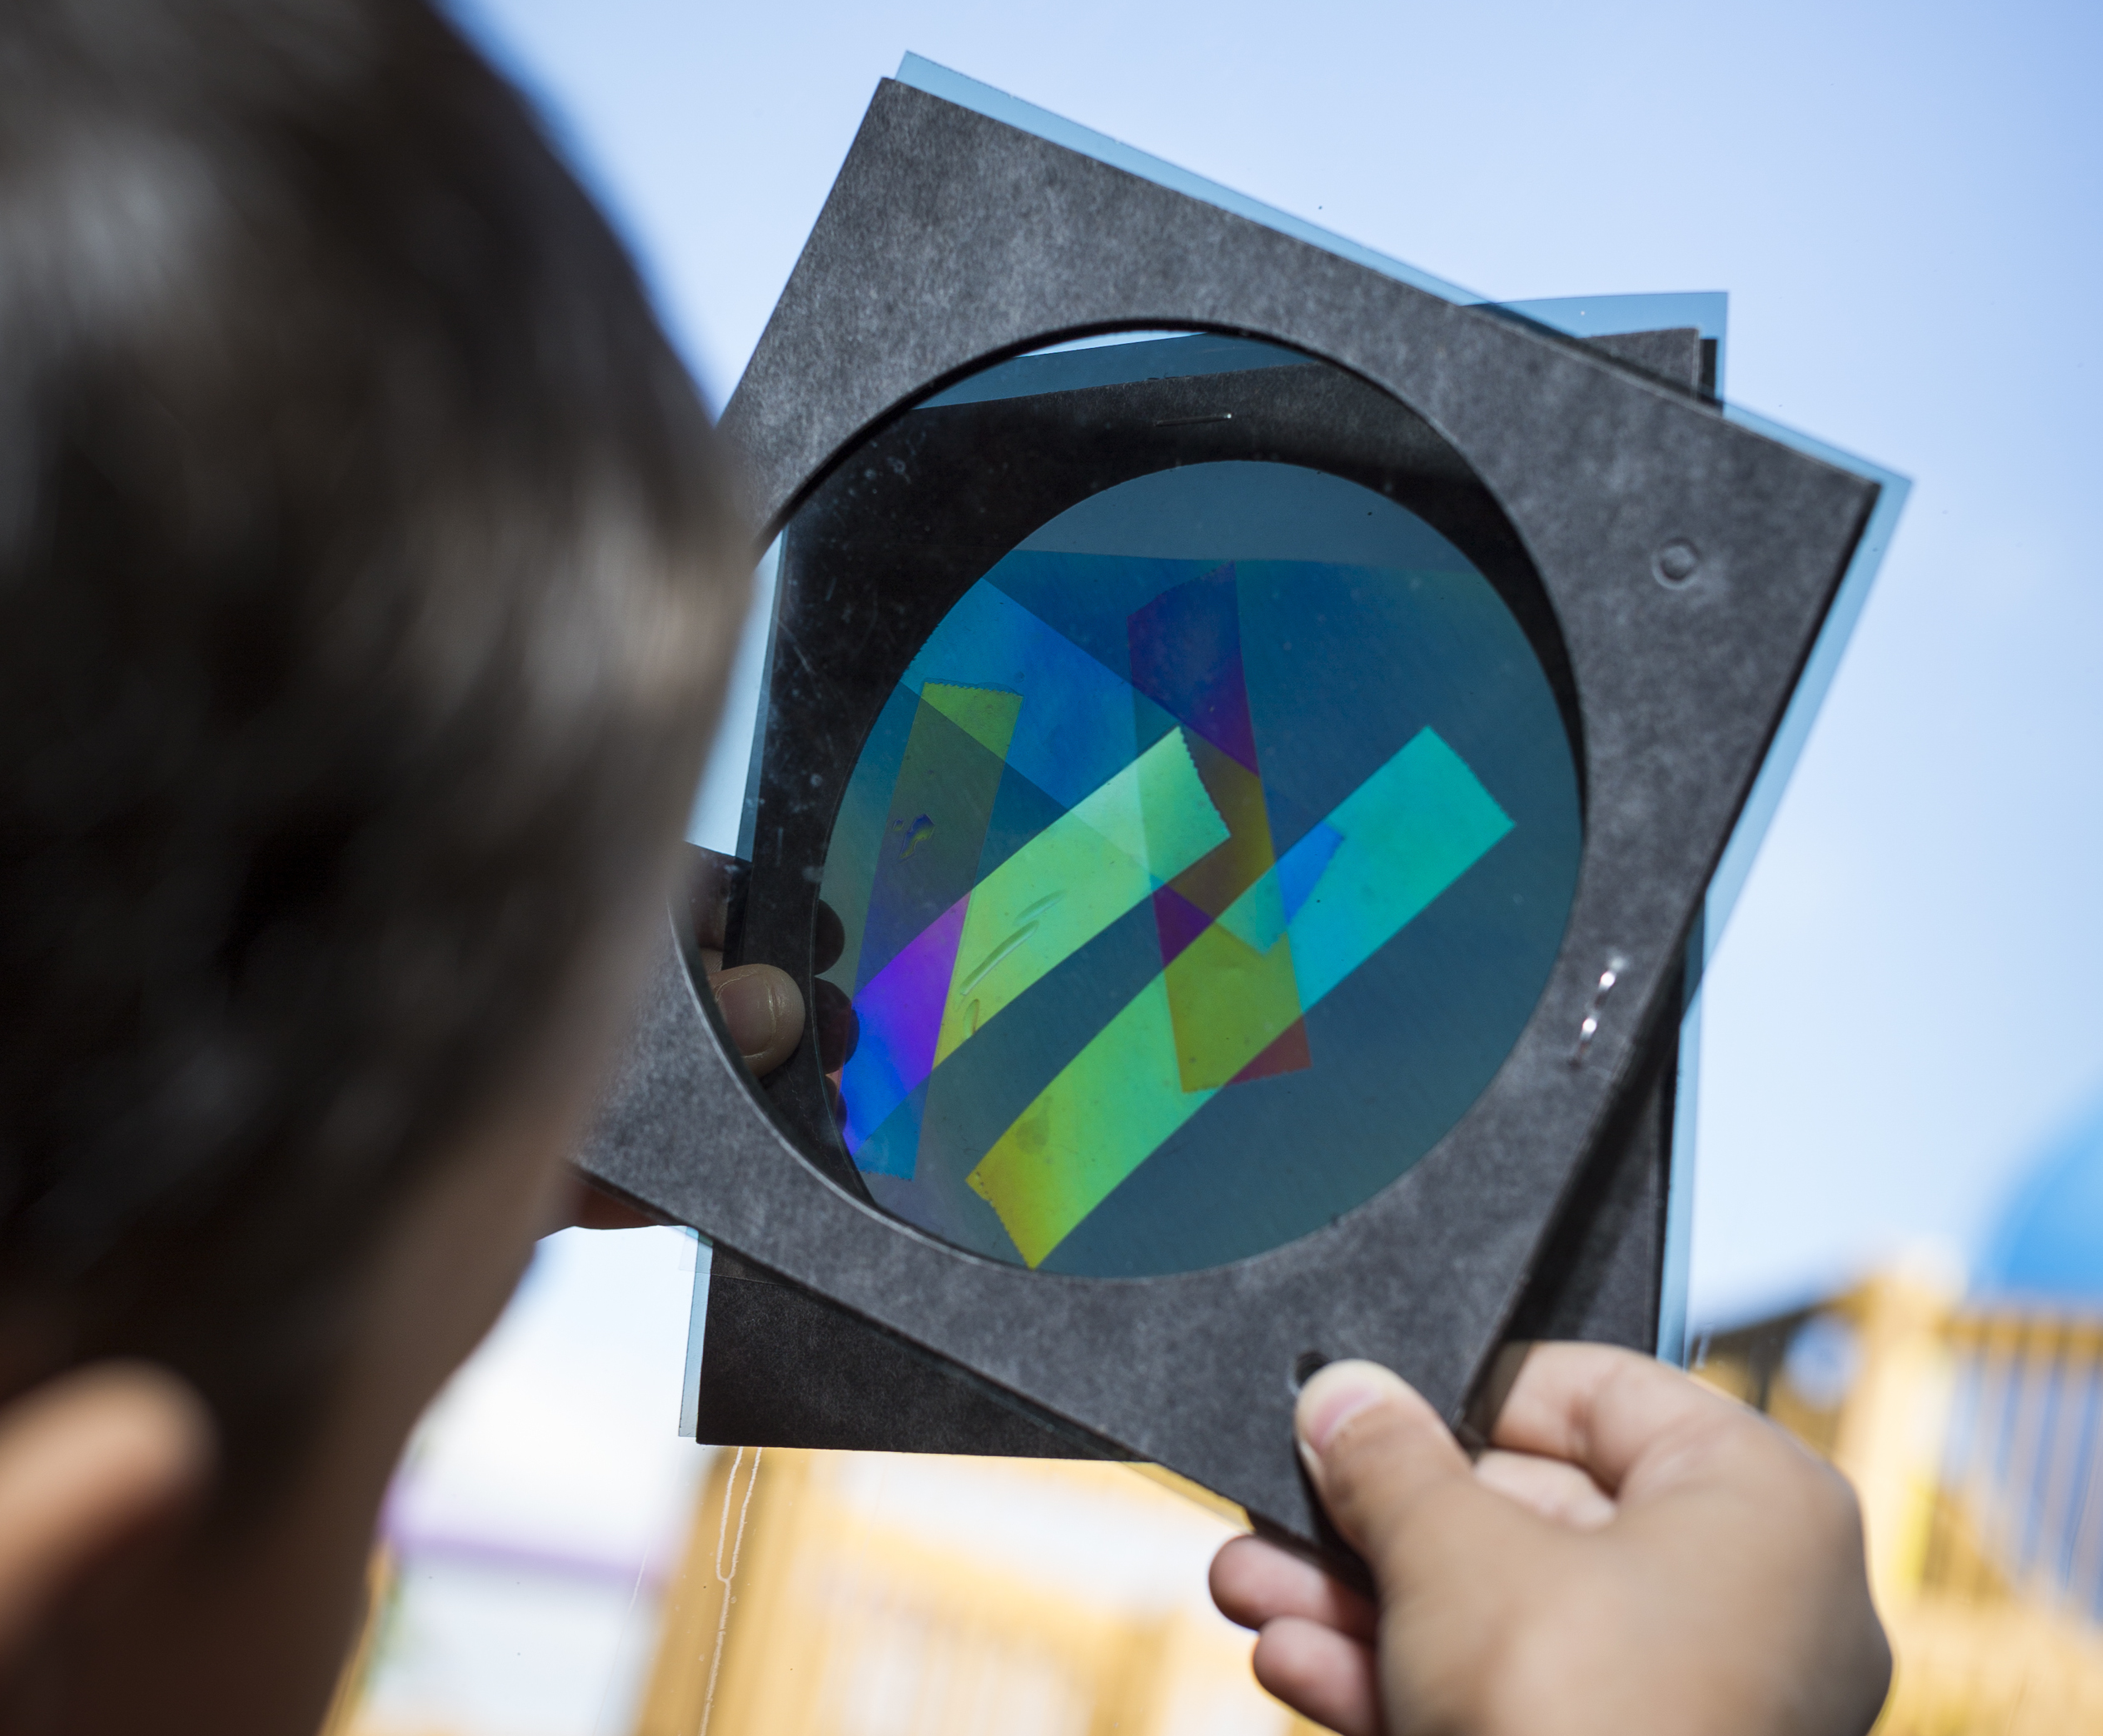

¿Qué sucede?  Los filtros polarizadores bloquean la luz. La luz que bloquean depende de la orientación de los polarizadores. Cuando dos polarizadores giran en la misma dirección, la mayoría de la luz pasa. Cuando se giran 90 grados hacia la dirección del otro polarizador, los filtros bloquean todas las ondas de luz, y se conocen entonces como "polarizadores cruzados."  Ciertos materiales como la mica, Plexiglas®, el jarabe de maíz, y la cinta adhesiva transparente exhiben hermosos colores cuando se colocan entre dos polarizadores cruzados. Estos materiales producen colores debido a que son birrefringentes. En los materiales birrefringentes, la luz pasa a través del material a diferentes velocidades. | 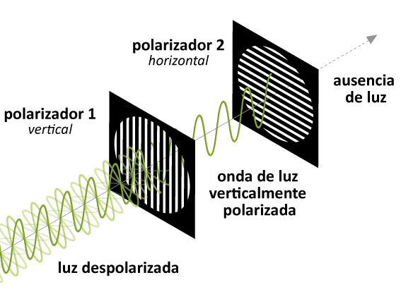  Los polarizadores sólo permiten pasar ciertas orientaciones de ondas de luz
La cinta adhesiva transparente interactúa con la luz polarizada de manera especial debido a la estructura de la cinta. La cinta se compone de moléculas de polímero largas que se extienden a lo largo de la cinta. Como resultado, la luz se mueve a través de la cinta a diferentes velocidades, dependiendo si está posicionada de manera paralela o perpendicular a las moléculas largas de polímeros. Una vez que la luz pasa a través de la cinta, los componentes de la luz que se movían rápidamente se combinan con los que se movían más lentamente, produciendo ondas con nuevas propiedades. El segundo filtro polarizador bloquea la mayoría de estas ondas que filtran la luz blanca y producen los diferentes colores que vemos. El color de la cinta es determinado por la dirección de los movimientos de la luz y el espesor de la cinta. Entonces, al colocar la cinta en diferentes ángulos o al apilar los trozos de cinta una sobre la otra, podemos producir diferentes colores.

¿Por qué es nanotecnología?

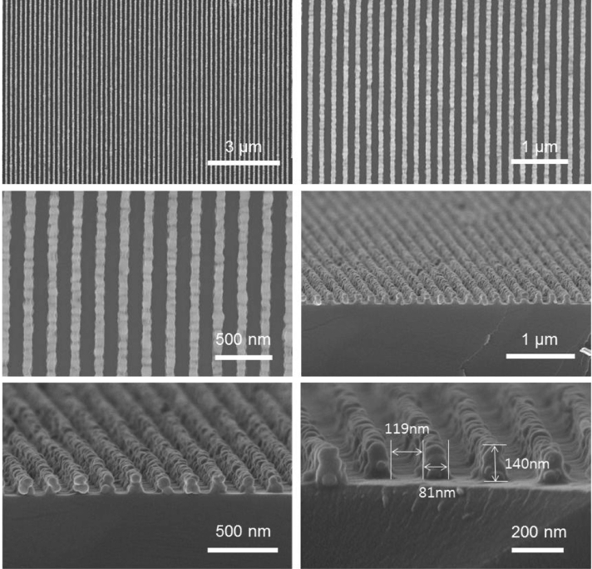  Polarizadores de retícula de nanohilos (NWGP) | La forma en que un material se comporta en la macroescala se ve afectada por su estructura en la escala nanométrica. Los investigadores están estudiando cómo hacer polarizadores con nanohilos metálicos alineados. Los nanohilos que utilizan miden menos de 100 nm de ancho, ¡demasiado pequeños para que podamos verlos a simple vista! En estos polarizadores de retícula de nanohilos (NWGP por sus siglas en inglés), la luz que está orientada paralela a los polarizadores interactúa con los hilos de metal y se refleja desde la superficie. Sin embargo, la luz perpendicular a los hilos los atraviesa.  Los NWGP muestran una gran promesa y tienen muchas ventajas sobre los polarizadores más convencionales. Por ejemplo, los NWGPs son más compactos y tienen amplios ángulos de visión, haciéndolos excelentes polarizadores. Sin embargo, al igual que muchas tecnologías nuevas, todavía hay retos de fabricación y rendimiento que los ingenieros deben resolver antes que estos polarizadores puedan llegar a ser ampliamente utilizados.

Learning objectives
- The way a material behaves on the macroscale is affected by its structure on the nanoscale.
- Nanotechnology takes advantage of special properties at the nanoscale to improve existing materials.

Materials
- Polarizing filters (2) in cardboard holders
- Overhead transparency sheets
- Transparent tape
- Diffuse light source (a window during daylight hours or an overhead light)
- “How polarizers block light” image sheet
Polarizing filters are available at www.teachersource.com (Item # PF-4).
Transparent tape can be found at office supply stores such as www.staples.com (Item # 609009).
Be sure to use “transparent” tape, not “invisible” or “magic” tape. It should have a clear, non-matte finish. Test the tape before you try this with visitors to ensure that it works for this activity.

Notes to the presenter
SAFETY NOTE: Visitors should not be looking at direct sunlight. If you are doing this activity outside or near a window, be careful not to ask visitors to look directly into the sun.
Ask visitors to hold the polarizers by the holders to avoid fingerprints on the polarizers.
Visitors can take home the clear plastic sheets with tape on them, but not the polarizing filters. Since visitors will not be allowed to take the polarizing filters with them, you can suggest one way that they can continue their experimenting at home using a computer screen and some polarized sunglasses. Filters inside the screen polarize the light coming out of the computer and the sunglasses act as the second filter. They can also look at materials such as plastic silverware, plastic wrap, or other molded clear plastics by placing them in front of the computer screen and looking through the sunglasses.

Related educational resources
The NISE Network website (www.nisenet.org) contains additional resources to introduce visitors to the fundamentals of nanoscale science and technology:
- Public programs include Nanotechnology: Small Science, Big Deal!
- NanoDays activities include Exploring Forces—Gravity, Exploring Forces—Static Electricity, Exploring Materials—Nano Gold, Exploring Properties—Surface Area, Exploring Properties—Electric Squeeze, and Exploring Properties—Capillary Action.
- Media include the Intro to Nanotechnology video, the Mr. O video series, the Nano and Me video series, and the What’s Nano About…? video series.
- Exhibits include the Nano mini-exhibition, At the Nanoscale, and Unexpected Properties.

Credits and rights
Image of Nanowire Grid Polarizer courtesy Kyung S. Park, Hanyang University, Seoul, Korea.

 | This project was supported by the National Science Foundation under Award No. 0940143 and 0937591. Any opinions, findings, and conclusions or recommendations expressed in this program are those of the author and do not necessarily reflect the views of the Foundation.
Copyright 2014, Sciencenter, Ithaca, NY. Published under a Creative Commons Attribution-Noncommercial-ShareAlike license: http://creativecommons.org/licenses/by-nc-sa/3.0.

Polarization Background Information

How do polarizers work?
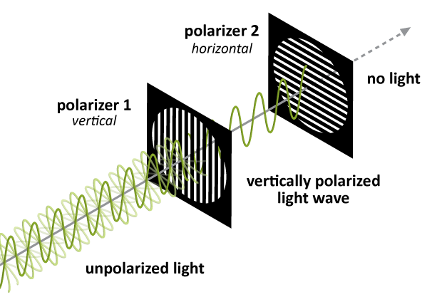
To understand how polarizers work, we need to think about light behaving like a wave. Every light wave has a particular orientation. Most light sources, like light bulbs or the sun, produce light waves oriented in all directions. We call this type of light randomly polarized light, meaning it doesn’t have a preferred orientation.
A polarizer affects light by blocking certain orientations of light. Once light goes through, it is plane polarized, meaning that all of the light waves are now parallel to each other.
When you look through two (or more) polarizer films, the brightness depends on how the polarizer films are aligned. So when you rotate the polarizer films, the brightness changes. When you have two polarizers that are aligned parallel to each other, the light that makes it through the first polarizer will make it through the second polarizer. Parallel polarizers like this let the most light through and look the brightest. Conversely, when you have two polarizers that are perpendicular to each other, the light that makes it through the first polarizer is oriented perpendicular to the second polarizer, so it will be blocked. Polarizers that are perpendicular to each other, called crossed polarizers, let the least light through and look the darkest. The quality of a polarizer is often measured by the difference in brightness between the brightest (parallel) and darkest (perpendicular) orientations.

How are polarizers made?
Polarizers are made in many ways. One of the most common polarizers is known as a Polaroid and consists of iodine crystals embedded in a polymer. To create the polarizer, the polymer film is stretched, which causes the polymers to align. Then the film is dipped in a solution of iodine and the iodine molecules attach themselves to the polymer. The Polaroid’s ordered structure allows it to absorb light that is parallel to the polymer chains and transmit light that is perpendicular to the chains. Researchers are trying to create even better polarizers using aligned nanowires instead of iodine-coated polymer chains.
Where do we use polarizers?
Polarizers are all around us! We use polarizers in liquid crystal displays, in telescopes, and in sunglasses. Polarized sunglasses are especially helpful when we’re looking at water or snow, because the glare from these surfaces is extremely polarized. Polarizers can very efficiently reduce the glare. Polarizers are even used in some of the glasses worn to make 3D movies come to life. |   Without polarized lens |   With polarized lens

