

Explorando materiales: Los ferrofluidos

¡Intenta esto!  - Mueve el imán alrededor del vial con arena negra. ¿Cómo reacciona la arena?  - Haz lo mismo con el vial con ferrofluido. ¿El ferrofuido y la arena actúan de la misma manera?  - Ahora acerca el imán al billete de un dólar. ¿Qué sucede con el billete? |  | 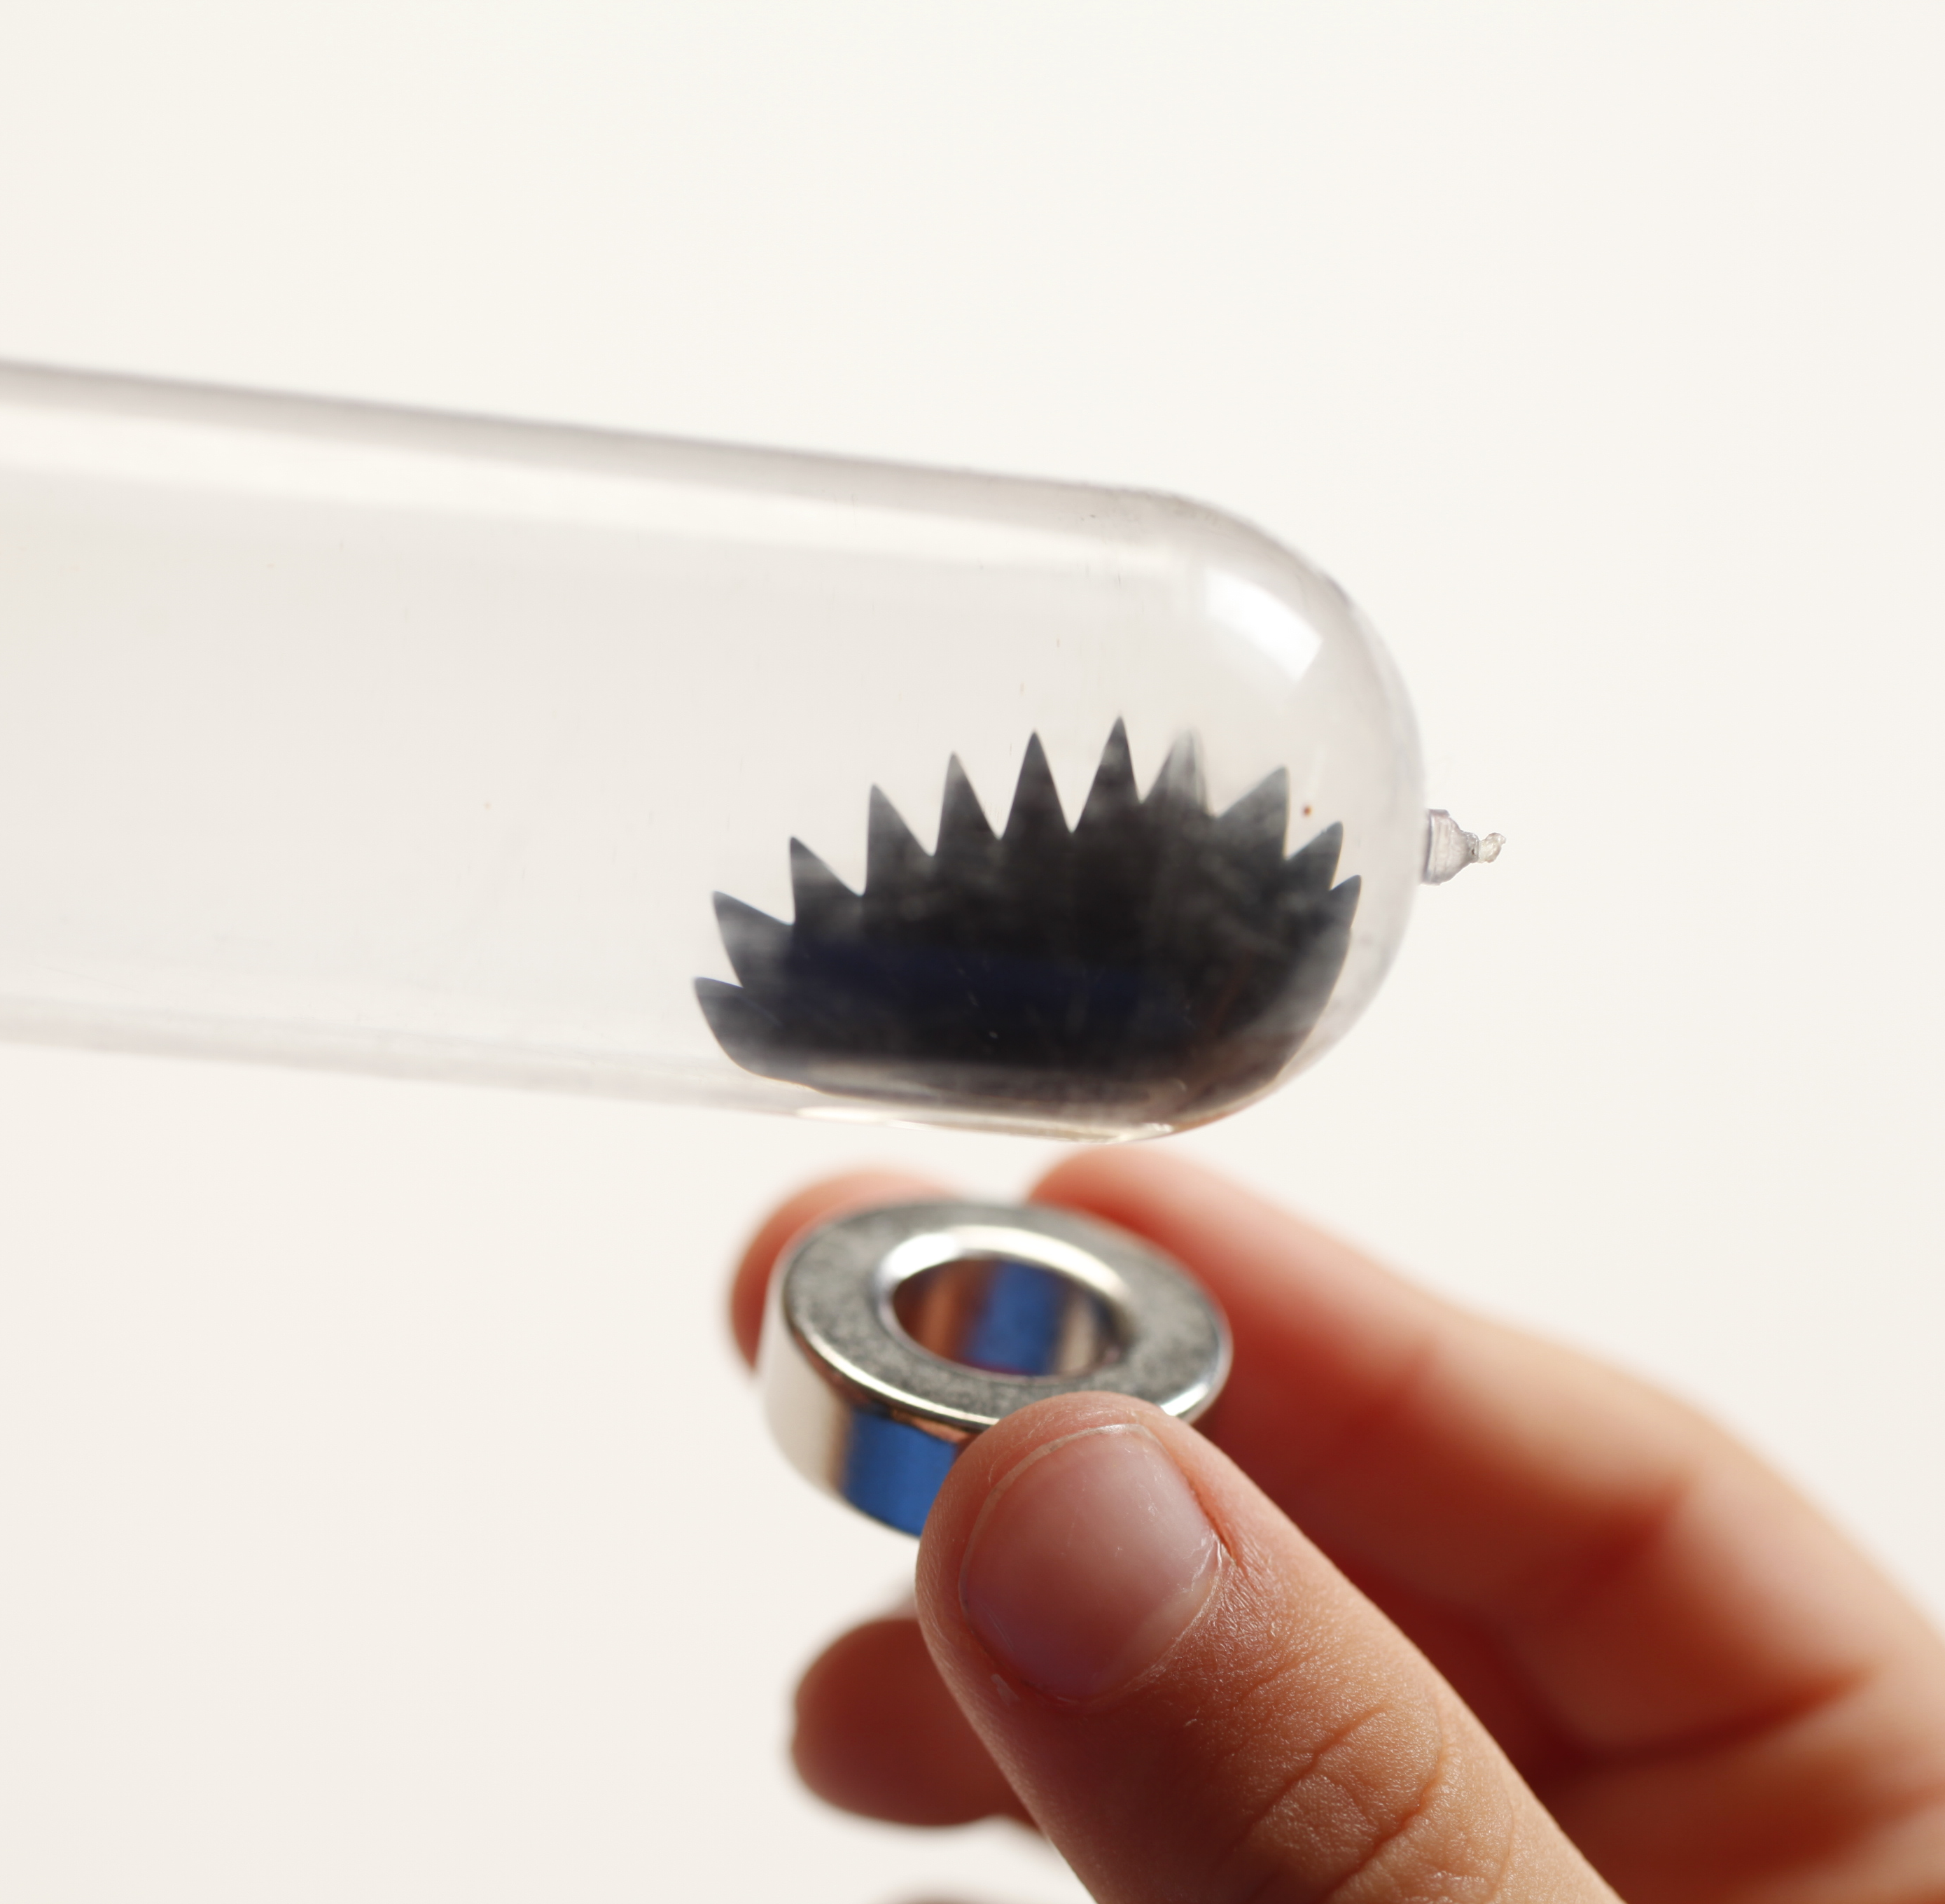
¿Qué sucede?
El ferrofluido es un material singular que actúa como un imán sólido y como un líquido. En contraste, la arena negra es un imán sólido regular. Sorpresivamente, ¡el ferrofuido y la arena negra están hechos de magnetita! La diferencia en su comportamiento se debe a su tamaño.

Los ferrofluidos están hechos de pequeñas partículas nanométricas recubiertas de magnetita suspendidas en líquido. Cuando no hay imanes cerca, el ferrofluido actúa como un líquido. Las partículas de magnetita se mueven libremente en el líquido. Pero cuando hay un imán cerca, las partículas se magnetizan temporalmente. Forman estructuras dentro del fluido, causando que el ferrofluido actúe más como un sólido. Cuando se retira el imán, las partículas se desmagnetizan y el ferrofluido actúa nuevamente como un líquido. La arena negra también está hecha de magnetita, pero no posee las propiedades inusuales de los ferrofluidos porque los granos de arena son mucho más grandes.

¡El billete de un dólar se mueve porque la tinta usada en la impresión contiene ferrofluido! Esta tinta especial se utiliza para prevenir su falsificación. ¡El ferrofluido utilizado en la tinta también ayuda a las máquinas vendedoras a identificar si el billete es de $1, $5 ó $20!

¿Por qué es nanotecnología?
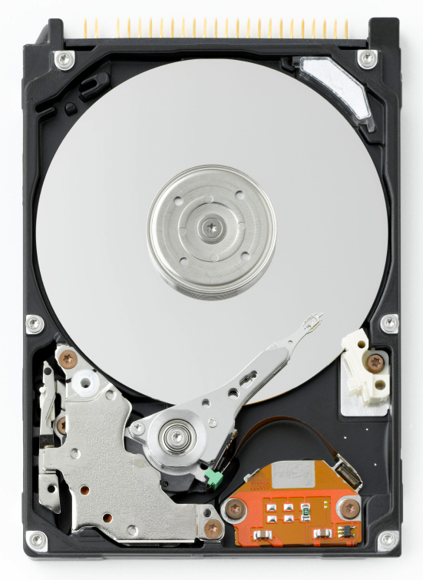  Interior de un disco duro | Un material puede actuar de manera diferente cuando es de tamaño nanométrico. (Un nanómetro es la milmillonésima parte de un metro). Cuando las partículas nanométricas de magnetita están suspendidas en un líquido (ferrofluidos) se comportan como paramagnetos, lo cual quiere decir que son magnéticos sólo en la presencia de un imán. Sin embargo, en la macroescala la magnetita es permanentemente magnética.  La nanotecnológica toma ventaja de las propiedades especiales de la nanoescala, como el paramagnetismo, para crear nuevos materiales y artefactos.  Además de estar en la tinta que se usa para imprimir los billetes, el ferrofluido se usa en las juntas rotativas de los discos duros de computadoras y otros motores de eje rotativo, y en altavoces para amortiguar las vibraciones. Los investigadores del campo de la medicina están buscando formas de utilizar el ferrofluido como un agente de contraste en las imágenes de resonancia magnética (IRM)

Learning objective
A material can act differently when it’s nanometer-sized.

Materials

Ferrofluid display cell
- Vial of magnetic black sand
- Neodynium magnet wand
- Dollar bill
- Bill sized paper
- 2 giant binder clips (only the black base)
- Ferrofluid Material Safety Data Sheet (MSDS)

Ferrofluid display cells are available from www.teachersource.com (#FF200).
Iron filings can be substituted for magnetic black sand, available from www.teachersource.com (#M-600).

Notes to the presenter
SAFETY: Small fingers can be pinched by magnets! To minimize the pinch hazard, have visitors use caution when holding magnets near magnetic metals.

Before doing this activity, read the information on the ferrofluid display cell provided by the supplier.

Related educational resources
The NISE Network online catalog (www.nisenet.org/catalog) contains additional resources to introduce visitors to nanomaterials:
- Public programs include Aerogel, Biomimicry: Synthetic Gecko Tape Through Nanomolding, Nanoparticle Stained Glass, Nanosilver: Breakthrough or Biohazard? and World of Carbon Nanotubes.
- NanoDays activities include Exploring Materials—Liquid Crystal, Exploring Materials—Memory Metal, Exploring Materials—Thin Films, and Exploring Structures—Buckyballs.
- Exhibits include the Nano mini-exhibition, Bump and Roll, Changing Colors, and Unexpected Properties.

Ferrofluid Background Information

What is ferrofluid?

Ferrofluid is a colloidal suspension of small magnetic particles in a fluid. In a suspension, solid particles are dispersed. The viscosity of the fluid, the tiny size of the particles, and the particles’ constant motion keep the solids from settling out. The magnetic particles in ferrofluid are around 10 nanometers in size. (A nanometer is a billionth of a meter.) Particles this size are known as colloids.
The magnetic particles in ferrofluids are usually iron oxide (magnetite), synthesized in solution and precipitated as nanoparticles:
- Iron salts (iron II chloride and iron III chloride) are mixed in a basic solution. Tiny particles of iron oxide (Fe₃O₄) precipitate from the solution.
- The iron oxide particles are coated with a surfactant to keep them from sticking to each other.
- The particles are dispersed in a water- or oil-based fluid.
Iron oxide is the same compound as magnetite, a naturally magnetic mineral found in many igneous and metamorphic rocks. The first ferrofluids, developed by NASA in the 1960s, were ground from natural magnetite.
How can it act like a liquid and a solid?
Ferrofluid is superparamagnetic, a property that is found only at the nanoscale. At the macroscale, ferromagnetic materials (like refrigerator magnets) are permanently magnetic. But when ferromagnetic materials are nanometer-sized, they became paramagnetic, which means that they behave like magnets only in the presence of a magnetic field.  When there is no magnet nearby, the magnetite particles in ferrofluid act like normal metal particles in suspension. But in the presence of a magnet, the particles are temporarily magnetized. They form structures within the fluid, causing the ferrofluid to act more like a solid. When the magnetic field is removed, the particles are demagnetized and ferrofluid acts like a liquid again. |   Ferrofluid near a magnet

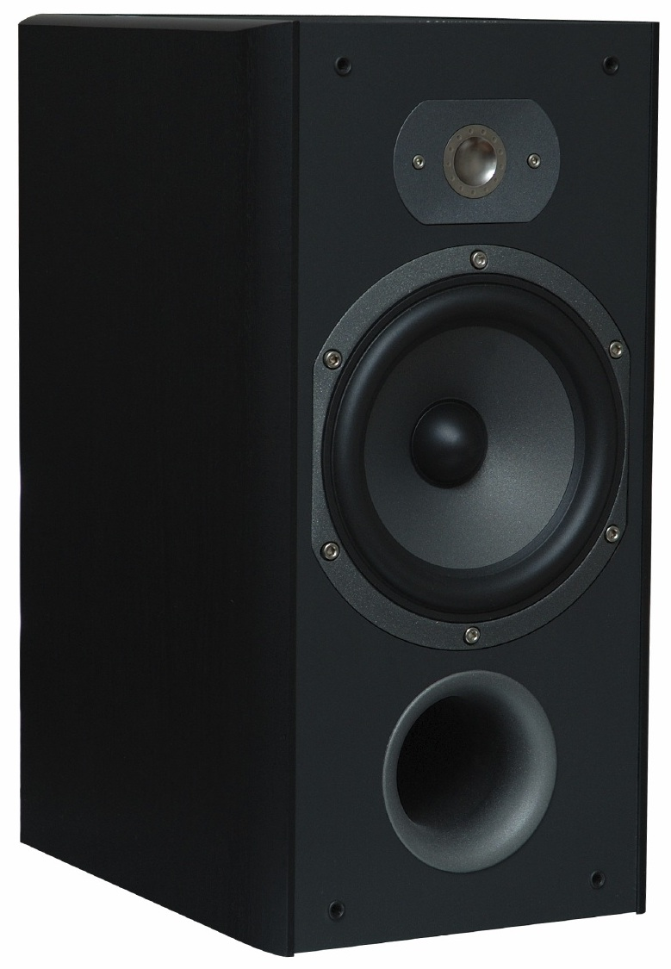  Speaker | How is ferrofluid used?  Ferrofluid’s properties make it useful for many different applications. The US government uses ferrofluid-based ink to print dollar bills as one of many anti-counterfeiting measures. Loudspeakers use ferrofluid to dampen vibrations. It is used in rotary seals for computer hard drives and other rotating shaft motors. In the future, ferrofluid might be used to carry medications to specific locations in the body.

Credits and rights
This activity was adapted from the NanoDays activity Exploring Materials—Ferrofluid supported by the National Science Foundation under Award No. ESI-0532536. The original program is available at www.nisenet.org/catalog.
And from the “Quick Reference Activity Guide: Ferrofluids,” developed by the National Science Foundation-supported Internships in Public Science Education (IPSE) Program at the Materials Research Science and Engineering Center (MRSEC) on Nanostructured Materials and Interfaces at the University of Wisconsin-Madison. The original activity is available at mrsec.wisc.edu/Edetc/IPSE/educators/ferrofluid.html.

Photo of ferrofluid courtesy of Opoterser. From Wikimedia Commons.

 | This project was supported by the National Science Foundation under Award No. 0940143. Any opinions, findings, and conclusions or recommendations expressed in this program are those of the author and do not necessarily reflect the views of the Foundation.

Copyright 2013, Sciencenter, Ithaca, NY. Published under a Creative Commons Attribution-Noncommercial-ShareAlike license: http://creativecommons.org/licenses/by-nc-sa/3.0/us/.

