Exploring Tools—3D Imaging

Try this!  - Look at the “micro view” images. What do you notice about them?  - Put on the 3D glasses and look at the images again. Do they look different?  - Can you guess what you’re looking at? (Flip it over to find out.)  What’s going on? | 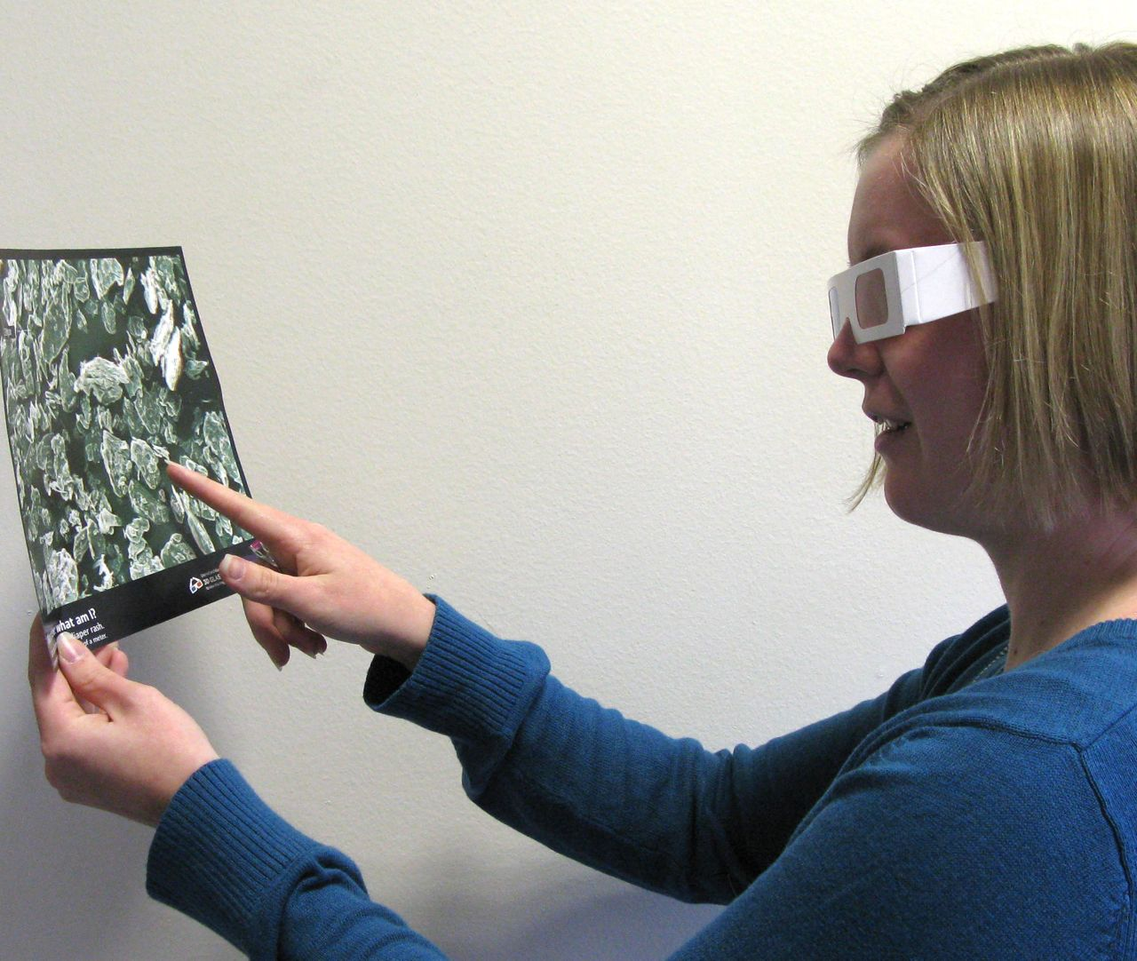

With the glasses, the images appear to be in three dimensions—the objects seem to pop out of the page. Without the glasses, the images appear blurry.  Each of these “3D” images is actually made of two photos of the same scene taken from slightly different angles. The two photos are printed on top of each other, one red and the other blue.  When you wear glasses with one red and one blue lens, the colored filters restrict your vision. One eye sees only the red photo and the other eye sees only the blue photo. Your mind merges these two separate images together into a single 3D image with depth. | 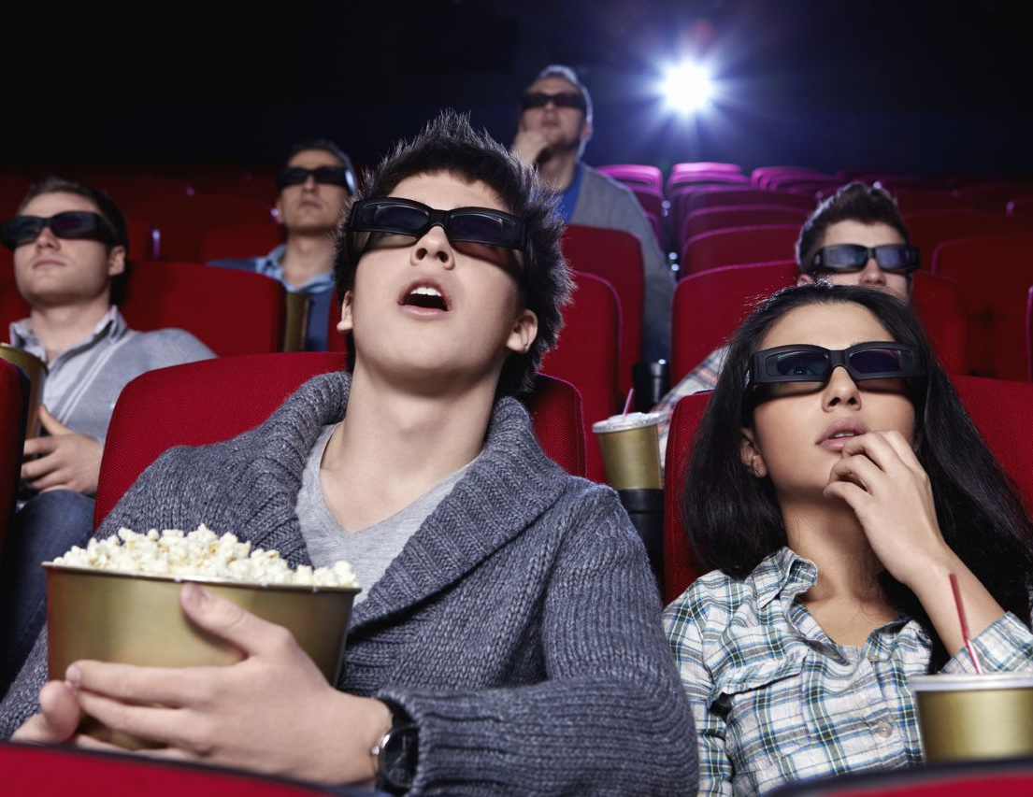

When we look at a regular (non-3D) photos printed on paper, we use other clues to figure out how things are positioned relative to each other. For example, in the picture above, we can tell that the people who look larger are in front of the people who look smaller and are partially blocked from view.

How is this nano?
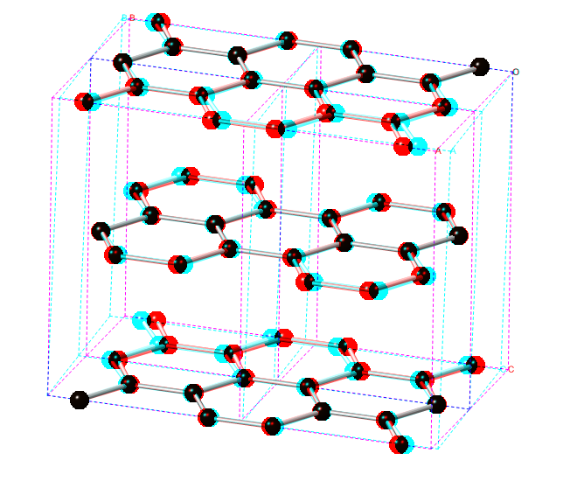  3D computer model of graphite sheets | Scientists use special tools and equipment to work on the nanoscale. Things that are measured in nanometers are very, very small. (A nanometer is a billionth of a meter.)  Nanometer-sized things are too small to be seen even with a powerful light microscope, so scientists use other tools to study them. Examples of these tools include scanning electron microscopes (SEMs) and atomic force microscopes (AFMs).  With special tools like these, scientists can’t directly see nano-sized objects. Instead, they see representations of them on a flat computer screen. Techniques like 3D imaging let scientists see the images with depth, making it easier to understand the relative position of things. This is especially important when scientists are studying complicated structures. Try looking at the image of graphite (to the left) with and without the 3D glasses!

Learning objective
Scientists use special tools and equipment to work on the nanoscale.

Materials
- Red/blue 3D glasses
- Set of 3D images
- “Seeing in 3D” sheet

Red/blue glasses are available from www.rainbowsymphonystore.com (#03101).

Notes to the presenter
It will be easier for small children and individuals in wheelchairs to see the images if you hold them up at their eye level (rather than placing them on the table).

In this activity, red/blue glasses are used to filter the red/blue images. The glasses force each eye to see only one of the images. There are other techniques to see 3D images, but they all rely on making each eye see a different image.

Extension
Try this activity to explore how our eyes see two different images of the same scene:
- Choose a stationary object in the distance. Close one eye, then hold up a thumb at arm’s length so that it blocks your view of the object.
- Without moving your thumb, close your other eye and open the first. What happens?
- Try the same experiment again, this time holding your thumb closer to your face. Does your thumb appear to move the same amount?
Your thumb doesn’t really move—it only seems that way. When you switch eyes, objects that are closer to your face appear to move more than objects that are farther away.
People have stereoscopic vision. Our eyes are a small distance apart, so each one sees the world from a slightly different angle. When we look at something with both eyes, we see two slightly offset images of the same scene. Our brain combines these two images into a single view of the world that has depth.

Related educational resources
The NISE Network online catalog (www.nisenet.org/catalog) contains additional resources to introduce visitors to nanotechnology and the tools researchers use to study and make things that are too small to see:
- Public programs include Attack of the Nanoscientist, Cutting it Down to Nano, Intro to Nano, Ready, Set, Self-Assemble, and Tiny Particles, Big Trouble!
- NanoDays activities include Exploring Size—Powers of Ten Game, Exploring Tools—Mitten Challenge, and Exploring Tools—Mystery Shapes.
- Media include the video What Happens in a Nano Lab?
- Exhibits include Creating Nanomaterials and NanoLab.

Credits and rights
Three-dimensional SEM images by John Hunt, Cornell Center for Materials Research, with support from NSF Award No. DMR-1120296.
Three-dimensional photographs of macro-sized objects by Emily Maletz for the NISE Network.
Graphite image courtesy Yingchao Yu, Cornell University.
This project was supported by the National Science Foundation under Award No. 0940143. Any opinions, findings, and conclusions or recommendations expressed in this program are those of the author and do not necessarily reflect the views of the Foundation.

Copyright 2012, Sciencenter, Ithaca, NY. Published under a Creative Commons Attribution-Noncommercial-ShareAlike license: http://creativecommons.org/licenses/by-nc-sa/3.0

