Space Elevators

Space elevator designs often include a base station on Earth, an orbiting station in space, and a cable stretching between the two. The elevator car moves up and down on the cable between Earth and space. Some researchers think that super strong, lightweight carbon nanotubes might allow us to create a cable that can support its own weight plus that of the elevator car—making the dream of a space elevator possible.

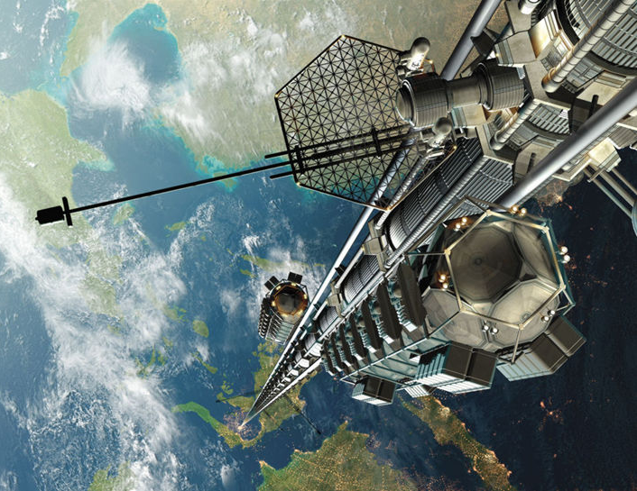  Mondolithic |  | 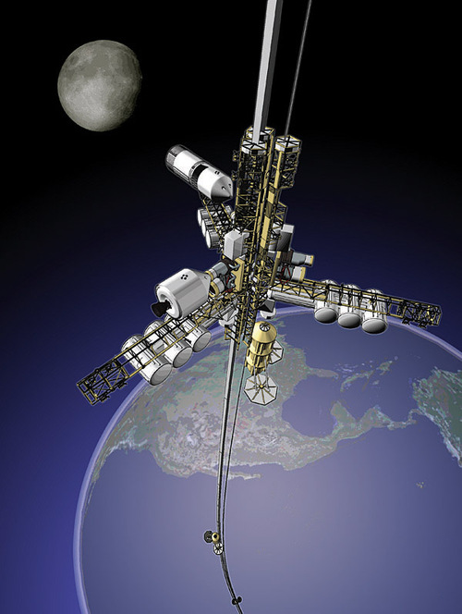  Dan Roam, © 2012
Artist illustrations of space elevator concepts

NOVA video about space elevators:
http://www.pbs.org/wgbh/nova/space/space-elevator.html

