Exploring Nano & Society—Space Elevator
Try this!  - What if it were possible to take an elevator into space? Imagine what our world would be like.  - Draw a picture of the future world you’re imagining. What would we need in space? What kinds of plans would we have to make?  Think about it… | 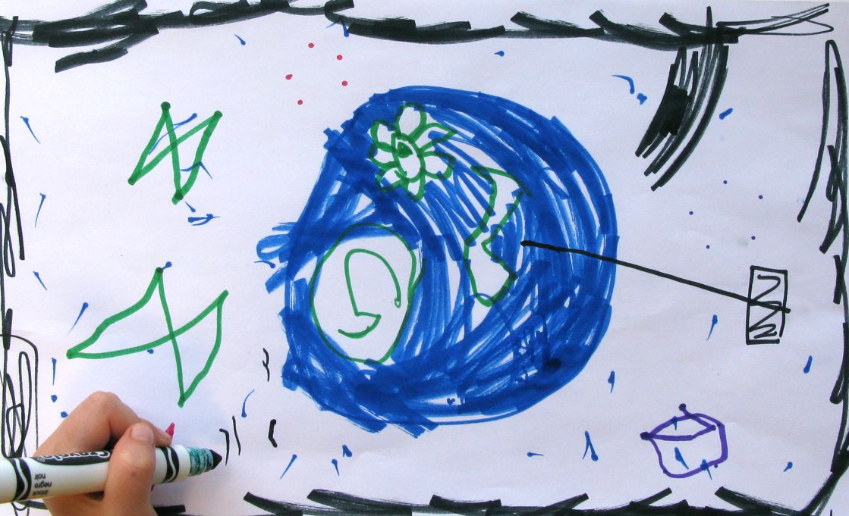
How would the space elevator work? What would power it?
Who would get to use the space elevator? Where would you get on?
When you got up in space, what would be there? What would you need to bring with you?

What’s going on?  It’s fun to imagine what our lives might be like in the future—and it’s also important. We have the things we do today because in the past, people thought about the kind of world they wanted and invented technologies to help make their dreams real.  Researchers really are working on creating a space elevator, including scientists at NASA and Google. They think that new materials like carbon nanotubes will make this technology possible.  If these scientists are successful, someday it might be cheap and easy to bring people and materials into space. And if it were possible for ordinary people to go into space, that could mean big changes to our lives. | 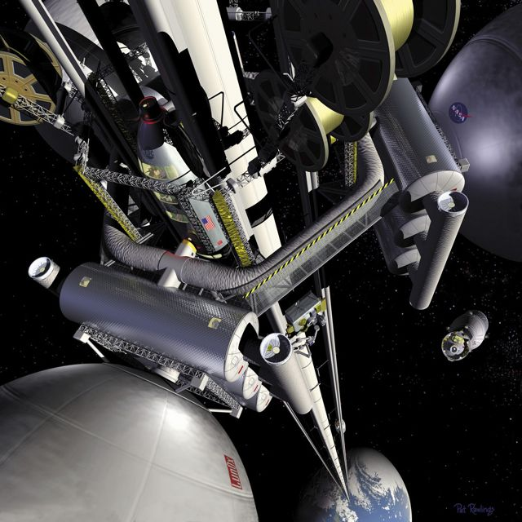  Illustration of a space elevator by NASA

We all need to think about the kind of world we want in the future, and begin planning for it. Do you think exploring and developing space is important? If so, what kind of society should we create there? Or do you think we should spend our time and money on something else, instead of a space elevator?

How is this nano?
Carbon nanotubes | Technologies and society influence each other. People’s values shape how nanotechnologies are developed and adopted.  Researchers think about the future world they would like to live in when they create new technologies. And when people decide to use new technologies, those technologies can change their lives in ways that are big and small.  New nanomaterials are making new technologies possible. For example, super strong, lightweight carbon nanotubes might allow us to make a cable that can support a space elevator. The space elevator is an old dream: people have been imagining the possibilities of taking an elevator into space since at least 1895!

Learning objectives
- Technologies and society influence each other.
- People’s values shape how nanotechnologies are developed and adopted.

Materials
- Large sheets of paper
- Markers
- “Space Elevators” sheet

Notes to the presenter
This activity is designed as an open-ended, conversational experience. Some visitors (such as adults) may prefer to talk about their ideas, rather than draw them.

You can use the “Think about it” questions to get visitors started. Once they’ve begun, you can ask them to explain what they’re drawing, and ask questions to help them think about the kinds of technologies and systems they’d need to support their vision of the future. In your conversation, consider how a space elevator would change our lives and how it would be connected to other things, rather than focusing on the elevator itself.

For larger groups, such as classes or camps, visitors can work collaboratively on a large sheet of butcher paper.

Related educational resources
The NISE Network online catalog (www.nisenet.org/catalog) contains additional resources to introduce visitors to the relationship between nanotechnology and society:
- Public programs include Exploring Nano & Society—Flying Cars, Nanotech and Consumer Products, Robots & People, and Would You Buy That?
- NanoDays activities include Exploring Nano & Society—You Decide! and Exploring Properties—Invisibility.
- Forums include Energy Challenges, Nanotech Solutions?, Nanomedicine in Healthcare, Privacy—Civil Liberties—Nanotechnology, and Risks, Benefits, and Who Decides?
- Media include Does Every Silver Lining Have a Cloud?, Is that Robot Real?, Let’s Talk About It, Same Sides, Societal and Ethical Implications Posters, and Wonders and Worries of Nanotechnology.
- Exhibits include Balance our Nano Future and Nanotechnology: Fact or Fiction?

Credits and rights
This activity was created as a collaboration of the NISE Network and the Center for Nanotechnology in Society at Arizona State University.

Image of space elevator concept by NASA, public domain.

Image of space elevator concept copyright Dan Roam 2012.

Image of space elevator concept courtesy Mondolithic.

This project was supported by the National Science Foundation under Award No. 0940143 and 0937591. Any opinions, findings, and conclusions or recommendations expressed in this program are those of the author and do not necessarily reflect the views of the Foundation.

Copyright 2012, Sciencenter, Ithaca, NY. Published under a Creative Commons Attribution-Noncommercial-ShareAlike license: http://creativecommons.org/licenses/by-nc-sa/3.0

