Exploring Properties—Invisibility
Try this!  - Look in the glass beakers. What do you see?  - Gently lift the craft stick out of one beaker, then the other. What’s on the end of the line?  What’s going on? | 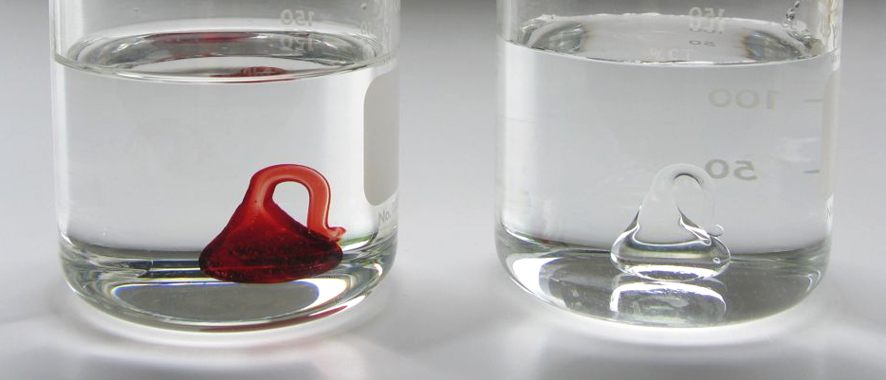
One of beakers has two glass objects in it! Before you lifted the objects out of the water, you might have thought each beaker had only one object—one red and one colorless. The beaker with two objects in it is filled with baby oil, while the beaker with one object is filled with plain water. The colorless object can be hidden in the oil because it’s made of borosilicate glass, which has a similar refractive index to baby oil. It can’t be hidden in the water, because borosilicate glass has a different refractive index from water.

The refractive index indicates how fast light can travel through a material. The higher a material’s refractive index, the slower light travels in that material. If two materials have a different refractive index, the speed of the light changes as it moves from one material to the other. This causes some of the light to reflect, or bounce off an object, and some of it to refract, or bend as it goes through an object.
You can’t see the colorless object in the oil, because light traveling from baby oil to glass doesn’t change speed very much. It doesn’t refract or reflect when it hits the glass, so you don’t see the object. It’s almost invisible!  In everyday life, you see refraction at work when a straw submerged in a glass of water appears to bend. The light interacts differently with the air outside the glass than the water inside the glass, creating the illusion that the straw is bent.  How is this nano? | 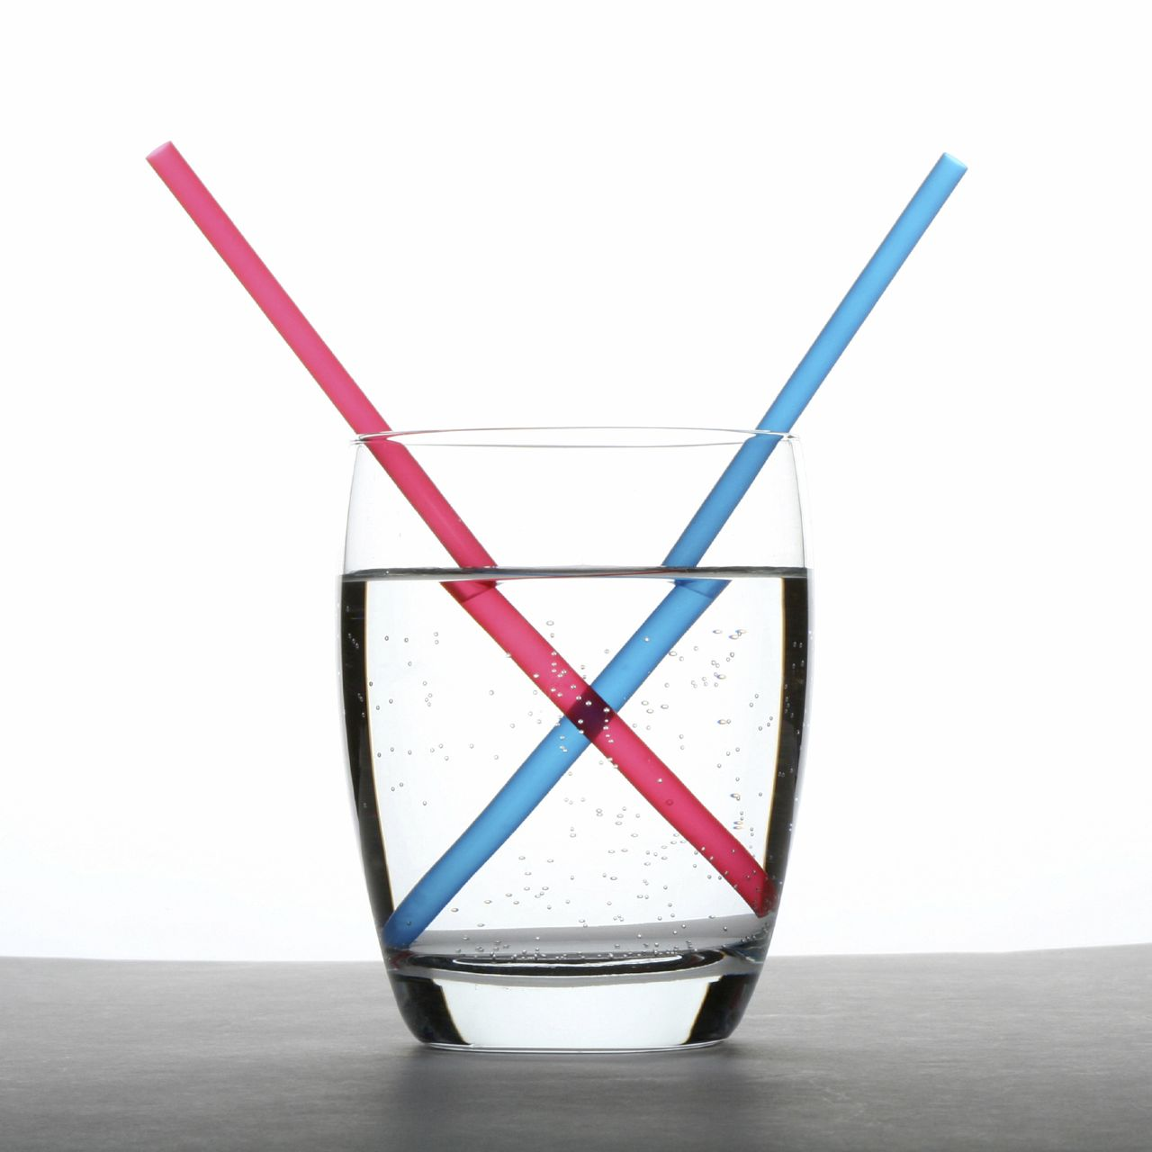

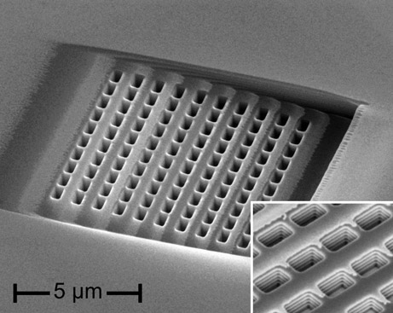  Metallic nanostructures  that bend light backwards | The way a material behaves on the macroscale is affected by its structure on the nanoscale. Using nanotechnology, it is possible to engineer new materials that can interact with light in special ways. Engineers have created special coatings that control reflection and refraction, improving the energy efficiency of windows and making better solar cells.  Researchers are even experimenting with ways of bending light to cloak objects—making them invisible to the human eye or to surveillance devices. For example, scientists at the University of California at Berkeley have created a tiny “carpet” that makes a three-dimensional object appear flat by reflecting the surface beneath it. Thin, metallic nanostructures create negative refraction, bending light “backwards” in directions it couldn’t go in nature.

Think about it…
- What would you do if you had an invisibility cloak? What do you think other people might do?
- Would you make rules for how people could use invisibility cloaks?

Technologies and society influence each other. When we use a new technology—whether it’s a cell phone or an invisibility cloak—we create new ways of interacting with each other. We work together to figure out when, where, and how it’s ok to use the new technology. Eventually, we create norms, rules, and laws that influence how we use it. New nanotechnologies will affect our social relationships, just like any other technology does.

Learning objectives
- The way a material behaves on the macroscale is affected by its structure on the nanoscale.
- Technologies and society influence each other.

Materials
- Glass beakers (2)
- Baby oil
- Water
- Borosilicate glass objects
- “Nanotechnology Mirage” sheet
- Sheet of “oil-resistant” white paper (laminated or synthetic)

The NanoDays physical kit includes two colorless glass pendants and one colored glass pendant. You can substitute other glass objects, but it’s important that they be borosilicate glass. (Some other kinds of glass don’t have the same refractive index, and won’t “disappear” in the baby oil.) Borosilicate glass stir rods are available from scientific suppliers, such as www.sciencelab.com (#22-1900-6-DZ).

Notes to the presenter
SAFETY: Visitors should be careful handling the glass objects. Visitors should not drink the liquids. Visitors should be supervised at all times while doing this activity.

Before doing this activity:
- Fill one beaker with baby oil and one beaker with water. Suspend the stick with two glass objects (red and colorless) in the beaker with baby oil. Suspend the stick with one glass object (colorless) in the beaker with water. Place the beakers on the sheet of laminated paper.
- Check the lighting in your demonstration space. In some spaces, you may still be able to see the “invisible” object because of the way the lights are placed. If this happens, try a different spot.

This activity is based on a demonstration about the refraction of light, but it provides an opportunity to engage visitors in conversation about the potential for an invisibility cloak.

The red object provided in the NanoDays kit is made from a kind of glass known as “Red Elvis.” The color comes from nanoscale particles of gold! Gold has been used to create red glass since the Middle Ages.

Related educational resources
The NISE Network online catalog (www.nisenet.org/catalog) contains additional resources to introduce visitors to the fundamentals of nanoscale science and technology:
- Public programs include Nanotechnology: Small Science, Big Deal!, Robots & People, Would You Buy That?, and Wheel of the Future.
- NanoDays activities include Exploring Forces—Gravity, Exploring Forces—Static Electricity, Exploring Materials—Nano Gold, Exploring Nano & Society—You Decide, Exploring Nano & Society—Space Elevator, and Exploring Properties—Surface Area.
- Media include the Intro to Nanotechnology video, the Mr. O video series, the Nano and Me video series, the Societal and Ethical Implications Posters, and the Wonders and Worries of Nanotechnology video series.
- Exhibits include At the Nanoscale and Unexpected Properties.

Credits and rights
This activity was created as a collaboration of the NISE Network and the Center for Nanotechnology in Society at Arizona State University.

Image of metallic nanostructures courtesy Jason Valentine, Vanderbilt University.

Images of “nanotechnology mirage” courtesy Ali Aliev, Alan G. MacDiarmid NanoTech Institute, University of Texas at Dallas.
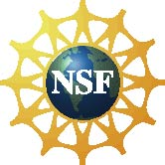 | This project was supported by the National Science Foundation under Award No. 0940143 and 0937591. Any opinions, findings, and conclusions or recommendations expressed in this program are those of the author and do not necessarily reflect the views of the Foundation.
Copyright 2012, Sciencenter, Ithaca, NY. Published under a Creative Commons Attribution-Noncommercial-ShareAlike license: http://creativecommons.org/licenses/by-nc-sa/3.0

