Data Storage

In this activity, the size of the magnets determines how much information can be stored in a given amount of space. We can store 1 byte of information with our eight magnet stands, which is enough for only one letter of the alphabet.

The eight magnets in the first picture below represent 8 bits (or 1 byte) of information. If the magnets were smaller, like in the second picture below, you could store 4 bytes of information (4 letters) in the same amount of space. If you had even smaller magnets, like in the last picture, you could store 16 bytes in the same amount of space.

Imagine how small the magnets would have to be to store enough information for a music file on your computer. A typical mp3 file is about 3.92 MB. That’s around 4 million bytes. That’s a lot of magnets for just one song!

1 byte | 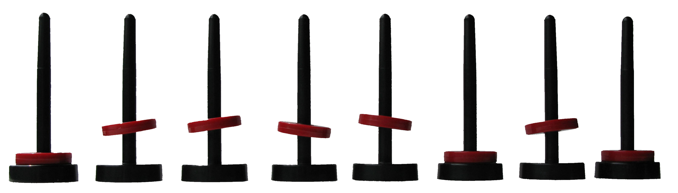

4 bytes

16 bytes

