Try this!

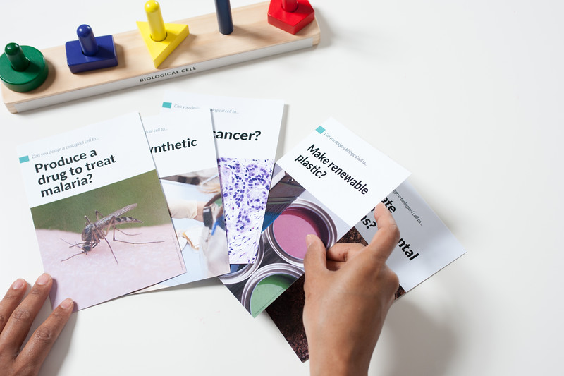
1
1. Look through the challenge cards and pick one. Turn it over and read about it.

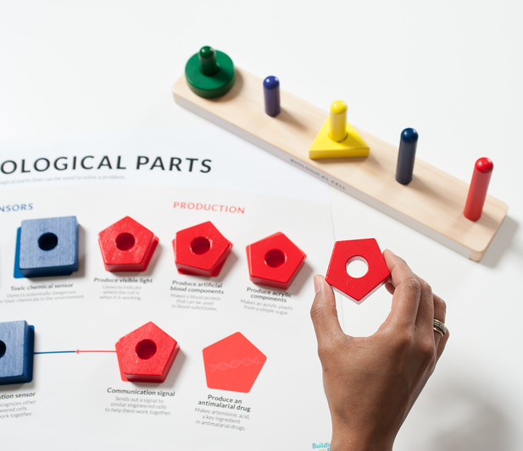
2. Use the colored blocks to complete the challenge on the card. The blocks represent biological parts made of genes that can do different things. They stack onto a wooden stand, which represents an empty cell.
2
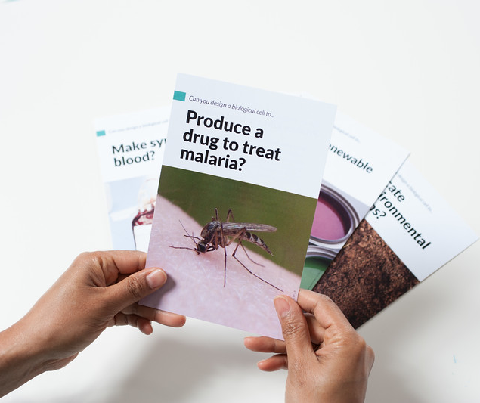
Think about which genetic parts to use. How do they work together to help solve the problem?
3
3. Now, pick a different challenge card. Do you need different genetic parts to solve this problem? Can you reuse any parts from the last challenge?

Talk about it…
How did you choose which cards to try? Do you think a toolkit of genetic parts is a good solution to those problems?
Scientists are building real toolkits of genetic parts. Do you think these toolkits should be available to everyone, to use for anything they want?
Should anyone be able to own or patent the parts of genetic toolkits?

Synthetic biology develops tools and knowledge to build new living organisms and materials.

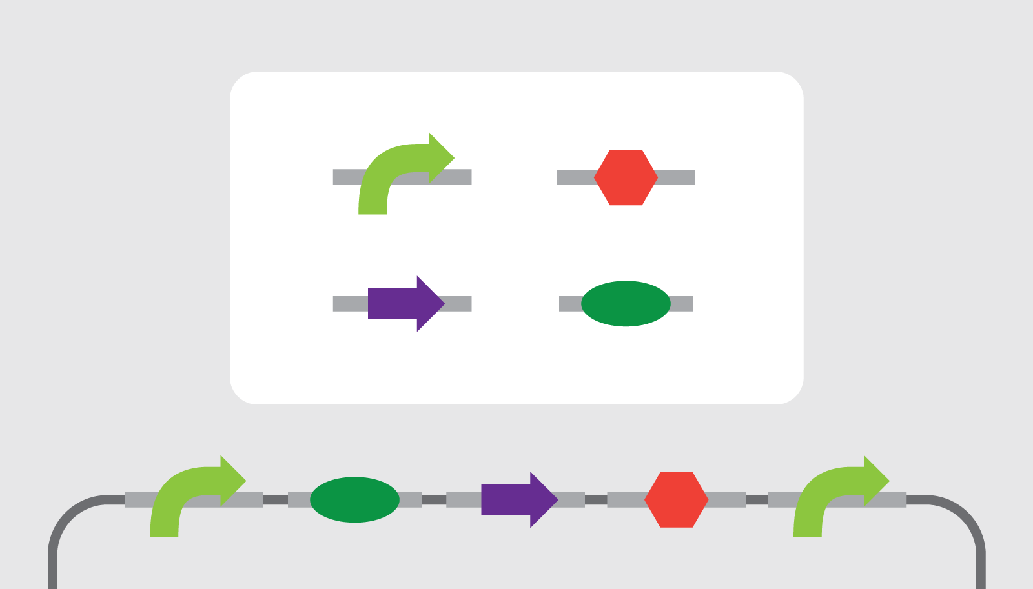
Synthetic biologists can create and use standardized parts made of genes. Some of these parts are derived from genes in existing systems. Others are completely artificial, made from scratch in a lab.
Researchers can create new living systems by adding new genetic parts to an organism’s existing genome. (A genome is an organism’s complete set of DNA, including all of its genes.) The new genetic parts act like instructions that make cells behave in certain ways.
Researchers use standardized parts called BioBricks to design and build complex living systems.
Synthetic biologists are building toolkits of interchangeable biological parts. One system, called BioBricks, is sort of like a free “operating system” for biotechnology.

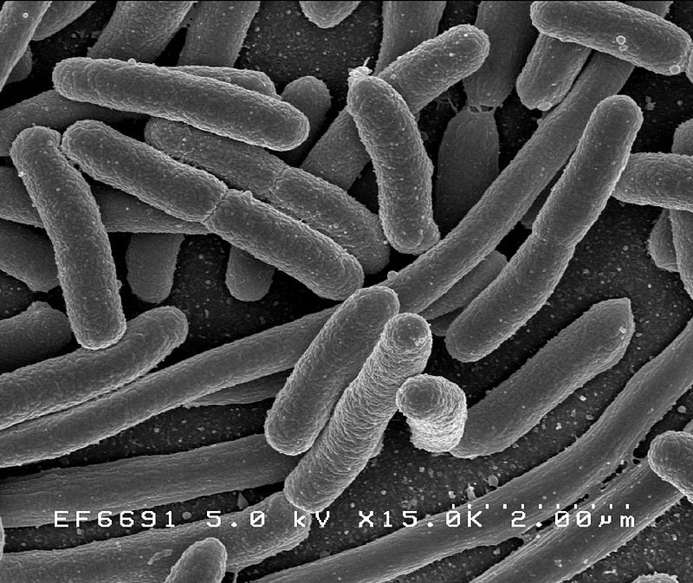
Synthetic biology may provide solutions to problems in areas such as food security, healthcare, energy, and the environment. Synthetic biologists solve problems by applying engineering principles to biological materials. They can build new living systems in controlled and precise ways.
It’s important that many different people consider the potential costs, risks, and benefits of introducing synthetic biological systems to our world. As individuals and as a society, we need to think ahead and talk about new and emerging technologies as they are developed and used.
New genetic parts may allow modified E. coli bacteria to produce malaria medication.

