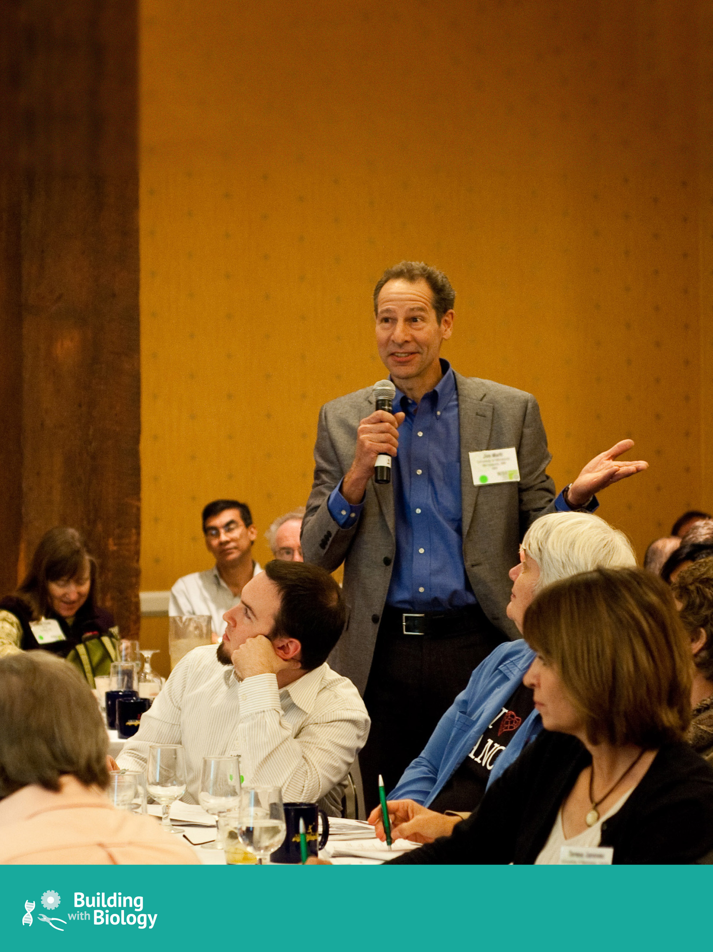
Forums Manual
Engaging visitors in thoughtful conversations

buildingwithbiology.org

This manual was prepared for the Multi-Site Public Engagement with Science – Synthetic Biology project led by the Museum of Science, Boston, with funding from the National Science Foundation under Grant Number DRL-1421179. Any opinions, findings, and conclusions or recommendations expressed in this document are those of the authors and do not necessarily reflect the views of the Foundation. It is adapted from an earlier version prepared by Brad Herring © 2007 Museum of Life and Science, Durham, North Carolina, for the Nanoscale Informal Science Education Network with funding from the National Science Foundation under Cooperative Agreement ESI-0532536.
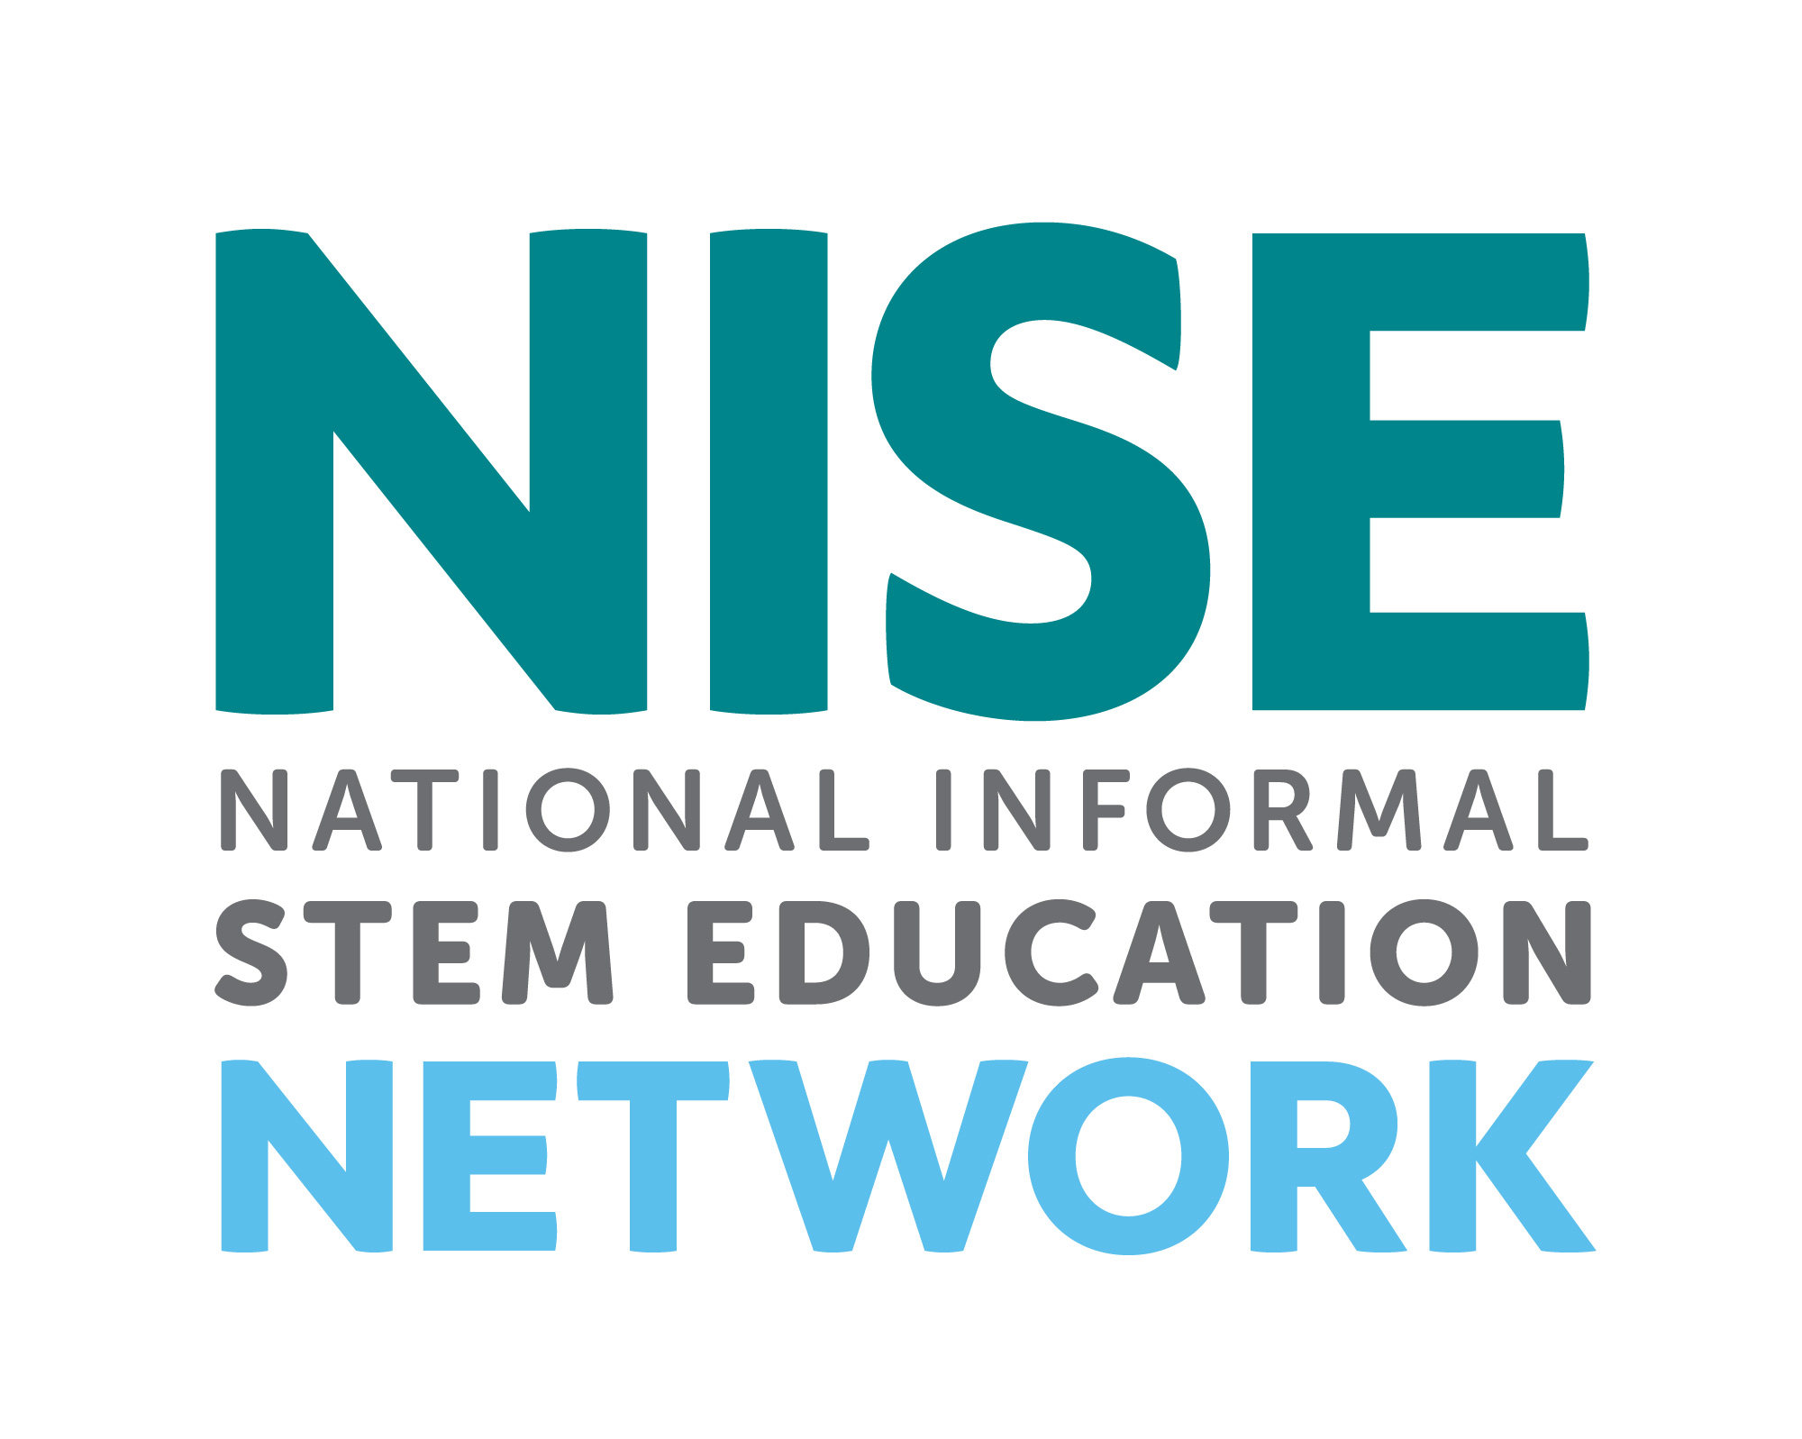
Distributed in partnership with the National Informal STEM Education Network.
Edited by Caroline Lowenthal
Copyright 2016, Museum of Science, Boston.
Published under a Creative Commons Attribution-Noncommercial-Share Alike license: creativecommons.org/licenses/by-nc-sa/3.0/us/CC-BY-NC-SA-3.0
You are free to copy, adapt, or distribute this manual and/or the text and images contained in it for educational, nonprofit purposes. The guide is available for download from www.buildingwithbiology.org. When making copies or excerpts, please include the copyright and credit information above. If adapting the contents, please cite the manual as a source.
Acknowledgments
This manual would not have been possible without the earlier writing, editing and guidance of the NISE Network Forums Team, and subsequent edits and additions by members of the Building with Biology project. Specific appreciation is given to the following individuals: Larry Bell, Elizabeth Kunz Kollmann, David Sittenfeld, and Katie Todd, Museum of Science, Boston; Brad Herring, Museum of Life and Science, Durham; Catherine McCarthy, Science Museum of Minnesota; and Ali Jackson and Michelle Kortenaar, Sciencenter, Ithaca. Gratitude is also expressed to Emily Maletz for providing her expertise with the design and layout of this manual and to the National Science Foundation for funding the project.

Table of Contents
Introduction to Public Forums 3
Forum Goals 4
Forum Format 4
Planning a Public Forum 4
Getting Your Institution on Board 5
Who Were These Forums Designed For? 7
Structure of a Forum 7
Welcome/Introduction 7
Speakers/Experts Present Topics, or Show Video 7
Q&A 8
Group Deliberation 8
Individual or Group Reflection/Report-Out 8
Post-Forum Evaluation 8
Materials 8
Forum 8
Room 9
Speaker Setup and AV Needs 9
Evaluation 9
Advance Preparations 9
How have different marketing methods worked for forums? 11
Setup 13
Group Facilitation 13
Ground Rules 14
Facilitating without Facilitators at Each Table 14
Ending a Forum 14
Cleanup 15
After the Forum 15
Forum Evaluation 15
Appendix 17
Forum Survey 17
Registration Survey 20
Media Consent and Release 21
Three Big Ideas in Technology and Society 22
Values shape how technologies are both developed and adopted 22
Technologies affect social relationships 23
Technologies work because they are part of larger systems 23
Example Public Forum Materials 25
Other Resources 26
References 26
Image Credits 27

Introduction to Public Forums
Public forums offer participants the opportunity to engage in thoughtful conversations about important issues regarding the potential societal and ethical implications of topics in current science, technology, and engineering. They provide a way for people with diverse views and backgrounds to deliberate on difficult issues and to seek a more comprehensive understanding of the topics. The purpose of this manual is to provide information on how to engage members of the public in thoughtful conversations about these important issues.
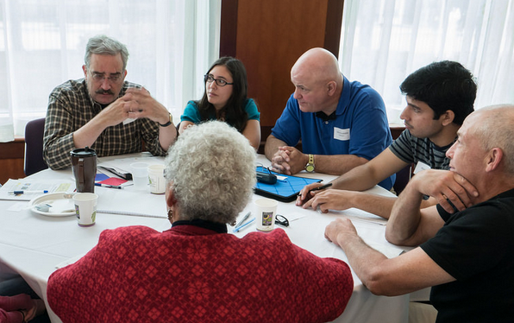
Science museums and other institutions are exploring new models for engaging adults and older youth in dialogue and deliberation on these types of issues. The democratization of public policy deliberation is a strategy for stimulating learning by scientists, social scientists, the public, and policy-makers, and for expanding the role of science museums in the life of the nation as a bridge between these groups.
These public forums address societal issues that can be informed, but not answered, by science, technology, and engineering. At public forums, participants consider how new technologies may affect people and the societies they live in and create. These technologies will open up new possibilities, shape our relationships, promote the values of those who develop, support, and purchase them, and may affect the environment, individuals, communities, and society more broadly, in ways both expected and unexpected. Decisions about developing and implementing new technologies involve not only scientific and engineering concepts but also personal and social values.
“The time is right to further develop science-center based facilitated dialogue between researchers and the public to accurately inform the public about this important and sometimes controversial work while at the same time engaging researchers in meaningful and informed discussions with the public around the societal, ethical, economic and other important implications of current science, technology and engineering.”
– Troy Livingston, Chief Executive Officer, Thinkery, Austin, TX
This type of program is different from many other museum programs because it seeks to encourage participants not just to think about science, technology, and engineering, but to bring their life experiences to the conversation. To achieve this, it encourages conversations that can help museum guests think about their own values, better understand other peoples’ viewpoints, recognize the expertise they have, and increase their confidence in contributing to the broader conversation about shaping the future.

Forum Goals
Overarching Goal: To convene informed multi-directional conversations among everyday citizens, stakeholders, scientists, and sometimes policymakers, about questions related to emerging technologies where both science and societal issues play a central role.
Sub-goals for participants include:
- Providing various publics with the opportunity to share their perspectives and expertise with scientists and policy-makers who are interested in getting public input to inform their work.
- Strengthening publics' and scientists’ familiarity with, and understanding of, diverse points of view related to applications of current science, technology, and engineering.
- Increasing the participants’ confidence in making decisions and participating in public discourse about technologies that raise complex societal issues, by giving them practice in considering different perspectives and sources of information in a deliberative problem-solving environment.
- Learning about an emerging technology and its potential societal impacts.
Sub-goals for institutions include:
- Attracting and engaging adult audiences in in-depth learning experiences.
- Increasing informal science educators’ knowledge, skill, and interest in developing and conducting programs that engage the public in conversation about societal issues raised by new and emerging technologies.
- Providing an important step toward defining a new role for the museum in the community, as a neutral place to hold conversations on controversial or unresolved societal issues related to science and technology.

Forum Format
Forum programs can take a variety of formats that engage participants for a few minutes or all day, but the most common format is a one- to two-hour program involving variations of the following four steps:
- Forum introduction
- Presentations and Q&A with experts
- Participant conversation
- Report out / wrap up
For more details on the forum format, see the Structure of a Forum section on page 7.

Planning a Public Forum
Public forums offer participants the opportunity to engage in thought-provoking conversations about important issues related to science, technology, and engineering and their potential societal and ethical implications. Forums are different from traditional museum lecture programs in that they set the stage for participants to play a more prominent role in the program. Through small group conversations, forums provide an opportunity for people with diverse views and backgrounds to deliberate on sometimes controversial societal issues and to seek a better understanding of their own views, and those of others, about how we as a society should address them. Public forums are typically geared toward adult and older youth audiences but may be adapted to fit your institution’s needs.
“Hosting forums has allowed us the opportunity to not only incorporate current science into our programming efforts but it's also helped us to engage our visitors in important issues at the intersection of science and society.”
– Brad Herring, Museum of Life and Science, Durham, NC

Getting Your Institution on Board
Some museums/institutions may wish to host a forum at their institution because it aligns with their mission of bringing current science to their visitors or as a new way to engage adult audiences. If this sounds like your institution, you might want to consider a forum on science, technology, and engineering. Forums:
- Focus on current science, technology, and engineering topics,
- Are easy to conduct when implementing one of the programs available online because the materials are provided, participants bring their own ideas and values, and the problem-solving types of interactions are familiar for people,
- Are relatively inexpensive because they don’t require much equipment or infrastructure to engage people deeply,
- Connect scientists with the public, and
- Connect participants with one another in enjoyable, meaningful ways.
It is important to keep in mind that this type of program does require you to assemble an audience without young children that is able to devote an hour or two to the activity. If the forum is being hosted during the day when the museum is open, there won’t be many visitors without kids who can just walk in and join the program, and it’s hard for people with kids to participate. If the event is at night, one possibility is to offer a science program for kids in a separate room while the older youth and adults participate in the forum.
The societal and ethical questions raised in forums level the playing field between scientists and the public and make for very interesting, lively conversations. Participants routinely report that they value the expert presentations and the small group conversations most (Goss & Kollmann, 2011; Kollmann, Reich, Bell, & Goss, 2013; Kollmann, Reich, & Lindgren-Streicher, 2009). We’ve evaluated these experiences for years across many partner museums and the vast majority of the participants who were surveyed agreed that they enjoyed the experience (Cohn, Kollmann, Ong, Pfeifle, & Todd, 2016; Kollmann, 2011). In addition, most surveyed participants agreed that they felt more informed about the technology discussed as a result of the forum, and that they felt comfortable expressing their opinions — all worthy goals for any program designed to reach adults and get them more involved in the life of your science museum (Flagg & Knight-Williams, 2008; Kollmann, 2011; Kollmann, Reich, Bell, & Goss, 2013). Summative studies have also showed participants continuing the exploration of the topic and the conversation with other activities in their own lives after attending a forum program (Flagg & Knight-Williams, 2008). Furthermore, when scientists and graduate students are involved in the conversations, they report learning a variety of things from the public participants, such as what others are thinking about synthetic biology, the complexity of the issues surrounding synthetic biology, and about civic discourse/public involvement (Cohn, Kollmann, Ong, Pfeifle, & Todd, 2016).
"Hosting a forum gave us at the Sciencenter the opportunity to engage scientists and an adult audience in deeper conversation. Everyone enjoyed the evening and wanted us to host more forums."
– Michelle Kortenaar, Sciencenter, Ithaca, NY
Science and technology museums, children’s museums, and other informal science learning organizations are increasingly finding ways to connect with our communities and make the experiences we offer relevant to visitors’ lives. Part of this effort involves understanding the many factors that influence learning in a museum environment, including the interests, values, and life experiences visitors bring with them. By recognizing and incorporating visitors’ own perspectives into their experiences at the museum and by fostering supportive social interactions, informal educators hope to make museum learning opportunities more effective and engaging for adults, as well as for children.
At the same time, scientific professional organizations seek to encourage conversations among scientists, engineers, policymakers, and people everywhere in order to help understand and solve a variety of pressing global and local issues. As institutions that are trusted by all of these parties, museums provide an important venue for these conversations.
The relationships we have with our communities are especially valuable for fostering conversations about emerging technologies. But sometimes people’s voices about science, technology, and engineering are muted because it can be difficult to know how to engage in these conversations. Science museums can inform people about new technologies, help them begin to reflect on the possibilities, and foster conversations to give them practice engaging in conversation around new technologies. This guide serves as a short introduction to how museum professionals can engage participants in conversations about technology and society and help make our science museums a place where the future of technology is not just imagined, but shaped.
Forums are a new type of program for many museums, and even holding programs for adults, rather than for children or family groups, may be new for some. If this is the case for your institution, it may be useful to ask for help from others within the organization. For example, it is usually educators who plan and run forums, but they may have little experience in running events after museum hours, with refreshments, and that require the use of A/V equipment. It may be helpful for educators who are organizing forum events to communicate with others within the organization who have relevant experience with similar activities.

Who Were These Forums Designed For?
These public forums were designed for an older audience than most general museum audiences. They are intended to be used with ages 16 and up, although they can be used with high school audiences (ages 14 and up) with slightly more guidance. Public audiences do not need to have any background in the subject matter, and scientists in the audience need not know anything about the specific topic, though it’s useful if some are familiar with or working in the relevant field. Scientists are valuable because they can contribute content knowledge and also take the public opinions they hear into consideration when they return to their work.
The audience you will get depends on your marketing strategy (see the section on Advance Preparations on page 9 for tips on marketing). If you market using a museum members email list, you will get a lot of members and people who are regular visitors to the museum. If you market the program to school groups, you will get a lot of students with their teachers. If you market the program with a partner organization, you can expect to get an audience that reflects that organization's audience demographics.

Structure of a Forum
The following example is a generic model of a forum agenda. Each forum will include its own particular agenda.

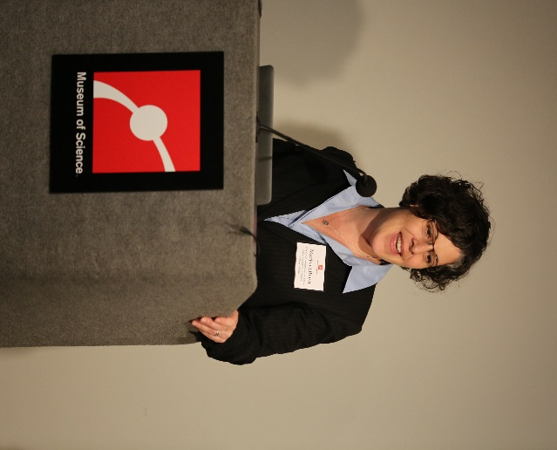
Welcome/Introduction
Have the host of the forum provide a welcome to the museum/institution as well as provide an introduction to the format and the topic of the forum.
Introduce the speaker(s) – obtain speaker biographies beforehand to use for introducing each speaker.

Speakers/Experts Present Topics, or Show Video
You may choose to have one or two speakers. If you have two, one speaker/expert gives an introduction to the science, technology, or engineering topic (20 minutes max) and another speaker/expert discusses societal and/or ethical implications (20 minutes max).
In some cases, finding a speaker is difficult or not desirable, and in those cases, there are often videos that can present background information to participants. Forum programs available online will often come with some recommended videos.

Q&A
Take approximately 5 minutes after the speaker(s) for the participants to ask any clarifying questions.

Group Deliberation
Have the host go over the ground rules for group conversation. These rules can be found in the Ground Rules section (page 14).
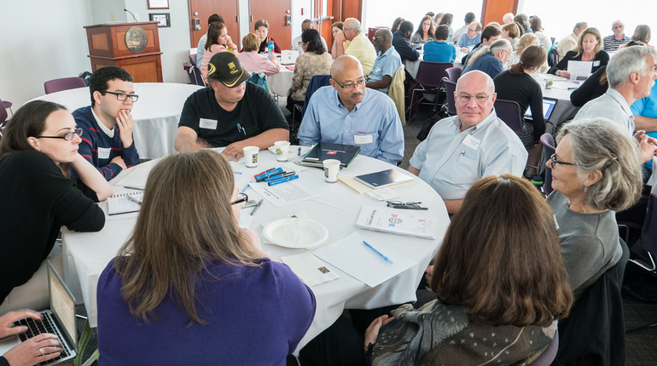
Each forum will usually include specific scenarios to stimulate conversation related to the more general topic of the forum. Have groups sit around their table and talk about the questions and scenarios as described in the agenda. The conversation time will vary depending on the number of scenarios and the number of questions for each scenario.
Ask the speaker(s) to circulate throughout the room and go from table to table to answer questions that the participants might have. Or you can have tables come up with questions and write them down, collect them, and have the experts provide answers to the entire room.

Individual or Group Reflection/Report-Out
There are several ways to have the groups report-out on what they talked about. You may wish to have each table create a statement based on their conversation and report to the whole group, or ask volunteers to stand up and share with everyone what they talked about. Encourage the participants to keep their table’s report-out brief. It's also possible to collect data electronically on choices participants made. Questions aimed at facilitating this part of the conversation can be found in the Ending a Forum section (page 14).

Post-Forum Evaluation
Refer to the Forum Evaluation section on page 15.

Materials

Forum
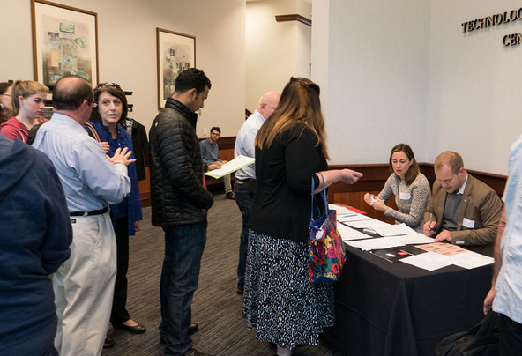
Photo Release Form: Prior to the start of the forum, have the participants sign a release form if you plan on taking pictures for later use. Note those who do not wish to have their picture taken and let your photographer know who they are. Most institutions require that some kind of photo release form be signed in order for you to circulate photos from your event. Whether or not this is a formal policy in your institution, you should always ask for permission before photographing participants, especially children. Getting signed releases gives you the flexibility to use your photos in newsletters, reports, and other settings. A sample form can be found in the Appendix (although you should check to see if your institution has a different form you should use).
Participants checking in at a registration table
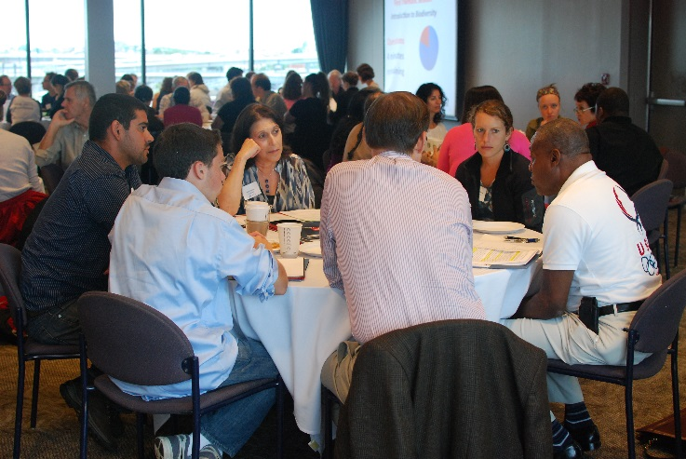
Conversation Materials and Scenarios: These are topic-specific for each forum and are included in the forum materials provided, either physically or for download. Feel free to modify or revise the materials to suit your needs and/or audience.

Room
Name tags for participants
Chairs arranged in groups of approximately 4-8, preferably around round tables
Tablecloths
Pens and paper for note-taking
Registration table
Pre-registered participant list
Refreshments/Water (optional)
Table for drinks and snacks (optional)

Speaker Setup and AV Needs
Podium
Microphone/Speakers
Projector/Computer
PowerPoint Slide Advancer

Evaluation
Evaluation forms
Pencils

Advance Preparations
This table represents an estimate of the staff time required to prepare and host a forum at your museum/institution. A brief description for each section listed in the table follows.

Staff Time Prior to Forum
Securing and prepping speakers | 10hrs
Marketing | 10
Pre-registration and communication with participants | 6
Event planning (assumes museum has tables, projectors) | 3
Document preparation (handouts, evaluations) | 4
Meeting with event volunteers and/or facilitators | 2
Staff Time at Forum
Forum host | 5
Additional staff | 6
TOTAL | 46

Securing and prepping speakers (or choose a video): Locate potential speakers from local universities, colleges, or research organizations based on their expertise and familiarity with the topic. It may be useful to become acquainted with someone at the local university who is in charge of communicating research or writing press releases about research that’s being done. This person will know what’s being done and who is doing it. You are looking for someone who can do a short introduction to the topic (generally about 10 minutes per speaker). It is recommended that you take the opportunity to meet with them to introduce yourself and the forum format before inviting them to speak. It is also a very good idea to make time to hear them speak to determine their comfort level and ability to address a public audience. Feel free to share with them any materials related to the forum, and don’t hesitate to ask to see their presentation beforehand to see if it fits with the forum topic and scenarios. You should also advise them who the audience will be and offer assistance in tailoring their presentation accordingly. Make sure to let them know that this is not a traditional lecture with Q&A, and that we seek more participatory dialogue. They need to be aware that participants really enjoy it when the experts engage in their conversations on the societal and ethical implication issues. Lastly, share the societal and ethical implications and forum scenarios (included with each forum package) for the speakers to review, if appropriate. If finding a speaker or speakers is not possible, you can instead decide to use one or more of the videos provided. If you choose to use a video, make sure you have watched it all the way through before showing it at your event.
Marketing: Attendance will vary depending on how extensively the forum is publicized. One thing that helps with marketing is mentioning that refreshments will be available (if you’re able to provide food) and to use language or marketing materials that your institution has found to work best with adult audiences.
The following methods are just a few ways to advertise your event:
Museum website/newsletter
Museum member email list
Social media (Facebook, Twitter, Instagram)
On-site marketing, including mentioning the event at regularly scheduled presentations, interpretations, and member events, as well as having flyers or slides up where people will see them
Local media outlets (newspapers, TV, community papers)
Craigslist (www.craigslist.org)
Meetup groups (http://www.meetup.com/)
Community calendars and email lists
Museum partner organizations
Posters/flyers
Area universities and colleges
Local businesses/organizations
Local research centers
Local Sigma Xi chapter (for scientists)
Local festivals or community events
Other email lists

How have different marketing methods worked for forums?
Past forum evaluations have investigated the effectiveness of marketing approaches. Two NISE Net formative evaluation reports identified strategies that worked in multiple museums for two different forum topics: a forum about nanotechnology in healthcare and another about nanotechnology and privacy. These reports outlined three primary approaches that were effective across these diverse contexts:
One strategy is to use internal email lists, member magazines, and lists of people who have previously attended similar programming to target people who already have a familiarity with your institution.
A second successful approach is to partner with community organizations that might be interested in the topic to target participants who are not already familiar with your organization.
A third approach is to work with related organizations to market the program to people who are already personally or professionally interested in the topic (Kollmann & Reich, 2011; Kollmann & Goss, 2011).
These three strategies point to the fact that different kinds of marketing are more or less appropriate depending on the target audience. Forum evaluations have also shown that certain audiences are attracted to different forum topics. For example, a NISE Net study found that forums about energy attracted more male participants; energy and consumer labeling events drew older adult participants; and forums about medicine drew more non-white participants than other forums (Kollmann, 2011). When developing a marketing strategy, it is advisable to consider what audience would be most interested, and to design your approach based on marketing techniques that are most likely to reach that group.
In general, marketing events prior to a forum is of great importance. During pilot events for the Building with Biology program, many sites relied on recruiting forum participants from the exhibit halls of their museums right when the program was about to begin. This often proved to be difficult. Many museum visitors were attending with children for whom the forum was not appropriate, and few visitors wished to commit to a lengthy program without prior planning.
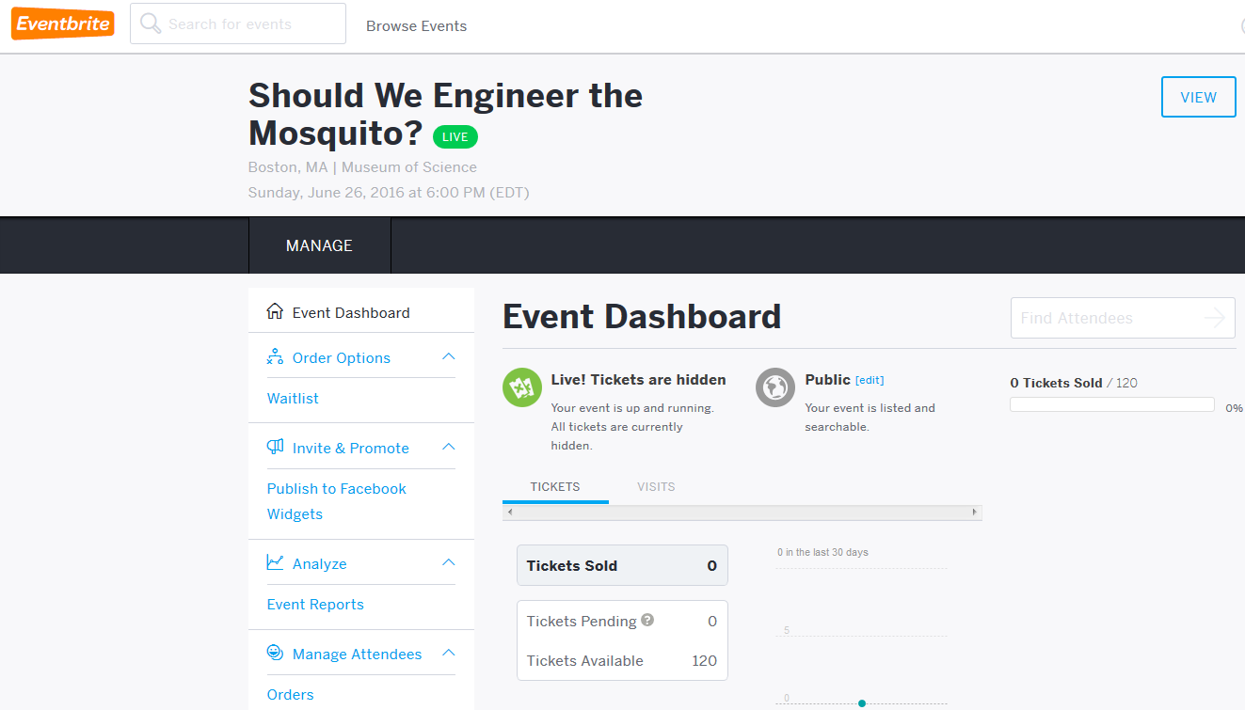
Pre-registration and communication with participants: There are several websites that allow you to manage a registration list. Some options are SurveyMonkey, Eventbrite, and Google Forms. Having participants pre-register using an online survey resource will allow you the opportunity to poll them prior to the event to obtain needed pre-forum information such as their email addresses; relationship to the forum; museum, community or business affiliation; how they heard about the forum; and any accommodations for people with disabilities. (Refer to the Registration Survey found on page 20.) This will allow you to keep track of who comes to the forum, learn a little bit about them, and make changes to your setup based on participants with disabilities (i.e. ASL interpreters). It is highly recommended that you send out an event reminder a few days prior to the forum.
Event planning: Secure the location for your event well in advance to ensure availability. If your museum/institution does not have tables, you may wish to rent them from an outside company. Round tables are preferable for the small group conversation part of the forum. Place chairs around each table and then place any necessary documents (evaluation forms, scenarios, background information sheets, etc.) at each table for the participants. Providing refreshments for the participants is optional but recommended. You may wish to place water at each seat or table or locate it near the back of the room for those who want it. If any registered guests require additional accommodations please note what they are and make any arrangements possible to accommodate them.
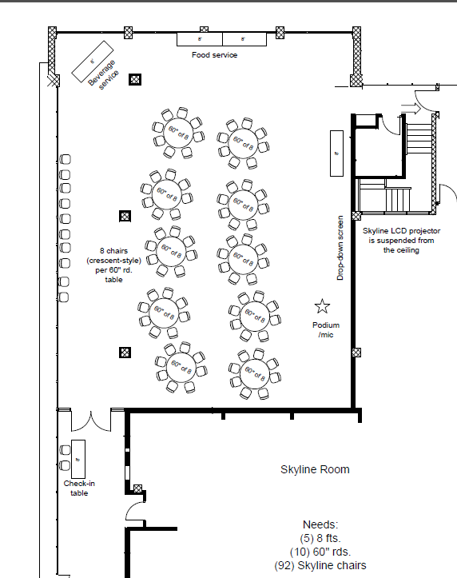
Example floorplan for a public forum

Document preparation: All necessary documents (evaluations, scenarios, background information, etc.) for each forum should be provided to you either physically in a kit that is mailed to you or electronically on the specified website for download. Download and print all necessary materials prior to the forum and place the necessary documents at each table. It may be useful organize materials in folders so they are easier to track and reference throughout the forum.
Forum host: Prior to the forum the host should gather the speakers’ CVs and other related information and synthesize them into a brief speaker introduction, or preview the videos if videos are being used instead of a speaker. The host should also become familiar with the forum format and topic prior to event. During the forum the host should introduce the event, give the group conversation instructions and facilitate the report-out section. The host should also run the question and answer segment after the speakers have presented. The host may also be a table facilitator if necessary, but it will be easier to have separate table facilitators, if facilitation is desired (see next section).
Additional staff: Additional staff may be needed to market the event, help set up the room with the tables and chairs, print forum documents and place them at each table, register participants as they arrive, and facilitate and take notes at breakout groups. Museum volunteers or graduate students of the speaker(s) can be a great help with some of these roles.
Additional preparations: Read the materials for each forum to become familiar with the forum. If you have never participated in or hosted a forum, you may wish to pilot a forum with your museum/institution staff or volunteers.

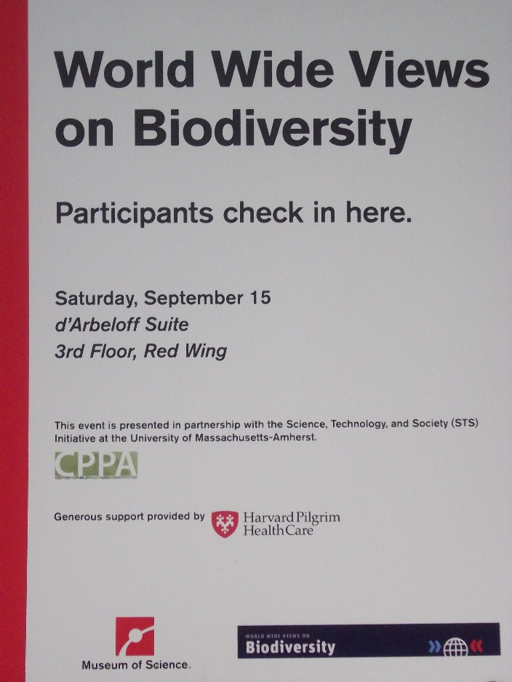
Setup
About an hour and a half prior to the event, have the registration/check-in table (optional, depending on your institution), signs, photo release form, and the pre-registered participant list ready. Set up and check the AV equipment (if needed) an hour before the event to make sure it is functioning properly. Have the tables and chairs set up with evaluation forms and any necessary forum materials at each seat.
The host should reserve time to review notes for introducing the forum, introducing the speaker(s), providing forum ground rules for the participants (unless facilitator will do so at each table), and guiding the flow of the event.
Example sign for a check in table at a public forum

Group Facilitation
The kind of group conversations that naturally take place regularly in life may or may not lead to a productive learning experience outcome. Often those conversations take place among people who all think about things in the same way and share the same values, and so new perspectives never arise. At other times differences of opinion lead to debate rather than dialogue, with participants focused on winning the argument rather than listening to the views of others. Arguments easily get sidetracked and no progress is made. Small group conversations in forum programs, therefore, require some type of facilitation strategy. One strategy for ensuring that everyone gets a chance to speak is to put a facilitator at each table. Another way is to use materials that facilitate the process, along with the host helping people to stay on track. In this second strategy, it is useful to put a copy of the ground rules (next section) on each table.

Ground Rules
Some good general rules to follow are:
- Be respectful of others’ opinions
- No interruptions
- Give everyone a chance to speak
- All ideas are OK
- Collaborate and focus on solving shared problems
- Assume that many people have pieces of the answer
- Listen to understand, find meaning, hear new options, and find agreement
- Consider a variety of solutions and approaches and develop common ground around those approaches together
- Reveal assumptions for reevaluation
You can put these on a tent card at each table so that everyone is on the same page.

Facilitating without Facilitators at Each Table
Facilitators at each table are not always available or within the budget of the event. In those cases other strategies can help to facilitate small group conversations. For Building with Biology, facilitators are not necessary because the materials should be able to guide participants through the process.
Another example of materials that can guide participants through the forum process is PlayDecide. For more information on PlayDecide, see the Example Public Forum Materials section on page 25.

Ending a Forum
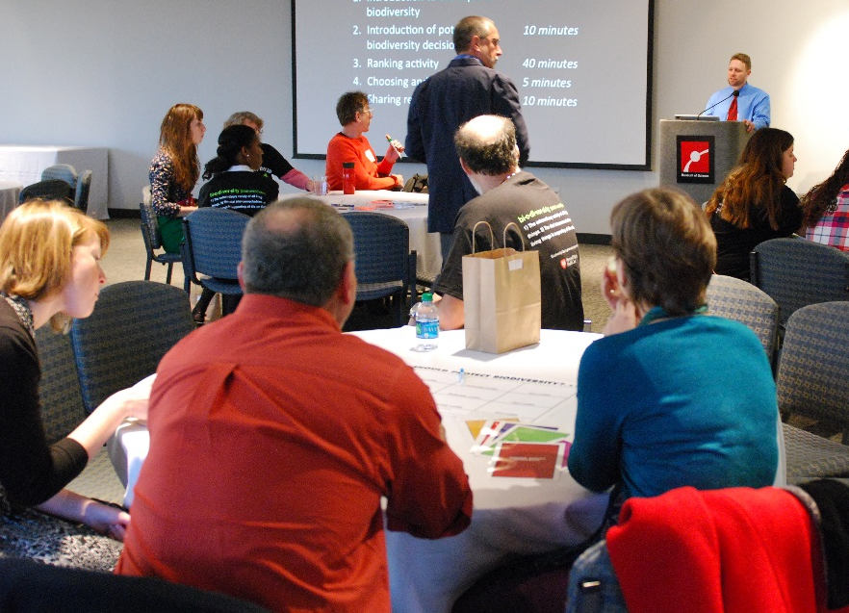
Before ending a forum you may wish to have individuals or a member of each small group report-out to the whole group some of the key points they talked about during the deliberation. The forum host may wish to enhance the report-out session by asking some of the following generic questions.
A forum host facilitating groups reporting out at the end of a forum
- What are some of the key points made in your group’s conversation?
- How did your or your group’s thinking change as a result of the forum?
- How has your thinking about other people’s views changed as a result of this forum?
- How has your perspective changed as a result of what you heard in this forum?
- How has this issue affected you personally?
- Were there any questions raised in the scenarios that made people uncomfortable?
- Did anything that you learned or that someone said during the conversation surprise you?
- Did anything in particular impact your point of view or change the way you feel about this technology?
- Is there anything now that you would want more information about?
The host should remain impartial and encourage other participants to respond to the comments from each report-out. Additional follow-up statements may be provided with the forum. If there is a speaker, he or she can serve as a “client” for the report out, and can provide some closing thoughts in response. If there is no speaker, it can be nice to have a partner present who can receive the information, such as a scientist, policymaker, or community leader.

Cleanup
Taking down the AV equipment, bidding guests and speakers farewell, and cleaning up the space can take up to an hour. Satisfied speakers and participants tend to linger and continue to discuss the topic. This is to be expected with a forum. It is helpful to have someone cleaning up while at least one other person plays genial host.

After the Forum
You should write an email thank you note to your speakers the day after your event, and follow that up with a physical thank you note to each of your speakers within a couple of days. A nice variant on this is to use a photo of them speaking at the event and print it on a card using a service like Shutterfly or Snapfish. Then you can write in the personalized card and mail it to them. Speakers have mentioned that they have kept those cards on their desks for a long time after receiving them.
If there are any results from your forum that will be shared with policymakers, scientists or other experts, or other groups, it is nice to let your participants know that you are going to or have done this. It adds to the satisfaction of participating to know that your input is being used for something after the event is over.

Forum Evaluation
Evaluating your forum can help you better understand your program and learn how to improve it for the future. Additionally, leaders of the Building with Biology team are interested in understanding how their forums impact difference audiences including scientists and publics. The Building with Biology Evaluation Team will provide several resources for forum evaluation, including a webinar about evaluating forums and a survey you can use to collect data from participants. In addition to this manual, information about these resources will be available at buildingwithbiology.org/project-evaluation.
In order to help the project better understand forum outcomes, the Evaluation Team has created a Forum Survey (see Appendix) that focuses on the following evaluation questions:
- What do scientists and publics learn from their experience? From each other?
- Does participation increase scientists’ and publics’ interests in PES or synthetic biology? If so, how?
- What follow-up behaviors does participation prompt in scientists and public audiences?
- What do scientists and publics value about their participation in PES?
The Forum Survey also includes several questions about how participants view the field of synthetic biology. This data will be shared with researchers who are investigating public perceptions of this emerging field.
If you are the recipient of a 2016 Building with Biology forum stipend, you will be required to participate in a coordinated evaluation effort led by the Building with Biology Evaluation Team. Stipend recipients will need to select one person who will be responsible for:
- Providing documentation that they have completed human subjects training from NIH or CITI. Documentation can be an existing completion certificate or the data collector can complete a 2-hour of Human Subjects online training course prior to the event (the online training from NIH is free to complete and can be found at https://phrp.nihtraining.com/users/login.php).
- Attending a 1-hour Building with Biology forum evaluation webinar prior to the event.
- Collecting data from forum participants using paper copies of the Forum Survey that the Evaluation Team will provide.
- Mailing the data to the Evaluation Team after the event. The Evaluation Team will provide a pre-paid envelope to send the materials.
Once this process is complete, each stipend site will receive a report that summarizes the data from their forum. If you have questions about the forum evaluation for stipend recipients, please contact Elizabeth Kollmann at ekollmann@mos.org.

Measuring the outcomes of your forum may also be of interest to your own organization because forums often lead to different types of outcomes than other programs you may be used to running. For example, at the Building with Biology pilot events in 2015, forum participants, who were a part of more in-depth conversational experiences, valued different things than participants who interacted with the hands-on activities, which were shorter experiences. The three most common things forum participants valued were hearing diverse viewpoints, discussing the topic with others, and considering or sharing opinions. The three most common things hands-on activity participants valued were the opportunity to listen, the opportunity to learn, and the positive experience for children (Cohn, Kollmann, Ong, Pfeifle, & Todd, 2016).
In addition to helping you understand your program, evaluation can help you learn how to improve your program. The Registration Survey (see Appendix) gathers some basic information about the people coming to your forum. This survey is designed to be used as part of the sign-up process. Please feel free to modify the questions in a way that best suits your organization’s needs. Rather than measuring the outcomes of the forum (as the Forum Survey does), this survey helps you understand who is coming, how they heard about the program, and whether they have any needs you can address. This information may help you to adjust your forum so it better suits the needs of your attendees. It may also help you learn what marketing strategies are most effective at attracting participants to a forum held at your institution.

Appendix

Forum Survey
See the next two pages.
Forum Survey
Are you 18 or older? If so, please tell us about your experience!
Participation is voluntary. All responses are anonymous.

- Thinking about your experience at this forum, how much do you agree or disagree with each of the statements below? (Please check)
 | Strongly disagree | Disagree | Agree | Strongly agree
I shared my views about synthetic biology.
I considered the benefits of synthetic biology.
I considered the risks of synthetic biology.
My group’s final plan reflected my personal views.
I learned about viewpoints different from my own.
I enjoyed this event.

- What, if anything, did you learn from participating in this forum?

- Did both scientists and non-scientists participate in your group discussion? (Please check)
Yes No I’m not sure

- What, if anything, did you learn from other participants during this forum?

- How much did you know about the following topics BEFORE this forum, and how much do you know AFTER the forum? (Check one ‘BEFORE’ and one ‘AFTER’ for each topic)
 | BEFORE the forum, I knew… |  |  |  | AFTER the forum, I know…
 | Nothing | A little | Some | A lot | Nothing | A little | Some | A lot
Facts about synthetic biology
Applications of synthetic biology
Societal aspects of synthetic biology
What other people think about synthetic biology
- How much did this event increase your interest in the following? (Please check)
 | Not at all | A little | Somewhat | A great deal
Checking out news stories (online, TV, and/or print) about synthetic biology
Learning about how synthetic biology is connected to my daily life
Talking to a scientist about the impacts of scientific research in my community
Sharing my views about synthetic biology with friends and family

- What, if anything, did you value about your participation in this forum?

- Do the following statements apply to you? (Please check all that apply)
 | Yes | No
I am a scientist or engineer.
I am an undergraduate or graduate student in a STEM (science, technology, engineering, or mathematics) field.
I study or work in the field of synthetic biology.
I attended a Building with Biology orientation.
I am a museum staff member or ongoing museum volunteer.

- How did you hear about this event?

- What is your age? _____________ What is your gender? ______________________

Even if you’re new to the ideas in synthetic biology, your opinions can shape the development of its tools and applications. The next questions are from scientists who want to know what you think!
- What applications of synthetic biology would you like scientists and engineers to work on? (Please check all that apply)
- Agriculture Fuel Software
- Electronics Medicine Other: __________________
- Food Personal Care None of the above

- How might synthetic biology change our lives?

- What question would you most like to ask a scientist about synthetic biology?

Registration Survey
Use these questions on the forum online registration survey so that there is a record of who is coming and what their needs are. You can also ask what marketing methods attracted people to the forum. Questions can be added, changed, or removed as needed.
1. Registrant name:
2. Registrant email address: (We will only use your email address to confirm your registration.)
3. How did you hear about this program? (Please check all that apply.)
❏ From the institution’s website
❏ From the institution’s Facebook page or Twitter account
❏ From Craigslist
❏ From Meetup
❏ From another website
❏ From an institution email
❏ From a non-institution email
❏ From a paper mailing
❏ Through a club/organization
❏ Through a friend/family member
❏ Through my work
❏ Through my college/university
❏ From print media (newspapers, magazines, etc.)
❏ Other:
4. If you are registering other individuals, please enter their name(s) and email address(es). We will send a separate confirmation email to them within a few days. Without providing this information, other individuals will not be registered.
5. Do you have any specific accommodation requests?
6. Would you like to be notified by email about future museum events?
❏ Yes
❏ No

Media Consent and Release
Photo Consent and Release
I, ___________________, hereby authorize [the Institution] to photograph, audiotape, and/or videotape me and grant [the Institution] the irrevocable right to use my photograph, audio recording, video recording, or any reproduction or modification thereof (the “Photograph”, “Audio”, and/or “Video”), in any manner or medium throughout the world an unlimited number of times in perpetuity in advertising, trade, promotion, exhibition, or any other lawful purpose.
I understand that I will not receive any monetary compensation for the permissions I am granting herein. I hereby waive any right of inspection of approval of the uses to which [the Institution] may put the Photograph, Audio, and/or Video. I acknowledge [the Institution] will rely on this permission and hereby release and discharge [the Institution] from any and all claims and demands arising out of or in connection with the Photograph or the exercise of the permissions granted here, including any or all claims for libel, invasion of privacy, or emotional distress.
I understand that I cannot withdraw my consent after I sign this form and that this consent and release is binding on me and my heirs, legal representatives and assigns.
YES NO (please check)
☐ ☐ I grant permission for Photographs to be collected and used by [the Institution].
☐ ☐ I grant permission for Audio to be collected and used by [the Institution].
☐ ☐ I grant permission for Video to be collected and used by [the Institution].

Date: ____________________ Signature: _____________________________________

Address: ________________________________________________________________

Telephone Number: __________________ Email Address: _______________________
If the individual named above is under 18 years of age, please complete the following:
I am the parent or legal guardian of the individual named above, and I hereby sign this Media Consent and Release on behalf of such individual in accordance with the statements above.
Date: ________________________ Signature: ______________________________________________
Address: _____________________________________________________________________________
_____________________________________________________________________________________
_____________________________________________________________________________________
Telephone Number: ___________________________________________________________________

Three Big Ideas in Technology and Society
This guide is focused on “three big ideas” that can provide a framework to help museum staff and participants feel empowered to reflect on the relevance of new technologies in their lives through open-ended conversation.
These three ideas don’t necessarily provide clear answers about technology and society, but they can help us to better understand the implications of technology and formulate better questions about the role that technology plays in our lives today and in the future. These three ideas provide us with a way to think about the larger implications of technology.

Values shape how technologies are both developed and adopted
Every time we make a decision about technology or science, we are making a values decision. When we choose what to study, what to buy, or how to use a technology we are deciding what is most important to our families, in our jobs, and for our communities. In this process—whether we are conscious of it or not—we look at the possibilities, reflect on our values, and then change the world—even if it is in a very small way.
This is perhaps most easily seen in the decisions we make as consumers. When we buy technologies we are often motivated by our goals, hopes, and dreams. We buy a hammer because we want to fix our house without having to pay an expensive contractor. We buy a computer so that our children can be better prepared for school. And we buy a 1967 Alfa Romeo 1600 Duetto Spider sports car because we want to cruise along the beach with the wind in our hair. In each of these cases we have a set of values we want to advance, and we choose to use a technology to advance them.
When we use technologies we also play a role in deciding which values are advanced and which ones are not. For instance, when we are worried about being late to work and drive 100 miles an hour to get there, we are prioritizing our time (and perhaps our reputation) over safety. When we handwrite a letter to a loved one rather than send an email, we prioritize being personable over being fast. Whether we choose to read a book or watch a movie depends on how we want to challenge our imagination.
Values also shape what scientists and engineers do. A combination of different values can motivate people to become scientists and engineers. They may do it because they find it fun. They may do it because they think they can make a lot of money at it. And they may do it because they hope to make the world a better place through innovation. Their work, in turn, has an impact on values—sometimes well beyond their knowledge.
Scientists, corporations, and funding organizations (like the US government) make incredibly powerful value decisions about science, technology, and engineering when they decide what work to pursue. They may choose to prioritize research on diseases that are prevalent in the United States and other wealthy countries, or diseases that affect significantly more people in the developing world, like malaria. They may decide to focus on developing medical technologies that help us live longer, or medical technologies that help us keep our independence later in life. And they may choose between developing technologies specifically for military use, or shifting funds and attention to solving domestic problems. As citizens, voters, and consumers we can exert some influence over these important decisions, especially when we recognize them as values decisions and not just technical decisions.
Unfortunately, making these decisions is not always easy because values are often in conflict. Sometimes different groups have different values—as when environmental groups prioritize protecting marine habitats and demand that ocean oil drilling be banned, while oil companies prioritize the nation’s economy and argue that the ability for millions of Americans to drive to work depends on such drilling.
We can also have conflicting values in ourselves. We would probably all like to get to work faster in the morning, but would also like to arrive safely. We must carefully think through our values as individuals and as larger communities to make better decisions about the technologies we research, buy, and use. Remembering that our values—and the values of others—are at stake in these decisions can help us make more informed decisions about technology.

Technologies affect social relationships
When we think of the impacts of technologies, we often focus on the technical details. A turbo diesel engine can make a car more fuel efficient. A new microchip can make a cell phone smaller. A fiber optic connection can make data transfer more reliable. But technologies also impact relationships between people. Sometimes these are small. When you buy a GPS system you are less likely to ask a friend or relative for directions. But sometimes they are much bigger. A hundred years ago, extended families tended to live close to each other—even in the same house. With the development of new transportation systems like airplanes and cars, coupled with instant communication systems like telephones, people can still feel connected to their families even if they live far away. Families in the United States now are often spread all across the country—a significant social change from the way life used to be.
Sometimes technologies are designed with the specific intention of impacting the relationship between people. Traffic lights tell drivers how to behave—and who has the right of way—when they arrive at an intersection. Wheelchairs help to reduce the divide between people with different walking abilities. Automated checkout machines eliminate our need to interact with grocery store clerks, and may ultimately result in grocery stores eliminating this position.
A technology like Facebook can impact relationships in a variety of ways. It can help us share information and stay connected and up to date with old friends. It can be used by companies to screen potential employees for potentially embarrassing personal lives. It can be used to communicate with people we have never even met face-to-face. And it can distract us from the people sitting next to us, perhaps harming our personal relationship with them.
Technologies impact all aspects of our society. Thinking about how a technology changes our relationships with our parents, our significant others, our friends, our co-workers, and even people we’ve never met face-to-face can help illuminate the ways in which our society and technology are interlinked. With this reflection we can choose technologies—and adapt the way we use them—to prioritize the types of relationships that we hold most dear.

Technologies work because they are part of larger systems
It can be tempting to think that technologies are devoid of values because they are simply pieces of plastic or a tangle of circuits. But technologies don’t work unless they are linked to larger systems. For instance, a cell phone does nothing without cell phone towers to relay messages, a power supply that can recharge a battery, and a company that routes the calls to the numbers dialed. Only when you look at the larger system you can see why the technology works. And by looking at that larger system you can also better see the impact that a technology might have on the world.
Let’s take a single carefully wrapped hamburger that you might buy at a grocery store as an example. It may seem a little odd to think of a hamburger as a technology, but it is a product of human ingenuity. It is the carefully crafted result of a large system that includes numerous people, technologies, institutions, and decisions. A farmer must raise the cow and decide what to feed it, whether to let it graze freely, and whether or not to treat it with antibiotics and growth hormones. A slaughterhouse must decide how to cut the meat, how to keep its equipment clean, whether to slaughter multiple animals together (risking contamination), and whether to take the extra steps to receive kosher or halal certification. A transportation company must decide how to move large amounts of meat around the country as well as what steps it will take to keep the meat fresh.
The United States Department of Agriculture must decide whether and how to certify the meat produced as fresh and safe to eat, how the hamburger should be labeled, and how it should be described in the food guide it produces to inform people’s eating habits. And the grocery store must decide how to package it, how to display it, and how much to charge.
Every step in the process of putting that hamburger in front of you involves important value judgments. By seeing the hamburger as part of a larger system you can observe all the different pieces and the values that go into it. By thinking through the larger system behind the technology you can decide how you want to be associated with it. Such a reflection can empower you as a consumer and as a citizen. When you buy a technology you become part of the systems around it.

Example Public Forum Materials
Building with Biology
http://www.buildingwithbiology.org
- Should We Engineer the Mosquito?
- Editing the Genome: Now We Can. Should We?
National Informal STEM Education Network (NISE Net)
http://www.nisenet.org
- Privacy. Civil Liberties. Nanotechnology.
- Nanomedicine in Healthcare
- Energy Challenges, Nanotech Solutions?
- Risks, Benefits and Who Decides?
- Same Sides and Let's Talk About It videos
- Cognitive Enhancement Teen Role Play Forum
World Wide Views
http://wwviews.org
- Climate and Energy
- Biodiversity
- Global Warming
Expert and Citizen Assessment of Science and Technology (ECAST)
http://ecastonline.org
- Asteroid Initiative
National Issues Forums
https://www.nifi.org/en/nifi-materials
- Climate Choices
- Prosperity
- Health Care
PlayDecide
http://www.playdecide.eu/
- PlayDecide is a discussion game designed to help participants talk in a simple and effective way about controversial issues. There are games on 23 topics in 20 languages. The games use a game board or "placemat" for each player, and stacks of story cards, info cards, and issue cards. The placemats provide the instructions for the game, including ground rules and times allotted to the different phases of the game, and the cards ensure that everyone participates. Ultimately the group develops a shared group response to four proposed policy issues and/or writes their own. They record their final individual votes on the four or five policies and one person uploads the data to the PlayDecide website. Play Decide has inspired a variety of game boards, cards, sealed envelopes containing the next question or scenario, and other mechanisms for organizing the flow of the conversations at small tables. Event organizers, or whole-room facilitators can provide instructions at various points during the events, show videos, project a count-down clock to advance the conversations through several steps, and collect data on paper or electronically to tabulate intermediate and final results.
Consortium for Science, Policy, and Outcomes – Science, Policy, and Citizenship Program
http://cspo.org/research/science-policy-and-citizenship-program/
- Geoengineering
- Synthetic Biology
- Biodiversity
- Nuclear Power

Other Resources
- Nanotechnology and Society: A Practical Guide to Engaging Museum Visitors in Conversations http://www.nisenet.org/sites/default/files/catalog/uploads/12249/nanotechnology_and_society_guide_14nov13.pdf
- Museum & Community Partnerships: Collaboration Guide and additional resources http://www.nisenet.org/collaboration-guide
- NISE Network Public Forums Manual: http://www.nisenet.org/catalog/tools_guides/nise_network_public_forums_manual
- Science Cafe Guide: http://www.nisenet.org/catalog/tools_guides/science_cafe_guide
- Science Cafes: http://www.sciencecafes.org
- Teen Science Café Network: http://teensciencecafe.org
- National Coalition on Dialogue and Deliberation Resources: http://ncdd.org/rc/

References
Cohn, S., Kollmann, E.K., Ong, A., Pfeifle, S., & Todd, K. (2016). Pilot events – summer 2015: Data collected from forum participants. Boston, MA: Museum of Science.
Cohn, S., Kollmann, E.K., Ong, A., Pfeifle, S., & Todd, K. (2016). Pilot events – summer 2015: Data collected from forum participants. Boston, MA: Museum of Science.
Cohn, S., Kollmann, E.K., Ong, A., Pfeifle, S., & Todd, K. (2016). Pilot events – summer 2015: Data collected from visitors at Building with Biology events. Boston, MA: Museum of Science.
Flagg, B., & Knight-Williams, V. (2008). Summative evaluation of NISE network's public forum: Nanotechnology in health care. Bellport, NY: Multimedia Research.
Goss, J., & Kollmann, E.K. (2011). NISE Network forum: “Energy Challenges, Nanotech Solutions?” Formative evaluation. Boston, MA: Museum of Science.
Kollmann, E.K. (2011). Engaging the public with societal and ethical implications content through NISE Network products. In C. Reich, J. Goss, E.K. Kollmann, J. Morgan, & A.G. Nelson (Eds.), Review of NISE Network evaluation findings: Years 1-5 ¬(pp. 83-117). Boston, MA: Museum of Science.
Kollmann, E.K. (2011). Engaging the public with societal and ethical implications content through NISE Network products. In C. Reich, J. Goss, E.K. Kollmann, J. Morgan, & A.G. Nelson (Eds.), Review of NISE Network evaluation findings: Years 1-5 ¬(pp. 83-117). Boston, MA: Museum of Science.
Kollmann, E.K., & Goss, J. (2011). NISE Network forum: “Privacy. Civil Liberties. Nanotechnology.” Formative evaluation. Boston, MA: Museum of Science.
Kollmann, E.K., Reich, C. (2011). NISE Network forum: “Nanomedicine in Health” Formative evaluation. Boston, MA: Museum of Science.
Kollmann, E.K., Reich, C., & Lindgren-Streicher, A. (2009). NISE Network forum: “Risks, Benefits, and Who Decides?” Formative evaluation. Boston, MA: Museum of Science.
Kollmann, E.K., Reich, C., Bell, L., & Goss, J. (2013). Tackling tough topics: Using socio-scientific issues to help museum visitors participate in democratic dialogue and increase their understandings of current science and technology. Journal of Museum Education (38)2, 174-186.

Image Credits
Cover photo by Emily Maletz for the NISE Network.
All other images are by the Museum of Science, Boston.

