Exploring Tools—Special Microscopes

Try this!  - Turn a magnet over so it’s black side up. | 
- Use the “probe strip” the way it’s shown in the picture, and pull it slowly across the magnet from left to right. What do you feel?  - Now pull the strip across the magnet from top to bottom, in the way it’s shown in the next picture. Does it feel different? |   Left to right | 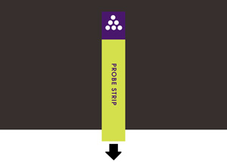  Top to bottom

How is this nano?

Scientists use special tools to work on the nanoscale. Scanning probe microscopes can detect and make images of individual atoms that are way too small to see.

The magnet is a model for how a scanning probe microscope (SPM) works. It lets you “feel” something you can’t see - a magnetic field! The north and south poles run in alternating bands across the magnet.

A SPM can also detect other kinds of things about a surface: nanometer-sized hills and valleys, atoms, conductivity, friction, stiffness, and more!

