Exploring Materials—Ferrofluid

Try this!

- Hold a magnet next to the vial of black sand. How does the sand react?  - Use the magnet to drag the sand up the sides of the vial. What happens when you remove the magnet?  - Now try the same things with the vial of ferrofluid. Does the ferrofluid act the same way the sand does? | 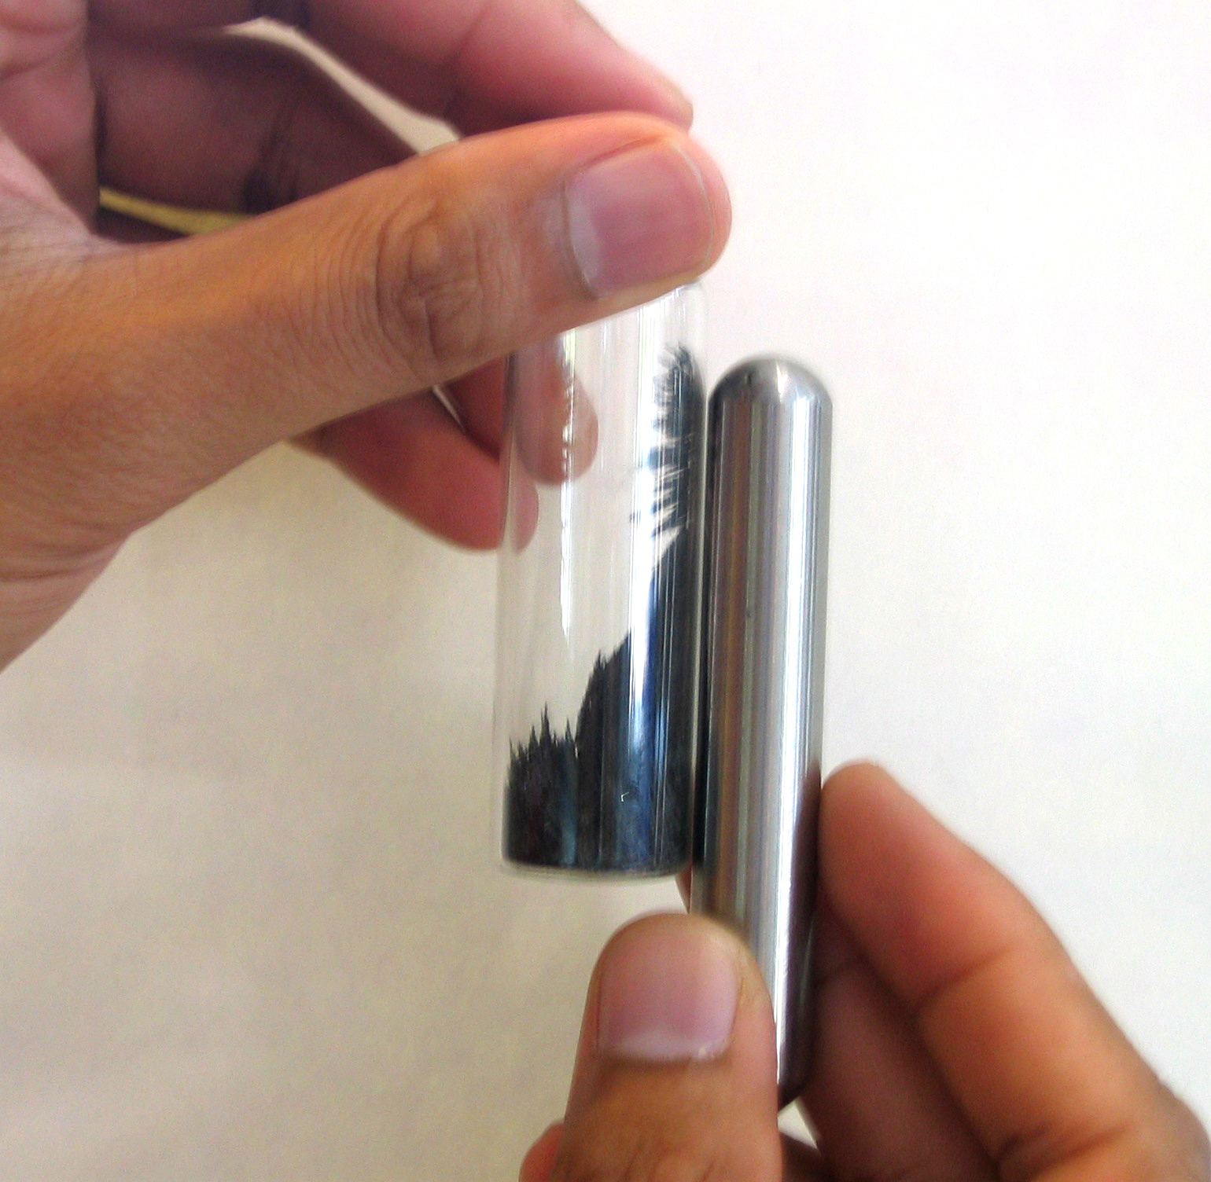  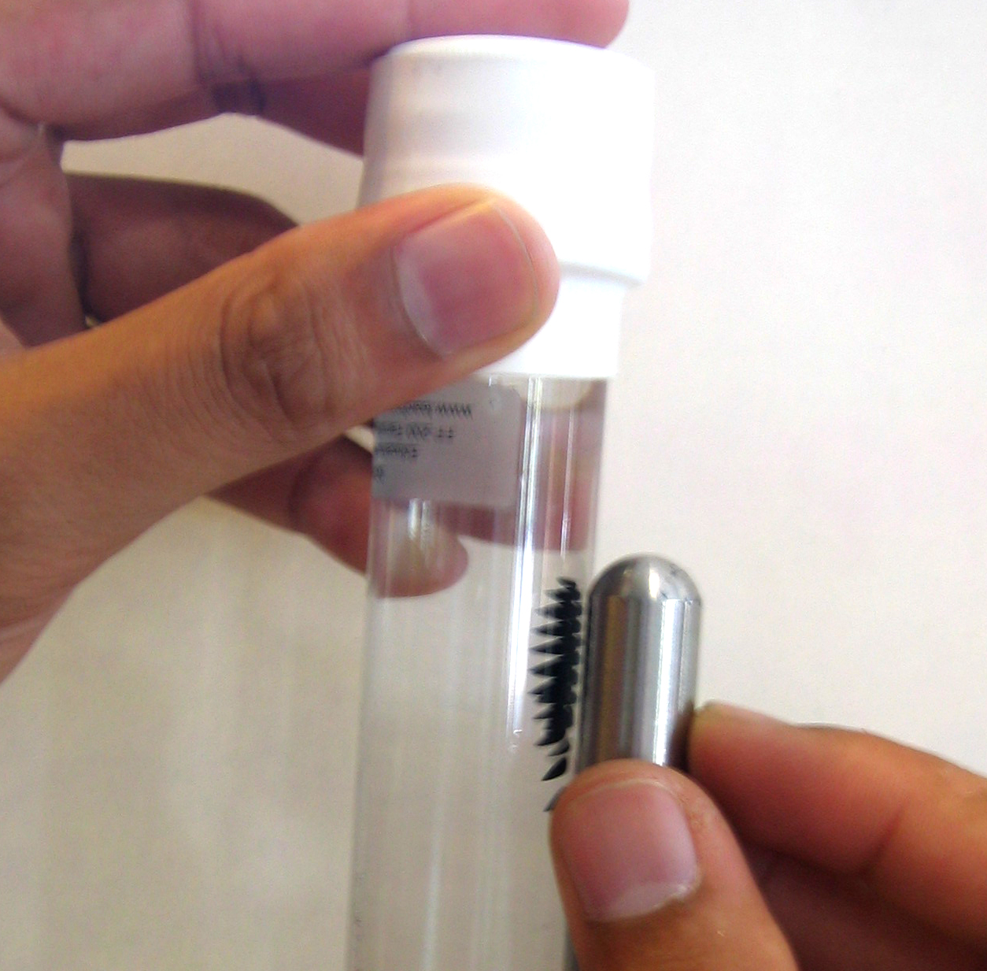
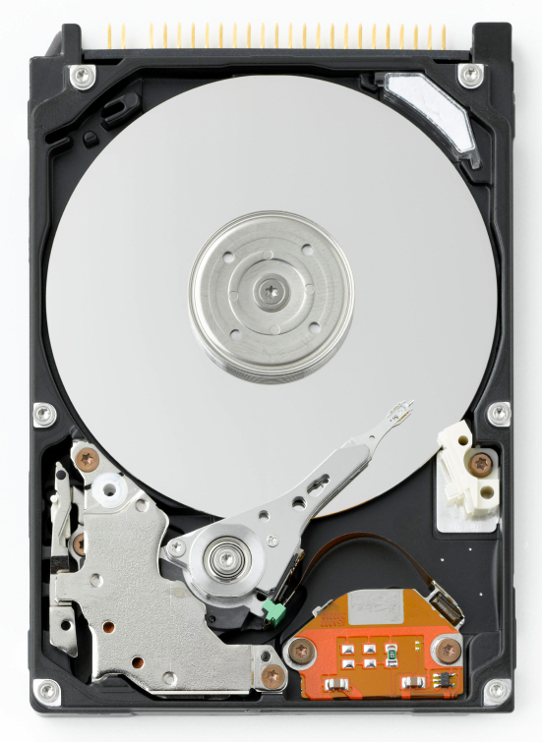  Inside a hard drive | How is this nano?  Ferrofluid acts like a magnetic solid and like a liquid.  Ferrofluid are nanometer-sized particles coated in magnetite suspended in liquid. When there’s no magnet around, ferrofluid acts like a liquid. When there’s a magnet nearby, the particles act like a solid.  Ferrofluid is used in computer hard drives and in loudspeakers. Ferrofluids may someday be used to carry medications throughout the body.

