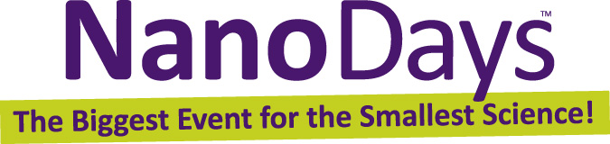

Tips for Visitor Conversations

Greet visitors
Say “hello,” make eye contact, and smile. Simply looking like you’re available and friendly will invite visitors to interact with you.

Let visitors do the talking
As much as possible, let visitors’ interests guide the conversation. You can help them reflect on their own ideas and form their own opinions. If visitors aren’t interested in an extended conversation, that’s fine.

Keep the conversation open-ended
In a conversation about individual values and perspectives, there’s no right and wrong answer. Your contributions can provide interesting things to think about, but shouldn’t suggest a conclusion.

Use examples from everyday life
Familiar examples can help explain abstract concepts. Be aware of visitors’ abilities, keeping in mind that children do not have the same skills or vocabulary as adults.

Ask questions
Help visitors observe and think about the activity. Try to use questions that have more than one answer, such as the ones included in the activity guide.

Be a good listener
Be interested in what visitors tell you, and let their curiosity and responses drive your conversation forward.

Offer positive and encouraging responses
When visitors are having trouble articulating their thoughts, you might say, “That’s an interesting idea. Why do you think that?” or “Have you thought about…?” Offer them an opportunity to reflect further.

Share accurate information
You can provide additional information or a different perspective, but maintain a neutral position on issues. If you aren’t sure about something, it’s OK to say, “I don’t know. That’s a great question!” Suggest that visitors go to whatisnano.org to learn more about nanoscale science, engineering, and technology.

Remain positive throughout the interaction
Keep things upbeat and positive. Remember that nonverbal communication is important, too. Maintain an inviting face and body language.

Thank visitors
Wrap up the conversation whenever it has run its course. A brief interaction is fine! As your interaction ends, suggest that they explore other NanoDays activities.

HAVE FUN! ☺ A positive experience will lead to learning.

 | This project was supported by the National Science Foundation under Award No. 0940143. Any opinions, findings, and conclusions or recommendations expressed in this document are those of the author and do not necessarily reflect the views of the Foundation.

Copyright 2011, Sciencenter, Ithaca, NY. Published under a Creative Commons Attribution-Noncommercial-ShareAlike license: http://creativecommons.org/licenses/by-nc-sa/3.0/us/

