

Exploring Materials—Nano Gold

Try this!  Look at the three containers. Which one contains gold?  What’s going on?  All three containers have gold in them! The difference in their appearance is due to the size of the gold particles. | 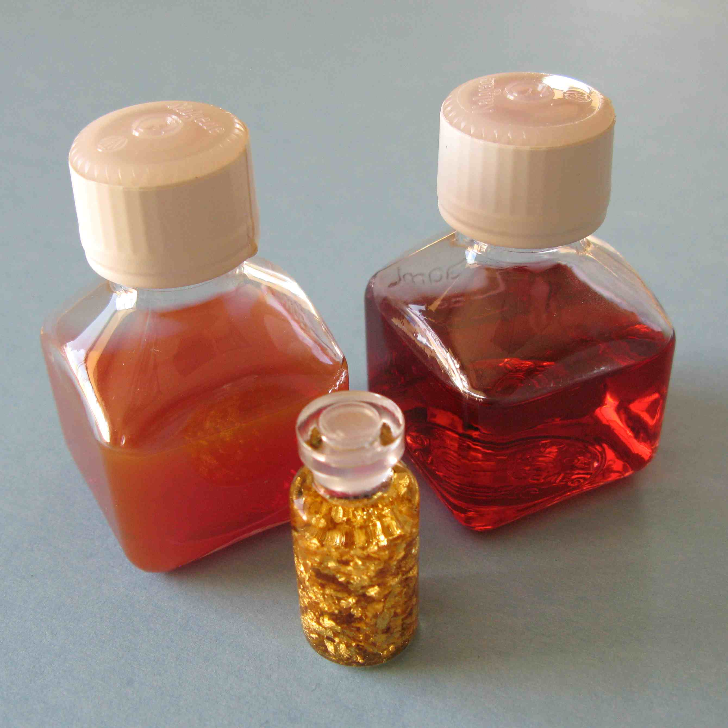

Large pieces of gold, like the flakes in one of the vials, look shiny and golden. But when gold gets very, very small, it looks different because it interacts differently with light. The containers with red and orange liquids in them have nano gold, tiny particles of gold so small that they’re measured in nanometers. A nanometer is a billionth of a meter—smaller than the wavelength of light.

Nano gold can look red, orange, or even blue! The color depends on the size and shape of the nanoparticles, as well as the distance between them. Here, the red nano gold particles are about 20 nanometers across, while the orange nano gold particles are about 80 nanometers across.

Take a look at the samples of stained glass. Their color comes from real gold! Nano gold has been used to make red stained glass since the Middle Ages. Different colors of glass contain different-sized particles of nano gold.
Now try…  - Place the container of orange (80 nm) nano gold on the white paper, and tilt the bottle.  - Shine the light through the bottle. What color do you see on the paper?  Tip: Squeeze the mini-light to turn it on. | 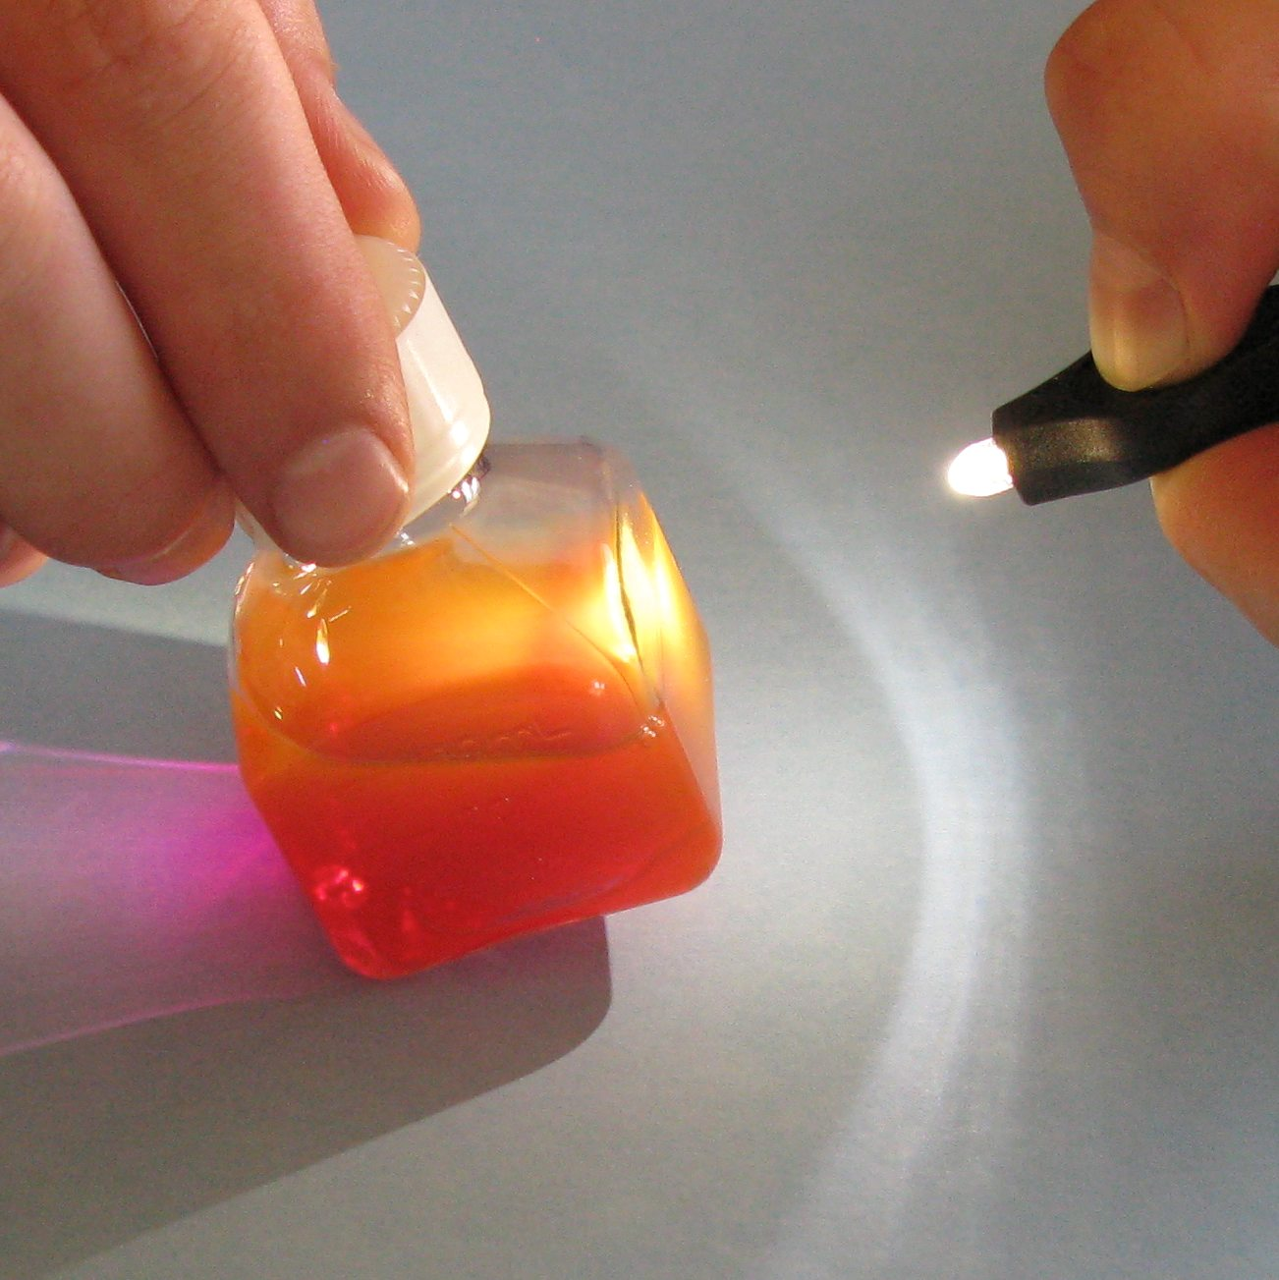
What’s going on?
Nano gold interacts with light in surprising ways. When you look at the container of 80 nm gold under regular ambient light, you see the longer, orange wavelengths of light that are scattered by the tiny particles of nano gold. But when you look at the light that shines through the container and onto the paper, you see the shorter, purple wavelengths of light that are transmitted by the suspension of nano gold.

How is this nano?
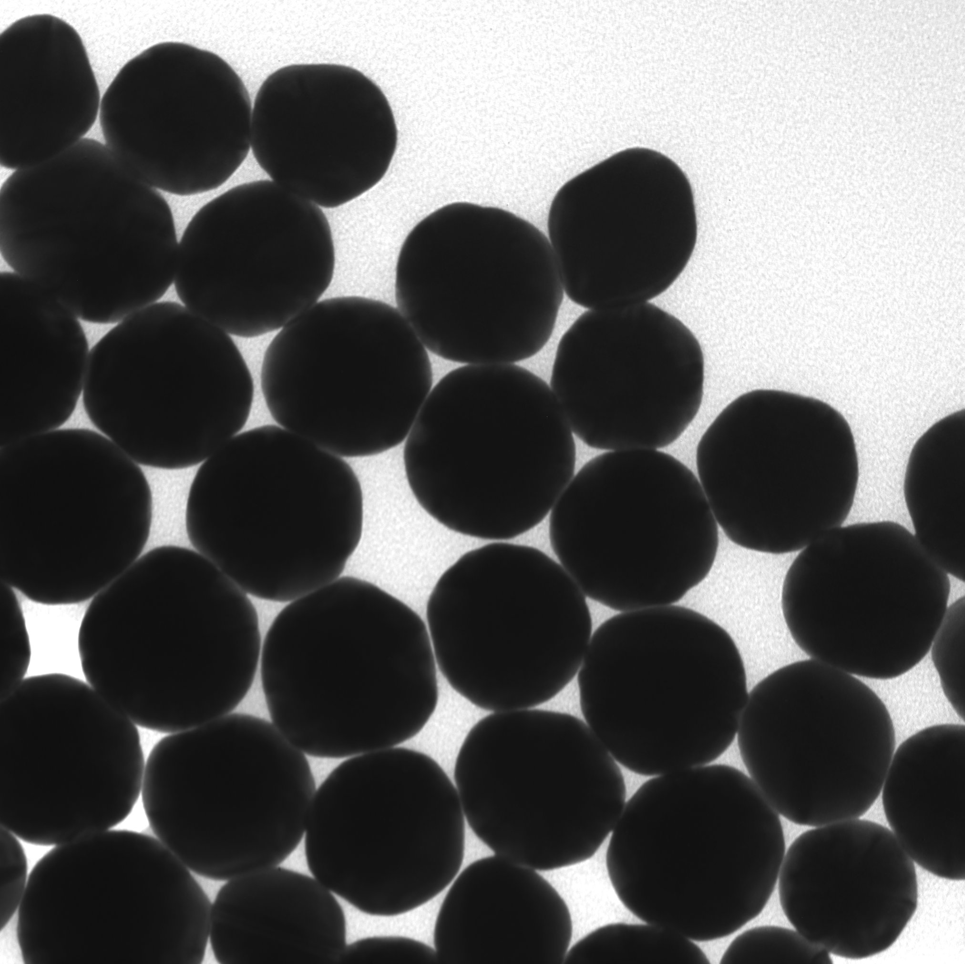  Nano gold particles  80 nm diameter | A material can act differently when it’s nanometer-sized. (A nanometer is a billionth of a meter.) Tiny particles of gold look red, orange, or blue—not shiny and golden.  Nanotechnology takes advantage of special properties at the nanoscale to create new materials and devices. Gold nanoparticles can be used as markers to indicate the presence of specific strands of DNA. And gold nanoshells—tiny spheres of glass covered with a thin layer of gold—are being tested as a part of a new cancer therapy.

Learning objective
A material can act differently when it’s nanometer-sized.

Materials

Vial of gold flakes
- Vial of red nano gold (20 nm)
- Vial of orange nano gold (80 nm)
- Samples of stained glass made with gold
- Mini-light (very bright white LED)
- Sheet of white paper
- Image of stained glass window

Vials of gold flakes are available from www.amazon.com.

Nano gold is available from www.nanocomposix.com (20 nm and 80 nm spheres are included in the NanoDays kit).

Stained glass samples made with gold are available from www.bullseyeglass.com (red #001311 and light orange #001823 are included in the NanoDays kit).

Notes to the presenter
SAFETY: Do not let visitors ingest the contents of the vials. Keep vials sealed shut.

SAFETY: Use caution when handling the stained glass samples. Do not remove them from their protective case.

Related educational resources
The NISE Network online catalog (www.nisenet.org/catalog) contains additional resources to introduce visitors to light and color at the nanoscale, nanomaterials, and nanomedicine:
- Public programs include Colors at the Nanoscale: Butterflies, Beetles and Opals; Nanoparticle Stained Glass; Nanosilver: Breakthrough or Biohazard?; Treating Tumors with Gold.
- NanoDays activities include Exploring Materials—Graphene, Exploring Materials—Hydrogel, Exploring Materials—Thin Films, Exploring Products—Sunblock, and Exploring Structures—Butterfly.
- Exhibits include Changing Colors, Nanomedicine Explorer, Treating Disease, and Unexpected Properties.

Nano Gold Background Information

What is nano gold?  Nano gold is tiny particles of gold that are so small they’re measured in nanometers. A nanometer is a billionth of a meter—smaller than the wavelength of light.  When gold is nano-sized, it has some surprising properties. For example, nano gold can look red, orange, or even blue. The color depends on the size and shape of the nanoparticles and the distance between them. | 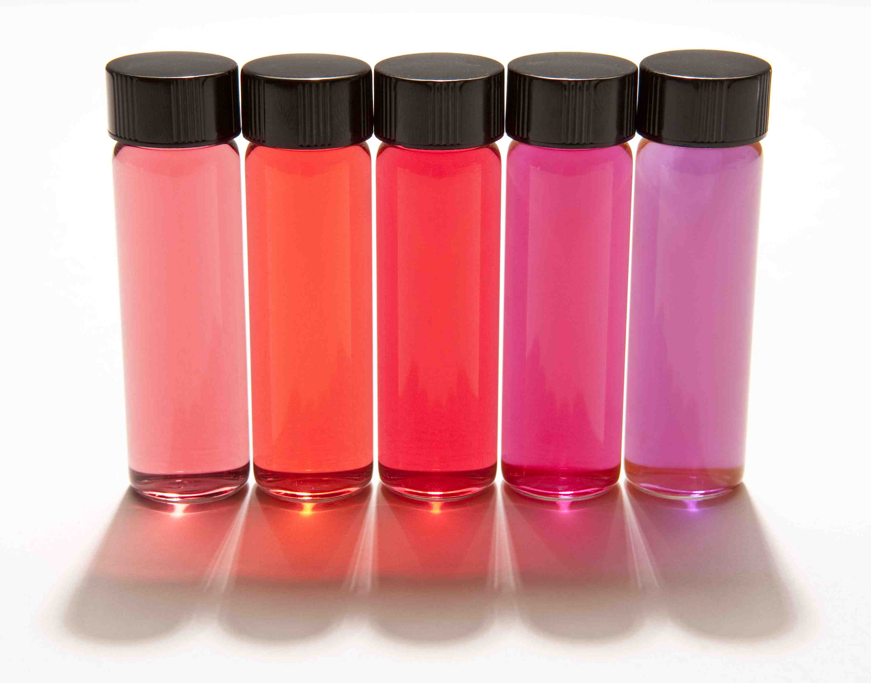  Nano gold
The different colors of nano gold come from a phenomenon called surface plasmon resonance. When light shines on the surface of a metal, it creates a surface plasmon, which is a group of electrons moving back and forth in sync across the surface of the metal. The electrons “slosh” back and forth on the metal surface, similar to the way waves of water move in a pond. When the electrons are moving at the same frequency as the light, the plasmon is said to be in resonance. When they’re in resonance, the electrons absorb and scatter light, producing the colors you see.
Nanoparticles of gold resonate at frequencies within the visible spectrum of light. Smaller nano gold particles absorb and resonate with purple, blue, green, and yellow wavelengths of light, so they look red. Larger nano gold particles absorb and resonate with green, yellow, and red wavelengths of light, so they look blue. | 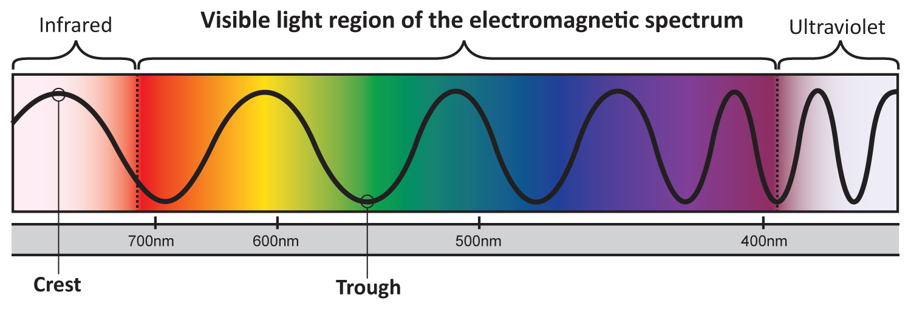

How is nano gold used?
Nano gold has been used to create the colors of stained glass since the Middle Ages. Different sizes of nano gold produce different colors of glass. Particles around 20 nanometers across produce red glass. Particles around 30 nanometers across produce pink glass, and particles around 80 nanometers across produce orange glass.

Today, gold nanoparticles can be used as markers to indicate the presence of specific strands of DNA. When strands of marked DNA combine, the gold nanoparticles come closer together, and the solution changes color.

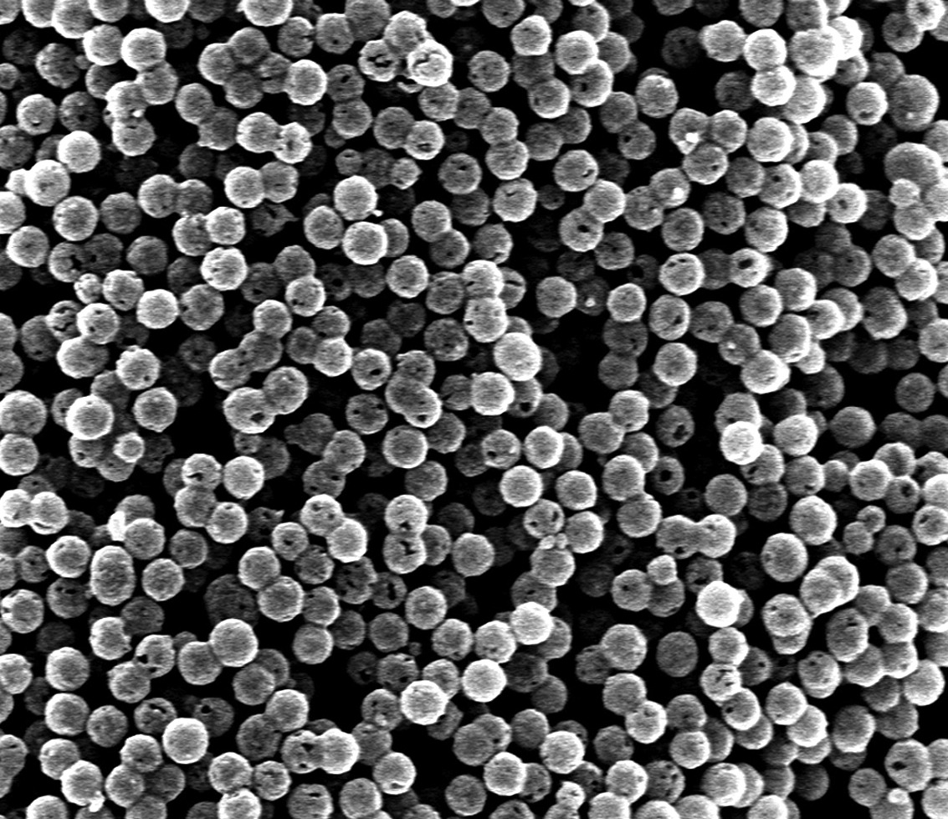  Gold nanoshells | Future cancer treatments might use gold nanoshells to fight tumors. Gold nanoshells are tiny spheres of glass covered with a thin layer of gold.  In an experimental treatment, gold nanoshells are injected into the body and collect in the tumor. Near-infrared light is then shined on the tumor. The light passes safely through healthy tissue, but heats the gold nanoshells and destroys the tumor. Pilot studies indicate that the treatment is successful, with minimal side effects.

Credits and rights
This activity was developed in consultation with Dr. Dave Sebba, nanoComposix.

Image of 80 nm nano gold particles courtesy nanoComposix.

Image of vials of nano gold in suspension courtesy nanoComposix.

Image of gold nanoshells courtesy G. Koeing, University of Wisconsin-Madison.

 | This project was supported by the National Science Foundation under Award No. 0940143. Any opinions, findings, and conclusions or recommendations expressed in this program are those of the author and do not necessarily reflect the views of the Foundation.

Copyright 2011, Sciencenter, Ithaca, NY. Published under a Creative Commons Attribution-Noncommercial-ShareAlike license: http://creativecommons.org/licenses/by-nc-sa/3.0/us/.

