The Future of Computing

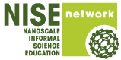
Organization: Museum of Science, Boston

Contact person: Karine Thate

Contact information: kthate@mos.org, 617-589-4483

General Description

Public Presentation with Demonstrations

“The Future of Computing” is a public presentation that looks at trends in computing technology and predicts what the future of computing might hold for us. Visitors are introduced to the idea of smaller, nanoscale transistors as the key to faster, more capable computers – and the barriers we face in continuing to shrink transistors to advance our computing technology (heat build-up, fabrication issues due to their small size, and quantum effects). Possible solutions include new materials for transistors like carbon nanotubes and graphene, or new paradigms for information processing like optical or quantum computing. Visitors are also asked to consider how smaller, faster, better computers in the future might impact their lives – in both positive and negative ways.

It is a slideshow presentation designed for medium-to-large audiences of teens/adults. The presentation could should be shortened and simplified if presenting to audiences with younger kids. It consists mostly of a lecture, with a few live demonstrations and audience interactions.

Program Objectives

Big idea: Our ability to shrink transistors down to nanoscale devices have led to continued advances in computing technology, but physical limits will soon prevent this trend from continuing. Nanotechnology provides some possible solutions to take our computing into the future – but we should also consider how smaller, faster, better computers may impact our lives in both positive and negative ways.

Learning goals:
As a result of participating in this program, visitors will be able to:
- Understand that transistors are tiny nanoscale devices in our computers and our ability to shrink transistors down to smaller sizes leads to advances in computing.
- Recognize there are barriers (heat, size, quantum effects) that prevent us from further shrinking transistors.
- Identify how new nanomaterials (carbon nanotubes and graphene) and nanotechnologies (optical computing and spintronics/quantum computing) could overcome these barriers and lead to faster, better, smaller computers.
- Recognize that the future of computers holds very promising applications that could improve our lives in a variety of ways, but we need to be aware of the risks (for example – privacy concerns with our personal data) that come with more advanced, capable computers.

NISE Network Main Messages:
[ ] 1. Nanoscale effects occur in many places. Some are natural, everyday occurrences; others are the result of cutting-edge research.
[ X ] 2. Many materials exhibit startling properties at the nanoscale.
[ X ] 3. Nanotechnology means working at small size scales, manipulating materials to exhibit new properties.
[ ] 4. Nanoscale research is a people story.
[ X] 5. No one knows what nanoscale research may discover, or how it may be applied.
[ X ] 6. How will nano affect you?

The Future of Computing

Table of Contents
General Description 1
Program Objectives 1
NISE Network Main Messages: 2
Table of Contents 3
Time Required 4
Background Information 4
Materials 5
Set Up 7
Step 1: 7
Step 2: 7
Step 3: 7
Program Delivery 7
Procedure and Discussion: 7
Tips and Troubleshooting: 15
Common Visitor Questions 15
Going Further… 16
Clean Up 17
Universal Design 17
Credits 17

Time Required

Set-up Program Clean Up
5 minutes 20 minutes 5 minutes

Background Information

Definition of terms
Nano is the scientific term meaning one-billionth (1/1,000,000,000) It comes from a Greek word meaning “dwarf.”
A nanometer is one one-billionth of a meter. One inch equals 25.4 million nanometers. A sheet of paper is about 100,000 nanometers thick. A human hair measures roughly 50,000 to 100,000 nanometers across. Your fingernails grow one nanometer every second.
(Other units can also be divided by one billion. A single blink of an eye is about one-billionth of a year. An eyeblink is to a year what a nanometer is to a yardstick.)
Nanoscale refers to measurements of 1 – 100 nanometers. A virus is about 70 nm long. A cell membrane is about 9 nm thick. Ten hydrogen atoms are about 1 nm.
At the nanoscale, many common materials exhibit unusual properties, such as remarkably lower resistance to electricity, or faster chemical reactions.
Nanotechnology is the manipulation of material at the nanoscale to take advantage of these properties. This often means working with individual molecules.
Nanoscience, nanoengineering and other such terms refer to those activities applied to the nanoscale. “Nano,” by itself, is often used as short-hand to refer to any or all of these activities.

Program-specific background
A few good resources on this topic are:

Background information on Transistors & Electronics:
http://electronics.howstuffworks.com/transistor.htm

General Information on the latest Computing Technologies & Research:
http://www.technologyreview.com/computing/?a=f

Possible future applications of more advanced computers:
http://money.cnn.com/2006/07/26/magazines/fortune/futureoftech_quantum.fortune/index.htm

Background on new technologies mentioned in presentation:
CNTs - http://en.wikipedia.org/wiki/Carbon_nanotube
Graphene - http://en.wikipedia.org/wiki/Graphene
Optical Computing - http://en.wikipedia.org/wiki/Optical_computing
Spintronics/Quantum Computing - http://en.wikipedia.org/wiki/Quantum_computer

Materials

- Powerpoint with images
- Variety of old consumer electronics and other objects that represent the capabilities inside a smart phone (old cell phone, old laptop, digital camera, video camera, atlas (or GPS), old video game system, CD player, etc). These shouldn’t need to be purchased – many people have these old items lying around their homes, so asking friends/colleagues to donate these items should yield the objects you need. Some could also be found at garage sales, or craigslist.

- 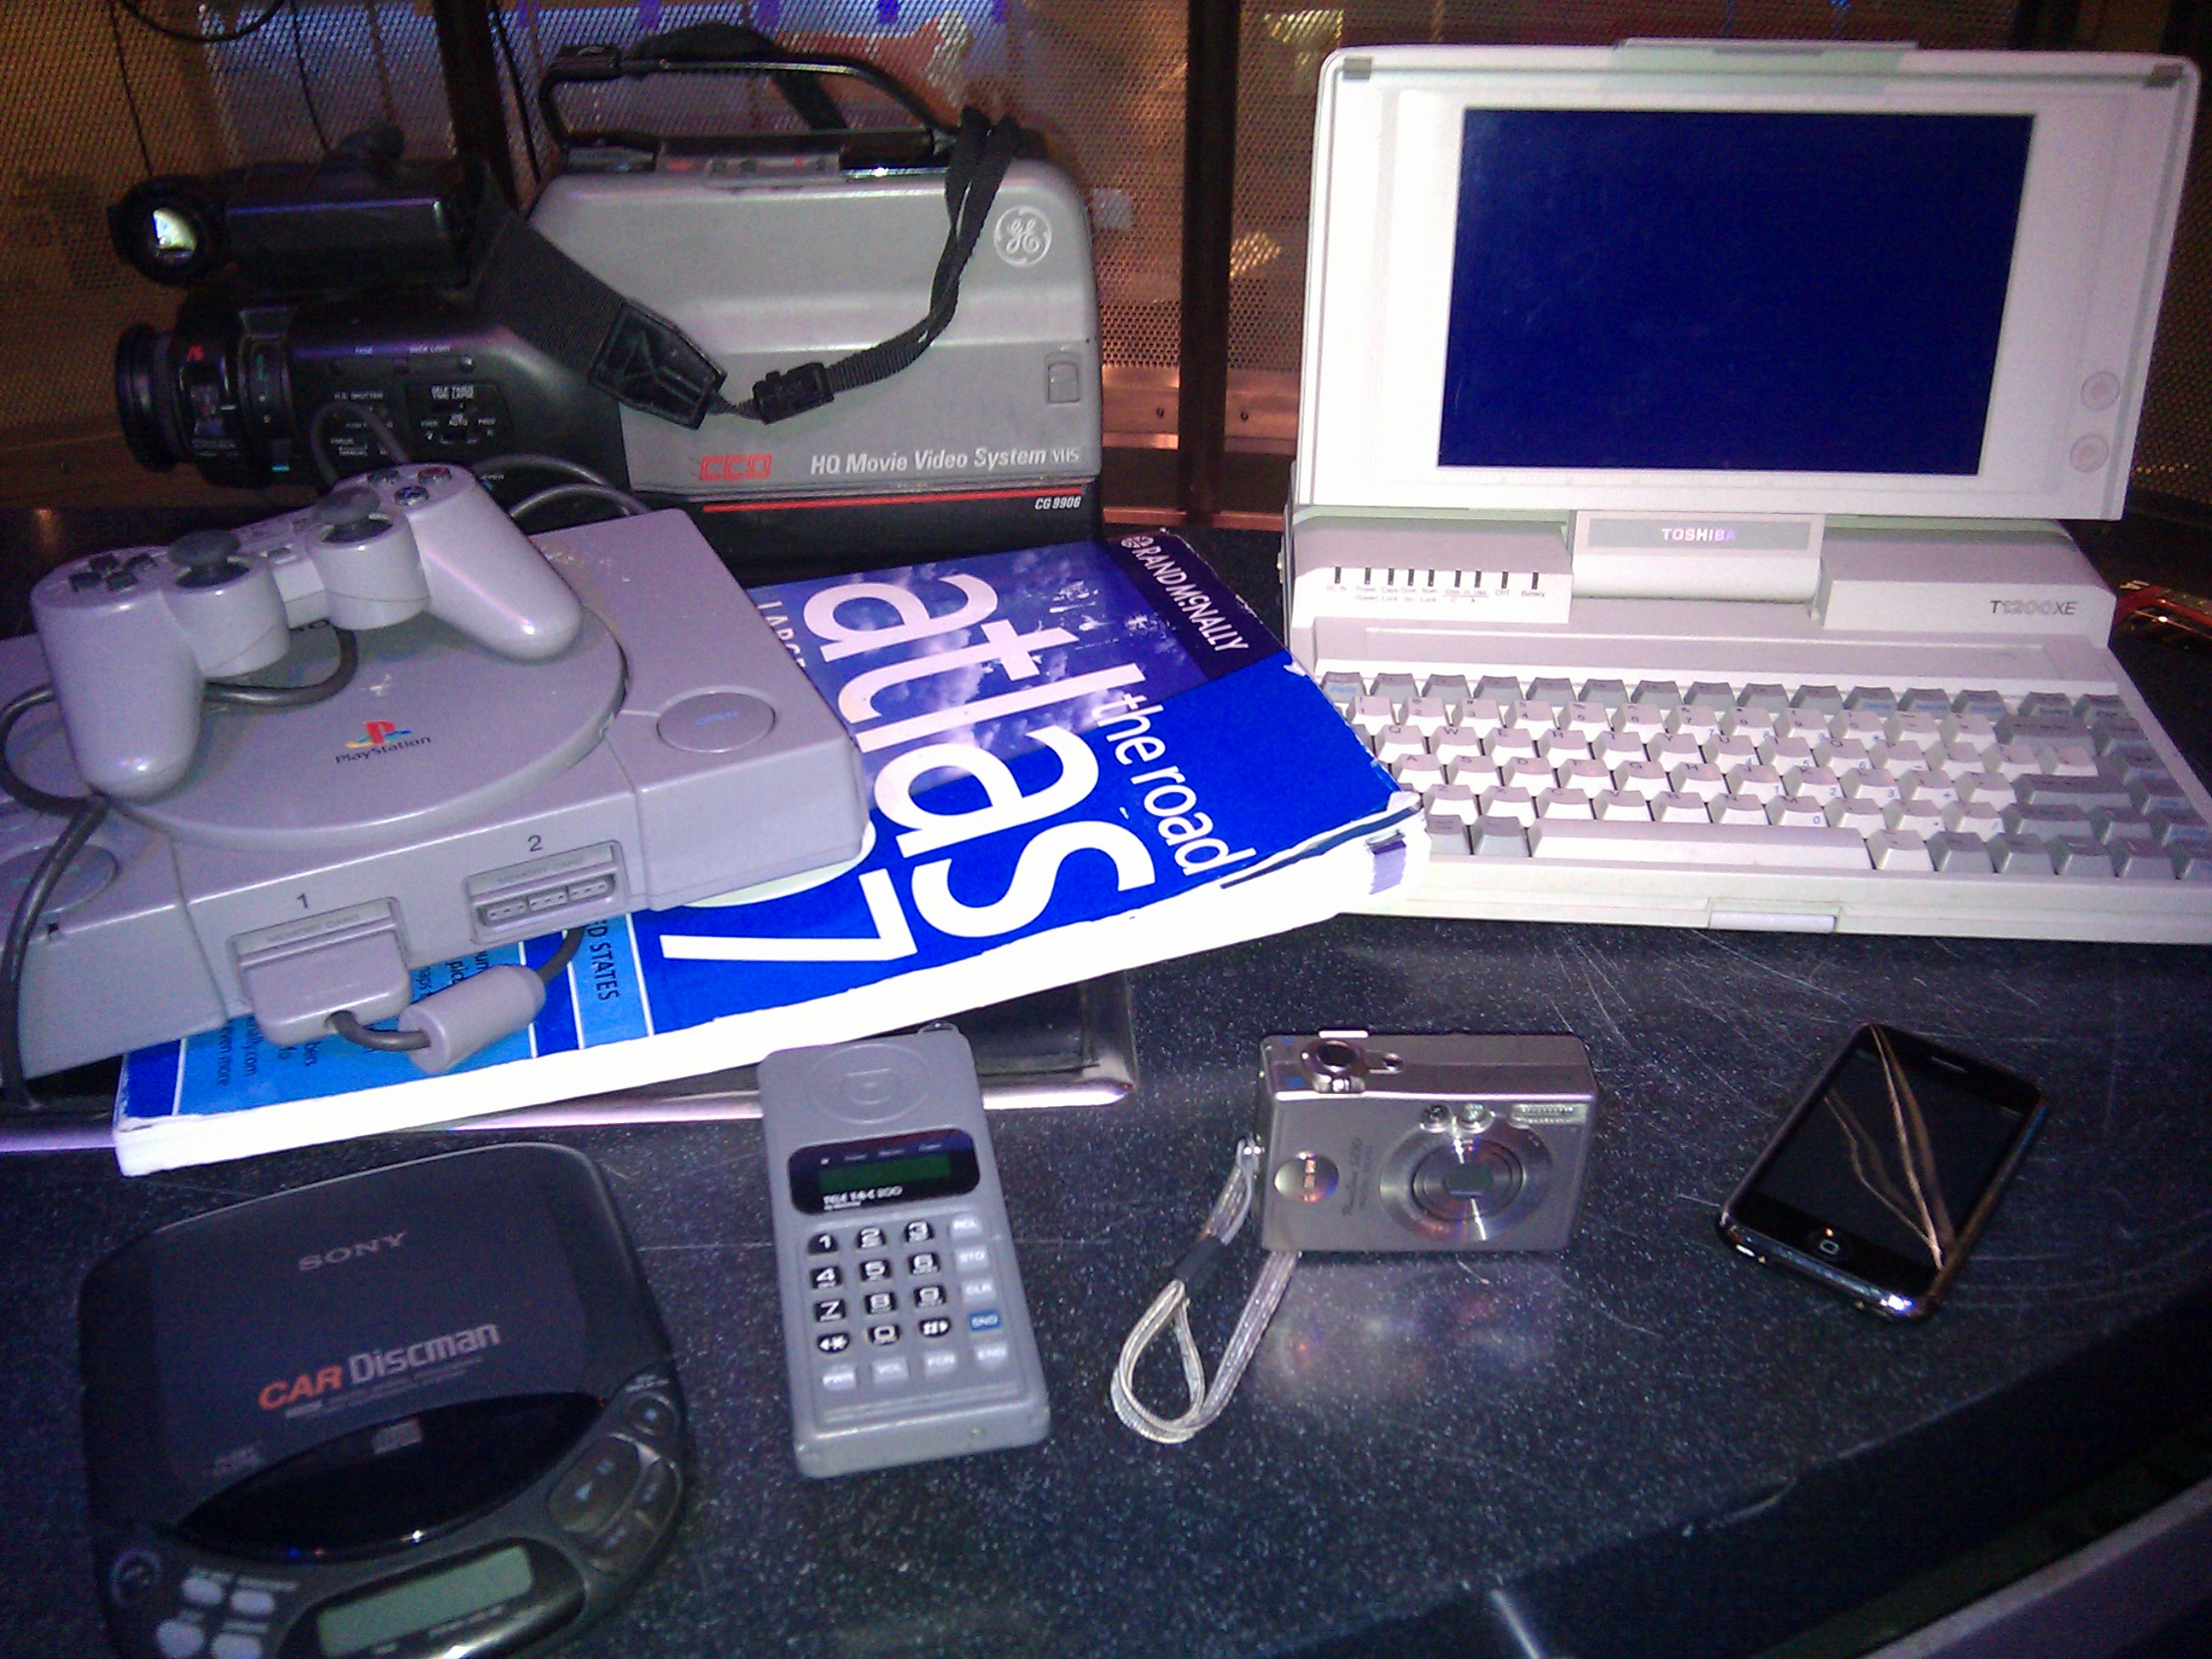

- A heat sink and fan from inside a computer. Ask your IT department if you could have these parts from an old obsolete computer.

- 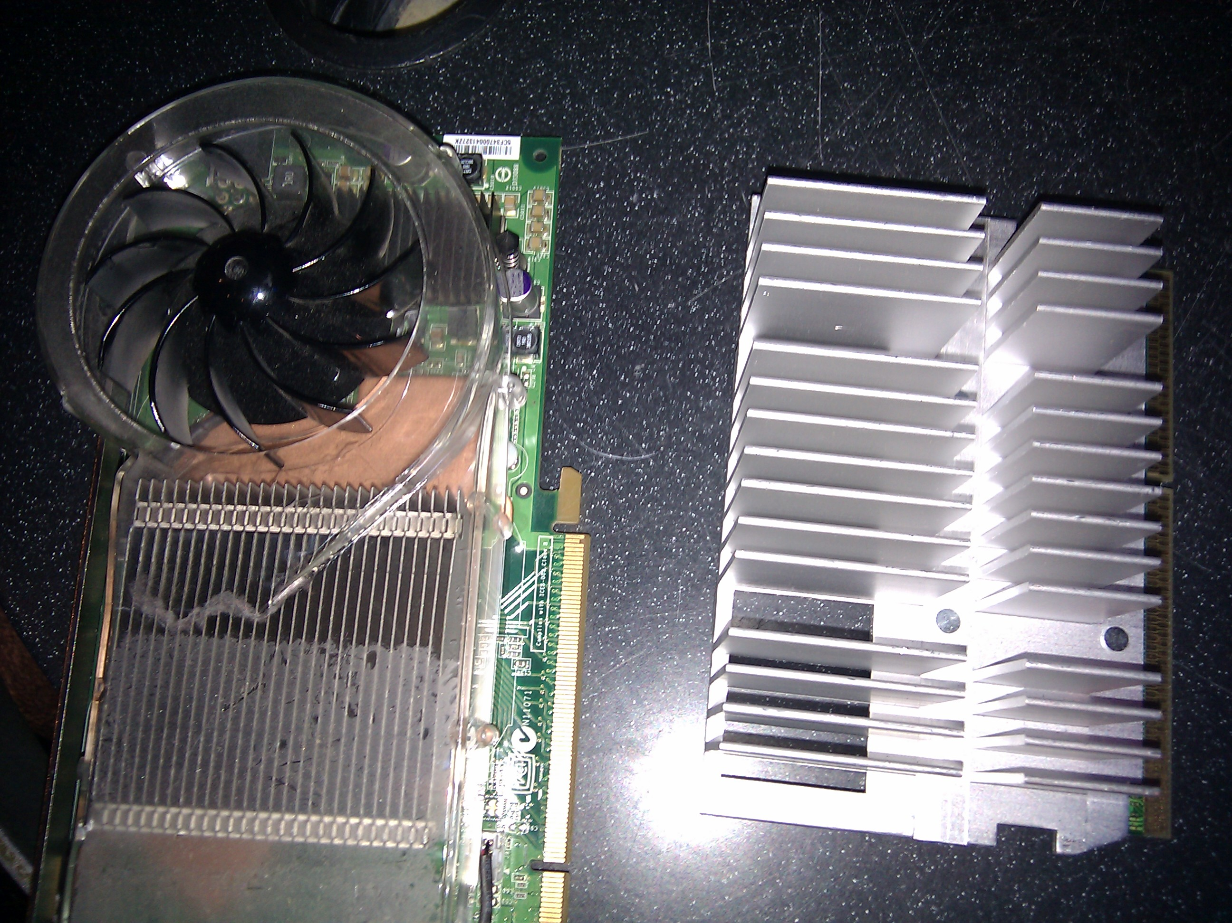

- Pencil and scotch tape

- Simple circuit mounted on wooden board so audience can see – including a small lightbulb, a 9 volt battery, some wires/alligator clips and a pencil sharpened at both ends exposing the graphite. Most of these items can be purchased at Radio Shack and assembled by you.

- 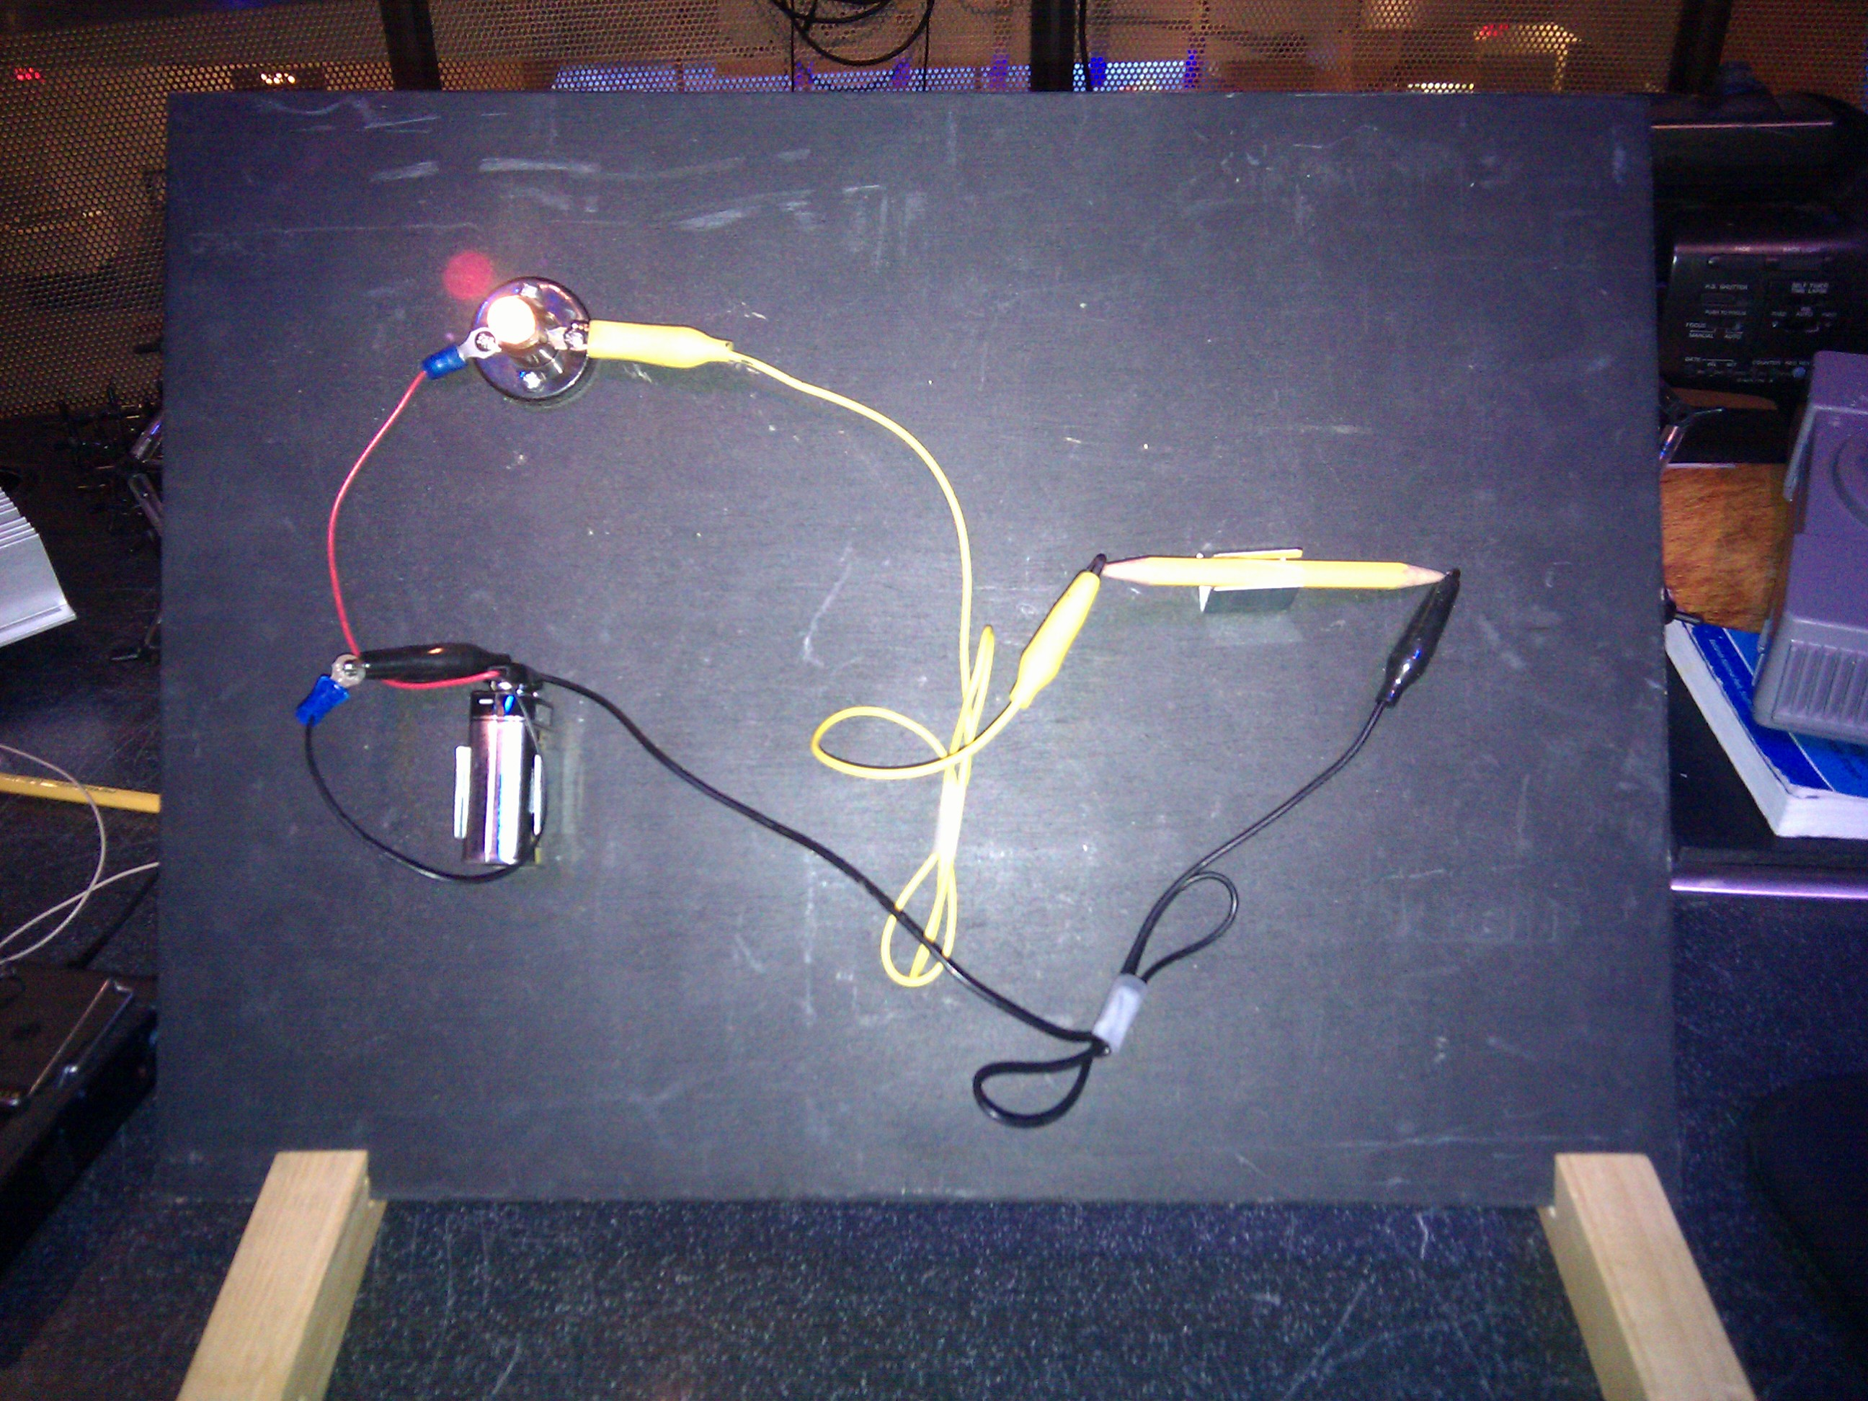

- Carbon Nanotube and Graphene Molecular Models – for example: (http://www.indigo.com/models/gphmodel/carbon-nanotube-model-W.html)

Set Up

Time: 5 minutes

Step 1:
- Set up “FutureOfComputing_ComputingPredictions_PPT” slideshow to play on the screen while you are setting up props. The PowerPoint should automatically advance and loop on its own and capture the audience’s attention as they enter the presentation space.

Step 2:
- Lay out props in the order they will be used. Keep the old electronics out of sight in a box or behind the table, so they are hidden from audience view.

- Check that circuit is working – battery may need to be replaced if light bulb is dim.

Step 3:
- Once you are set up and ready to begin, turn off the “Computing Predictions” slideshow and put up the main slideshow “FutureOfComputing_MainPPT”.

Program Delivery

Time: 20 minutes

Procedure and Discussion:

The Future of Computing

[Slide 1] (Title and Intro)
Welcome to the [your institution name here]. My name is [your name] and today, we’re going to talk about the Future of Computing.

[Slide 2] (Examples of electronics in our lives)
Isn’t it funny how computers have become such a big part of our daily lives? Think about how often you use computers in your daily life – beyond just using a computer at home, school or work, many of use: [Advance through images] cell phones or PDAs, ATM and credit card machines, video games, ipods, GPS, DVRs, even your treadmills at the gym have computers in them.
[To make it more interactive, you could also ask volunteers in the audience to suggest ways they rely on computers].
But 20-30 years ago, who would have predicted these new technologies?
[Slide 3] (von Neumann’s quote)
The quotes at the beginning of this presentation show you that even “experts” in the field couldn’t necessarily predict what would happen with computing in the future. But one of them did have an inkling that he might be wrong… [click to show second part of quote]
So, today we’ll try to tackle this very difficult task and take a look at what the future of computing might look like for us… That said, you might be laughing at these predictions 5 years from now, but lets take a shot at anyway….
[Slide 4] (4 Questions for Presentation)
So, today’s presentation will be organized to answer these 4 questions:
1) How far have we come? How have computers changed over the years?
2) Can we keep going? Are there barriers to continuing the trends we’ve seen?
3) Where do we go from here? Which technologies will take us into the future?
4) What does it mean for us? New applications? Risks and Benefits?
[Slide 5] (ENIAC, calculator and Jaguar)
So, let’s start by seeing how far we’ve come. [ENIAC = calculator] This is one of the first electronic computers built in the 1940s – the ENIAC – it was HUGE (took up a large room and weighed 30 tons) It had about the same processing power as a regular $1 calculator does today – so obviously, we’ve made computers much smaller. Now, the ENIAC was incredibly powerful at the time – it could do 500 operations per second – compare that with our current room-sized computers - The Jaguar – the most powerful supercomputer today (it’s at Oak Ridge National Labs) – it’s able to do 1 quadrillion operations per second (that’s a 1 with 15 0s after it or a million x a billion). So, obviously, we’ve also been able to make our computers much more powerful.
[Slide 6] (Old cell phone and new smartphone)
Now another example that most of you are familiar with - cell phones! Take this old cell phone from the 80s. This was incredible technology back then – calling anyone wirelessly! Wow… that was a novel idea! Now, if we compare that to a cell phone 20 years later – the latest iphone – boy things have changed! It’s not just a cell phone – [pull out props/old electronics one at a time] it’s a camera, it can record video, it’s a GPS that’ll give you directions, you can play music or video games, it can surf the internet, and do many more amazing things! That’s a lot more computing power in one small package!
So – the trends we’ve seen are to make our computers much smaller but also much more powerful at the same time! Can these trends continue? In a decade from now, instead of an iphone will something with as much capability that is the size of a button on my coat? Will we soon have supercomputers like the Jaguar that fit in the palm of our hands? Can we keep going down this path?
[Slide 7] (people with laptops on their laps)
Well, there are a few problems that could be significant hurdles we need to overcome to continue advancing our computers along the trends we’ve seen so far... and you’ve probably noticed at least 1 of them... Especially, if you ever been working like this - with your tiny powerful laptop sitting on your lap… HEAT build-up!
[Slide 8] (burned thigh and band-aids)
There have actually been medically documented reports of heat burns/rashes/blisters on people’s thighs caused by laptop computers… the injuries themselves are a bit besides the point – but they highlight a big problem with continuing to shrink electronics while we make them more powerful– they use more energy/power and cause heat build up! When you touch electronics when they are running (DVD player, some TVs, laptops, even some cell phones)… you can feel the incredible amount of heat they generate.
[Slide 9] (laptop on fire)
Now your laptop won’t necessarily catch fire – the CPU in a computer is supposed to run about up to 140F, but they can run hotter – some computing parts run as hot as an electric stove !
[Slide 10] (heat sinks and fans)
Which is why computers have heat sinks and fans [hold up examples] to keep the computer cool. Fitting these cooling devices into our tiny electronics as we shrink them is proving to be a major challenge! Now you might wonder, what exactly it is that’s using so much power that its generating this much heat?
[Slide 11] (circuitboard)
Well, when you look inside a computer – at the heart of the computer is the CPU chip – the microprocessor. And a microprocessor has billions of tiny electrical switches – called transistors.
**** Any of the following slides – 12 through 16 – could be left out if in the interest of time/simplicity***
[Slide 12] (Switch and Lightbulb)
These switches turn on and off (flick lights on and off) and controls an electric current - whether or not electrons flow. Now, that’s how our computers code/read information – with these tiny on/off switches.
[Slide 13] (Switch and Lightbulb with 1 and 0)
There are 2 states to a switch – it can be off (0) or on (1). Well when the switch is on – electrons are flowing and that represents a 1. When the switch is off – electrons don’t flow and it represents a 0.
[Slide 14] (Your Data as 1s and 0s)
You may have heard that computers work in a binary language of 1s and 0s. They use 1s and 0s to represent anything and everything – your photos, music, documents are all stored and processed by your computer as 1s and 0s. All of your complex data is broken into the smallest pieces and stored as “bytes” of data.
[Slide 15] (Transistor Switches – 8 1s and 0s as 1 byte)
Information is broken down into the smallest pieces - Each small piece of information is a block of 8 of these on/off switches – that’s 1 byte of data. For example this code of 8 bits - 8 1s and 0s - codes for lower case letter “a”.
[Slide 16] (1s and 0s spelling out a name)
These 1s and 0s code for my name “Karine”. All information – fonts, colors of pixels, sounds, etc. are all coded in these 1s and 0s, these on and off switches. And your computer stores and reads this information by controlling how electricity/electrons flow through these transistors – turning off and on very very quickly.
[*A google search for “ASCII Alphabet Characters” will yield many websites that show the 8 bit code for each alpha character so you can spell your own name.]
[Slide 17] (microprocessor)
And obviously we need A LOT (millions and billions) of these switches or transistors crammed into these tiny computer chips to do the complex computations that our computers do. How can we fit 2 billion of anything on a tiny computer chip - well, transistors are pretty small. They are nanoscale devices - in the neighborhood of 30-40 nanometers wide - to give you some size perspective - the width of one human hair is more than 100,000 nanometers. So transistors are thousands of times smaller the the width of a human hair. They haven’t always been small though....
[Slide 18] (transistors and microchips)
This is the first transistor – in 1947 – about ½ inch. [advance to next photo] Then in the 50s they were made smaller and put on chips – called an integrated circuit. Over the last 40 years, they’ve been getting smaller and smaller, so that we’ve doubled the transistors we fit onto a chip every 2 years. [advance to next photo]. You may have heard of this trend as Moore’s Law. And THAT is the key to increasing the speed and capability of your computer - more transistors = more information can be stored and processed and it explains why every few years it seems the latest generation of computers seems so much better than the one we have at home! [advance to next photo]. We’re at the point where we can fit more than 2 BILLION transistors onto a microchip about 1 cm square! So, to make the next generation of more powerful computers, we need to make even smaller transistors so we can fit more on a chip.
[Slide 19] (Physical Limitations)
Here you can see just how small these chips are - this is silicon wafer and each square is 1 single microprocessor chip that would run your computer.
So that brings us back to the some of the physical limitations we are running into when making transistors even smaller to fit more on computer chips to give us smaller more powerful computers:
1) The problem we began with – HEAT. Think about it - each tiny microchip has billions of electrical switches – the electrons moving through this many transistors in such a tiny space leads to a lot of heat build up. That’s a problem.
2) Now there are other problems with making even smaller transistors – the fabrication process –we just don’t have the tools we need to keep making these tiny devices even smaller.
Now scientists and engineers in the field of nanotechnology that deal with these types of tiny nanoscale devices are trying to overcome these limitations and believe there are 2 options for the future of computers.
[Slide 20] (New materials, New switches)
So what’s the solution?
o New materials (we’ve relied on silicon to make our microprocessors – but are there better materials than silicon to deal with heat/power/size)
o New “switches” (instead of electrical switches – moving electrons – are there new ways to represent 1s and 0s?)
*** Some of the following 4 slides/technologies can be eliminated in the interest of time/simplicity.****
[Slide 21 – Carbon Nanotubes]
There are some very cool materials recently discovered with nanotechnology that could make better transistors in the future. Carbon Nanotubes – just discovered in the mid-90s – they are made entirely of carbon – a sheet of hexagon shaped carbon rings rolled up into a tube. [show model] They are TINY - only 1-2 nm across – but have really unique electrical properties . Now a nanotube transistor could be a lot smaller than our current transistors, but even better the unique shape and geometry of a CNT – they control the flow of electrons much better than silicon and can operate at lower voltages (1/2 or ¼ of the current power required to turn on/off a transistor) – which helps the power & heat problem! So, with CNT transistors, we could see computers 10x as fast that use less power! The hurdle here – fabricating the right kind of nanotubes in the right orientation for large-scale manufacturing – but we’re getting there…
[Slide 22] (Graphite)
Another material that might be in our transistors of the future is graphene – just discovered in 2004. Now the best way to visualize graphene is to start with a CNT and unroll it – it’s a flat sheet of carbon – just 1 atom thick - with the same hexagon shaped rings.
• Now graphene is related to a very common material, that you’re familiar with – called graphite – that’s the black material in a pencil. Graphite is many sheets of graphene stacked on top of one another. When you write with a pencil, bunches of these carbon sheets come sliding off.
Now you may not have realized that this material in a pencil can conduct electricity. Here is a simple circuit – just a lightbulb connected too a battery with 2 unconnected wires here. I can close the circuit with a pencil (sharpened on both ends) to show you that even graphite is an electrical conductor. [close the circuit so light bulb lights up]. Now graphite has a lot of impurities – so it’s not nearly as good as graphene - but when we get just a single pure sheet – wow – those electrons can move quickly and unimpeded… and there are tons of potential applications.
Now people knew theoretically graphene probably existed and that it would have some really incredible useful properties – but most thought a single flat sheet of graphene couldn’t possibly be stable or exist on its own. They thought it would always roll up into a tube…
[Slide 23 – Graphene]
But in 2004, a man named Andre Geim in the UK, using “high tech” equipment like pencils and scotch tape [hold up the pencil and scotch tape] to peel off incrementally thinner and thinner layers finally isolated single sheet of graphene – and research in this area has exploded ever since!
Just like CNTs, graphene has unique electrical properties. Electrons can move VERY quickly, with little resistance and be controlled with very little power – greatly reducing the heat and power issue. Graphene could be used to make transistors just a few carbon atoms wide. Again, we’re not quite there yet – fabrication issues have to be overcome – how do we make a large single uniform sheet of graphene – that’s the challenge.
So those are just 2 potential solutions – new materials that could help us make smaller faster transistors for future computers that solve some of the current problems. But we can only go so small – in a few decades, we’d again be stuck on how to make transistors smaller…. And all of these are electrical devices – they use moving electrons.
So, another hot area of research is whether or not we can represent the 1s and 0s of computer language in another way – a totally new paradigm - instead of moving electrons representing 1s and 0s? Now the research is these areas is at a much earlier stage – but some ideas are:

[Slide 24] (Optical Computing)
One area of research is optical computing - instead of using moving electrons, we could use photons (packets of light energy) to perform computations. We already use photons for long-range data communications - you’ve probably heard of fiber optic cables, but we haven’t yet figured out how to leverage this inside a computer for data processing. But researchers are working on it and if we can figure it out, we could have computers that work much faster and run much cooler. Photons travel faster than electrons and they don’t produce nearly as much heat.

[Slide 25 ] (Spintronics & Quantum Computing)
Instead of moving electrons and using it’s charge, can we use another property of an electron – its spin - to represent a 1 or 0? Spin up = 1, spin down = 0. In theory this is very promising – could be VERY low energy – only need enough energy to flip the spin of an electron. Still very theoretical – but it’s an exciting area of research.
And Quantum Computing takes advantage of the complex quantum mechanics of electrons - basically, it could lead to infinite parallel processing - computers more powerful than we could ever imagine.
So there are promising ideas for totally different ways to represent & process 1s and 0s, but research is in the early stages here – so real applications are still further off into the future.
[Slide 26 – Computing into the future????]
So what does all this mean?
Well, on the one hand it means that computers will probably keep getting much faster, smaller and more powerful.
Why do we even need more powerful computers? What are the risks and benefits of better computers? We’ve all seen science fiction movie depictions of the future world of computers - both good and bad - things like iRobot, Minority Report, the Matrix, or 2001: A space odysey. But what can we realistically expect to see in the coming decades? That’s what’s so hard to predict. I have a few ideas from experts in the field to get your imaginations going...
More computational ability could mean things like:
a) NEW WAYS TO INTERFACE WITH OUR COMPUTERS – what if you you could do away with laptops and key boards and wear your computer or cell phone as a headband or lapel pin - you could just speak instructions to your computer and it would understand and follow instructions with no errors. Or perhaps control and communicate with your computer with eye movements or brainwaves?
b) BETTER MEDICAL TREATMENTS – sequencing the human genome was an incredible computational breakthrough - with more computing power we can better understand complex systems like how genes and proteins behave and interact and function – leading to more effective and personalized treatments.
c) ARTIFICIAL INTELLIGENCE – how soon could we see a computer that works as well as or better than a human brain?
Those are a few possibilities… along with so many others that I can’t even begin to imagine!
But what are the risks?
Other things to consider – with more computing power, we can collect, store and process more personal information.
[Slide 27 – Privacy Concerns]
Think about all the personal information that is already collected about you – search engines tracking what websites you visit, credit card transactions that record what you buy and where you buy it, cell phones with GPS that know your location, even a Charlie card that records where you ride on the T. Right now, we don’t have the computing power, networking ability and storage capability to sort, interpret and act on this data in a timely manner.
But how will that change as computers become faster and more powerful? Could data about your location be sold to advertisers who would constantly bombard you with ads from businesses near your cell phone? Could the CIA have enough data storage and processing ability to record every cell phone call made and automatically search for criminal conversations?
[Slide 28 – Questions?]
Hopefully, the future will hold a balance – where new technologies make our activities more convenient, efficient and sustainable – but where our privacies are also protected. The key is to be aware of these advances in computing, keep in mind that they can and will impact our lives, and weigh in on the debate.

I hope I gave you a little bit of food for thought about the future of computing. If you want to learn more – please feel free to come up and ask me questions after the presentation.
Thank you. Enjoy the rest of your day here at the museum.

Tips and Troubleshooting:

NOTICE: Feel free to alter this program to suit your needs. If you find something that works, share it with the rest of the community by posting your revisions on www.nisenet.org.
Due to the technical nature of this program and the required vocabulary, this program is best suited for ages 13 and up.

It can be modified for younger, more general audiences – they typically enjoy learning about how computers work in general, and possible future applications for powerful computers – in this case, you can trim some of the specific technical details around the 4 nanotech solutions mentioned in the program (or leave 2 of them out altogether). Another way to shorten the program would be to exclude some of the background info on how computers store/process information.

Common Visitor Questions

Questions I get often:
1) “What can you tell me about DNA computing or molecular computing?”
Answer – DNA computing is a form of computing which uses DNA, biochemistry and molecular biology, instead of the traditional silicon-based computer technologies. The idea is based on the fact that DNA is a chemical language of 4 bases (not that different from the binary computing language of 2 digits) – so has complex coding capabilities. Essentially, millions of natural supercomputers exist inside living organisms, including your body. DNA molecules, the material our genes are made of, have the potential to perform calculations many times faster than the world's most powerful human-built computers. DNA might one day be integrated into a computer chip to create a so-called biochip that will push computers even faster. DNA molecules have already been harnessed to perform complex mathematical problems. They could be low power (using ATP as a power source).

For more info on DNA Computers:
http://en.wikipedia.org/wiki/DNA_computing
http://computer.howstuffworks.com/dna-computer.htm

Molecular Computing – Molecular computing is a somewhat generic term to describe computers that use individual molecules or atoms as transistors to solve computational problems (instead of silicon circuits). It is often associated with DNA computing or can also refer to quantum computing or molecular logic gates. Refer to resources on DNA computing or quantum computing for more info.

“So, do you think computers are going to take over the world?”
”What do you think of the Singularity?”
“Will computers get smarter than humans?”
When visitors ask these questions they are usually thinking of scary Sci-Fi movies where computers are out of control with power.

To give some brief background on this topic:
The technological singularity (and these other questions) refer to a hypothetical event in the 21st century when technological progress becomes very rapid due to positive feedback, making the future after the singularity qualitatively different and hard to predict. If computing advanced at such a rate to create “smarter-than-human” intelligence – it would represent a breakdown in human’s ability to model their future, since humans cannot predict the actions of more intelligent entities. Another conception of singularity is an “intelligence explosion” – current technological progress has been limited by human intelligence, so with the increasing power of computers, it might be possible to build a machine that is more intelligent than humanity. If smarter-than-human intelligences were invented, it could bring greater problem-solving and inventive skills than humans and even re-write its own source code to be more intelligent, leading to recursive self-improvement.

I usually answer this question by not giving any personal opinion but rather saying that some people are concerned about the Singularity (and explain what it is) and that a lot of people aren’t concerned about it because they don’t think it can happen. I encourage them to look up more information on this topic if they are interested in it so they can decide for themselves.

“Aren’t carbon nanotubes also used for….(any number of things – wiring, displays, space elevator, water filters, etc)?”
Answer – YES, carbon nanotubes have so many potential uses… and describe some of them…
For general info: http://en.wikipedia.org/wiki/Carbon_nanotube

Going Further…
When visitors want to learn more about the latest in computing technology, I often refer them to:
MIT’s Technology Review – Online Magazine/Computing Section
http://www.technologyreview.com/computing/?a=f

Clean Up

Time: 5 min

Pack up props.

Universal Design

This program has been designed to be inclusive of visitors, including visitors of different ages, backgrounds, and different physical and cognitive abilities.

The following features of the program’s design make it accessible:

[ X ] 1. Repeat and reinforce main ideas and concepts

[ X] 2. Provide multiple entry points and multiple ways of engagement.

[ ] 3. Provide physical and sensory access to all aspects of the
program
To give an inclusive presentation of this program:

Try and describe actions or language for low-vision visitors, allow visitors to explore tactile models on their own, don’t obstruct mouth while speaking, etc.

Credits
 | This project was supported by the National Science Foundation under Grant No. ESI-0532536. Any opinions, findings, and conclusions or recommendations expressed in this program are those of the author and do not necessarily reflect the views of the Foundation.
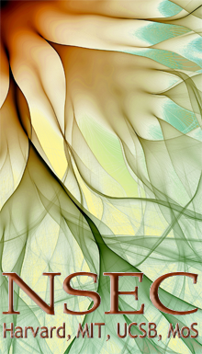 | Development of this product was also supported by the Nanoscale Science and Engineering Center headquartered at Harvard University, the Center for High-rate Nanomanufacturing at Northeastern University, University of Massachusetts-Lowell, and University of New Hampshire, with support from the National Science Foundation.
 | Published under a Creative Commons Attribution-Noncommercial-ShareAlike license: http://creativecommons.org/licenses/by-nc-sa/3.0/us/

