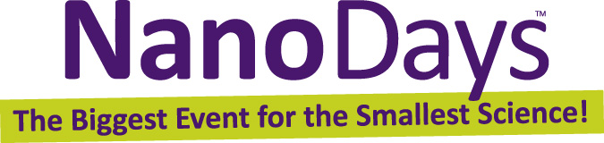

Exploring Size—StretchAbility Game

Try this!  - Players take off their shoes.  - The referee spins the spinner and calls out the first move.  - All players place a hand or foot on a circle of the right scale—macro, micro, or nano.  - The referee spins again, and players try the next move.  - Players who fall over (or support themselves on any body part other than hands and feet) are out of the game.  - Keep spinning! The last player to stay up wins.  What’s going on? | 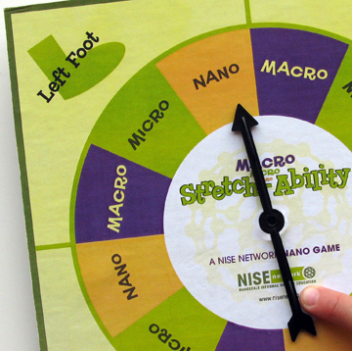  Left foot nano!
Things come in different sizes—and size is important! We use different scales to measure things that are different sizes. In this game, we explore three different scales: the macroscale, the microscale, and the nanoscale.
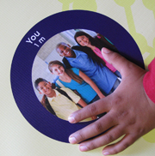 | Macroscale objects are in purple circles  The macroscale includes objects we can see with our eyes. There are lots of ways to measure objects on the macroscale, including meters. (A meter is a little over three feet.) Kids around six or seven years old are about a meter tall.
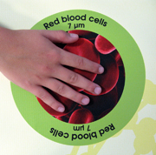 | Microscale objects are in green circles  The next scale down is the microscale. To see microscale things clearly, we need tools like microscopes. Objects on the microscale are measured in micrometers. A micrometer is a millionth of a meter. Red blood cells are measured in micrometers.
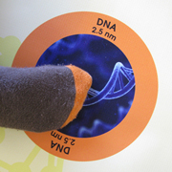 | Nanoscale objects are in orange circles  There’s an even smaller scale: the nanoscale! Nanoscale things are so tiny that we can’t see them with just our eyes—we need special tools to make images of them. Nanoscale objects are measured in nanometers. A nanometer is super small—a billionth of a meter! DNA is measured in nanometers.

How is this nano?
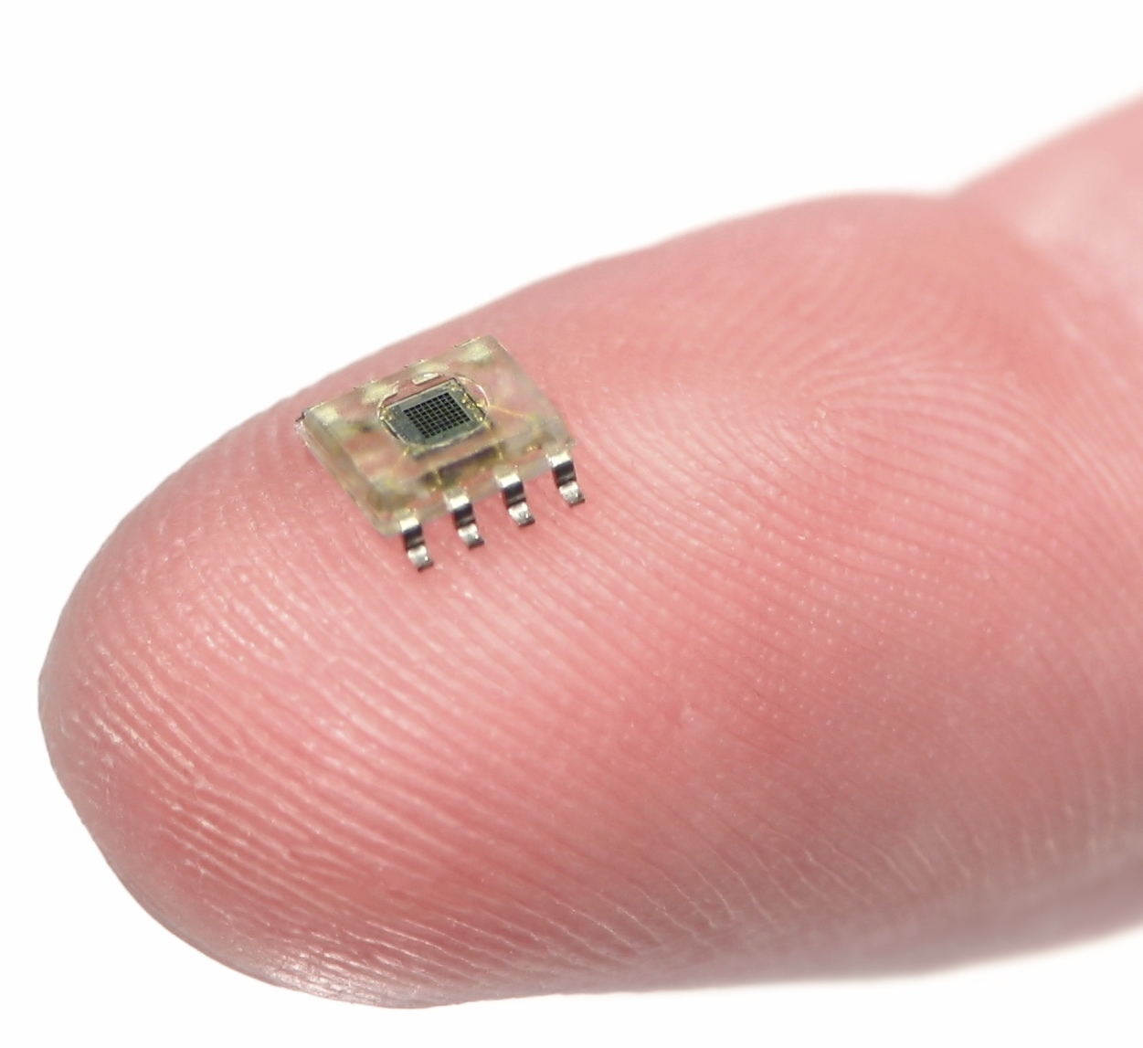  Microchip on finger | A nanometer is a billionth of a meter. That’s really tiny! Nanometers are used to measure things that are too small to see, like atoms and molecules, the basic building blocks of our world.  Nanoscale science focuses on things that are measured in nanometers. Scientists use special tools and equipment to work with things that have nanometer-sized parts, such as microchips.  In the field of nanotechnology, scientists and engineers make new materials and tiny devices. Nanotechnology allows them to make things like smaller, faster computer chips and new medicines to treat diseases like cancer.

Learning objectives
- Things come in different sizes—and size is important!
- A nanometer is a billionth of a meter.

Materials
- Playing mat
- Spinner
- “Macroscale Objects,” “Microscale Objects,” and “Nanoscale Objects” sheets

Graphics for the playing mat, spinner, and chart can be downloaded from www.nisenet.org/catalog
- The playing mat is available as one file (to print on a large format printer) or as individual circles (to print separately and attach to a shower curtain).
- The spinner graphic can be attached to blank 4-inch spinner board, available from www.rolcogames.com (#GSPI007L).

Notes to the presenter
This game was developed by the NISE Network, and cannot be referred to as “Twister.”

Related educational resources
The NISE Network online catalog (www.nisenet.org/catalog) contains additional resources to introduce visitors to the nanoscale and nanometers:
- Public programs include Cutting it Down to Nano and Shrinking Robots!
- NanoDays activities include Exploring Size—Measure Yourself, Exploring Size—Memory Game, Exploring Size—Powers of Ten Game, Exploring Size—Scented Balloons, Exploring Size—Scented Solutions, and Exploring Size—Tiny Ruler.
- Media include the poster and book How Small is Nano?, Image Scaler Software, Intro to Nano, Multimedia Zoom into a Human Hand, Multimedia Zoom into a Nasturtium Leaf, Scale Ladder, Zoom into a Butterfly Wing, Zoom into a Computer Chip, and Zoom into the Human Bloodstream.
- Exhibits include At the Nanoscale and Three Drops.

Credits and rights
This activity was adapted from Macro, Micro and Nano Stretch-Ability, developed by the Children’s Museum of Houston for the NISE Network. The original program is available at www.nisenet.org/catalog

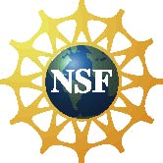 | This project was supported by the National Science Foundation under Award No. ESI-0532536. Any opinions, findings, and conclusions or recommendations expressed in this program are those of the author and do not necessarily reflect the views of the Foundation.

Copyright 2010, Sciencenter, Ithaca, NY. Published under a Creative Commons Attribution-Noncommercial-ShareAlike license: http://creativecommons.org/licenses/by-nc-sa/3.0/us/

