Tiny Solutions to Our BIG Energy Problem

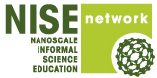
Organization: Museum of Science, Boston

Contact person: Karine Thate

Contact information: kthate@mos.org, 617-589-4483

General Description

Public Presentation with Demonstrations

This is a revision/update of the previous Energy and Nanotechnology stage program. It gives a brief overview of energy sources and our current energy crisis and discusses a variety of ways that nanotechnology can improve the way we harness energy (improving solar cells), distribute energy (carbon nanotube transmission lines) and use energy (nanotech-enhanced LED bulbs). It is primarily a slideshow presentation, designed for medium-to-large audiences. It consists mostly of a lecture, with a few live demonstrations and a few audience interactions.

Program Objectives

Big idea: Nanotechnology can have a big impact on the future of energy.

Learning goals:
As a result of participating in this program, visitors will be able to:
- Identify a few potential applications for nanotechnology in alternative and renewable energies.
  - Solar cells can be made cheaper and easier with nanotechnology.
  - Carbon nanotube transmission lines would reduce energy loss.
  - Nanotech-enhanced LED lighting could save energy.

NISE Network Main Messages:
[ X ] 1. Nanoscale effects occur in many places. Some are natural, everyday occurrences; others are the result of cutting-edge research.
[ ] 2. Many materials exhibit startling properties at the nanoscale.
[ X ] 3. Nanotechnology means working at small size scales, manipulating materials to exhibit new properties.
[ ] 4. Nanoscale research is a people story.
[ ] 5. No one knows what nanoscale research may discover, or how it may be applied.
[ X ] 6. How will nano affect you?

Tiny Solutions to Our BIG Energy Problem

Table of Contents
General Description 1
Program Objectives 1
NISE Network Main Messages: 1
Table of Contents 2
Time Required 3
Background Information 3
Materials 4
Set Up 6
Step 1: 6
Program Delivery 6
Procedure and Discussion: 6
Tips and Troubleshooting: 14
Common Visitor Questions 14
Going Further… 15
Clean Up 15
Universal Design 15
Credits 16

Time Required

Set-up Program Clean Up
5 minutes 20 minutes 5 minutes

Background Information

Definition of terms
Nano is the scientific term meaning one-billionth (1/1,000,000,000) It comes from a Greek word meaning “dwarf.”
A nanometer is one one-billionth of a meter. One inch equals 25.4 million nanometers. A sheet of paper is about 100,000 nanometers thick. A human hair measures roughly 50,000 to 100,000 nanometers across. Your fingernails grow one nanometer every second.
(Other units can also be divided by one billion. A single blink of an eye is about one-billionth of a year. An eyeblink is to a year what a nanometer is to a yardstick.)
Nanoscale refers to measurements of 1 – 100 nanometers. A virus is about 70 nm long. A cell membrane is about 9 nm thick. Ten hydrogen atoms are about 1 nm.
At the nanoscale, many common materials exhibit unusual properties, such as remarkably lower resistance to electricity, or faster chemical reactions.
Nanotechnology is the manipulation of material at the nanoscale to take advantage of these properties. This often means working with individual molecules.
Nanoscience, nanoengineering and other such terms refer to those activities applied to the nanoscale. “Nano,” by itself, is often used as short-hand to refer to any or all of these activities.
Program-specific background
A few good resources on this topic are:

Nanowerk Article: “Nanotechnology applications could provide the required energy breakthroughs” - http://www.nanowerk.com/spotlight/spotid=7424.php

“Saved by the Sun” documentary can be viewed online - www.pbs.org/wgbh/nova/solar/
www.understandingnano.com (click on Energy Tab)
National Renewable Energy Laboratory: www.nrel.gov

Energy Information Administration: www.eia.gov

Article on Photovoltaics: en.wikipedia.org/wiki/Photovoltaics

Article on LED lighting: http://en.wikipedia.org/wiki/Light-emitting_diode

Materials

- Powerpoint with images and video files
- Balloon & pump (so you don’t get spit in the balloon)
- Fruit-powered clock (use 2 apples/oranges if you have trouble getting the clock to work with a single fruit) 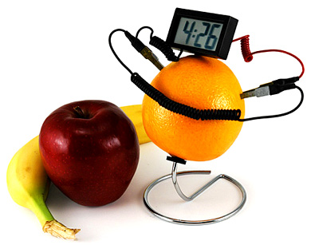
- Solar cell with motor and (needs to work under indoor light) & desk light with bright bulb. For example: Elenco SK-40 Solar Deluxe Educational Kit or a solar toy car
- 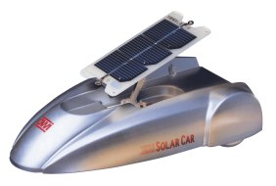

- If possible, get a free sample of Thin film solar cells (may be able to get a sample from www.konarka.com or www.nanosolar.com). Powerfilm also has a flexible solar panel product which gets the idea across, but these panels are not made with nanotechnology. Purchasing a sample may be too expensive. You may want to use a flexible plastic sheet as a prop to transmit the idea, but use the photo to show exactly what they look like.
- 2 hand-crank generators 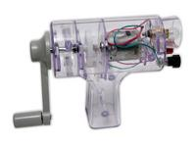
- Dual Light Bulb Test Apparatus (custom built) that has 2 simple circuits each with a light bulb – but one has 1 foot of wire, the other has spools with 200 extra feet of wire (parts include a piece of wood on stand (so audience can view); 2 small light bulbs and lamp holders (2.4V, 300 mA) or similar, spools of wire, (knife switches and battery back-up as shown on this board are not required - just optional in case you don’t have volunteers to participate).
- 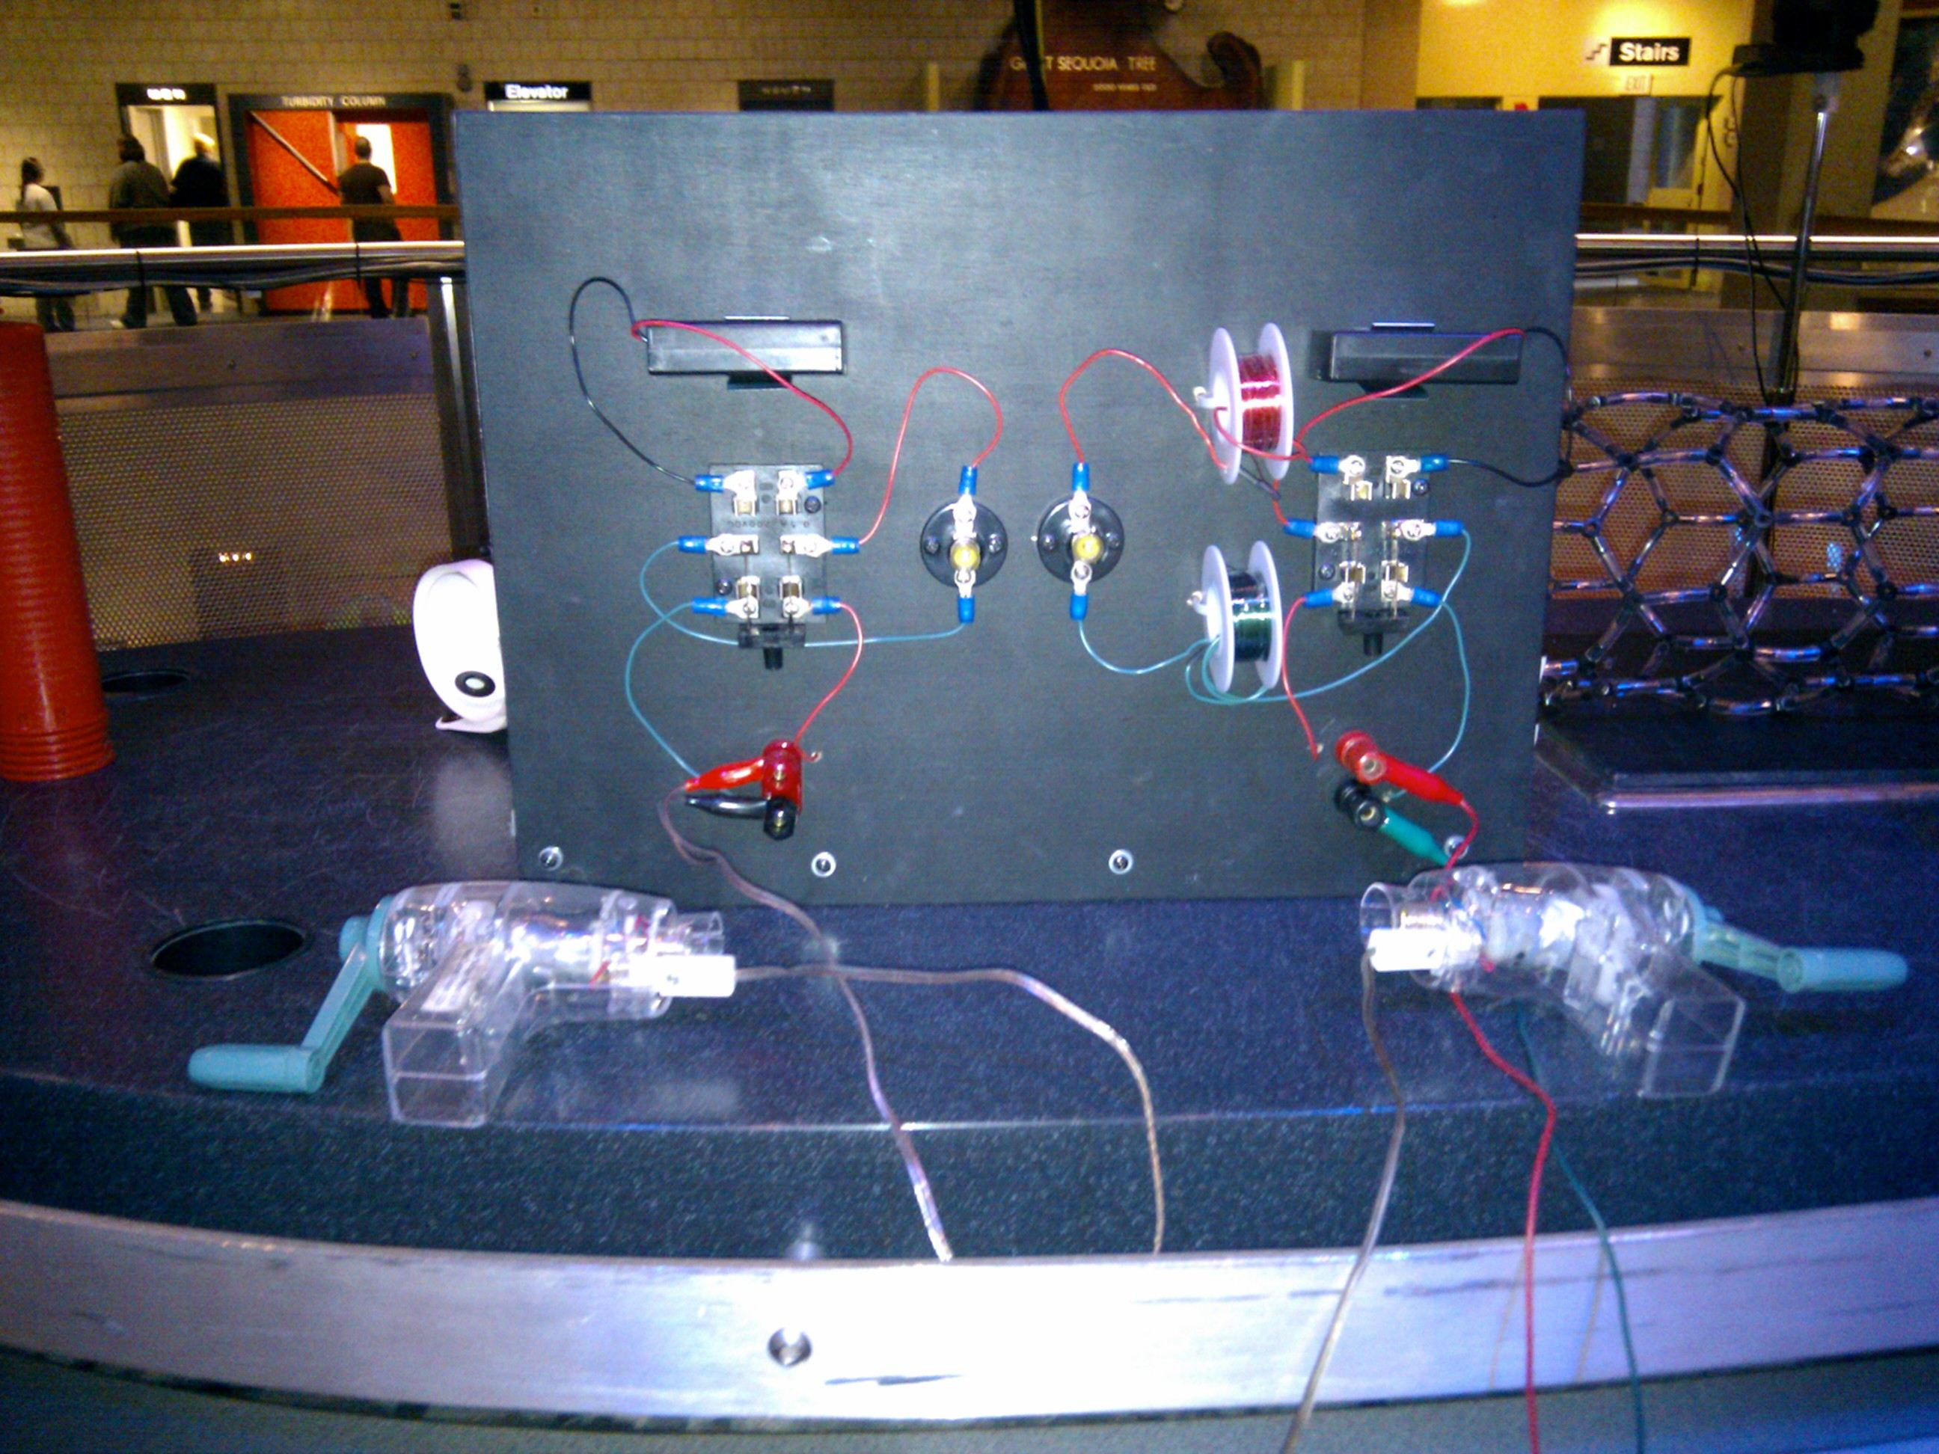

- Carbon Nanotube Molecular Model – for example: (http://www.indigo.com/models/gphmodel/carbon-nanotube-model-W.html)
- Incandescent bulb
- LED bulb and desk lamp
- 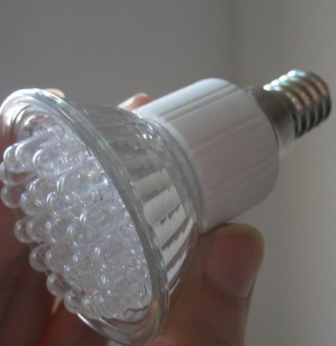

Set Up

Time: 5 minutes

Step 1:
- Lay out props in the order they will be used.

- Check that the solar cell toy, the dual light bulb set up, and hand crank generators are all working. (I’ve noticed screws and handle can loosen a bit on the hand crank - tighten screws, attachments if necessary.)

Program Delivery

Time: 20 minutes

Procedure and Discussion:

Tiny Solutions to Our BIG Energy Problem

[Slide 1 – Title and Intro]
Today we’re going to discuss Energy. We all know energy is important – it’s all around us - it keeps our houses warm and our fridges cold and keeps your car going. Energy is the engine of the economy, and the fuel on which modern society runs. But where does all this energy come from? Might we run out of our important sources of energy? How can science and engineering help us secure a safe, clean and reliable supply of energy in the future? Over the next fifteen minutes or so, I am going to try and answer some of these questions for you, and hopefully we can have a little fun together along the way.

[Slide 2 – What is Energy?]
(images of candle burning, kids playing, waterfall, race car)

So, what exactly IS energy?
Well energy isn't really a thing that you can hold in your hand --it's an idea, a concept. One way scientists define energy as some force (that's a push or a pull) multiplied by some movement through space. So if I blow up this balloon....
[blow up balloon]
I have pushed the latex through space, and added energy to the balloon. The balloon is now a battery of sorts, and it is storing the energy I have added to it. I could release it all at once, by popping it with a pin. Or I could let it out slowly to produce sound…
[making squeaking noise]
--Sound is one of the forms of energy--or I could release the energy more quickly to create motion.
[release balloon, letting it fly]
Motion is a form of energy, too. Energy has other forms. Light is energy. So is heat and so is electricity. And one of the most important ideas in science is that energy is never created or destroyed, it just changes forms. Most of the time, we use energy to do something useful, like running to get somewhere…
[run across stage]
and the energy used by my body to do that is converted into heat. That's why exercising and moving around makes you warm.
Now, does anyone know where the energy that I use while running around comes from?
(My food)
That's right. You can see that in action here with this fruit-clock. The energy from the food is being converted directly into electricity to run the clock. (Cool, right?) And the energy in the food, does anyone know where that came from?
[Slide 3] (Sun, grass, cow, hamburger)
(The Sun) That's right, the Sun. In fact just about all the energy on the Earth came originally from the Sun. But that energy has been stored and transferred in many different ways. [Advance through images] Plants convert and store the sun’s energy, animals then consume that energy, and we have a hamburger…
So, our bodies and minds run on energy derived from the sun… but what about energy outside our bodies? Where does that energy come from? [Slide 4] (Boston city lights at night)
[Slide 5]
Here is a graph showing the breakdown of energy used in America last year, by source. The big red chunk is petroleum, and we use that mostly for transportation. Gasoline in cars, diesel fuel in trucks, jet fuel in airplanes, all comes from petroleum. The purple piece is natural gas, which we use mostly for heat and cooking. The orange piece is coal, which we use to generate electricity, and the green and blue pieces, renewables and nuclear, are also used for generating electricity. So by far the biggest part--coal, oil, and natural gas--are what we call fossil fuels. Does anyone know why we call these fossil fuels?
(They are fossils.)
That's right, because they come from fossils.
[Slide 6] (dino habitat artists rendition)
The material in fossil fuels was all once living things--plants and animals that lived millions of years ago trapped the energy from the Sun in carbon compounds, and then got trapped themselves under layers of earth or sand or ocean.
[Slide 7] (photo of petroleum, coal, natural gas)
Those materials were compressed and turned into the coal, oil, and natural gas that we pump out of the ground. Now, this system has worked pretty well over the last couple hundred years or so, but it has a couple of problems.
[Slide 8] (problems with fossil fuels)
The first is that this is a one-way system. Once we burn the fuels, they're gone. It took them hundreds of thousands of years to form, and they won't come back anytime soon.
[Slide 9] (problems with fossil fuels)
But the second problem is that when we burn those carbon compounds, they combine with oxygen in the atmosphere, and create carbon dioxide. And carbon dioxide is a greenhouse gas.
[Slide 10] (Greenhouse)
Now we hear that word a lot, but you might wonder what it means. We call it a greenhouse gas because it does the same thing that glass does in a greenhouse. It lets light in, but it doesn't let heat back out. Think about how warm it is inside a green house….
[Slide 11] (Atmosphere)
Greenhouse gases in our atmosphere do the same thing… Let sunlight in and trap some heat. Now that’s actually a good thing. These gases keep earth warm enough for liquid water and LIFE. But too much a good thing is sometimes bad…
[Click to show effect of more carbon dioxide]
The more carbon dioxide, the more heat gets trapped, and that heat is slowly warming the Earth.
[Slide 12, 13, 14] (Effects of global warming)
The warming planet has many consequences, including the loss of habitat in polar regions and the increase of severe weather events (like droughts and hurricanes), but the most dangerous by far is the melting of ice. Much of the water on Earth is trapped in enormous ice caps in Greenland in Antarctica. If that ice were to melt, it would flow into the oceans and raise the level of the sea.
[Slide 15] (Boston sea levels today) [www.abcnews.go.com has similar images for a variety of coastal cities – search for story called “What global warming looks like”]
If all the ice were to melt, it would raise global sea levels by something like 100 feet. That would put nearly every major city on Earth underwater, and that would be very bad. This is an aerial view of Boston today.
[Slide 16] (Boston with sea levels 3 meters higher) This is a prediction of what Boston would look like if sea levels rose just 3 meters. Much of the city is underwater. So, this is one of the reasons we’re looking for alternatives to fossil fuels to meet our energy needs.
[Slide 17] (renewable energy sources)
So there are lots of scientists in lots of places trying to figure out solutions to this problem – trying to find cleaner, safer and more renewable sources for ALL the energy society needs. Now, one problem is that none of the renewable energy sources we’ve found so far – solar power, wind turbines, and biofuels - have proven capable of coming up with ENOUGH energy at a LOW enough cost to replace fossil fuels. So, we need other solutions - that’s where an emerging field known as nanotechnology comes in.
[Slide 18] (What is nanotechnology?)
Now, nanotechnology is just science at a very special scale, the size of individual atoms and molecules. We have known about atoms and molecules for a long time, but we couldn't do much with them until recently. We couldn't manipulate matter at such a tiny scale. But that has begun to change… Recently scientists have made advances working at the nanoscale – and are able to manipulate the individual atoms and molecules these renewable energy materials are made of. This advances have vastly improved the capabilities, cost and efficiencies of renewable energy technologies.
[Slide 19] (3 themes)
Now while there are many applications of nanotechnology in the renewable energy sector, there are a couple of specific examples that I’m going to share with you today. These nanotechnology advances will impact how we:
1) Harness energy, 2) Distribute energy, and 3) Use energy
So, the first problem to tackle is how to produce or harness the energy we need in the first place. Does anybody remember where we said all the energy on Earth comes from?
[Slide 20] (Sun)
That's right, the Sun. In fact, more energy comes from the Sun to the Earth than humans could possibly use. If you total up all the energy people use in the whole world for an entire year, it works out to less than one hour of worldwide sunshine. One hour!
[Slide 21 – Solar Map]
This map shows global sunshine. Orange areas are the places where the sun shines a lot, blue places are places where it doesn't shine much at all. And the black dots are places where, if we built solar farms the size of those black dots, we could provide the whole world with all the energy it needs. All we need is an inexpensive way to build those farms. And this is perhaps the greatest promise of nanotechnology.
[Slide 22] (Solar Panel)
[Show panel and motor]
See, solar panels can do something that nothing else can do. They can create electricity directly from sunlight, without creating any waste. [Demonstrate this by holding panel close to any light source.] Every other system that produces energy also produces waste and that’s not a good thing. Think about – our bodies even produce waste when we produce energy from the food we eat. Burning fossil fuels produce a lot of waste and pollution. Even nuclear power and biofuels create waste. But nothing comes out of a solar cell, nothing at all.
[Slide 23 – Problems with traditional solar cells]
Despite these benefits, solar power hasn’t caught on in the U.S. In 2008, solar and wind power combined produced less than 1% of the total energy we used. Why? Well, problems with expense, installation, and durability have discouraged many people from pursuing solar energy. Modern panels work by creating a sandwich of two thick layers of semiconducting silicon crystals. The light hitting the material knocks loose an electron which creates an electric current. The problem here is that because there is so much semiconductor material, it takes a tremendous amount of energy to make the cells, which is why they cost A LOT. Also, silicon has a crystalline structure which is delicate so you have to sandwich it between thick layers of glass, which makes them heavier, harder to ship and install – all driving up the cost! To put 4 KW of solar panels on an average sized house will cost you about $20K!
[Slide 24] (Thin film video)
So nanotechnology is providing several ways we can improve solar cells – to make them cheaper, more durable and ready for widespread use. The next generation of solar cells, made possible with nanotechnology, are thin film solar cells – flexible sheets of solar panels that are easier to produce and install. They use semiconducting nanomaterials (nanotubes, nanowires, and nanoparticles) embedded in a conductive plastic. Now remember – nanotechnology means that we are manipulating matter at the level of atoms and molecules – these materials are often just a few molecules thick. So new solar cells made with nanotechnology work the same way as traditional solar cells, but use much less material and are less costly to produce.
[Slide 25 – Printing Process]
In fact, they are made by a process similar to an ink-jet printer. You start with an ink of semiconducting nanoparticles and it’s sprayed onto a foil or plastic surface – no special vacuum rooms – just open air printing – almost like you’d print a newspaper.
[Slide 26 – Nanosolar]
This shows the process at a company in California called Nanosolar. They can print a mile long roll – 50,000 solar cells – in just a few hours. This new process has the potential to make solar cells MUCH less expensive.

[Slide 27 - Konarka]
There are a number of nanotechnology companies developing these thin film cells – and one is local – a Lowell, Massachusetts company called Konarka is able to make these thin films into lightweight flexible plastic sheets.
[Slide 28 - Konarka]
What’s interesting about Konarka is they are looking at collecting solar energy in other places - not just on the roof! These sheets can be incorporated into a briefcase that charges your laptop when you are walking around town. They are working on a solar fiber to be woven into fabrics. Imagine a coat that could charge your cell phone and ipod when you were outside. And a few months ago, they announced that they are also developing a transparent thin film solar cell that may one day be incorporated into windows!
[Slide 29] (Glass office building)
Think about it – one day in the future, a huge office building like this could use solar panel thin films in their windows, and produce enough energy for all the offices inside – and for the surrounding neighborhood!
[Slide 30 & 31] (Nanosolar paint)
There are lots of research projects on other ways to collect solar power – like nano-solar paint! The idea is that a dark, sunlight-absorbing paint coated onto the surface of aluminized mylar, which conducts electricity. A protective clear layer of indium tin oxide that covers the paint also conducts electricity. When sunlight strikes the paint, electrons are knocked loose, reaching wires that channel electricity to the home. It’s a bit further off into the future but could provide a lot of solar power at a fraction of the cost. So those are just a few of the ways that nanotechnology is improving how we harness the sun’s energy.
[Slide 32] (transmission wires)
Another area of potential improvement is how we distribute energy – we can use renewable technologies to produce energy with sun and wind, but not everywhere is sunny and windy… so, how do we get that energy from where it’s produced to where people want to use it? In other words, how do we move electricity over long distances? I have a demo to try to show you the problem. Here I have a simple hand crank generator, which turns movement into electricity. [Crank the generator.] Big power stations work in exactly the same way -- they use steam from a reactor or a boiler, or the motion of water under a dam, to turn a great big crank. And that's what makes our electricity. Now I need a volunteer.
[Select volunteer, bring on stage, introduce to audience]
Alright, now (volunteer's name) and I are going to have a contest. We have to identical generators, and two identical bulbs here, but (volunteer) has about 1 foot of wire in their circuit, and I have these extra spools of wire in my circuit – there is about 200 feet of wire coiled up here – between my crank and the lightbulb. Ok (volunteer), ready? Go!
[Crank generators. Volunteer’s lights; yours doesn’t]
Now what's happening here?
(I am too far away)
That's right – I’m too far away! Copper wire is an imperfect conductor – there is resistance in the wires. When you move electricity, you lose some electricity. The farther you move it, the more you lose. This is a problem when you want to move it a long distance.
[Slide 33] (carbon nanotubes and transmission wires)
But a new material that's recently been discovered, called the carbon nanotube, might change all that. Now carbon nanotubes are really cool – this is a great big model – the real ones are tiny (just a few nanometers across) – fifty thousand could fit across the width of a human hair… made of carbon atoms – but they don’t act like regular old carbon – at the nanoscale, carbon has some pretty unique properties! They are very lightweight, flexible, super-strong (many times stronger than steel), and excellent conductors of electricity!!! Nanotubes have much lower resistance than copper wires, and might allow us to make wires that carry electricity across vast distances with much greater efficiency. That will make a big difference in letting us use and access more solar and wind power – and get it from those great sunny and windy places out to all the places we need to use electricity.
[Slide 34 - Lighting]
So, the last example I want to talk about today is how nanotechnology can change the way we use and conserve energy. Specifically, lighting! 20% of the electric power consumed in the world is used to generate light! Now, standard light bulbs like this one [show bulb], known as incandescent bulbs, actually spend more energy generating heat than they do generating light. A lot more. Have you ever touched a lightbulb that’s been on for a long time? Ouch! A better alternative that’s becoming more popular is what we call compact fluorescent lights, which use much less energy to produce the same amount of light.
But, an even better alternative is what we call LED bulbs – LED stands for light emitting diode – and these use less than a tenth as much energy as incandescent bulbs, produce very little heat, and last more than 20 years! Can I have a volunteer come up here and touch the LED bulb… Is it hot? The problem is that currently they are very expensive and not as bright as traditional bulbs. But a number of people are use nanotechnology to make LED bulbs brighter, and more affordable, and that could also make a big difference. Adopting these much more energy efficient light bulbs could cause a significant reduction in energy consumption worldwide.

[Slide 35] (German solar farm)
So, that was just a quick summary of a few ways that nanotechnology can help solve our problem of providing energy for the future. Now, the question as to whether or not these technologies will succeed is one of investment. For example, one of the countries farthest ahead in developing solar technology is Germany, because the German government has made a huge investment in this research and in getting their citizens and industries to adopt it. This picture you see here is of a solar farm in Germany. Germany already gets 15-20% of its energy from renewables – and they are aiming for 30% by 2020. By comparison, the U.S. currently gets less than 1% of our energy from solar power. We have a long way to go to catch up….
Nanotechnology might offer us the potential to change the world by finding new ways to create and consume our energy. But we as a society must decide to pursue that technology if we wish to see it develop.
[Slide 36] - websites
I hope you have learned a little about nanotechnology and energy today. If you’re interested in finding out more, I suggest you look at these 2 websites. Also, we have interesting exhibits on the lower level on solar and wind power. If you have any questions, I would be happy to answer them. Thank you for listening and I hope you enjoy the rest of your day at the museum.

Tips and Troubleshooting:

NOTICE: Feel free to alter this program to suit your needs. If you find something that works, share it with the rest of the community by posting your revisions on www.nisenet.org.
This program leans more on general science in the beginning, and specific technical applications at the end. Thus, I generally give the older, more science-literate audiences a fast beginning and a long end, but flip it for younger, more general audiences.

Common Visitor Questions
You are going to get LOTS of questions about solar cells in general and a whole host of different alternative energies – a lot of questions are not necessarily nano-related.

Questions I get often:
“Have you heard about [some alternative energy of local importance]?”
“What about nuclear power?”
“What about BioDiesel?”

The answers to mostly all of these questions vary widely, and experts disagree. Your best bet is to be as informed as possible, especially about things that are relevant to your local community.

“Where can I buy Konarka’s (or Nanosolar’s) solar panels?”
(Answer – NanoSolar has a utility panel that is only sold to utility companies – a residential product is stil in the pipeline; Konarka’s panels are generally not for residential roofs – they are focusing on other applications and sell to manufacturers who incorporate their cells into products – which are already on the market). It’s a good idea to check their websites to stay on top of latest developments.

“Why aren’t transmission lines already made of CNTs?” “Are CNTs safe?”
(Answer – issues with fabricating large amounts of CNTs; and safety is a concern – many studies are currently investigating the safety issue)

Going Further…
Here are some resources you can share with your visitors:
“Saved by the Sun” documentary can be viewed online - www.pbs.org/wgbh/nova/solar/
www.understandingnano.com (click on Energy Tab)
Nanowerk Article: “Nanotechnology applications could provide the required energy breakthroughs” - http://www.nanowerk.com/spotlight/spotid=7424.php

Clean Up

Time: 5 min

Pack up props. Every week or two, you’ll need to switch out the fruit in the fruit clock.

Universal Design

This program has been designed to be inclusive of visitors, including visitors of different ages, backgrounds, and different physical and cognitive abilities.

The following features of the program’s design make it accessible:

[ X ] 1. Repeat and reinforce main ideas and concepts

[ X] 2. Provide multiple entry points and multiple ways of engagement
Participation, visitor activities.

[ ] 3. Provide physical and sensory access to all aspects of the
program
To give an inclusive presentation of this program:

Again, try and describe actions or language for low-vision visitors, allow visitors to explore tactile models on their own, don’t obstruct mouth while speaking, etc.

Credits
 | This project was supported by the National Science Foundation under Grant No. ESI-0532536. Any opinions, findings, and conclusions or recommendations expressed in this program are those of the author and do not necessarily reflect the views of the Foundation.
 | Development of this product was also supported by the Nanoscale Science and Engineering Center headquartered at Harvard University, the Center for High-rate Nanomanufacturing at Northeastern University, University of Massachusetts-Lowell, and University of New Hampshire, with support from the National Science Foundation.
 | Published under a Creative Commons Attribution-Noncommercial-ShareAlike license: http://creativecommons.org/licenses/by-nc-sa/3.0/us/

