Wheel of the Future


Organization: Science Museum of Minnesota

Contact person: Stephanie Long

Contact information: 651-221-2587 or slong@smm.org

General Description

Stage presentation

Museum visitors are contestants on “Wheel of the Future,” a game show that encourages visitors to learn more about nanoscale science and technology. Round one is an introduction, round two focuses nanoparticle solar cells, and finally, round three concentrates on the concerns people have for nanoscale science and technology. The show is also designed to work with other topics.
The script is formatted so that new information can be plugged in as needed.

Program Objectives

Nano is in many realms and is both everyday and cutting edge.

Nano means working at super small size scales to manipulate materials to exhibit new phenomena.

Nano is a people story.
To encourage the visitor to learn more about nanoscale science and technology.
To introduce the visitor to the field of nanoscale science and technology
To explain the importance of being informed about nanoscience and technology.

Time Required

Set-up Program Clean Up
5 minutes 15 minutes 5 minutes

Program/Demo Title

Table of Contents
General Description 1
Program Objectives 1
Time Required 1
Table of Contents 2
Background Information 3
Materials 3
Set Up 3
Step 1: 3
Program Delivery 3
Safety: 3
Procedure and Discussion: 3
Tips and Troubleshooting: 3
Common Visitor Questions 3
Going Further… 3
Clean Up 3

Background Information

The script contains all the information you'll need to give the audience during the game show.

Materials

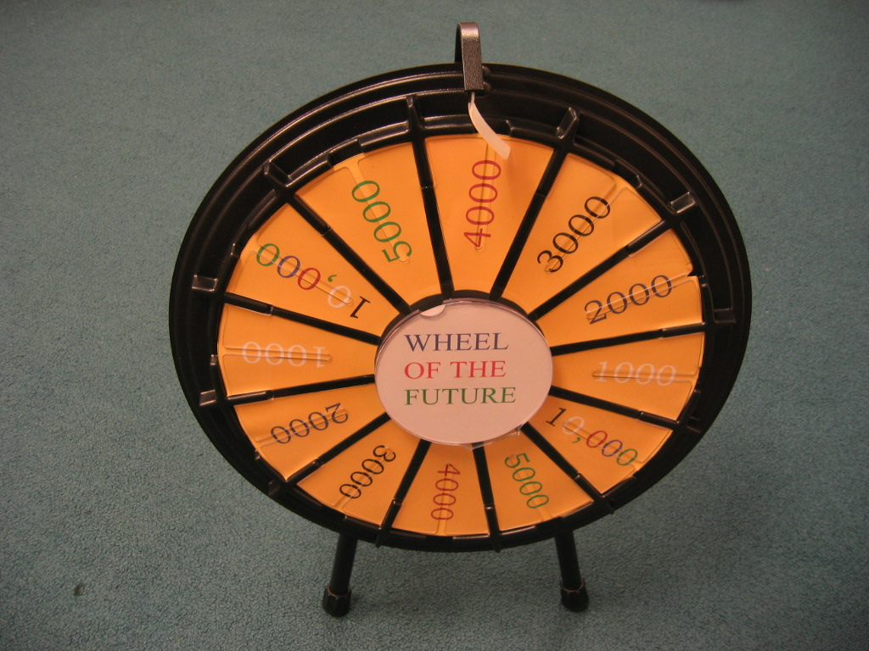
- Game wheel
- Sturdy table for the wheel
- Score Board (We’ve used a dry erase board, including dry erase markers and the eraser)
- Two Easels, one for Score Board and one for visuals
- Note cards with game questions on them
- Posters with visuals aids on them

Set Up

Time: 5 minutes

Step 1:

Place wheel and easels with scoreboard in any arrangement that suits the presenter. Create a row between the benches or chairs that visitors are sitting on. (The row divides the two teams)

Program Delivery

Time: approximately 15 minutes

Safety:
The only possible safety concern is to ensure that the wheel is on a sturdy table.

Procedure and Discussion:

It is important to keep the show moving quickly.

Wheel of the Future
Science Museum of Minnesota
Stephanie Long
2006
(Presenter may use note cards as opposed to memorizing the script.)
Welcome to Wheel of the Future, a game show about Nanoscale Science! My name is ____ and I will be your host. Wheel of the Future consists of three rounds. Before each round, I’m going to share some information with you: Listen closely because the answers to the game will be revealed! And, you will all be contestants on Wheel of the Future! The teams are dived by this row. (Gestures) This is Team A. (Gestures) This is Team B.
How many of you have heard of nanoscale science? (Visual) Great! The field of nanoscience involves the manipulation of atoms to form new structures. It sounds like science fiction, doesn’t it? But, nanoscience is very real. It will impact our lives! Some say the field of nanoscience will impact our lives more than any other prior invention – more than electricity, more than cars, more than television and more than computers. Some cars and computers already use technology on the nanoscale. So, we should all be paying attention to nanoscience.
The word nano is a prefix that means dwarf and (Visual) a nanometer is one one-billionth of a meter. Nano-sized particles are so small that scientists (Visual) cannot see them with their eyes or even ordinary microscopes. They have to use special tools that can feel things on the nanoscale. These instruments can move atoms and molecules around to build nano-products.
Nano-sized materials are found in nature and in your body.
Things on the nanoscale behave differently than they do on the macro-scale. (Visual) For example, macro-gold is yellow while nano-gold is red or purple.
Are you ready to play Round One of Wheel of the Future? (Audience cheers) First, I need an official scorekeeper. (Have the volunteer stand by the scoreboard) Round One is a true or false round. I need a team representative from each team who’s willing to spin the wheel. (Get the volunteers names and have each volunteer stand by the wheel) All right, you will spin the wheel to find out how much pretend money the question is worth. Teams shout out the answer to your team representative. We will start with Team A. Spin that wheel. (You may want to encourage all the visitors to shout, “Spin that wheel.”)
1. True or false? A nanometer is one one-billionth of a meter.
True. In fact, one molecule of sugar is approximately one nanometer. That means one sugar cube contains 2 sextrillion, 110 quintillion molecules of sugar. (Visual)

2. True or false? Things on the nanoscale are not found in nature.
False. That is false. Why even things found in the human body are on the nanoscale. DNA is only two nanometers wide.

3. True or false? Scientists use touch to manipulate things on the nanoscale?
True. Scientists move atoms and molecules around on the nano-scale using instruments like the atomic force microscope.

4. True or false? Things behave differently on the nanoscale.
True. On the nanoscale, forces that hold surfaces together become very strong.

What a great Round One! The score stands at_______. Team representatives, you can have a seat. Please give them a round of applause.

How will we use nanotechnology? One option is energy use. (Visual) Solar cells convert sunlight into electricity, which is great for the environment, but hard on the checkbook. Well, some scientists predict that solar cells built with nano-materials will be less expensive to produce than current solar panels. And any electricity that is not consumed can be stored in a battery for use on a cloudy day.
There is even the possibility that nanoparticle-solar cells could be sprayed on like paint. Some scientists envision nanoparticle-solar cells embedded into your clothes. Imagine powering your cell phone with the clothes you’re wearing.
Round Two is a true or false round about nanoparticle solar cells. I need two team representatives to spin that wheel. (Ask the Volunteers for their names) We will start with Team B this round. Spin that wheel!
1. True or false? Nanoparticle solar cells may be less expensive to produce
True. The reason why current silicon solar cells are so expensive is because they rely on highly defect free silicon.

2. True or false? Nanoparticle solar cells could be sprayed on like paint
True. Portable energy is a possibility

3. True or false? Any electricity that is not consumed will be lost.
False. It can be stored in a battery for use on a cloudy day.

4. True or false? Solar cells convert sunlight into electricity
True. They do this by moving electrons around in a circular motion.

That concludes Round Two. Please give your team representatives a round of applause. The score stands at _______.
Many people are concerned about the potential risks associated with the new technologies. (Visual) Since materials behave differently when they get small, scientists are concerned that small particles of a material may affect the human body differently than large particles of the same material, and make people sick. (Visual) People are also concerned about a loss of privacy. Super small devices could keep track of what you buy or where you go or who you talk to without your even knowing it. There are also concerns about the environment, (Visual) because new materials can sometimes accumulate in certain organisms, and pose a threat to vulnerable species like fish. (Visual) It is also alarming that there are currently no rules requiring companies to prove that the new-sized materials are safe, and scientists and politicians are grappling with how to balance encouraging new technology with protecting public health. (Visual)
These are all valid concerns and things we need to think about. We need to weigh the benefits against the risks. We also do not want to miss out on the benefits of nanoscale technology because we were too cautious. So, we as citizens need to know the facts. Hopefully, Wheel of the Future will help you start thinking about these issues. But for now, are you ready to play Round Three of Wheel of the Future? (Audience cheers)

Round Three is about concerns people have about nanoscale technology. I need two team representatives to spin that wheel. (Get the volunteers names and have each volunteer stand by the wheel)

1. True or false? Since materials behave differently when they get small, scientists are concerned that small particles may cause health problems.
True. Scientists need to run the appropriate experiments.

2. True or false? We already have all the laws and regulations in place to deal with nanotechnology?
False. We have no regulations about how to monitor something so small.

3. True or false? People are also concerned about a loss of privacy.
True. Super small devices could keep track of you and your whereabouts.

4. True or false? Materials can sometimes accumulate in certain organisms and the environment?
True. This is called bioaccumulation.

That ends Round Three and our game Wheel of the Future! The final score is______. Well done! I hope you continue to learn about nanoscale science! Have a great day at the museum!

Take questions after the game show is completed.

Tips and Troubleshooting:
The presenter must make sure contestants do not stand in front of the wheel blocking it.

The presenter must have fun with the program and encourage the competition between the teams.

Our wheel has dollar signs on it. So, I refer to the points as pretend money. Referring to the points as “points” will be just fine.

Going Further…
These websites have lots of information on nanotechnology and nanoscience:
Science Museum of Minnesota - Science Buzz
  - http://www.smm.org/buzz/

MIT Technology Review
  - http://www.technologyreview.com/

The Big Picture on Nanoscience (Issue 2, June 2005)
  - http://www.wellcome.ac.uk/node5954.html

Nanowerk
  - http://www.nanowerk.com

PhysicsWorld (Formerly PhysicsWeb)
  - http://physicsworld.com/cws/home

National Geographic
  - http://www.nationalgeographic.com/

Clean Up

Time: 5 minutes
Return props to appropriate storage space.

This project was supported by the
National Science Foundation under Grant No. ESI-0532536.

