

Lab-on-a-Chip & Paper Diagnostics

Nanotechnology is making it cheaper and faster to detect diseases. Small chips the size of a postage stamp could run a variety of medical tests, using only a drop of blood and producing results in just a few minutes. These “labs-on-a-chip” owe their efficiency to tiny channels that take advantage of capillary action and nano-sized sensors. These devices are currently available, but scientists are working to make even smaller channels with faster response time. Researchers are also working on special patterned paper that wicks tiny amounts of fluid—like blood—to test for illness. The paper diagnostics that have been made so far use microtechnologies, but nanoscale features may make them even more useful and accurate. Patients could quickly learn if they have an infectious disease or have been exposed to toxic chemicals.

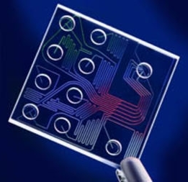 | 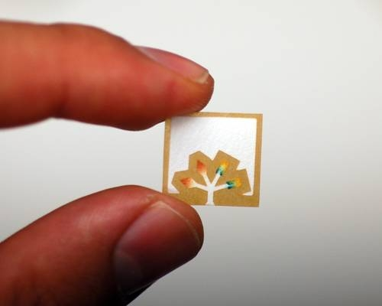
Small devices the size of a postage stamp move fluid  through tiny channels by capillary action | Paper wicks fluid for different diagnostic tests

