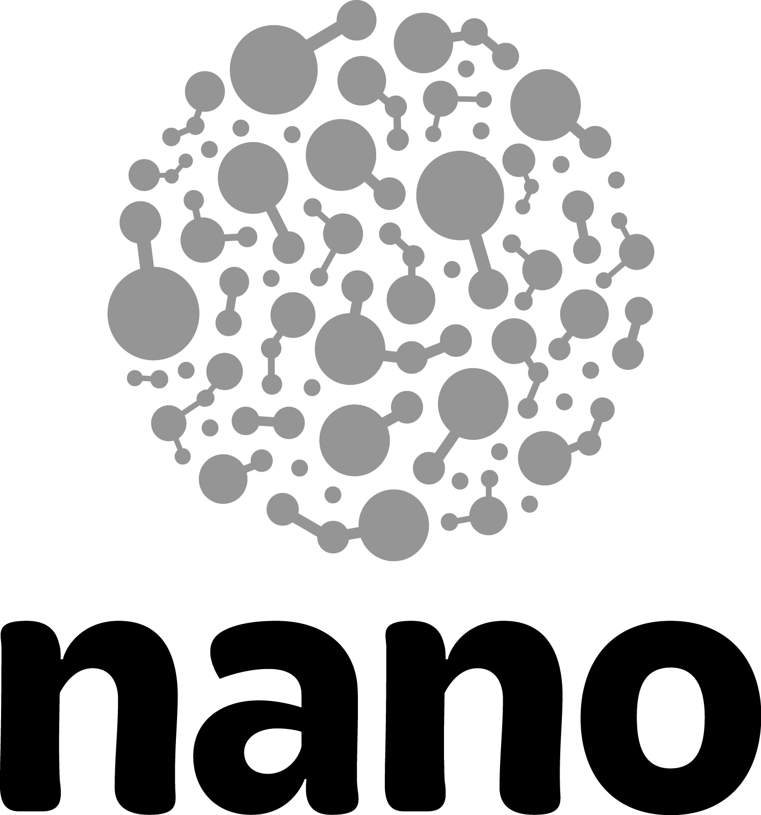

“Decisions in Innovation Systems” Training Guide

During the “Decisions in Innovation Systems” training discussion, participants follow the general process for taking a new nanotechnology product from initial idea to consumer product. In addition to outlining the basic parts of the innovation system, the activity also highlights the decisions researchers make as they create nanotechnologies and the way that values can inform those decisions. The activity can be done as a live presentation, or by watching a video. A discussion follows the presentation.
Time  15 minutes  Materials  - “Decisions in Innovation Systems” video (video presentation option)  - Whiteboard and markers (live presentation option)  Overview  - Watch video or give live presentation of innovation system (10 minutes)  - Review Big Ideas (5 minutes) | 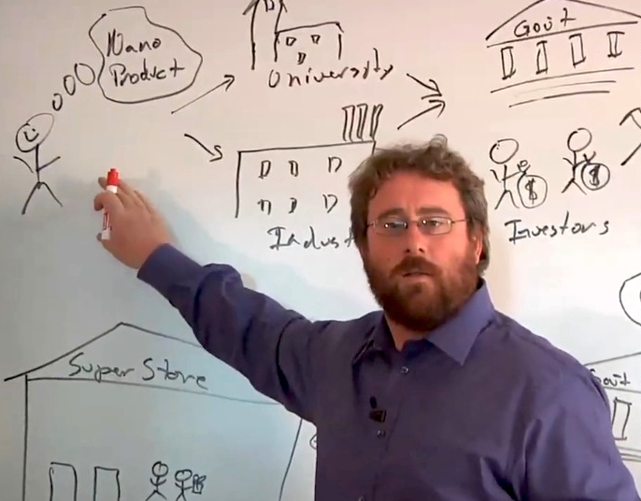
Presentation
The “Decisions in Innovation Systems” video walks through the basic process of taking an idea for a new nanotechnology to market. The presenter then goes through the process a second time, explaining how the values of the different parties involved (researchers, investors, manufacturers, government regulators) affect the decisions they make, shaping the eventual nanotechnology.

During the training, you can show the video and then have a brief discussion afterwards, or you can do the presentation live. If you choose to give the presentation yourself, review the video ahead of time to remind you of the major steps in the process and the decisions to discussion. These are summarized below.

Steps in the innovation process:
- Idea for nano product
- Place to do the research (university or industry)
- Funding (government grants or private investors)
- Iterative research process (often involves getting additional funding until breakthrough is made)
- Patents (to protect your intellectual property)
- Production (license intellectual property or manufacturer yourself)
- Manufacture (raw material, factory, product, and by-products)
- Regulation (if food or drug product)
- Market

Values and decisions in the innovation system:
- Idea for nano product
  - Values inform the idea for the product—who it’s for and how it will be used
- Place to do the research
  - University allows longer-term projects
  - Industry seeks to get a product to market relatively soon
- Funding
  - Government grants may support longer-term projects
  - Investors seek a return, so they want a product relatively soon
- Iterative research process
  - Researcher can think ahead to manufacturing process, market
  - Some great ideas are accidents
- Patents
  - Protect intellectual property but also reveal trade secrets
- Production
  - Licensing frees the researcher to focus on developing another idea
  - Being involved means the researcher can control how the idea is manufactured and marketed
- Manufacture
  - Source for raw materials
  - Location for the production facility
  - Handling the by-products (waste)
- Regulation (applicable to some products)
  - The government regulates some products, such as food and drugs, to protect consumers
  - The regulation process can take years, slowing the progress of the product to market
- Market
  - Who uses the product? For what? How much does it cost?
Discussion
After the presentation of the innovation system, allow time for an open-ended discussion of the process. Conclude by reviewing the “big ideas” the activity introduces.

Big Ideas
This training activity explores Nano & Society Big Ideas 1 and 3:
Values shape technologies
- Our values shape how technologies are developed and adopted.
- The adoption of technologies benefits some people more than others.

Technologies work because they are part of systems
- Technologies are part of larger systems that include technological, political, social, and environmental components.
- Many people and groups are involved in the development and adoption of new technologies.
- We affect the development and use of technologies through our actions and choices (as consumers, citizens, voters, workers, parents).
- In order to understand the role that technologies play and the effects they have, we need to think about the ways they’re connected to systems and people.

 | This project was supported by the National Science Foundation under Award Nos. 0940143 and 0937591.  Any opinions, findings, and conclusions or recommendations expressed in this document are those of the author and do not necessarily reflect the views of the Foundation.

Copyright 2012, Sciencenter, Ithaca, NY.

