Robots & People


Organization: Sciencenter
Contact person: Ali Jackson
Contact information: ajackson@sciencenter.org

General Description

Type of program:
Stage presentation plus facilitated activity

In the first part of the Robots & People program, visitors learn what robots and nanobots are, what they can do, and how they affect our lives. In the second part of the program, visitors imagine and draw a robot, designing it to do a particular task.

Program Objectives

Big idea:
Robots and people influence each other.

Learning goals:
As a result of participating in this program, visitors will be able to:

- Explain that a robot is a machine that can sense, plan, and act.
- Explain that nanobots would be robots the size of cell or molecules—but they don’t yet exist.
- Give examples of some of the things people have created robots to do.
- Describe how robots and people influence each other; for example:
  - Values shape the kinds of robots we create and use.
  - Robots can change the relationships between people.
  - Robots are part of larger systems that include technological, political, social, and environmental components.

NISE Network content map main ideas:
[x] 1. Nanometer-sized things are very small, and often behave differently than larger things do.

[ ] 2. Scientists and engineers have formed the interdisciplinary field of nanotechnology by investigating properties and manipulating matter at the nanoscale.

[ ] 3. Nanoscience, nanotechnology, and nanoengineering lead to new knowledge and innovations that weren’t possible before.

[x] 4. Nanotechnologies have costs, risks, and benefits that affect our lives in ways we cannot always predict.

National Science Education Standards:
1. Science as Inquiry
K-4: Abilities necessary to do scientific inquiry
5-8: Abilities necessary to do scientific inquiry

5. Science and Technology
K-4: Abilities to distinguish between natural objects and objects made by humans
K-4: Abilities of technological design
K-4: Understanding about science and technology
5-8: Abilities of technological design
5-8: Understanding about science and technology

6. Personal and Social Perspectives
K-4: Science and technology in local challenges
5-8: Science and technology in society

7. History and Nature of Science
K-4: Science as a human endeavor
5-8: Science as a human endeavor

Table of Contents
General Description 1
Program Objectives 1
Table of Contents 3
Time Required 4
Background Information 4
Definition of terms 4
Program-specific background 4
Materials 9
Setup 9
Program Delivery 9
Safety 9
Talking points and procedure 9
Tips and troubleshooting 17
Cleanup 18
Universal Design 18

Time Required

Setup Program Cleanup

5 minutes 30 minutes 5 minutes

Background Information

Definition of terms

Nano is the scientific term meaning one-billionth (1/1,000,000,000). It comes from a Greek word meaning “dwarf.”
A nanometer is one one-billionth of a meter. One inch equals 25.4 million nanometers. A sheet of paper is about 100,000 nanometers thick. A human hair measures roughly 50,000 to 100,000 nanometers across. Your fingernails grow one nanometer every second.

(Other units can also be divided by one billion. A single blink of an eye is about one-billionth of a year. An eyeblink is to a year what a nanometer is to a yardstick.)

Nanoscale refers to measurements of 1-100 nanometers. A virus is about 70 nm long. A cell membrane is about 9 nm thick. Ten hydrogen atoms are about 1 nm.

At the nanoscale, many common materials exhibit unusual properties, such as remarkably lower resistance to electricity, or faster chemical reactions.
Nanotechnology is the manipulation of material at the nanoscale to take advantage of these properties. This often means working with individual molecules.
Nanoscience, nanoengineering, and other such terms refer to those activities applied to the nanoscale. “Nano,” by itself, is often used as shorthand to refer to any or all of these activities.

Program-specific background

Robots are machines designed to perform a function. They can sense and respond to their environment. They require a source of power and control to do their job. Once programmed, they can work on their own. In other words, robots are machines that can sense, plan, and act.

Nanobots do not currently exist. Nanobots would be nanoscale robots: tiny robots the size of cells or molecules. There are significant challenges to developing nanoscale robots. It is difficult to make, power, and control machines that small.

Wikipedia provides general information about robotics and nanorobotics:
http://en.wikipedia.org/wiki/Robot
http://en.wikipedia.org/wiki/Nanobot
http://en.wikipedia.org/wiki/Robotic_arm
http://en.wikipedia.org/wiki/Industrial_robot
http://en.wikipedia.org/wiki/Humanoid_robot
http://en.wikipedia.org/wiki/Robot_swarm

Below are sources for additional information on the robots included in this program.

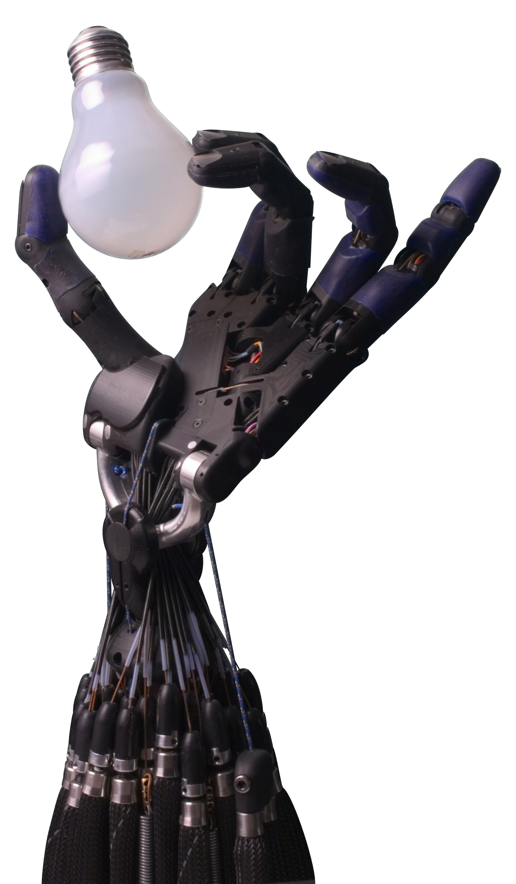 | Shadow Robot Company  Information:  http://www.shadowrobot.com/  Videos:  http://www.shadowrobot.com/hand/videos.shtml
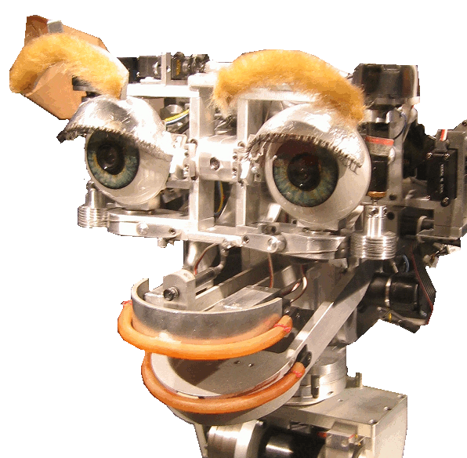 | Kismet, Massachusetts Institute of Technology  Information:  http://www.ai.mit.edu/projects/humanoid-robotics-group/kismet/kismet.html  http://en.wikipedia.org/wiki/Kismet_(robot)  Videos:  http://www.ai.mit.edu/projects/sociable/videos.html
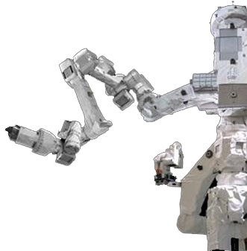 | Dextre, NASA and Canadian Space Agency  Information:  http://en.wikipedia.org/wiki/Dextre  Videos:  http://www.youtube.com/playlist?list=UUdNtqpHlU1pCaVy2wlzxHKQ&feature=plcp
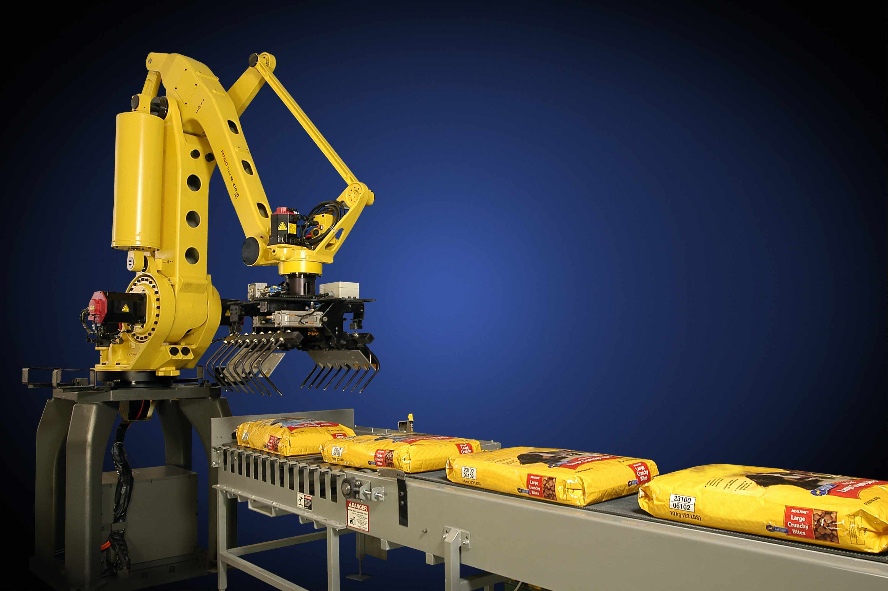 | FANUC Robotics  Information and videos:  http://www.fanucrobotics.com/Products/Robots/Atoz.aspx
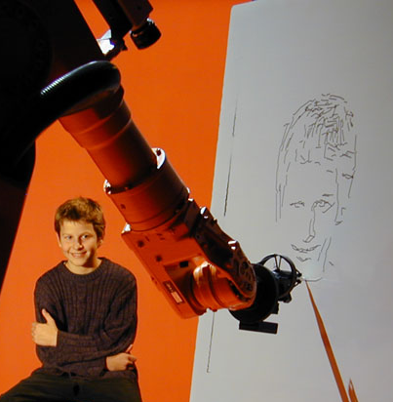 | autoportrait, robotlab  Information:  http://www.robotlab.de/auto/portrait_engl.htm  Videos:  http://www.robotlab.de/auto/video_engl.htm  http://www.youtube.com/watch?v=DWRT8wW4-QA
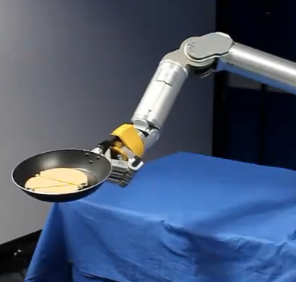 | Italian Institute of Technology  Information and videos:  http://kormushev.com/research/videos/  http://www.youtube.com/watch?v=W_gxLKSsSIE
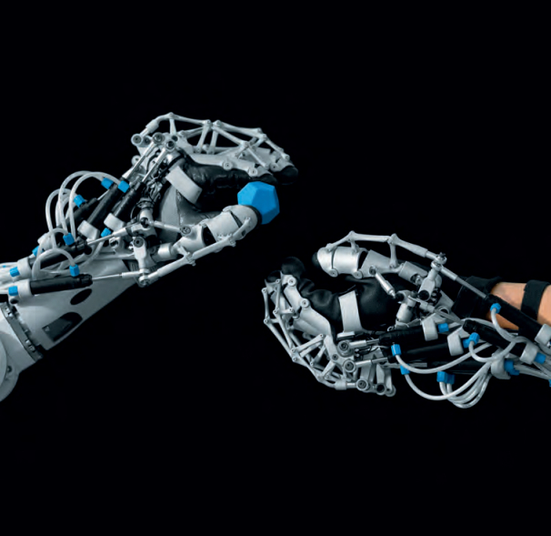 | ExoHand, Festo  Information:  http://www.festo.com/cms/en_corp/12713.htm  Videos:  http://www.festo.com/cms/en_corp/12713_12721.htm#id_12721  http://www.youtube.com/watch?v=5SmeEq_v7XU&list=UUHn6sgbOb_cq_oGtyGv9E8g&index=3&feature=plcp  http://www.youtube.com/watch?v=EcTL7Hig8h4&list=UUHn6sgbOb_cq_oGtyGv9E8g&index=10&feature=plcp
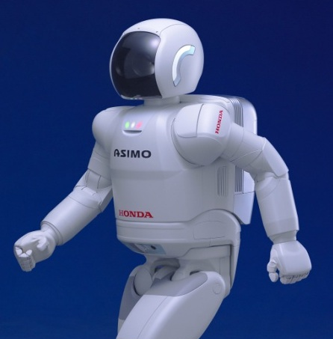 | ASIMO, American Honda Motor Co., Inc.  Information:  http://asimo.honda.com/world.honda.com/ASIMO  http://en.wikipedia.org/wiki/Asimo  Videos:  http://asimo.honda.com/asimotv/  http://www.youtube.com/watch?v=LuymCZL5aWM
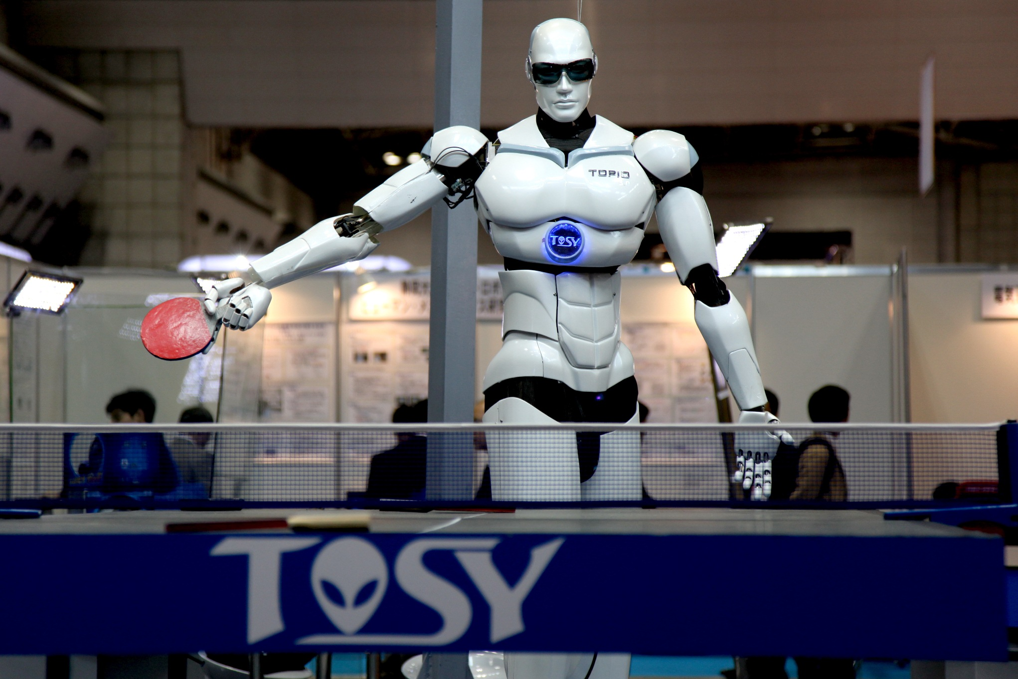 | Topio, TOSY  Information:  http://topio.tosy.com/about.shtml
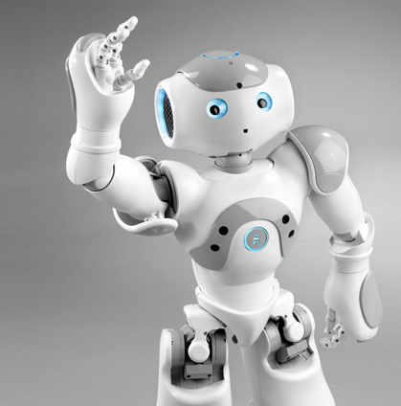 | Nao, Aldebaran Robotics  Information:  http://www.aldebaran-robotics.com/en/  Videos:  http://www.youtube.com/watch?v=2STTNYNF4lk  http://www.aldebaran-robotics.com/en/Discover-NAO/videos-gallery.html
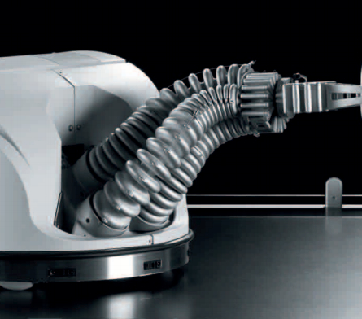 | Robotino, Festo  Information:  http://www.festo.com/cms/en_corp/11367_12623.htm  Videos:  http://www.festo.com/cms/en_corp/11367_11435.htm#id_11435  http://www.youtube.com/watch?v=0F71NcQPomU&list=UUHn6sgbOb_cq_oGtyGv9E8g&index=7&feature=plcp  http://www.youtube.com/watch?v=5TjRRqPwBuY&list=UUHn6sgbOb_cq_oGtyGv9E8g&index=2&feature=plcp
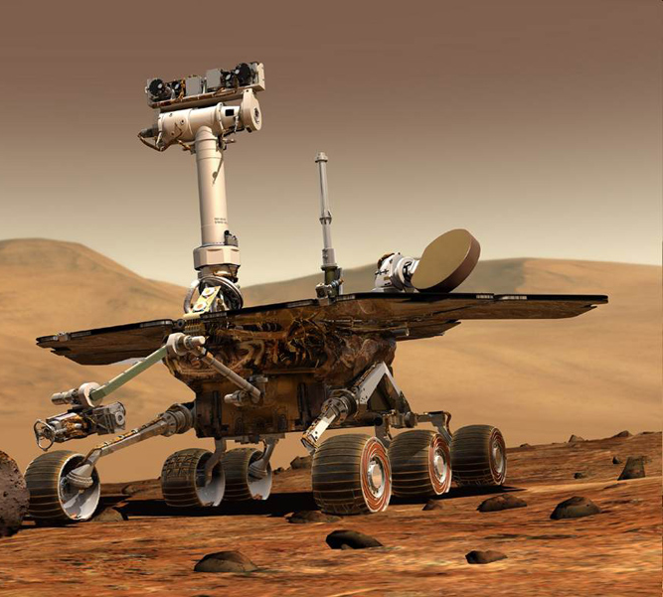 | Mars rovers, NASA  Information:  http://marsrover.nasa.gov/home/index.html  http://en.wikipedia.org/wiki/Mars_rover  Videos:  http://marsrover.nasa.gov/gallery/video/spirit01.html  http://www.youtube.com/channel/HCKFjArZgc8CA
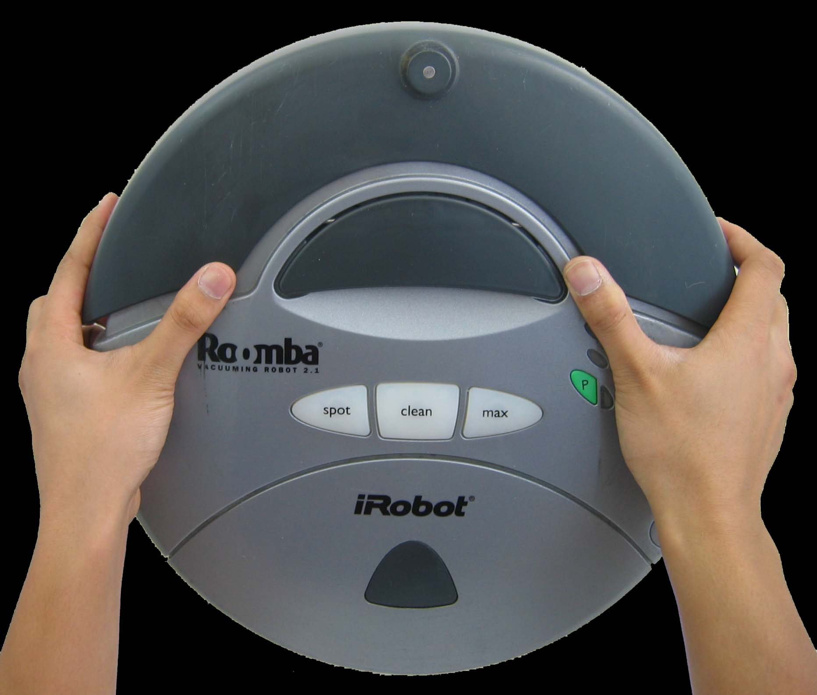 | Roomba, iRobot  Information:  http://www.irobot.com/us/robots/home/roomba.aspx  http://en.wikipedia.org/wiki/Roomba  Videos:  http://www.irobot.com/us/robots/home/roomba.aspx  http://www.youtube.com/watch?v=Lu_61SCjUAg
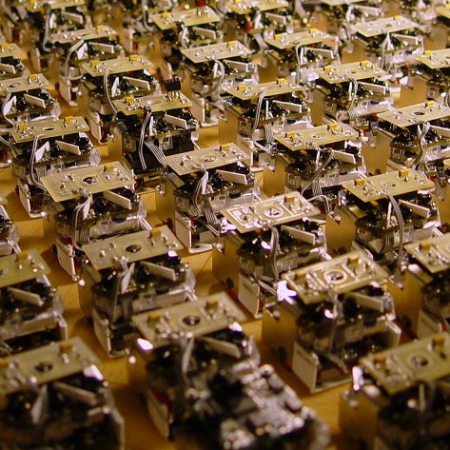 | Jasmine, University of Stuttgart and University of Karlsruhe  Information:  http://www.swarmrobot.org/  Videos:  http://www.swarmrobot.org/imagesvideos.html
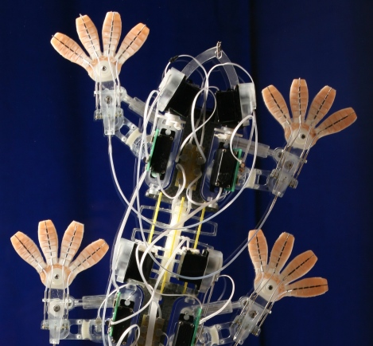 | Stickybot, Stanford University  Information:  http://news.stanford.edu/news/2010/august/gecko-082410.html  Videos:  http://www.youtube.com/watch?v=e4ntbQ6isIk&feature=plcp  http://bdml.stanford.edu/Main/StickybotIIIClimbing
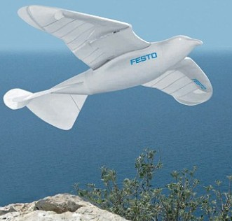 | SmartBird, Festo  Information:  http://www.festo.com/cms/en_corp/11369_11653.htm  Videos:  http://www.festo.com/cms/en_corp/11369_11439.htm#id_11439  http://www.youtube.com/watch?v=kA7PNQiHT1Q&list=UUHn6sgbOb_cq_oGtyGv9E8g&index=5&feature=plcp  http://www.youtube.com/watch?v=9fbmWQ3ExEs&list=UUHn6sgbOb_cq_oGtyGv9E8g&index=9&feature=plcp
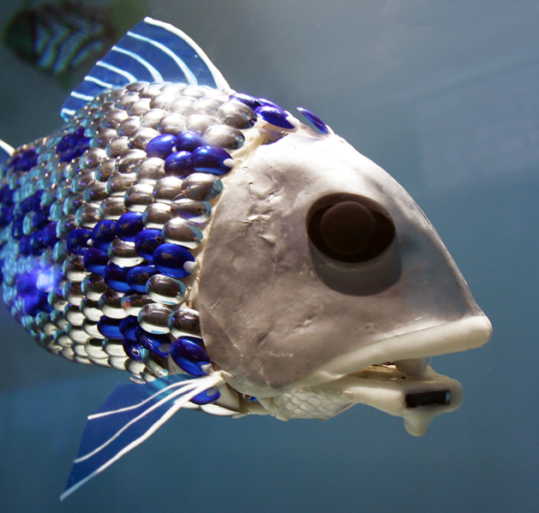 | Robofish, University of Essex  Information:  http://www.dailymail.co.uk/sciencetech/article-1163125/Schools-robofish-sniff-pollution-Thames.html  Videos:  http://www.youtube.com/watch?v=eO9oseiCTdk  http://www.youtube.com/watch?v=7Q7ZCi-G5jM
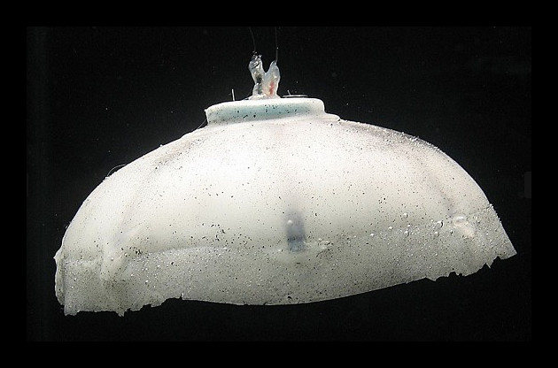 | Robojelly, Virginia Tech  Information:  http://www.emdl.mse.vt.edu/projects/alex.html  http://www.popsci.com/technology/article/2012-03/hydrogen-powered-robojelly-pulses-through-water-conduct-surveillance  Videos:  http://www.youtube.com/watch?v=U2OSJQhHQp8  http://www.youtube.com/watch?v=KPrkwhhiArI
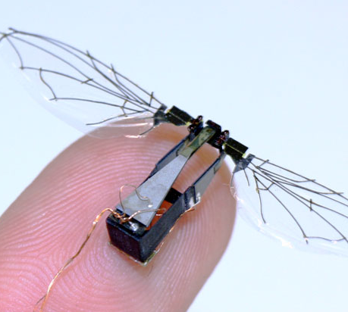 | Robobee, Harvard University  Information:  http://robobees.seas.harvard.edu/  http://www.benfinio.com/  Videos:  http://www.benfinio.com/media/  http://www.youtube.com/watch?v=GgR-mH6X5VU
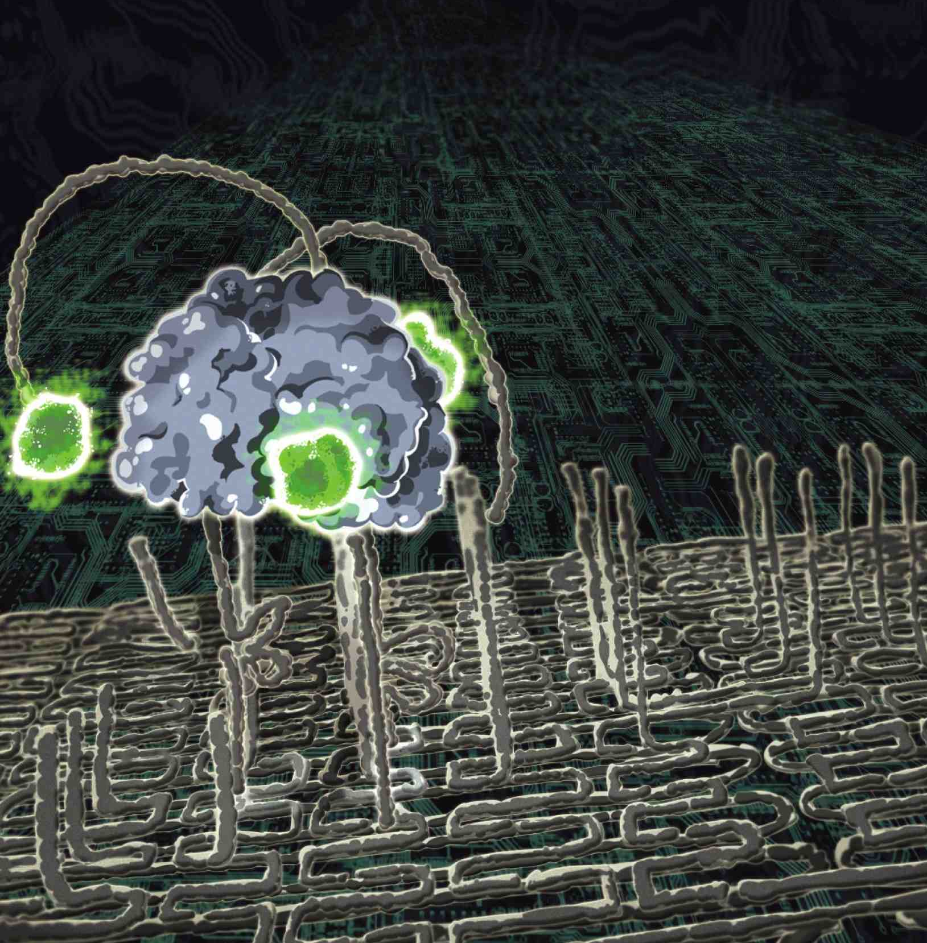 | DNA spider, Arizona State University  Information:  https://asunews.asu.edu/20100512_dnarobots  http://media.caltech.edu/press_releases/13345

Materials

PowerPoint presentation
“My Robot” drawing sheets
Markers

Setup

Time:
5 minutes
Set up the PowerPoint presentation.
Photocopy “My Robot” drawing sheets and gather markers.

Program Delivery

Time:
10-15 minutes for the presentation and 15 minutes for the drawing activity.

Safety

Use nontoxic, washable markers.

Talking points and procedure

<Slide 1: Robots & People>

Our program today is about robots and people—how we work together and influence each other.

<Slide 2: Today’s Program>

In the first part of the program, we’re going to talk about what robots are, find out what they can do, and think about how they affect our lives.

Has anyone ever heard of nanobots, tiny robots that are as small as cells or molecules? Do you think they’re real, or they could be real?

[Audience response]

We’ll find out.

Then, in the second part of the program, we’re going to think about what kind of robot we would design if we were going to invent one, and draw a picture of it.

<Slide 3: What is a robot?>

Let’s start by talking about what a robot is. Does anyone have any ideas?

[Audience response]

<Slide 4: Robots are machines that can sense, plan, and act>

Robots are machines that are designed to do a job. They need a source of power to do their job, and they need to receive commands to tell them what to do. Once they are programmed, robots can work on their own. Many robots can sense and react to their surroundings.

So robots are machines that can sense, plan, and act.

<Slide 5: What can robots do?>

If robots are made to do all different kinds of jobs, do you think they all look the same and are the same size?

[Audience response]

Robots are designed to do their jobs well, so they are built differently. Sometimes they are wheeled vehicles. Sometimes robots look like mechanical people or animals. And sometimes they just have a moving arm. We’ll see lots of different examples of robots in this program.

<Slide 6: Robotic arms>

First, let’s talk about robotic arms.

<Slide 7: Work in a factory>

Many industrial robots are basically just arms with different tools on the end. The robot in this picture is loading heavy bags onto a pallet. It uses the grabber on the end of its arm to pick up the bags and stack them up on the pallet.

Why do you think we’d use a robot for this job?

[Audience response]

Robots are good at doing this kind of repetitive work. They don’t get tired, they work quickly, and they can do the job just the way they’re supposed to, over and over.

<Slide 8: Draw portraits>

This is a robotic arm originally designed to be used in a factory. It’s been reprogrammed to create artistic works. It senses the features of the person sitting and draws a portrait.

Why do you think artists wanted to make the robots do this kind of job?

[Audience response]

Maybe to make us think about the difference between robots and people!

<Slide 9: Make pancakes>

This is a robot that can learn! A person shows it how to do a task, like flip pancakes, and the robot keeps practicing until it gets it. Scientists are trying to make robots that are more like people—for example, by being able to learn.

This robot is a great example of our definition: it senses where the pancake is, plans how to flip it, and acts differently next time if it fails.

<Slide 10: How would YOU use this robot?>

Here is a robot that is a pair of two different kinds of robotic arms! There’s a glove that can make a human hand stronger, and a robotic arm that can do very precise work. They can interact with each other, like you see in the picture.

If you had this robot, what would you do with it?

[Audience response—solicit several ideas]

Robotic arms help us to see how our VALUES shape the technologies we develop and use. For example, sometimes we value getting work done more quickly, precisely, or safely, so we make robots to do jobs people used to do.

[Talk/ask about the values behind the audience ideas. If the audience needs encouragement, you could ask how they feel about a robot taking a job a person used to do, or about how fair it would be for people to use a robotic arm like the one pictured in a sports competition.]

<Slide 11: Humanoid robots>

Humanoid robots are robots that look and move like people.

<Slide 12: Help at home>

This is an example of a humanoid robot. Why would we want to make robots that are built like humans?

[Audience response]

So that it can live and work alongside people. For example, it has legs so it can go up and down steps. The robot has cameras and sensors that let it map objects and people around it, and react to them. The robot’s designers hope that eventually it will be able to assist elderly and disabled persons in their homes, and do dangerous jobs like fight fires.

<Slide 13: Play ping-pong>

What is this robot doing?

[Audience response]

Yes, playing ping-pong! Maybe it could be adapted to play other sports, too.

<Slide 14: How would YOU use this robot?>

How would you use this robot?

[Audience response—solicit several ideas]

Humanoid robots help us to think about the ways that technologies can change our social relationships. If we had robots living in our homes and working with us, how would that change our interactions with other people?

[Talk/ask about how robots would change our social relationships, connecting to the ideas mentioned by the audience. If the audience needs encouragement, you could ask what would happen if a person living alone had a robot for a companion and helper. Would they view the robot as a friend? How do we feel about robots doing caregiver work?]

<Slide 15: Robot vehicles

Now let’s talk about robots with wheels! What can they do?

<Slide 16: Explore space>

The Mars rovers are examples of robots. Who knows what the Mars rovers are designed to do?

[Audience response]

The rovers help scientists study the planet Mars. They have six wheels and a special suspension that lets them drive over the rocky surface of Mars. Scientists on Earth send them commands.

The rovers can sense their environment and override their commands if they need to. So, for example, if the scientists tell them to go straight, and the rovers realize there’s a big drop-off in front of them, they can plan how to go around it and then get back on the path they’re supposed to take.

<Slide 17: Vacuum>

Here’s another wheeled robot, but it doesn’t do its work on Mars. Where would you find this robot?

[Audience response]

Yes, in your house! This is a robot vacuum cleaner. This vacuuming robot is controlled by a computer that sends it around the room in spiral and crisscross patterns until a whole area has been covered. It has special sensors to keep it from bumping into things or falling down stairs.

<Slide 18: How would YOU use this robot?>

These wheeled robots help us to see how technologies are part of bigger systems. For example, the Mars rover works because it’s in communication with scientists on Earth. Many different technologies are involved in getting the rover to Mars and communicating with it once it’s there. And many different people have been involved in creating the rovers and using them.

These little swarm robots interact with each other. They can be programmed to do different things. How would you use these robots? How would they be part of a system?

[Audience response—solicit several ideas]

<Slide 19: Biomimetic robots>

Biomimetic robots are inspired by things in nature.

<Slide 20: Soar like a bird>

Scientists are building robots that look and move like animals, because they hope to make robots that perform well in all different kinds of environments.

What kind of animal does this robot imitate?

[Audience response]

That’s right, a bird. The company that made it invested a lot of time studying the natural flight of a bird. This robot can fly and land on its own, or it can be controlled remotely.

<Slide 21: Monitor pollution>

How about this robot? What kind of animal were scientists imitating?

[Audience response]

Yes, it was inspired by fish. It was invented to detect pollution in rivers, lakes, and seas across the world.

<Slide 22: Spy on ships and subs>

Here’s another underwater robot. This robot looks and moves like a jellyfish. It was designed for the US Navy to use for surveillance. Why do you think they wanted it to look like a jellyfish?

[Audience response]

Right, so it could hide in plain sight!

<Slide 23: How would YOU use this robot?>

Here’s a mini robot that can fly! It’s the size of a bee. What would you use a very small flying robot for?

[Audience response—solicit several ideas]

A flying robot could be used for all sorts of things, because it could go places people can’t go, and it could hide really well. It would be good for spying and monitoring, reconnaissance, and search and rescue. This kind of robot would probably work in teams, or swarms. This is an example of a small robot.

[Ask the audience how they feel about swarm robots. If they need encouragement, you could ask if they’re reassured by the security possibilities or nervous about privacy issues.]

<Slide 24: What are nanobots? Are they real?>

Has anyone heard of nanobots? What have you heard or read about them?

[Audience response]

Some scientists, fiction writers, and other people think that some day there might be tiny little robots the size of cells, or even as small as molecules.

They might work in swarms, like some of the other robots we’ve seen. They might do helpful things like live in your body and fight viruses that make you sick. Or they might figure out how to make copies of themselves, and start doing things they weren’t designed to do. Some people worry they could take over the world!

To figure out if nanobots could be real, let’s think about exactly how small they would be.

<Slide 25: Nanobots would be very, very small robots!>

Nanobots would be tiny robots the size of molecules. They’d be so tiny that they’d be measured in nanometers.

A nanometer is one-billionth of a meter! Let’s see if we can picture how small that is. A meter is the length from my chin to my hand. If you divided that into a billion pieces, you’d have a nanometer. Here’s another way to think about how small a nanometer is: Your fingernails grow a nanometer every second! A nanometer is way, way too small to see.

Could there really be super-tiny robots that are so small you can’t even see them, so small that they’re the size of DNA? What do you think? Are nanobots real?

[Audience response]

<Slide 26: Nanobots don’t exist…yet>

Nanobots don’t yet exist.

What are some of the reasons we can’t make nanobots, at least not right now?

[Audience response]

Well, first of all, if you were as small as a molecule or a cell, air would feel as thick as honey. So that’s one big challenge to overcome: making a tiny robot that can move on its own.

And when things are as small as a molecule, they shake a lot, they move all around, and they stick to other things! If someone managed to make a nanobot, it might jiggle itself apart! Or it might bump into other molecules and stick to them.

Nature can build things this small, so scientists are studying bacteria, viruses, and other tiny, natural “machines” to help them figure out how to build micro- and nano-sized robots.

Although true nanobots don’t exist, researchers are making impressive progress in creating very tiny machines that have some of the capabilities of robots. And many of the robots that we do have use nanotechnology. New nanomaterials—and modern computer chips with nano-sized features—are allowing robots to do things they couldn’t do just a few years ago.

<Slide 27: DNA spider can walk>

This cool spider is made of DNA. It walks along a surface that’s also made of DNA.

The walking surface is made of strands that match the strands that make up the spider’s legs. As the spider takes a step, its leg sticks to a matching strand and cuts it. The cut pieces don’t interact as strongly with the spider’s legs as the full-length pieces do. The spider’s legs are attracted to the path ahead of it instead of the path behind it, so it walks forward. It’s a very clever system—but not really a robot by our definition.

<Slide 28: Today’s program>

So, we’re done talking about robots. Now we’re going to think about what kind of robot we’d like to invent, and draw a picture of it.

But first, let’s quickly review the things we talked about today.

What is a robot?

[Audience response]

Yes! A robot is a machine that can sense, plan, and act.

We’ve seen lots of ways that people and robots affect each other.

What is a nanobot?

[Audience response]

A nanobot would be a robot measured in nanometers—about the size of a molecule.

Do nanobots exist?

[Audience response]

No! Right now, nanobots don’t exist.

By the time the kids in this room are old enough to be engineers, maybe we’ll be able to make nanobots. Maybe one of you will invent one!

<Slide 29: What can YOUR robot do?>

Meanwhile, it’s fun to think about what kind of robot or nanobot you would invent if you could.

Like the engineers and scientists who are working on real robots, you’ll have to think about what you want your robot to do, and design it so it could do that job. Be sure to think about how you and your robot will interact, and how your robot could change your life!

There are drawing sheets that you can use to help you plan your robot, and markers. I’ll walk around and see what you come up with. Have fun!

Tips and troubleshooting

Stage presentation

Keep the program moving at a good pace. There are many examples of robots, and if you talk too much about each one the program will be too long.

Don’t shortchange the conversational parts, however. Be sure to ask the audience questions and have them reflect on how robots and people influence each other.

Drawing activity

Kids usually don’t have any trouble getting started with the drawing activity. If they need encouragement, you can ask questions to help them start thinking about what kind of robot they would invent.

If you like, you can do a craft-building activity in addition to the drawing activity. After kids have designed their robots, invite them to create a three-dimensional model. You can use a variety of materials for this extension activity. Suggestions include:
- Recycled materials, such as:
  - Assorted containers and cups
  - Container lids and caps
  - Paper tubes and boxes
  - CDs and other “tech” materials
  - Spools
  - Fabric scraps
  - Other clean, safe materials
- Craft materials, such as:
  - Craft foam
  - Construction paper
  - Straws
  - Craft sticks
  - Pipe cleaners
  - Pompoms
  - Yarn
  - Googly eyes
- Supplies:
  - Safety scissors
  - Nontoxic markers
  - White glue
  - Clear tape
  - Masking tape
  - Hole punches

Cleanup

Time:
5 minutes for drawing activity; longer for optional craft activity

Universal Design

This program has been designed to be inclusive of visitors, including visitors of different ages, backgrounds, and different physical and cognitive abilities.

The following features of the program’s design make it accessible:

[x] 1. Repeat and reinforce main ideas and concepts

- The presentation is organized into discrete chunks.
- A content overview is provided at the beginning of the program (program outline). The content is also summarized at the end of the program.
- Learning objectives are repeated throughout the presentation.

[x] 2. Provide multiple entry points and multiple ways of engagement

- The content is connected to visitors’ prior knowledge, and to their observations and questions.
- Concise key phrases are used to support main ideas.
- Main ideas are presented through sight and hearing.
- The program engages visitors in a hands-on activity, and provides a guided discussion that helps them to understand its significance.

[x] 3. Provide physical and sensory access to all aspects of the program

- Main ideas are presented through both sight and hearing.
- Slides are made accessible by using large, high-contrast text and images, clear fonts and graphics, and color to make distinctions.

To give an inclusive presentation of this program:

During the presentation:
- Make sure your face is visible at all times.
- Make sure you don’t stand in the way of the slides.
- Pace the program so that visitors can follow the content easily.
- Ask the audience questions, and check in with them along the way to make sure they’re engaged and following you.
- Use descriptive language when presenting objects and images.
- Make a handout of the slide presentation available to visitors, either to use during the presentation or to take home.
- Make sure your audience knows about any special accommodations you offer.

During the facilitated activity:
- Allow the activity to be self-paced, so that visitors of varying levels of interest and physical ability can finish the activity.

 | This project was supported by the National Science Foundation under Award No. 0940143. Any opinions, findings, and conclusions or recommendations expressed in this program are those of the author and do not necessarily reflect the views of the Foundation.
 | Copyright 2013, Sciencenter, Ithaca, NY. Published under a Creative Commons Attribution-Noncommercial-ShareAlike license: http://creativecommons.org/licenses/by-nc-sa/3.0.

