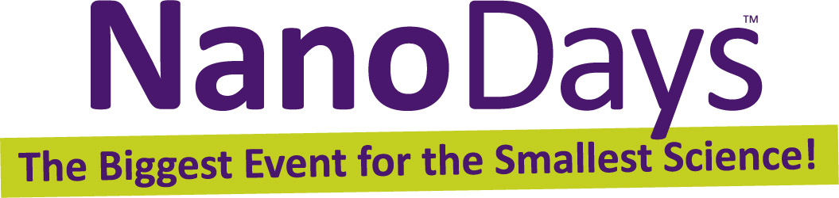
February 24, 2015

For more information or additional photos contact:

Ali Jackson
Director of National Collaborations, Sciencenter
601 First Street Ithaca, NY 14850
607.272.0600, ajackson@sciencenter.org

Get ready for NanoDays!
At the end of next month, hundreds of museums, science centers, and university research centers across the United States will be hosting events to help children and adults explore the tiny world of atoms, molecules, and nanoscale forces. These events are part of NanoDays, a weeklong, nationwide festival of educational programs about nanoscale science, engineering, and technology.

NanoDays, organized by the Nanoscale Informal Science Education Network (NISE Net), will take place nationally from March 28 – April 5, 2015. These community-based events collectively make up the largest public outreach effort in nanoscale informal science education. Over 300 science museums, research centers, and universities across the United States are involved, from Puerto Rico to Alaska.
NanoDays events bring scientists and researchers together with science educators to engage people of all ages in learning about this emerging field, which holds the promise of developing revolutionary materials and technologies. Most NanoDays events combine fun hands-on activities with presentations on current research. A range of exciting NanoDays programs demonstrate the special and unexpected properties found at the nanoscale, examine tools used by nanoscientists, showcase nano materials with spectacular promise, and invite discussion of technology and society.
Local communities experience many of these activities first hand at museum and research institutions. Visitors can experience the power of science fiction storytelling—imagining their own future full of new nanotechnologies. Hands-on activities invite visitors to explore polarized light, investigate how scientists use special tools to study tiny things, and envision how nanotechnology could change how we eat! Other activities include experimenting with heat transfer and completing an electrical circuit using just a pencil and paper.

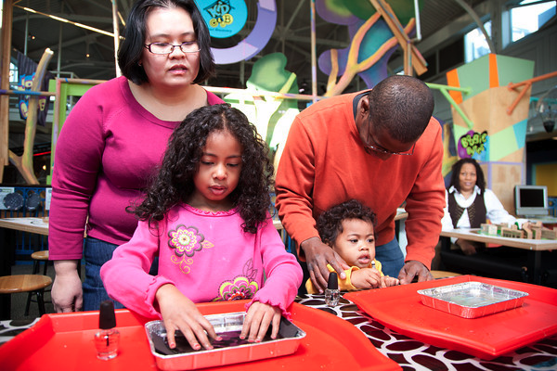
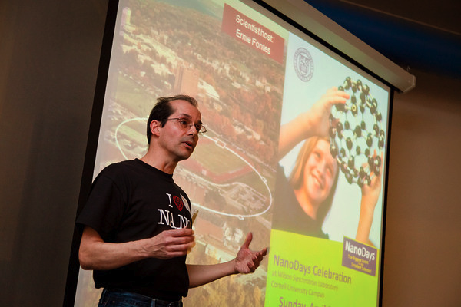
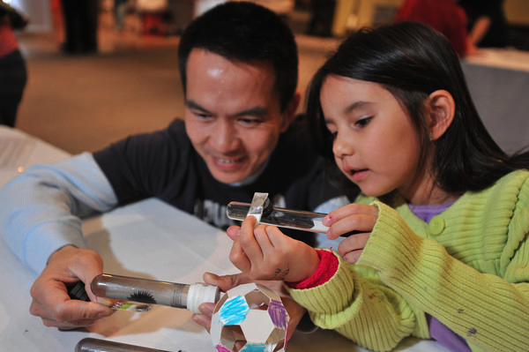
From left: NanoDays activities at the Museum of Science, Boston; Sciencenter in Ithaca, NY; and Port Discovery Children’s Museum in Baltimore, MD.

More information
The NISE Network is led by 14 organizations, and includes hundreds of museums and universities across the nation. Originally launched in 2005 with funding from the National Science Foundation to the Museum of Science in Boston, and its lead partners—the Science Museum of Minnesota and the Exploratorium, the NISE Network was awarded a second five-year $21 million grant in 2010. This second grant allows partners to continue to find ways to engage public audiences in this cutting edge science and technology into the next decade.

NISE Network lead organizations include:
- Association of Science-Technology Centers, Inc. in Washington, DC
- Center for Nanotechnology in Society at Arizona State University (CNS-ASU)
- Children’s Museum of Houston in Houston, TX
- Exploratorium in San Francisco, CA
- Franklin Institute in Philadelphia, PA
- Lawrence Hall of Science in Berkeley, CA
- Materials Research Society in Warrendale, PA
- Museum of Life + Science in Raleigh-Durham, NC
- Museum of Science in Boston, MA
- Oregon Museum of Science and Industry in Portland, OR
- Sciencenter in Ithaca, NY
- Science Museum of Minnesota in St. Paul, MN
- SRI International in Menlo Park, CA
- University of Wisconsin - Madison

For more information about NISE Net, NanoDays, and how to get involved, please visit:
http://www.nisenet.org/nanodays

To see a listing of (regularly updated) 2015 NanoDays events nationwide, please visit: http://nisenet.org/nanodays/participants-2015

For general information about nanoscience, engineering, and technology, please visit:
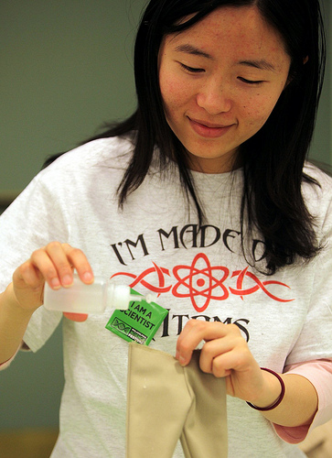
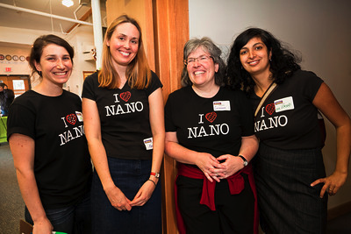
http://www.whatisnano.org

NanoDays staff and volunteers at the Museum of Science, Boston, Franklin Institute in Philadelphia, PA, and Sciencenter in Ithaca, NY.
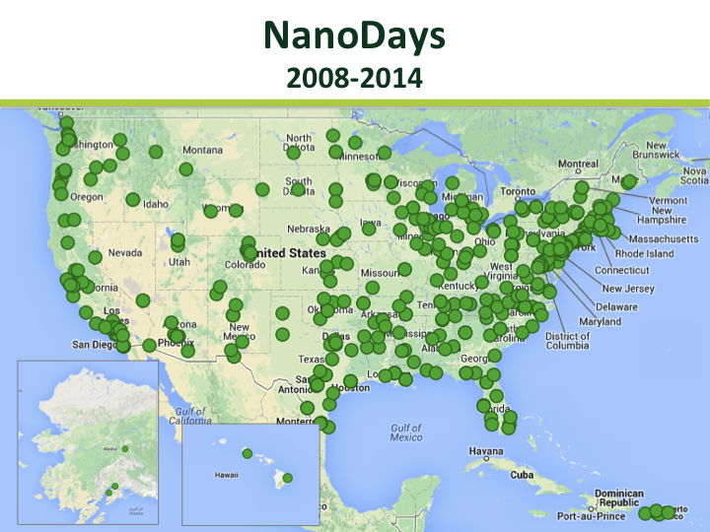

While several communities conducted NanoDays events in prior years, the first nationwide week of events took place in 2008 with more than 100 institutions participating. This has grown to more than 250 events over the past few years.

This project is based on work supported by the NSF under Award Numbers ESI-05322536 and DRL-0940143. NanoDays™ is trademarked by North Carolina State University and used by NISE Net with permission.

