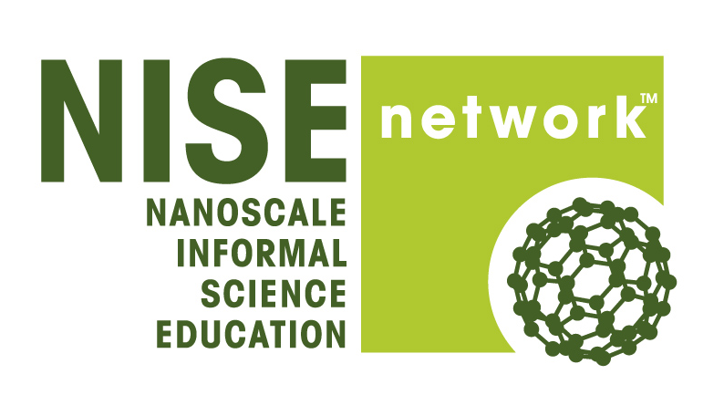

Application to Participate in the NISE Net Workshop, "Implementing the Sharing Science Workshop & Practicum" at the Museum of Science, Boston (Nov. 14-16, 2014)

Applications due August 20, 2014
Does your organization currently - or in the future want to - involve nano researchers in doing outreach to family audiences at a science museum or other informal science setting? The
Sharing Science Workshop & Practicum (SSW&P) is a professional development program that your museum or university can provide for nano researchers that prepares them for interacting successfully with family audiences in free-choice settings, using already-vetted NanoDays hands-on demos as a starting point. The SSW&P can be implemented as a one-day or two-half-day program. It was developed by the Museum of Science (MOS) and has been verified through multiple evaluations.
During this SSW&P Implementation Workshop, participants will observe how the SSW&P is implemented at MOS with graduate students from local research center partners. They will work out ways to plan and adapt the program for implementation at their home institutions. The NISE Network is awarding each Implemenation Workshop participant air and lodging expenses, workshop tuition and materials, and meals onsite. Applicants must be able to implement the SSW&P at their own or a partnering institution before March 31, 2015, and must also apply for a physical 2015 NanoDays kit. For more information about the workshop, contact nano@mos.org.
Please complete all fields of the application form. The checkboxes on page one are the pre-requisites for attending the Workshop. You can save and return to the survey later by clicking on the green bar at the top of each page after page one. You will be emailed a link to return to your saved application form (please check your spam folder if you don't receive this email). To download a copy of the application to review questions and plan your responses, please click here.

1) Check all those that apply:
☐ I wish to attend this workshop at the Museum of Science, Boston.

☐ I can attend this workshop in its entirety (Fri. Nov. 14 at 2pm through Sun. Nov. 16 at 12pm, exclusive of travel time).

☐ I have the backing of my institution and my supervisor to attend this workshop.

☐ I can commit my institution to implementing a Sharing Science Workshop & Practicum for a minimum of four early-career researchers (graduate students, post-docs, junior faculty) prior to March 31st, 2015, and to inviting them to volunteer for a NanoDays or other similar event. I will be personally involved in planning and implementing the SSW&P. If it is successful, we will probably repeat it at least one other time.

☐ My institution will apply for a physical NanoDays 2015 kit and will host a NanoDays event.

☐ After the Implementation Workshop, I will complete one questionnaire about my workshop experience, and, after implementing the SSW&P at my institution, I will complete a second questionnaire to provide valuable feedback on the implementation process.

☐ I will facilitate the collection of feedback data from program participants using SSW&P Participant Surveys.

2) Contact Information:
First Name*: _________________________________________________
Last Name*: _________________________________________________
Job Title: _________________________________________________
Institution*: _________________________________________________
Address 1*: _________________________________________________
Address 2: _________________________________________________
City/Town*: _________________________________________________
State*: _________________________________________________
Zip*: _________________________________________________
Email Address*: _________________________________________________
Phone Number*: _________________________________________________
Institution Website: _________________________________________________

3) Which best describes your organization?
( ) Museum/Science Center
( ) College or University - Focus on Nanoscale Science and Engineering
( ) Other ______________________________

4) Is your institution active in one of the following NISE Net regional hubs? If so, check one.
( ) Northeast (NY, VT, NH, ME, RI, CT, MA)
( ) MidAtlantic (PA, NJ, MD, DC, DE, OH, WV)
( ) Southeast (VA, NC, SC, KY, TN, LA, MS, AL, GA, FL, Puerto Rico)
( ) South (TX, AR, OK)
( ) Midwest (ND, SD, NE, KS, MN, IA, MO, WI, IL, MI, IN)
( ) West (AK, WA, OR, ID, MT, WY, CO, UT, NM)
( ) Southwest (CA, NV, AZ, HI)

5) Does your organization already have one or more partnerships with a research center (or, if your organization is a research center, partnerships with a science museum or other informal science organization?)

( ) Yes ( ) No

If yes, please list and describe this (these) partnerships. Include information about the current involvement of researchers and/or graduate student volunteers, and indicate how you are involved.
Collaboration #1: ____________________________________________
Collaboration #2: ____________________________________________
Collaboration #3: ____________________________________________
Collaboration #4: ____________________________________________
Others:

If no, please describe any plans you have for forming such partnerships:
____________________________________________
____________________________________________
____________________________________________
____________________________________________

6.) What current education and outreach training does your institution provide for early career researchers and how are you involved in these efforts?
____________________________________________
____________________________________________
____________________________________________
____________________________________________

7.) Please describe how you and your institution could benefit from your participation in this workshop.
____________________________________________
____________________________________________
____________________________________________
____________________________________________

8.) Is there anything else you would like us to know about your interest in this workshop?
____________________________________________
____________________________________________
____________________________________________
____________________________________________

9.) Please jot down any questions you may have about the SSW&P Implementation Workshop.
____________________________________________
____________________________________________
____________________________________________
____________________________________________

Thank you!

Your workshop application is now complete. You will be contacted by a NISE Network representative if there are additional questions about your application. You can expect to hear about the status of your request via email in late August 2014.

A PDF copy of your application has just been sent to the email address you provided. If you do not see it, be sure to check your spam folder.

