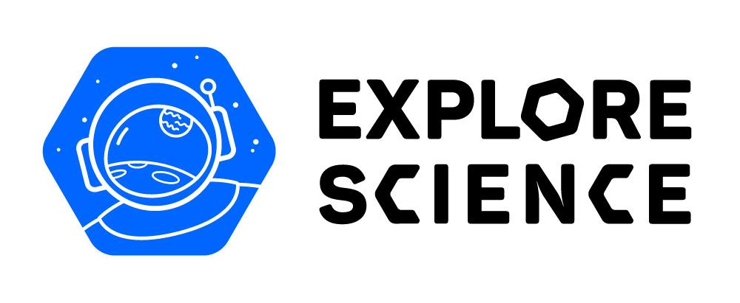
Voyage through the Solar System

2023 Report

Part 1 - Contact Information

Thank you for participating in the NISE Network’s 2023 Voyage through the Solar System project!

We ask that you please fill out this report as best you can.

The report asks about your public engagement efforts in 2023, and then asks about your plans for 2024.

All partners receiving physical kits are required to report to the NISE Network about their experiences through this online survey. In turn, the NISE Network then is required to share summaries of this data with our funders.

As you fill out this report, some of the questions will also ask about other NISE Network kits with Earth and space content in addition to the Voyage through the Solar System kit.

- 2023 Voyage through the Solar System kit
https://www.nisenet.org/solarsystem-kit
- 2017, 2018, 2019, and 2020 Explore Science: Earth & Space kits
https://www.nisenet.org/earthspacekit
- 2020 Moon Adventure Game
https://nisenet.org/moongame

Important Information About Filling Out the Report:
The report takes approximately 30 minutes to complete. Please note that it is NOT possible to save your work in the Alchemer (formerly SurveyGizmo) online form and return for additional edits. Reports left idle for too long will go blank when you progress to the next screen. Please plan to complete the online report in one session. You may want to write your responses in a Word doc, save, and then cut and paste that information into this report; you may download in Word Document format or PDF format from: https://www.nisenet.org/voyage-solar-system

If you have any questions about this report, please contact Christina Leavell, NISE Network Community Manager: Christina.Leavell@asu.edu

Contact Information

1) Your Contact Information:

First Name: _________________________________________________
Last Name: _________________________________________________
Job Title: _________________________________________________
Organization: _________________________________________________
Address 1: _________________________________________________
Address 2: _________________________________________________
City/Town: _________________________________________________

State (DROPDOWN MENU)
Country: _________________________________________________
Zip: _________________________________________________
Email Address: _________________________________________________
Organization Website: _________________________________________________
Phone Number: _________________________________________________

2) For organizations located in States beginning with the letter A through L:

Please confirm your organization in the pull-down selection below.
Organizations are sorted alphabetically by state, then city, and organization.
If your organization is not listed, please choose "OTHER" at the bottom of the list.

(DROPDOWN MENU)

3) For organizations located in States beginning with the letter M through Z:

Please confirm your organization in the pull-down selection below.
Organizations are sorted alphabetically by state, then city, and organization.
If your organization is not listed, please choose "OTHER" at the bottom of the list.

(DROPDOWN MENU)

Overall Museum Attendance

4) Annual On-Site Attendance:

How many visitors did your organization estimated to reach in 2023 at your facility?

You may use data from sources such as ticket sales, gate entrance, program registration, visitor logs, and staff estimates.

If you do not serve on-site visitors at your facility, please enter zero.
Please enter numbers only.
________

5) Annual Off-Site Attendance:

How many in-person participants is your organization reach estimated to reach in 2023 at locations outside your facility? (Not including virtual or online attendance)

You may use data from sources such as program registration, visitor logs, or staff estimates.

If you do not serve off-site participants, please enter zero.
Please enter numbers only.

_______

Public Engagement in 2023

6) Use of Any NISE Network Earth & Space kits

Please tell us how often your organization has incorporated ANY of the NISE Network kits that feature Earth and space science content during 2023.

Please base your response on the use of any of the following NISE Network materials:
- 2023 Voyage through the Solar System kit
https://www.nisenet.org/solarsystem-kit
- 2017, 2018, 2019, and 2020 Explore Science: Earth & Space kits
https://www.nisenet.org/earthspacekit
- 2020 Moon Adventure Game
https://nisenet.org/moongame

 | Not applicable to my organization | Daily | Several times a week | Once a week | Once a month | Several times a year | Once a year | Not sure
cart demonstrations / brief table top activities | ( ) | ( ) | ( ) | ( ) | ( ) | ( ) | ( ) | ( )
longer museum programs (e.g. forums, classes, labs, science club) | ( ) | ( ) | ( ) | ( ) | ( ) | ( ) | ( ) | ( )
K-12 school outreach (e.g. classes, field trips, science fair) | ( ) | ( ) | ( ) | ( ) | ( ) | ( ) | ( ) | ( )
afterschool programming | ( ) | ( ) | ( ) | ( ) | ( ) | ( ) | ( ) | ( )
special events (e.g. space events, Earth science events, family nights, festivals) | ( ) | ( ) | ( ) | ( ) | ( ) | ( ) | ( ) | ( )
camps (e.g. summer camp, holiday camp, day camp) | ( ) | ( ) | ( ) | ( ) | ( ) | ( ) | ( ) | ( )
local youth service organizations outreach (4-H, Boys & Girls Clubs of America, Boy Scouts of America, Girl Scouts, Girls Inc., PTA, the Y, YWCA, etc.) | ( ) | ( ) | ( ) | ( ) | ( ) | ( ) | ( ) | ( )
library outreach | ( ) | ( ) | ( ) | ( ) | ( ) | ( ) | ( ) | ( )
home school programs | ( ) | ( ) | ( ) | ( ) | ( ) | ( ) | ( ) | ( )
adult-only events | ( ) | ( ) | ( ) | ( ) | ( ) | ( ) | ( ) | ( )
lesson activities within college courses | ( ) | ( ) | ( ) | ( ) | ( ) | ( ) | ( ) | ( )
longer term display of materials in public spaces (e.g. within exhibits, on the museum floor, on a table) | ( ) | ( ) | ( ) | ( ) | ( ) | ( ) | ( ) | ( )
celestial events (e.g. star gazing, meteor showers, moon viewing, eclipses, etc.) | ( ) | ( ) | ( ) | ( ) | ( ) | ( ) | ( ) | ( )

7) DIY Sun Science and DIY Solar System Apps

The NISE Network has developed the DIY Solar System app and DIY Sun Science app, which are available for iPhones/iPads and Android devices, in both English and Spanish.

We'd like to ask you a few questions about the apps.
- DIY Sun Science app https://nisenet.org/diy-sun-science-app
- DIY Solar System app https://nisenet.org/diy-solar-system-app

(Please check all that apply)

[ ] I am aware of the app(s)
[ ] I have download the app(s)
[ ] We have promoted the DIY app to visitors in some way (in person, on social media, etc.)

8) Use of Materials During 2023

Please briefly describe your Earth and space science in-person, virtual, or other public programming during 2023 (including the annual solar eclipse). Include the types of public engagement activities you offered, and how you worked with any collaborators, and audiences reached.

Keep in mind we would like to hear any specific stories or anecdotes about your experiences or the overall impact on your organization.

Please base your response on the use of any of the following NISE Network materials:
- 2023 Voyage through the Solar System kit
https://www.nisenet.org/solarsystem-kit
- 2017, 2018, 2019, and 2020 Explore Science: Earth & Space kits
https://www.nisenet.org/earthspacekit
- 2020 Moon Adventure Game
https://nisenet.org/moongame

(Maximum: 300 words)

____________________________________________

Earth & Space Public Engagement

9) Audiences During 2023

Please identify the underserved audiences you reached through your Earth & Space public engagement in 2023.

Please base your response on the use of any of the following NISE Network materials:
- 2023 Voyage through the Solar System kit
https://www.nisenet.org/solarsystem-kit
- 2017, 2018, 2019, and 2020 Explore Science: Earth & Space kits
https://www.nisenet.org/earthspacekit
- 2020 Moon Adventure Game
https://nisenet.org/moongame

(Please check all that apply)

[ ] racial and ethnic minorities / communities of color
[ ] American Indian / Alaska Native
[ ] girls
[ ] low-income / lower socio-economic status
[ ] Spanish-speaking audiences
[ ] other non-native English speakers
[ ] disabled / differently abled
[ ] rural
[ ] inner city
[ ] at-risk youth
[ ] other underserved audiences: _________________________________________________*
[ ] N/A

10) Collaborations During 2023

Please note the kinds of collaborations with individuals or organizations you have that support your Earth & space science public engagement.

(Please check all that apply)
[ ] early childhood programs
[ ] K-12 schools and teachers
[ ] youth-serving organizations (scouts, afterschool programs, 4-H etc.)
[ ] community groups and/or faith-based organizations
[ ] museums or libraries
[ ] college students
[ ] college faculty and/or staff
[ ] NASA scientist or educator
[ ] Earth and space science enthusiasts or amateur astronomy club members
[ ] Solar System Ambassador
[ ] other - please describe: _________________________________________________

Plans for 2024

11) Public Engagement Plans in 2024

How does your organization plan to use any NISE Network Earth and space science public engagement materials in 2024?

Please base your response on the use of any of the following NISE Network materials:
- 2023 Voyage through the Solar System kit
https://www.nisenet.org/solarsystem-kit
- 2017, 2018, 2019, and 2020 Explore Science: Earth & Space kits
https://www.nisenet.org/earthspacekit
- 2020 Moon Adventure Game
https://nisenet.org/moongame

 | Yes | No | Not sure
cart demonstrations / brief table top activities | ( ) | ( ) | ( )
longer museum programs (e.g. forums, classes, labs, science club) | ( ) | ( ) | ( )
K-12 school outreach (e.g. classes, field trips, science fair) | ( ) | ( ) | ( )
afterschool programming | ( ) | ( ) | ( )
special events (e.g. space events, Earth science events, family nights, festivals) | ( ) | ( ) | ( )
camps (e.g. summer camp, holiday camp, day camp) | ( ) | ( ) | ( )
local youth service organizations outreach (4-H, Boys & Girls Clubs of America, Boy Scouts of America, Girl Scouts, Girls Inc., PTA, the Y, YWCA, etc.) | ( ) | ( ) | ( )
library outreach | ( ) | ( ) | ( )
home school programs | ( ) | ( ) | ( )
adult-only events | ( ) | ( ) | ( )
lesson activities within college courses | ( ) | ( ) | ( )
longer term display of materials in public spaces (e.g. within exhibits, on the museum floor, on a table) | ( ) | ( ) | ( )
celestial events (e.g. star gazing, meteor showers, moon viewing, eclipses, etc.) | ( ) | ( ) | ( )

12) Total Solar Eclipse April 8, 2024

Do you plan to use any NISE Network materials in advance or during the April 8, 2024 Total Solar Eclipse?

Please note that the NISE Network has a compilation of solar eclipse public engagement materials available online: https://nisenet.org/solareclipse
( ) Yes
( ) No
( ) No sure

13) Plans in 2024

Please briefly describe your Earth and space science in-person, virtual, or other public programming plans for 2024.

Please base your response on the use of any of the following NISE Network materials:
- 2023 Voyage through the Solar System kit
https://www.nisenet.org/solarsystem-kit
- 2017, 2018, 2019, and 2020 Explore Science: Earth & Space kits
https://www.nisenet.org/earthspacekit
- 2020 Moon Adventure Game
https://nisenet.org/moongame

(Maximum: 300 words) ​

___________________________________________

Kit Report Complete

Thank you for taking the time to fill out this report!

Your 2023 Voyage through the Solar System report is now complete. You should receive an automated email from Alchemer (formerly SurveyGizmo) with a PDF of your completed report attached. You may need to check your email spam filter for the automated email.

If you have any questions about this report or experienced any problems with the kit, please contact Christina Leavell, NISE Network Community Manager: Christina.Leavell@asu.edu

------------------------

This material is based upon work supported by NASA under grant numbers 80NSSC21M0082 and 80NSSC18K1219 and cooperative agreement award numbers NNX16AC67A and 80NSSC18M0061.

Any opinions, findings, and conclusions or recommendations expressed in this material are those of the author(s) and do not necessarily reflect the view of the National Aeronautics and Space Administration (NASA).

